Insert Laboratory Specific Name Here
Illumina MiSeq Waste Disposal SOP

- Purpose
The following document acts as a procedure on the proper disposal methods for Illumina MiSeq waste.

- Scope
This document applies to all staff that operate the Illumina MiSeq and supervisors that oversee these operations.

- Related Documents
Title | Document Control Number
N/A | Specify number

- Responsibilities
Position | Responsibility
All laboratory staff | - Ensure the MiSeq waste is disposed of in accordance with manufacturer recommendations or program disposal procedures  - Follow documented waste disposal procedures
Laboratory Leadership | - Ensure personnel are trained on the documented procedures for the disposal of iSeq 100 waste
Safety Staff | - Ensure that all safety procedures are established and followed
Quality Manager | - Ensure documented MiSeq waste disposal procedures are available to the end user  - Review records of instrument maintenance / calibration, as required

- Reagents and Media
Reagent | Manufacturer | Catalog #
Deionized water | N/A | N/A
- Supplies, Other Materials
Supply/Material | Manufacturer | Catalog #
Absorbent Material | N/A | N/A
Pipette, pipette tips | N/A | N/A
Storage Bags | N/A | N/A
Spill Proof Storage Tray | N/A | N/A

- Safety Precautions
  - All practices and safety equipment must comply with the recommendations for the specific biosafety level (BSL) and as listed in the most current version of Biosafety in Microbiology and Biomedical Laboratories (BMBL).
  - Appropriate personal protective equipment (PPE) must be worn at all times when working in the laboratory, including laboratory coat, gloves, and safety glasses.
- Formamide waste will be labeled for chemical waste disposal through the Laboratory Waste Management System (specify your laboratory’s system/process here).
  - For the MiSeq reagent cartridge, a small amount of formamide is present in well 8 of the cartridge.
  - Place tape over cartridge well 8 and place the entire cartridge in a storage bag (e.g., Ziploc bags). The bags can be left to accumulate in a spill proof tray.
  - The spill proof tray will need to have a satellite accumulation label if it accumulates material beyond the use day.
  - Once ready for disposal, create a label for pickup (specify your laboratory’s process for indicating waste is ready for disposal).
  - Liquid waste from a run must also be disposed of as hazardous due to formamide content.
  - Select the appropriate waste profile (specify to your laboratory’s waste management system profile) (e.g., “Toxic liquid, organic, non-regulated”) when creating the labels.
  - Appropriately trained Hazardous Waste Management Personnel (specify the title for these personnel in your laboratory) packages the formamide waste cartridges and plates into drums and sends them to be incinerated. Since this waste is not regulated the extra weight from the cartridges does not change the waste generator status.
- The flow cell undergoes a wash cycle after formamide exposure. Illumina recommends that the flow cell does not need to be discarded as chemical waste.
  - The flow cell can be discarded as “hard waste”, following proper hard waste disposal procedures.
- Please see below for information regarding how to determine the concentration of formamide.
  - For MiSeq, overall volumes will change depending on which version and cycle kit is used.
    - V2 has 50, 300, and 500 cycles
    - V3 has 150, and 600 cycles
- Formamide concentration in the final waste solution of each run varies depending on the instrument and the length of the run. To determine the concentration of formamide, measure the final waste volume and perform the appropriate calculations as explained in the following table.
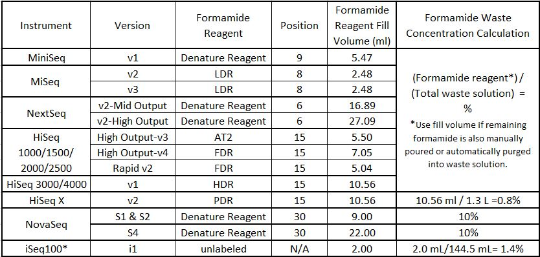
- Quality Control
N/A
- References
  - Reference Laboratory Specific Waste Disposal Procedure
- Appendices
N/A
- Revision History
Rev # | DCR # | Change Summary | Date

- Approval
Approved By: _________________________________ Date: _______________
Author
______________________________________________________
Print Name and Title

Approved By: _________________________________ Date: _______________
Supervisor
______________________________________________________
Print Name and Title

Approved By: _________________________________ Date: _______________
Quality Manager
______________________________________________________
Print Name

