"STD 101 in a Box” -
Ready-to-Use Presentations
Discussion Questions
June 9, 2014

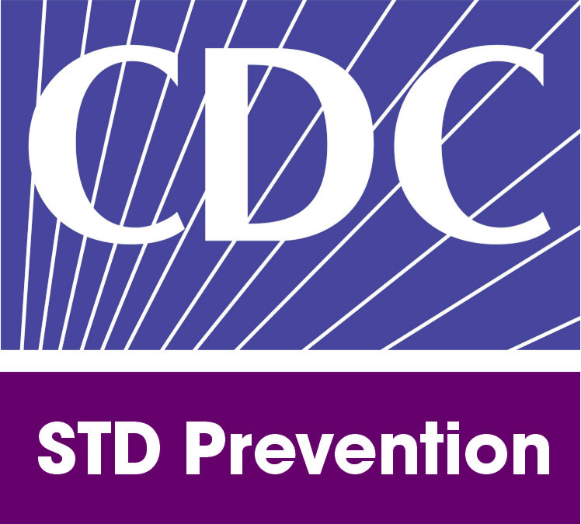

1600 Clifton Rd.
Atlanta, GA 30333
U.S.A.

Discussion Questions by Objective

These questions are designed to initiate discussion between presenters and participants. The presenter should be reasonably familiar with the topic to ensure an interesting and informative discussion.

Objective one: Describe the signs, symptoms, and complications of common STDs

- Which STDs are characterized by a lesion or sore?

- Which STDs are characterized by a discharge?

- What STD complications do you see most often in your setting?

Objective two: Describe the importance of screening for and early detection of STDs

- Which diagnostic tests does your area use to screen for STDs?

- Which STDs are screened in your area?

- Why do you think screening for and early detection of STDs is important?

Objective three: Describe the connection between STDs and other public health problems

- What do you see as the connection between STDs and other public health issues in your area?

- What services exist in your area for clients who experience problems with multiple public health issues?

Objective four: Describe expanded opportunities for STD prevention

- What STD prevention opportunities exist in your jurisdiction?

Objective five: Identify populations in the U.S. with high and increasing STD morbidity

- What STDs have the highest prevalence in your area?

Objective six: Describe the function and purpose of state and local STD prevention programs

- What services does your local/state STD prevention program provide?

- Can you describe the function of Disease Investigation Specialist?

