The Social Distancing Law Assessment Template

A Practical, Field-Tested Methodology to Assess Your Jurisdiction’s
Legal Preparedness for Pandemic Influenza

“The Social Distancing Law Project provided a very valuable tool for Michigan to improve its legal preparedness for pandemic influenza. It provided a framework to consolidate legal work we had already completed through a structured and comprehensive assessment. I highly recommend the project to other state health directors.”

-- Janet Olszewski, MSW, Director, Michigan Department of Community Health

The Association of State and Territorial Health Officials
and
The Public Health Law Program, U.S. Centers for Disease Control and Prevention

July 2010
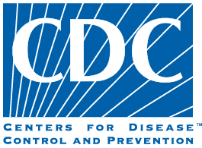

DISCLAIMER

Information contained in this document should not be construed to represent any determination or policy of the Centers for Disease Control and Prevention and does not represent legal advice or guidance. Always seek the advice of a qualified attorney for legal advice and guidance.

Contents
I. BACKGROUND: THE SOCIAL DISTANCING LAW PROJECT 3
A. Introduction 3
B. Responding to HSC and HHS Directives 4
C. The Role of Public Health Law 5
D. Round I of the Social Distancing Law Project (2007) 6
E. Round II of the Social Distancing Law Project (2009-2010) 8
F. The Template: An Assessment Tool for All Jurisdictions 9
II. THE SOCIAL DISTANCING LAW ASSESSMENT TEMPLATE 11
A. Purpose 11
B. Planning Your Jurisdiction’s Social Distancing Law Project 11
C. Assessing Your Jurisdiction’s Legal Authorities for Social Distancing 12
D. Your Jurisdiction’s Legal Consultation Meeting 13
III. ACTION STEPS FOLLOWING YOUR PROJECT 15
IV. A NOTE FROM ASTHO AND THE CDC PUBLIC HEALTH LAW PROGRAM 16
V. APPENDICES 17
APPENDIX A 19
APPENDIX B 33
APPENDIX C 39
APPENDIX D 40
APPENDIX E 48
APPENDIX F 55

BACKGROUND: THE SOCIAL DISTANCING LAW PROJECT

Introduction

This report has two purposes. First, it describes the Social Distancing Law Project as conducted by 15 states, the District of Columbia, and Puerto Rico in 2007, and by 9 additional states in 2009-2010, to assess their legal preparedness to implement social distancing measures during a potential influenza pandemic. Second, it provides all jurisdictions with a template they may use in conducting similar assessments.

History teaches that the recurrence of a widespread influenza pandemic is not a question of if, but of when. Some one hundred years since the deadly 1918 influenza pandemic, the possibility looms large as health officials monitor the H5N1 avian influenza virus for mutation and efficient human to human spread. Even if H5N1 does not ultimately become a pandemic-causing virus, future influenza pandemics are inevitable, as was demonstrated graphically in the global H1N1 pandemic that began in 2009.

Global efforts to combat the next influenza pandemic will rely on both pharmaceutical and non-pharmaceutical interventions. Community infection control measures (referred to in this project as “social distancing measures”) comprise a variety of non-pharmaceutical strategies designed to limit the transmission of pandemic influenza. These measures work by reducing the opportunity for people to come in contact with infected persons and thus for the virus to spread, reducing the total number of persons affected and helping to “buy time” until sufficient supplies of vaccines or antivirals become available to support a mass response effort.

Historical studies and modeling projects suggest that social distancing measures can help mitigate the severity of an influenza pandemic or other infectious disease epidemic. Analysis of responses to the 1918-1919 influenza pandemic in the United States, for example, indicates that early, sustained, and layered implementation of social distancing measures in St. Louis, Missouri, lowered the overall and peak attack rates of the disease as compared with some other jurisdictions. These measures, even when not perfectly implemented, can decrease transmission rates. Even a so-called “leaky quarantine”—quarantine with gaps in its implementation—can quench an emerging epidemic.

The use of law-based community-wide infection control procedures, however, has not been widely practiced in the United States since the first half of the 20th Century. New and re-emerging infections and the threat of an influenza pandemic have made it necessary to take a fresh look at the legal underpinnings of community infection control measures, especially at the state level where public health and other officials will direct front-line responses to the emergence of such a potentially catastrophic thereat.

Sponsored by the U.S. Centers for Disease Control and Prevention (CDC) and directed by the Association of State and Territorial Health Officials (ASTHO), Round I of the Social Distancing Law Project was conducted in 17 jurisdictions in 2007 to assess the sufficiency of their legal preparedness to implement social distancing effectively. In addition, the participating jurisdictions assessed their legal authority to prescribe and dispense pharmaceutical drugs on a mass basis as a key potential countermeasure for an influenza pandemic.

Many of the lessons learned during Round I had direct relevance to all-hazards public health emergencies—such as anthrax attacks and natural disasters—especially in identifying opportunities to enhance coordinated responses across public health and other agencies and across local and state boundaries.

Responding to HSC and HHS Directives

In the fall of 2005, the President released the National Strategy for Pandemic Influenza, which was followed in 2006 by the detailed National Strategy for Pandemic Influenza Implementation Plan (“HSC Implementation Plan”) from the U.S. Homeland Security Council (HSC). The HSC Implementation Plan assigned tasks across the federal government to improve pandemic influenza preparedness. Nearly 200 of these action items were assigned to the U.S. Department of Health and Human Services (HHS). Many of those were assigned, in turn, to CDC and managed by the agency’s Influenza Coordination Unit.

The HSC Implementation Plan acknowledged the important role social distancing measures will play in helping to reduce the impact of pandemic influenza and, also, the need for governments at all levels to assess their legal capacity to flexibly respond to shifting circumstances during a pandemic. The action items assigned to CDC stimulated creation and implementation of the Social Distancing Law Project. Generally, Chapter 6 of the HSC Implementation Plan, which dealt with the protection of human health, called for providing guidance to all levels of government “…on the range of options for infection control and containment, including those circumstances where social distancing measures, limitations on gatherings, or quarantine authority may be an appropriate public health intervention.” The specific action items pertinent to the Social Distancing Law Project appear in Appendix B.
As part of its plan to address these action items, HHS asked CDC to evaluate the sufficiency of states’ existing legal authorities to implement such social distancing measures as suspension of public gatherings, quarantine, and curfew, among other limits on movement, as well as their legal authority to dispense antiviral and other prescription drugs on a mass or community-wide basis. (The related issue of the legal basis for student dismissal and school closure had been addressed in a separate CDC-sponsored project and thus was not addressed in the Social Distancing Law Project, but questions on this topic have been included in this document.)

The Role of Public Health Law

Law has long played a critical role in addressing both acute and chronic public health problems, dating back to Dr. John Snow’s legendary and legally authorized intervention to remove the handle of the cholera-tainted Broad Street pump in London in 1855. Law was a direct and critical underpinning of the great public health achievements of the 20th Century, including, for example, improved motor vehicle safety, vaccination, safer and healthier food, and safer workplaces. Law and legal preparedness will be crucial tools against new and emerging threats to the public’s health.

State and local governments have made important improvements in their legal preparedness for public health emergencies following the Sept. 11 and anthrax attacks of 2001, the 2003 SARS outbreak, and the 2005 Gulf Coast hurricanes. Few U.S. jurisdictions, however, have had experience with community-wide infection control since the mid-1950s, raising questions about the adequacy of the underlying legal authorities and about the capacity of public health agencies to implement them effectively in the novel and potentially highly charged setting of an influenza pandemic.

The federal government’s approach to social distancing in the context of an influenza pandemic emphasizes reliance on an informed public’s voluntary compliance with the recommendations of public health officials. In most cases, voluntary compliance is believed to be sufficient to achieve the desired level of mitigation of the spread of pandemic influenza. Mandatory social distancing measures raise fundamental questions about the balance between individual rights and protection of the health of the larger community. The HSC directives referenced above and the Social Distancing Law Project itself are attempts to clarify understanding of the legal bases for officials’ issuance of recommendations, both voluntary and mandatory, recognizing that the clear preference will be for voluntary measures.

Round I of the Social Distancing Law Project (2007)

CDC’s Influenza Coordination Unit requested assistance from the CDC Public Health Law Program to address the HSC action items. Created in 2000, the Public Health Law Program’s strategic goal is improvement of the public’s health through law. More specifically, the program develops and disseminates tools to state, tribal, and local public health officials and their partners to improve the understanding and practical use of law to support effective public health interventions. Among these tools are training curricula, model intergovernmental and intersectoral mutual aid agreements, legal preparedness checklists, the 2007 National Action Agenda for Public Health Legal Preparedness, and the guidance and template that the participating jurisdictions used in conducting their Social Distancing Law Project assessments and exercises. (Additional information on these and other legal preparedness tools is available at http://www.cdc.gov/phlp.)

The Public Health Law Program has long-standing partnerships with public health practitioners and the professional associations that serve them, including ASTHO. ASTHO’s members, the chief health officials of all the states and U.S. territories, are dedicated to formulating and influencing sound public health policy, and to assuring excellence in state-based public health practice.

Recognizing the central role ASTHO plays in supporting state and territorial health officials, the CDC Public Health Law Program engaged that organization’s experts in conceptualizing and conducting the Social Distancing Law Project. ASTHO’s expertise and relationship with those officials has been critically important to the success of the project.

Project Goals

The overall purpose of the Social Distancing Law Project is to assist the participating states in assessing the sufficiency or adequacy of their legal authorities – their legal preparedness -- to support effective social distancing measures in the context of an influenza pandemic. (Participating jurisdictions also review their legal authorities to support mass distribution of prescription drugs, e.g., antiviral drugs, to the communities they serve.)

Project Methods

Practical and resource considerations precluded conducting the Social Distancing Law Project assessments in all 50 states in 2007. For this reason, CDC chose to focus on 17 jurisdictions (including both states and territories) that either hosted CDC quarantine stations or that bordered on jurisdictions that host those stations. This selection criterion captured the central role CDC’s quarantine stations play in detecting travelers who have infectious disease, because they typically are located in populous states that experience high levels of international traveler traffic, and because most are located in areas with multiple and overlapping government jurisdictions that pose challenges to effective implementation of social distancing measures. The 17 Round I participating jurisdictions were: Alaska, California, Connecticut, the District of Columbia, Florida, Georgia, Hawaii, Illinois, Maryland, Massachusetts, Michigan, New Jersey, New York, Puerto Rico, Texas, Virginia, and Washington.

A key feature of the Social Distancing Law Project methodology is that the assessments of each jurisdiction’s legal preparedness for implementing social distancing measures are conducted by its public health officials, their legal counsel and public health emergency preparedness staff, and by other key state personnel. This element of the project design ensures that those most familiar with the provisions and implementation of a given jurisdiction’s relevant social distancing laws were those who identify, interpret, and assess their sufficiency.

The Social Distancing Law Project has two primary components, as specified by CDC and ASTHO:

- Legal Assessments

Legal counsel to the public health agency for each of the 17 participating jurisdictions conducted an analysis of its social distancing laws and prepared a report detailing the sufficiency of those laws both during and absent declared public health emergencies. The purpose of the legal assessments was to: 1) identify and assess the sufficiency of the legal authorities to support implementation of social distancing measures (and to issue mass prescriptions of antiviral drugs); and 2) identify any gaps, uncertainties, or ambiguities in those authorities.

As one of its contributions to the project, CDC’s Public Health Law Program developed a set of standard questions the 17 participating jurisdictions used in their assessments, helping to assure that the legal assessments addressed the Homeland Security Council action items. The questions focused on such key points as: which officials are legally permitted to authorize the use of social distancing measures; which agencies are responsible for implementing and enforcing those measures; the penalties, if any, for violations of such measures; due process protections for those affected by social distancing measures; and liability issues potentially faced by the officials involved in implementing social distancing measures.

Following completion of this analysis, each jurisdiction reported on its assessment of the sufficiency or adequacy of its legal basis for implementing social distancing measures and additional issues or concerns that surfaced during the analysis. They also pointed out any unique features of their laws or preparedness plans pertinent to pandemic influenza.

- Legal Consultation Meetings and After-Action Reports

Twelve of the Round I jurisdictions also conducted “Legal Consultation Meetings” that were designed as one-day exercises that combined on-site review of the results of the legal assessments with a tabletop scenario to assess the sufficiency of legal authority for social distancing in the setting of a simulated influenza pandemic. The project guidance document included a scenario developed by the CDC Public Health Law Program that could be adapted to each jurisdiction’s specific laws, along with suggestions for participants and for approaches to conducting the meetings. (It was suggested that jurisdictions provide participants with a copy of their legal assessment report two weeks before the meeting so they could be familiar with the existing legal authorities.)

The guidance document recommended that the legal consultation meetings include representatives from all the government agencies and private-sector organizations likely to be involved in implementing social distancing measures during an influenza pandemic, for example:
- State and local health officers and counsel
- Counsel to the Governor and counsel from the office of the attorney general
- State legislative counsel
- Senior preparedness officials from agencies responsible for law enforcement, emergency response, homeland security, education, and transportation
- Members of state and local boards of health and education
- Representatives of the judiciary
- Tribal leaders and their health and legal officials
- Representatives from the business community (e.g., health care, hospitals, chambers of commerce)
- Members of the private bar (e.g., attorneys for health care and other relevant organizations), and
- CDC quarantine station officers and other appropriate federal officials (e.g., attorneys from the U.S. Department of Health and Human Services).
The number of participants in the 12 legal consultation meetings ranged from 25 to 130. The majority of the project jurisdictions held their meetings between August and early November 2007. As per the project guidance provided by ASTHO and CDC, the states that conducted legal consultation meetings included summaries of the proceeding and key findings, along with any revisions to their legal assessment reports, in final after-action reports.

Round II of the Social Distancing Law Project (2009-2010)

The advent of the global A H1N1 influenza pandemic, beginning in early 2009, galvanized the Nation’s public health community and focused renewed, intense attention on the key contribution social distancing measures can make to interrupt the transmission of infectious, contagious diseases. In many jurisdictions schools were closed or school calendars were modified as part of comprehensive disease control strategies.

Against the backdrop of the H1N1 outbreak and use of at least one type of social distancing measure, the CDC Public Health Law Program and ASTHO invited state health agencies not included in Round I to participate in a second round. Nine states did so and received modest grants provided by CDC’s Office of Public Health Preparedness and Response. (The Round II states were Alabama, Missouri, Nebraska, New Hampshire, North Dakota, Ohio, Oregon, Pennsylvania, and Utah.)

The Round II projects used the same tools and methods as in 2007, including this document, “The Social Distancing Law Assessment Template,” attorney-conducted assessments of the participating states’ current legal authorities for social distancing, and legal consultation meetings.

The participating states’ principal findings were similar to those of the Round I states. Key findings were:
- The legal counsel concluded their states had adequate legal authority to implement social distancing measures but that a number of important questions and gaps needed to be addressed (e.g., confusion about the interplay of state and local laws), and
- Additional work was needed to improve coordination across agencies and jurisdictions in implementing social distancing measures (e.g., to address enforcement and liability issues.)

Based on these and other findings, the Round II states made plans to take corrective, follow-up steps, including, among others:
- Educating policy makers and partners about the need to improve their jurisdictions’ capacity to implement social distancing laws
- Enhancing and clarifying existing social distancing laws
- Assisting businesses and other private bodies to develop continuity of operations plans to implement during influenza outbreak, and
- Developing model public health emergency ordinances for local governments.

ASTHO, the participating states, and the CDC Public Health Law Program considered Round II a success and recommend other states, and local jurisdictions as well, conduct the project to strengthen their legal preparedness for future outbreaks of influenza and influenza-like illnesses.

The Template: An Assessment Tool for All Jurisdictions
In addition to the assessments of the sufficiency of their social distancing laws that the Social Distancing Law Project facilitated, the Round I and Round II jurisdictions also demonstrated the practical value of the project’s two-part methodology. Each jurisdiction appropriately modified the standard methodology that ASTHO and CDC staff had prepared for the project to reflect specific issues and concerns of special interest. This experience substantiated that the standard methodology, in part because of its flexibility, has broad utility for all states and other jurisdictions.

For example, Massachusetts, one of the Round I states, concluded that:

“The exercise provided a valuable forum to judge the adequacy of legal authorities, policies, and procedures for dealing with pandemic influenza at the state and local levels…”

and noted, among other important legal lessons learned from the project, that:

“…participants were more confident about the availability and sufficiency of legal authorities than they were about policies and procedures for implementing them.”¹³

Section II of this document presents this methodology in the form of “The Social Distancing Law Assessment Template” for use by public health officials throughout the United States as part of their continuing work to strengthen their preparedness for an influenza pandemic and for potential outbreaks of other highly virulent infectious disease outbreaks.

__________________
13. Savoia E et al. Impact of tabletop exercises on participants’ knowledge of and confidence in legal authorities for infectious disease emergencies. Disaster Medicine and Public Health Preparedness. 2009;3(2):104-1100.

II. THE SOCIAL DISTANCING LAW ASSESSMENT TEMPLATE

Purpose

The Social Distancing Law Assessment Template (see Appendix A) is intended to be used by the public health officials of any state, tribe, locality, or territory as a tool to assess their agencies’ and jurisdictions’ legal preparedness for implementing social distancing measures in the context of an influenza pandemic or an outbreak of a similar highly infectious, contagious disease.

The template was used in Rounds I and II of the Social Distancing Law Project co-sponsored by the Centers for Disease Control and Prevention (CDC) and the Association of State and Territorial Health Officials (ASTHO) and conducted by 24 states, the District of Columbia, and Puerto Rico to assess the sufficiency of their legal preparedness for pandemic influenza. The template was modified, based on that experience, to be used by any state, tribe, locality, or territory. The scenario used in Part 2 of the template can easily be modified to address other issues and fact patterns of interest to the public health officials of any jurisdiction.

The Social Distancing Law Template has three parts:

- Planning your jurisdiction’s Social Distancing Law Project
- Assessing your jurisdiction’s legal authorities for social distancing and presenting the results of that assessment in a written report; and
- Conducting a legal consultation meeting and preparing an after-action report on the sufficiency of your jurisdiction’s social distancing law together with recommendations for any steps to address observed weaknesses and opportunities for improvement.

The following sections offer guidance for your Social Distancing Law Project based on the experience of the initial 26 Round I and II participating jurisdictions.

Planning Your Jurisdiction’s Social Distancing Law Project
The State or Territorial Health Official should take overall leadership of your jurisdiction’s Social Distancing Law Project because of its significance to developing comprehensive preparedness for pandemic influenza and because the project has far-reaching implications for many other government agencies and private-sector organizations.
Key steps in organizing and planning for the project include:

- Identifying Project Team Members and Forming the Project Team

The project lead should work with senior staff of all the agencies with roles to play in implementing social distancing measures—and with counterparts in health care and other private sectors—to identify and enroll members of the project team. Team members may include staff in emergency management, education, law enforcement, and other government agencies as well as representatives of health care providers, private employers, and state and local elected officials. Inclusion of local public health officials and other agencies is strongly advised.

- Developing a Plan for the Project

Once the Social Distancing Law Project team has been formed, it can meet to develop a plan for conducting the Legal Assessment and Legal Consultation Meeting. Important elements of the plan will be the project timeline, designation of responsibility for conducting the assessment of legal authorities (presumably the responsibility of senior legal counsel to the public health agency), designation of responsibility for organizing and conducting the legal consultation meeting, and designation of responsibility for preparing reports on that meeting’s findings, follow-up actions, and implications of the entire project.

Assessing Your Jurisdiction’s Legal Authorities for Social Distancing

The Legal Assessment Template is a tool to use in analyzing your jurisdiction’s laws, regulations, policies, and plans related to social distancing measures. The purpose of the analysis is to identify the full range of all such legal authorities available to your state, trial, or territorial public health agency, local public health agencies, and to the other agencies that would be involved in supporting social distancing measures during an influenza pandemic or a similar, highly virulent infectious disease outbreak. The senior legal counsel to your state or territory’s public health agency should conduct or supervise the legal assessment.

The template contains a series of questions that are organized to aid legal counsel in identifying and characterizing the legal authorities that support key types of social distancing measures – restrictions on the movement of persons, interjurisdictional cooperation in restricting the movement of persons, closure of public places, dismissal of schools, and cancellation of mass gatherings – and in clarifying a number of critical operational issues associated with those measures.

Within each of these areas, questions are posed – both in the context of an officially declared public health emergency and in the absence of such a declaration – regarding the legal basis for activating a given type of social distancing, the locus of authority for exercise of those measures, procedures for their implementation, due process and other protections for those subject to the measures, and other related issues.

The Legal Assessment Report

It is recommended that the responses to the questions presented in the template be captured in your jurisdiction’s legal assessment report or memo. It is suggested recommended that the report include a “table of authorities” as an appendix that presents citations to all the relevant legal authorities and procedures (including, for example, statutes, regulations, case law, and attorney general opinions), the texts of those authorities and procedures, and hyperlinks, if available, to relevant statutes, regulations, court rulings, and other legal resources.

The written report will serve at least two important purposes:

- It will report on the sufficiency of your jurisdiction’s legal authorities to support social distancing measures in the context of an influenza pandemic. In addition, as determined by the legal counsel who conducts the assessment, in consultation with officials of the jurisdiction’s public health agency and partnering agencies, it may point to actual or potential gaps and ambiguities in those authorities and to impediments to their effective implementation. The findings presented in the report thus may give assurance that the jurisdiction’s legal authorities vis-à-vis pandemic influence are sufficient or, alternatively, may indicate that steps should be taken to correct problems identified through the assessment.

- It will be an important resource for your jurisdiction’s Legal Consultation Meeting. That meeting will take the form of a table-top exercise in which key officials from public health, emergency management, law enforcement, and other agencies (ideally, joined by elected officials and representatives of the judiciary and of critical private-sector organizations) will use a standardized scenario to test their ability to implement social distancing and other law-based measures effectively in an influenza pandemic or a similarly virulent infectious disease outbreak. The report will help familiarize these key stakeholders with the legal authorities for social distancing measures before the Legal Consultation Meeting and also serve as a reference during the meeting.

Your Jurisdiction’s Legal Consultation Meeting

In the Legal Consultation Meeting key actors from multiple agencies (e.g., public health, emergency management, law enforcement, and education), jurisdictions (e.g., state, tribal, and local), and the public and private sectors test the capacity to coordinate implementation of social distancing measures based on the legal authorities identified earlier in the Legal Assessment Report. The majority of the states that conducted legal consultation meetings in Rounds I and II of the Social Distancing Law Project devoted a full day to their legal consultation meetings.

Ideally, the meeting should be led by the State or Territorial Health Official.

The “Legal Consultation Meeting Template” is included in Appendix B.

Objectives

The objectives of the Legal Consultation Meeting are to:
- Convene key stakeholders
- Using the “Outbreak of Pandemic Influenza” scenario provided in Appendix B (which may be customized to the specific needs of your jurisdiction), explore the participants’ understanding of the jurisdiction’s social distancing legal authorities, their sufficiency to support implementation of social distancing measures, and the capacity of the involved entities to coordinate in their implementation across jurisdictions and sectors
- Identify any ambiguities or gaps in the jurisdiction’s social distancing legal authorities and/or social distancing measure implementation, and
- Develop next steps for resolving gaps and/or ambiguities identified.

Participation

The Legal Consultation Meeting should include representatives of agencies, jurisdictions, and sectors that play significant roles during response to an influenza pandemic, for example:
- Senior-level state health agency officials, including representatives from public health preparedness, infectious disease, and legal counsel.
- Senior-level local health agency officials, including representatives from public health preparedness, infectious disease, and legal counsel
- Counterparts from agencies with emergency preparedness roles: emergency management, law enforcement, homeland security, education, transportation, and corrections agencies.
- Judges and court administrators
- Elected officials and their legal counsel (e.g., from the offices of the jurisdiction’s chief executive officer, the office of general counsel, attorney general’s office, and legislative officials)
- Representatives from non-profit organizations and the private business sector
- Legal counsel to hospitals and other health care organizations, and
- Representatives of other organizations and sectors critical to successful implementation of social distancing measures in your jurisdiction.

See Appendix B for additional guidance and suggestions for conducting your jurisdiction’s Legal Consultation Meeting.

ACTION STEPS FOLLOWING YOUR PROJECT

Participating in the Social Distancing Law Project is an opportunity for a state or other jurisdiction to assess its legal preparedness for an influenza pandemic. In this context “legal preparedness” refers to the sufficiency of the jurisdiction’s laws to support social distancing measures and, in addition, to the capacity of the involved agencies to implement those measures in a coordinated and highly effective manner.

The two components of a jurisdiction’s Social Distancing Law Project – the legal assessment and the legal consultation meeting – generate new, in-depth information about legal sufficiency and coordinated implementation. Some of the Round I states identified ambiguities in their existing social distancing laws and even more discovered that they needed to clarify roles and responsibilities in coordinating implementation of social distancing measures.

The final stage in the Social Distancing Law Project is to use the results and findings to identify such opportunities for strengthening legal preparedness for social distancing. This stage should be an integral part of the plan each state and other jurisdiction prepares for its Social Distancing Law Project. Senior officials in the participating agencies, together with legal counsel, should review findings from both project components, identify opportunities for improvement, and commit to taking the appropriate action steps.

ASTHO and the CDC Public Health Law Program recommend that at least three types of actions be considered for the purpose of translating lessons learned from the project into improved legal preparedness for pandemic influenza:

- Action steps to improve the sufficiency of the laws and legal authorities that support social distancing and mass dispensation.

- Action steps to improve coordinated implementation of social distancing measures across agencies, sectors, and jurisdictional boundaries, and

- Action steps to improve implementation of mass dispensing.

While the explicit focus of the Social Distancing Law Project is on pandemic influenza, many lessons learned from legal assessments and legal consultation meetings are directly relevant to outbreaks of other infectious and highly contagious diseases and to other types if public health emergencies. Effective response hinges critically in all these cases on the presence of sufficient legal authorities, on their appropriate use, and on close coordination.

For this reason -- and to take full advantage of the Social Distancing Law Project -- ASTHO and the CDC Public Health Law Program also recommend taking action steps to improve response to public health emergencies not related to infectious disease outbreaks, e.g., anthrax attacks, natural disasters, and chemical and radiologic incidents.

As they identify these opportunities, public health officials and their partners have access to many resources they can use to deliver law-related training in public health emergency preparedness, improve coordination across public health, law enforcement, corrections, and the judiciary, develop mutual aid agreements across state, local, and international boundaries, and learn about emerging issues and developments in public health law. These and additional, relevant resources are accessible on the website of the CDC Public Health Law Program: http://www.cdc.gov/phlp.

A NOTE FROM ASTHO AND THE CDC PUBLIC HEALTH LAW PROGRAM

ASTHO and the CDC Public Health Law Program, as co-sponsors of the Social Distancing Law Project, are interested in learning about the use states, Tribes, and localities make of “The Social Distancing Law Assessment Template” and about the steps they take to strengthen their legal preparedness for pandemic influenza and other infectious disease outbreaks based on their conduct of the Social Distancing Law Project.

Please share this information, as well as any recommendations and other comments, by contacting the CDC Public Health Law Program at phlawprogram@cdc.gov.

APPENDICES

  - Legal Assessment Template

  - Legal Consultation Meeting Template
- Scenario: “Outbreak of Pandemic Influenza”
  - Homeland Security Council Directives

  - The Michigan Legal Assessment and After-Action Report

  - Leeb, Chrysler, and Goodman, “The Social Distancing Law Project Template: A Method for Jurisdictions to Assess Understanding of Relevant Legal Authorities.” Disaster Medicine and Public Health Preparedness, Vol. 4, No. 1; March 2010. (Reproduced by permission of the Editor, Disaster Medicine and Public Health Preparedness.)

  - Additional Resources

APPENDIX A

Legal Assessment Template
Overview
This Legal Assessment involves an analysis of your jurisdiction’s laws, regulations, policies, and plans related to social distancing measures. The purpose of the analysis is to identify the full range of all such legal authorities available to the public health agency of your jurisdiction, local public health agencies, and to the other agencies that would be involved in supporting social distancing measures against an influenza pandemic or a similar, highly virulent infectious disease. The senior legal counsel to your state or territory’s public health agency should conduct or supervise the Legal Assessment.

The results and findings of the Legal Assessment can be used for at least two important purposes. First, they will portray the relevant laws and legal authorities in your jurisdiction and thus offer a basis for identifying potential gaps, ambiguities, or opportunities for improving social distancing law. Second, as an inventory of your jurisdiction’s relevant public health laws they will serve as a critical, factual basis for the Legal Consultation Meeting.

This Legal Assessment Template contains a series of questions that are organized to aid legal counsel in identifying and characterizing the jurisdiction’s legal authorities that support key types of social distancing measures – restrictions on the movement of persons, interjurisdictional cooperation in restricting the movement of persons, closure of public places, dismissal of schools, and cancellation of mass gatherings – and in clarifying a number of critical operational issues associated with those measures.

Within each of these areas, questions are posed – both in the context of an officially declared public health emergency and in the absence of such a declaration – regarding the legal basis for activating a given type of social distancing, the locus of authority for exercise of those measures, procedures for their implementation, due process and other protections for those subject to the measures, and other related issues.

Customization
As you work through the specific questions below, consider whether there are additional social distancing measures available to your jurisdiction through existing legal authorities. Customize the template to address these measures as well.

Definitions

- “Legal authority” means any provision of law or regulation that carries the force of law, including, for example, statutes, rules and regulations, and court rulings.
- “Procedures” means any procedures established by your jurisdiction relating to the legal question being researched, regardless of whether the procedures have the force of law.
- “Restrictions on the movement of persons” means any limit or boundary placed on the free at-will physical movement of adult natural persons in the jurisdiction.
- “Closure of public places” means an instruction or order that has the effect of prohibiting persons from entering a public place.
- “Public place” means a fixed space, enclosure, area, or facility that is usually available for entry by the general public without a specific invitation, whether possessed by government or private parties.
- “Mass Gathering” means an assembly or grouping of many people in one place where crowding is likely, whether formal or informal, and whether for one day or many.
- “Person” means a natural person, whether or not individually identified.
- “Public health emergency” means any acute threat, hazard, or danger to the health of the population of the jurisdiction, whether specific or general, whether or not officially declared.
- “Superior jurisdiction” means the federal government in respect to a state, or a state in respect to a locality.
- “Inferior jurisdiction” means a state in respect to the federal government, or a locality in respect to a state government.

Sections
- Restriction on the Movement of Persons
- Inter-jurisdictional Cooperation and Restricting Movement of Persons
- Closure of Public Places
- Dismissal of Schools
- Cancellation of Mass Gatherings
- Optional: Mass Prophylaxis Legal Readiness

QUESTIONS

- Restrictions on the Movement of Persons

  - Legal authorities to restrict movement of persons during a declared public health emergency
Identify the legal authorities that could enable, support, authorize, or otherwise provide a legal basis for any restrictions on the movement of persons during a declared public health emergency. List all legal powers, authorities, and procedures (including, but not limited to, police powers, umbrella powers, general public health powers, or emergency powers or authorities) that could be used to authorize specific restrictions on movement. (Examples: state’s legal powers, authorities, or doctrines for quarantine (see also subsection I-C below), isolation, separation, or other orders for persons to remain in their homes.)
This set of questions includes all provisions of law or procedure that:
- Regulate the initiation, maintenance, or release from restrictive measures, including, but not limited to:
a. Which official(s) are authorized to declare or establish such restrictions?
b. Which official(s) are authorized to enforce such restrictions?
c. What legal authorities exist for group quarantine?
d. What legal authorities exist for area quarantine?
e. What penalties, if any, are there for violations of restrictions on movement?
- Provide any due process measures for a person whose movement is restricted.
- Relate to how long such measures can last, whether and how they can be renewed, and the authority/process/notice requirements for ending the measures.
- May create liability for ordering the restriction of movement of persons.
- Would otherwise tend to limit the legal basis of the jurisdiction.

  - Sufficiency of legal authorities during a declared public health emergency
Assess the sufficiency of existing legal authorities to restrict the movement of persons during a declared emergency and identify any potential gaps or uncertainties in those powers and authorities.
    - Are there gaps or shortcomings in these legal authorities?
    - Are there uncertainties about the sufficiency of these legal authorities?
    - Do any existing legal provisions inhibit, limit, or modify the jurisdiction’s legal authority to restrict the movement of persons? (Examples could include state administrative practice acts and specific provisions in law related to movement restrictions, among others.)

  - Legal authorities specifically related to quarantine enforcement during a declared public health emergency
With specific respect to quarantine orders, identify all state and/or local legal authorities to enable, support, authorize, or otherwise provide a legal basis for enforcement of individual and group quarantine during a public health emergency.
    - Do law enforcement agencies have legal authority to enforce quarantine orders issued by the jurisdiction’s public health agency?
    - Do any laws prohibit or inhibit law enforcement agencies’ enforcement of an official quarantine order?
    - Do law enforcement agencies have legal authority to enforce a quarantine order issued by the federal government?
    - Do any specific legal authorities prohibit or inhibit the use of law enforcement agencies to enforce a federal quarantine order?
    - What are the legal powers and authorities prohibiting or inhibiting the use of law enforcement to assist the federal government in executing a federal quarantine order?

  - Sufficiency of legal authorities to enforce quarantine during a declared public health emergency
Assess the sufficiency of legal authorities to enforce quarantine orders and identify any potential gaps or uncertainties in those powers and authorities.
    - Are there any potential gaps in those legal authorities?
    - Are there any uncertainties in those legal authorities?
    - Are there any other legal provisions not listed in I-C above that could inhibit, limit, or modify the jurisdiction’s legal basis to restrict the movement of persons? (Examples could include state administrative practice acts and specific provisions in law related to quarantine, among others.)

  - Legal authorities to restrict movement of persons in the absence of a declared public health emergency
Identify legal authorities and procedures that could enable, support, authorize, or otherwise provide a legal basis for any restrictions on the movement of persons in the absence of a declared public health emergency? (Examples could include, among others, the jurisdiction’s legal authorities and procedures for quarantine, isolation, separation, or other orders for persons to remain in their homes.)
The following questions address all provisions of law or procedure that regulate the initiation, maintenance, or release of persons from restrictions on movement, including, but not limited to:
1. Which officials are authorized to declare or establish such restrictions?
2. Which officials are authorized to enforce such restrictions?
3. What are the legal authorities for group quarantine?
4. What are the legal authorities for area quarantine?
5. What are the penalties, if any, for violations of restrictions on movement?
6. What due process measures are provided for those whose movement is restricted?
7. How long may such measures continue; can they be renewed; what are the legal and procedural requirements for ending the measures?
8. Are officials who order restrictions on the movement of persons at risk of legal liability?

  - Sufficiency of legal authorities in the absence of a declared public health emergency
Assess the sufficiency of the jurisdiction’s legal authorities to restrict the movement of persons in the absence of a declared emergency, and any potential gaps or uncertainties in those powers and authorities.
    - Are there potential gaps in those legal authorities?
    - Are there potential uncertainties about those legal authorities?
    - Are there any legal provisions that could inhibit, limit, or modify the jurisdiction’s legal basis to restrict the movement of persons? (Examples could include state administrative practice acts and specific provisions in law related to movement restrictions, among others.)

- Inter-jurisdictional Cooperation and Restricting Movement of Persons

  - Legal provisions/procedures for inter-jurisdictional cooperation on restricting the movement of persons during a declared public health emergency
What provisions or procedures under law apply to giving and receiving assistance and otherwise working with other jurisdictions regarding restrictions of movement of persons during a declared public health emergency?
    - Provisions or procedures governing the relationships among superior jurisdictions? Among inferior jurisdictions?
    - Provisions or procedures governing the relationships between superior and inferior jurisdictions? (Include relationships among all levels of government and the federal government. See also section I-C above specifically related to quarantine orders.)
    - What is the legal authority of the jurisdiction to accept, utilize, or make use of federal assistance?

  - Sufficiency of powers/authorities to cooperate with other jurisdictions during a declared public health emergency
Discuss the sufficiency of the authorities and powers to cooperate with other jurisdictions during a declared public health emergency, and any potential gaps or uncertainties in those powers and authorities.
    - Potential gaps?
    - Uncertainties?
    - Legal provisions that could inhibit, limit, or modify the jurisdiction’s legal basis to cooperate with other jurisdictions? (Examples: state administrative practice acts, specific provisions in law related to inter-jurisdictional cooperation.)

  - Legal provisions/procedures for inter-jurisdictional cooperation on restricting the movement of persons in the absence of a declared public health emergency
What provisions or procedures under law apply to giving and receiving assistance and otherwise working with other jurisdictions regarding restrictions of movement of persons in the absence of a declared public health emergency?
    - Provisions or procedures governing the relationships among superior jurisdictions? Among inferior jurisdictions?
    - Provisions or procedures governing the relationships between superior and inferior jurisdictions? (Include relationships among all levels of government and the federal government. See also section I-C above specifically related to quarantine orders.)
    - What is the legal authority of the jurisdiction to accept, utilize, or make use of federal assistance?

  - Sufficiency of powers/authorities to cooperate with other jurisdictions in the absence of a declared public health emergency
Discuss the sufficiency of the authorities and powers to cooperate with other jurisdictions in the absence of a declared public health emergency, and any potential gaps or uncertainties in those powers and authorities.
    - Potential gaps?
    - Uncertainties?
    - Legal provisions that could inhibit, limit, or modify the jurisdiction’s legal basis to cooperate with other jurisdictions? (Examples: state administrative practice acts, specific provisions in law related to inter-jurisdictional cooperation.)

  - Interagency/inter-jurisdictional agreements on restricting movement of persons
Where available, identify and provide copies of all interagency and inter-jurisdictional agreements (both interstate and intrastate) relating to restrictions on the movement of persons during public health emergencies and the enforcement of such restrictions.

- Closure of Public Places

- Legal powers/authorities to order closure of public places during a declared public health emergency
What are the powers, authorities, or procedures to enable, support, authorize, or otherwise provide a legal basis for closure by state or local officials of public places (e.g., public facilities, private facilities, and business) during a declared public health emergency? For each of the jurisdiction’s legal powers, authorities, and procedures including, but not limited to, umbrella, general public health, or emergency powers or authorities, that could be used to authorize, prohibit, or limit closure, please address the following issues:
    - What are the powers and authorities authorizing closure?
    - What are the powers and authorities prohibiting closure?
    - Who can declare or establish closure?
    - Who makes the decision to close a public place?
    - What is the process for initiating and implementing closure?
    - What is the process for enforcing closure and who enforces it?
    - What are the penalties for violating closure?
    - What are the procedural and due process requirements for closure?
    - Is compensation available for closure? If so, what is it?
    - How long can a closure last?
    - How can it be renewed?
    - Describe the authority/process/notice requirements for ending a closure.

  - Sufficiency of powers/authorities to authorize closure of public places during a declared public health emergency
Discuss the sufficiency of the authorities and powers to authorize closure of public places during a declared public health emergency, and any potential gaps or uncertainties in those powers and authorities.
    - Potential gaps?
    - Uncertainties?
    - Legal provisions that could inhibit, limit, or modify the jurisdiction’s authority to close public places? (Examples: state administrative practice acts, specific provisions in law related to closure.)

  - Legal powers/authorities to order closure of public places in the absence of a declared public health emergency
What are the powers, authorities, or procedures to enable, support, authorize, or otherwise provide a legal basis for closure by state or local officials of public places (e.g., public facilities, private facilities, and business) in the absence of a declared public health emergency? For each of the jurisdiction’s legal powers, authorities, and procedures that could be used to authorize, prohibit, or limit closure, please address the following issues:
    - What are the powers and authorities authorizing closure?
    - What are the powers and authorities prohibiting closure?
    - Who can declare or establish closure?
    - Who makes the decision to close a public place?
    - What is the process for initiating and implementing closure?
    - What is the process for enforcing closure and who enforces it?
    - What are the penalties for violating closure?
    - What are the procedural and due process requirements for closure?
    - Is compensation available for closure? If so, what is it?
    - How long can a closure last?
    - How can it be renewed?
    - Describe the authority/process/notice requirements for ending a closure.

  - Sufficiency of powers/authorities to authorize closure of public places in the absence of a declared public health emergency
Discuss the sufficiency of the authorities and powers to authorize closure of public places in the absence of a declared public health emergency, and any potential gaps or uncertainties in those powers and authorities.
    - Potential gaps?
    - Uncertainties?
    - Legal provisions that could inhibit, limit, or modify the jurisdiction’s authority to close public places? (Examples: state administrative practice acts, specific provisions in law related to dismissal.)

- Dismissal of Schools

  - Legal powers/authorities to authorize dismissal of schools during a declared public health emergency
What are the powers, authorities, or procedures to enable, support, authorize, or otherwise provide a legal basis for school closure by state or local officials (e.g., public schools, private schools, universities, day care centers) during a declared public health emergency? For each of the jurisdiction’s relevant legal powers, authorities, and procedures including, but not limited to, umbrella, general public health, or emergency powers or authorities, that could be used to authorize, prohibit, or limit closure, please address the following issues:
      - What are the powers and authorities authorizing dismissal?
      - What are the powers and authorities prohibiting dismissal?
      - Who can declare or establish dismissal?
      - Who makes the decision to dismiss schools (i.e. to implement a declaration of dismissal)?
      - What is the process for initiating and implementing dismissal?
      - Are there plans in place to continue reduced and free lunches to students who receive those services while schools are open?
      - Are there plans in place to use school facilities and/or employees for other functions/services while classes are not in session?
      - How long can a dismissal last?
      - How can it be renewed?
      - Describe the authority/process/notice requirements for ending dismissal/reopening schools?

  - Sufficiency of powers/authorities to authorize dismissal of schools during a declared public health emergency
Discuss the sufficiency of the authorities and powers to authorize dismissal of schools during a declared public health emergency, and any potential gaps or uncertainties in those powers and authorities.
      - Potential gaps?
      - Uncertainties?
      - Legal provisions that could inhibit, or restrict the jurisdiction’s authority to dismiss schools? (Examples: state administrative practice acts, specific provisions in law related to dismissal.)

  - Legal powers/authorities to authorize dismissal of schools in the absence of a declared public health emergency
What are the powers, authorities, or procedures to enable, support, authorize, or otherwise provide a legal basis for school dismissal by state or local officials (e.g., public schools, private schools, universities, day care centers) in the absence of a declared public health emergency? For each of the jurisdiction’s legal powers, authorities, and procedures that could be used to authorize, prohibit, or limit closure, please address the following issues:
      - What are the powers and authorities authorizing dismissal?
      - What are the powers and authorities prohibiting dismissal?
      - Who can declare or establish dismissal?
      - Who makes the decision to dismiss schools?
      - What is the process for initiating and implementing dismissal?
      - Are there plans in place to continue reduced and free lunches to students who receive those services while schools are open?
      - Are there plans in place to use school facilities and/or employees for other functions/services while classes are not in session?
      - How long can a dismissal last?
      - How can it be renewed?
      - Describe the authority/process/notice requirements for ending dismissal/reopening schools?

  - Sufficiency of powers/authorities to authorize dismissal of public places in the absence of a declared public health emergency
Discuss the sufficiency of the authorities and powers to authorize dismissal of schools in the absence of a declared public health emergency, and any potential gaps or uncertainties in those powers and authorities.
      - Potential gaps?
      - Uncertainties?
      - Legal provisions that could inhibit, limit, or modify the jurisdiction’s authority to close schools? (Examples: state administrative practice acts, specific provisions in law related to dismissal.)

- Cancellation of Mass Gatherings
(Please note that while the term ‘cancellation’ is used throughout this section, ‘postponement’ and ‘suspension’ of mass gatherings should also be considered. Cancellation and postponement are measures used before a gathering has started; whereas suspension is used when a gathering has already begun. )
  - Legal authorities to order cancellation of mass gatherings during a declared public health emergency
Identify the legal authorities and procedures that enable, support, authorize, or otherwise provide a legal basis for state or local officials’ cancellation of mass gatherings (e.g., city-wide holiday celebrations, large sporting events, and large trade shows) during a declared public health emergency. For each of the jurisdiction’s relevant legal powers, authorities, and procedures--including, but not limited to, umbrella/overarching, general public health, or emergency powers or authorities.
    - Which officials are authorized to declare cancellations of mass gatherings?
    - Which officials are authorized to implement cancellations of mass gatherings?
    - What is the process for initiating and implementing cancellations of mass gatherings?
    - What is the process for enforcing cancellation; which officials are authorized to enforce cancellations of mass gatherings?
    - What, if any, are the penalties for violating cancellations of mass gatherings orders?
    - What procedural and due process requirements are associated with cancellations of mass gatherings?
    - Is compensation available for cancellations of mass gatherings? If so, what is it and how is it accessed?
    - How long can a mass gathering be suspended or postponed?
    - How can an order to suspend or postpone mass gatherings be changed, renewed or extended?
    - What legal authorities and procedures are associated with ending a suspension of mass gatherings order?

  - Sufficiency of legal authorities to authorize cancellation of mass gatherings of public places during a declared public health emergency
Assess the sufficiency of the jurisdiction’s legal authorities to cancel mass gatherings during a declared public health emergency and identify any potential gaps or uncertainties in those powers and authorities.
    - Are there potential gaps in those legal authorities?
    - Are there potential uncertainties in those legal authorities?
    - Are there any legal provisions that could inhibit, limit, or modify the jurisdiction’s authority to cancel mass gatherings?

  - Legal authorities to order cancellations of mass gatherings in the absence of a declared public health emergency
    - Which officials are authorized to declare cancellations of mass gatherings?
    - Which officials are authorized to implement cancellations of mass gatherings?
    - What is the process for initiating and implementing cancellations of mass gatherings?
    - What is the process for enforcing cancellations of mass gatherings; which officials are authorized to enforce cancellations of mass gatherings?
    - What, if any, are the penalties for violating cancellation of mass gatherings orders?
    - What procedural and due process requirements are associated with cancellations of mass gatherings?
    - Is compensation available for cancellations of mass gatherings? If so, what is it and how is it accessed?
    - How long can a mass gathering be suspended or postponed?
    - How can an order to suspend or postpone mass gatherings be changed, renewed or extended?
    - What legal authorities and procedures are associated with ending a suspension of mass gatherings order?

  - Sufficiency of legal authorities to cancel mass gatherings in the absence of a declared public health emergency
Assess the sufficiency of the jurisdiction’s legal authorities to cancel mass gatherings in the absence of a declared public health emergency and identify any potential gaps or uncertainties in those powers and authorities.
    - Are there any potential gaps in those legal authorities?
    - Are there any potential uncertainties about those legal authorities?
    - Are there any legal provisions that could inhibit, limit, or modify the jurisdiction’s authority to cancel mass gatherings?

- OPTIONAL

Mass Prophylaxis Legal Readiness

Mass prophylaxis is not a type of social distancing measure but was included in Round I of the Social Distancing Law Project given interest then in assessing the sufficiency of laws to support mass prophylaxis during a large-scale infectious disease outbreak. The following questions were used to aid in understanding legal authorities, and related operational issues, associated with mass prophylaxis, i.e., with issuance of blanket prescriptions for mass distribution of antiviral medications, vaccines and other countermeasures.

  - Legal authorities for issuance of blanket prescriptions and use of other mass prophylaxis measures during a declared public health emergency

If it became necessary during a declared public health emergency to issue blanket prescriptions or order the use of other mass prophylaxis measures to enable emergency mass distribution of medical countermeasures (e.g., antiviral drugs and vaccines), what legal authorities and procedures would enable, support, authorize or otherwise provide a legal basis for doing so? List all the legal powers and authorities, policies, and procedures that could be used to authorize blanket prescriptions or other mass prophylaxis measures. For each of the identified powers and authorities, determine:

- Which officials are authorized to make the decision to issue blanket prescriptions or other mass prophylaxis measures?

- Which officials are authorized to implement blanket prescriptions or other mass prophylaxis measures?

- What legal authorities would determine how countermeasures would be distributed?

  - Sufficiency of legal authorities and procedures to issue blanket prescriptions or order the use of other mass prophylaxis measures during a declared public health emergency

Assess the sufficiency of the jurisdiction’s legal authorities to issue blanket prescriptions or order the use of other mass prophylaxis measures during a declared public health emergency and identify any potential gaps or uncertainties in those powers and authorities.

    - Are there any potential gaps in those legal authorities?

    - Are there any potential uncertainties about those legal authorities?

    - Are there any legal provisions that could inhibit, limit, or modify the jurisdiction’s authority to issue blanket prescriptions or order the use of other mass prophylaxis measures? (Examples could include state administrative practice acts and specific provisions in law related to blanket prescriptions/mass prophylaxis, among others.)

  - Legal powers/authorities for issuance of blanket prescriptions and use of other mass prophylaxis measures in the absence of a declared public health emergency

If it became necessary in the absence of a declared public health emergency to issue blanket prescriptions or order the use of other mass prophylaxis measures to enable emergency mass distribution of medical countermeasures (e.g., antiviral drugs and vaccines), what legal authorities and procedures would enable, support, authorize or otherwise provide a legal basis for doing so? List all the legal powers and authorities, policies, and procedures that could be used to authorize such blanket prescriptions or order the use of other mass prophylaxis measures. For each of the powers and authorities listed, determine:

    - Which officials are authorized to make the decision to issue blanket prescriptions or other mass prophylaxis measures?

    - Which officials are authorized to implement blanket prescriptions or other mass prophylaxis measures?

    - What legal authorities would determine how countermeasures would be distributed?

  - Sufficiency of authorities/procedures to issue blanket prescriptions or order the use of other mass prophylaxis measures in the absence of a declared public health emergency

Assess the sufficiency of the jurisdiction’s legal authorities to issue blanket prescriptions or order the use of other mass prophylaxis measures in the absence of a declared public health emergency and identify any potential gaps or uncertainties in those powers and authorities.

  - Are there any potential gaps in those legal authorities?

  - Are there any potential uncertainties about those legal authorities?

  - Are there any legal provisions that could inhibit, limit, or modify the jurisdiction’s authority to issue blanket prescriptions or order the use of other mass prophylaxis measures? (Examples could include state administrative practice acts and specific provisions in law related to blanket prescriptions mass prophylaxis, among others.)

APPENDIX B

Legal Consultation Meeting Template

Overview
The Legal Consultation Meeting will convene key stakeholders to test the jurisdiction’s ability to implement coordinated social distancing measures involving multiple agencies (e.g. public health, law enforcement, education, corrections, etc.) , jurisdictions (state and local), and sectors (public and private) based on the legal authorities identified in the legal assessment. Ideally, this meeting should be led by the State or Territorial Health Official. Issues identified during the Influenza A H1N1 response beginning in early 2009 should be considered when developing the agenda.

Objectives
The objectives of the Legal Consultation Meeting are to:
- Convene key stakeholders.
- Using the “Outbreak of Pandemic Influenza” scenario below, which may be customized to the specific needs of your jurisdiction, explore the participants’ understanding of the jurisdiction’s social distancing legal authorities, the sufficiency of those authorities to support implementation of social distancing measures, and the capacity of the involved entities to coordinate in their implementation across jurisdictions and sectors.
- Identify any ambiguities or gaps in the jurisdiction’s social distancing legal authorities and/or social distancing measure implementation.
- Develop next steps for resolving gaps and/or ambiguities identified.

Participation
The Legal Consultation Meeting should include representatives of agencies, jurisdictions, and sectors that play significant roles during response to an influenza pandemic, for example:
- Senior-level state health agency officials, including representatives from public health preparedness, infectious disease, and legal counsel.
- Senior-level local health agency officials, including representatives from public health preparedness, infectious disease, and legal counsel
- Counterparts from agencies with emergency preparedness roles: emergency management, law enforcement, homeland security, education, transportation, and corrections agencies.
- Judges and court administrators
- Elected officials and their legal counsel (e.g., from the offices of the jurisdiction’s chief executive officer, the office of general counsel, attorney general’s office, and legislative officials)
- Representatives from non-profit organizations and the private business sector
- Legal counsel to hospitals and other health care organizations, and
- Representatives of other organizations and sectors critical to successful implementation of social distancing measures in your jurisdiction.

Agenda
A suggested agenda for a one-day Legal Consultation Meeting is outlined below. Your jurisdiction’s planning committee can customize this draft to reflect its decisions on the goals, content, and participants in the meeting. The planning committee is encouraged to plan the agenda to take greatest advantage of the expertise of the meeting participants, to maximize opportunities for active participation by attendees, and to ensure in-depth dialogue about the sufficiency of the jurisdiction’s legal preparedness for pandemic influenza.

Session One: Introduction
(Approx. 1 to 2 hours)
This session should include an introduction of the meeting participants and an overview of the meeting’s goals and methodology by the moderator. The senior public health legal counsel should then give a brief presentation on the jurisdiction’s social distancing laws and their sufficiency. The presentation should summarize the findings of the Legal Assessment and of any other memoranda or reports on the jurisdiction’s pandemic influenza legal preparedness. Before beginning the exercise the moderator should provide the opportunity for question and answers from public health legal counsel, other meeting participants, and observers.

Session Two: Exercise
(Approx. 3 to 4 hours)
In this session participants exercise the jurisdiction’s legal authorities to implement social distancing measures in the context of declared and undeclared public health emergencies. Resources for the exercise include: the completed Legal Assessment and the optional Legal Assessment Report on the jurisdiction’s social distancing legal authorities; the hypothetical scenario presented below; and any additional materials the planning committee may wish to provide, for example, the jurisdiction’s pandemic influenza preparedness plan.
The methodology of the exercise involves presenting the Legal Consultation Meeting participants with a chronological fact pattern about an emerging influenza pandemic. The questions from the Legal Assessment can then be posed where relevant at each stage for the participants to discuss, giving them the opportunity to assess the legal authorities, explore feasibility of implementing them through coordination across the critical agencies and sectors, and identify issues they may want to address following the meeting.
Several different approaches to conducting the exercise could be adopted, for example, having participants interact as one body or, alternatively, dividing them into groups to discuss specific legal authorities and then reporting back to the full body. The scope of the meeting discussion should generally cover the same topics and areas of inquiry that appear in the Legal Assessment and be framed to address the use of the relevant legal authorities in both declared and undeclared emergencies.

Session Three: Review and Next Steps
(Approx. 1.5 to 2 hours)
The concluding session is the opportunity for meeting participants to review what they learned from the exercise. Special focus should be given to identifying strengths and potential gaps and/or ambiguities in legal authorities’ support for social distancing measures revealed during the exercise. Next steps to address gaps and/or ambiguities should also be drafted.

Customization
Prior to the Legal Consultation Meeting, the exercise below should be customized to your jurisdiction. In addition to filling in the names of specific officials, agencies, or places throughout the scenario, your jurisdiction may want to add include additional events specific to your jurisdiction. Further your jurisdiction may want to discuss any social distancing measures considered and/or implemented during the response to the Influenza A H1N1pandemic that began in early 2009 and further explore any issues that may have arisen at that time.
SCENARIO: “OUTBREAK OF PANDEMIC INFLUENZA”
Context
The facts and events in this scenario are specific to [insert the name of your jurisdiction].

Caveat
The fact pattern below is predicated on a pandemic influenza scenario of much greater severity than the Influenza A H1N1 pandemic that began in early 2009. While your jurisdiction’s response to Influenza A H1N1 may help to guide your decision making and planning, the intent of this hypothetical exercise is to test the sufficiency of your jurisdiction’s legal authorities for social distancing measures and ability to coordinate across multiple agencies, jurisdictions, and sectors in potentially much more demanding circumstances.

Scenario
November 20: Within the past 30 days, the World Health Organization (WHO), the U.S. Centers for Disease Control and Prevention (CDC), and other agencies have confirmed the isolation of a novel and highly virulent strain of influenza A (H5N1) from clinical specimens obtained from persons on several continents. Four days ago, on November 16, CDC announced confirmation of isolation of the same strain from ill persons in several U.S. states, even though the strain had not yet been isolated from any persons in your jurisdiction.
Preliminary findings from epidemiological investigations indicate the following:

- Illness typically presents as classical influenza with abrupt onset of fever, malaise, myalgia (muscle aches), cough, and runny nose.

- In approximately 20% of cases, illness rapidly progresses to a primary viral pneumonia, acute respiratory distress syndrome, and death.

- At-risk populations include persons in all age groups regardless of their previous health (i.e., includes persons who previously have been in good health, as well as those who with pre-existing chronic disease conditions).

- The average incubation period (i.e., time from patient’s exposure to an infected person to time of onset of initial symptoms) is approximately 36-48 hours.

No information is available yet regarding the effectiveness of the current formulation of influenza vaccine administered to persons in settings worldwide prior to onset of this pandemic, and preliminary evaluation indicates that anti-viral chemotherapeutic agents administered both pre- and post-exposure are only marginally effective in preventing or attenuating severity of illness.

On November 16, following CDC’s announcement of the confirmation of the circulation of the pandemic strain in the United States, your jurisdiction’s Communicable Disease Surveillance and Control Unit (CDSCU) fully activated its plan for intensified morbidity, virological, and mortality surveillance for influenza, including active daily surveillance for cases of influenza-like-illness (ILI) diagnosed in all hospital emergency rooms, selected urgent-care outpatient facilities, and in sentinel providers’ offices located throughout the jurisdiction.

Overnight and early this morning (November 20), the CDSCU received reports of ILI among persons visiting emergency rooms, urgent care facilities, and sentinel providers’ offices located in the metropolitan area of the capital of your state, but also in scattered places elsewhere in your jurisdiction. The CDSCU immediately informed your jurisdiction’s chief public health officer who then, according to your jurisdiction’s pandemic preparedness plan, notified the office of the Governor or chief executive officer. Within a short time, she convened your jurisdiction’s Pandemic Influenza Response Group, comprising representatives from your jurisdiction’s homeland security task force, health department, attorney general’s/legal counsel’s office, public safety, civil defense, emergency management, and court administrator’s offices, as well as leaders from your jurisdiction’s legislative body.

The Governor/chief executive officer opened the meeting by asking the CDSCU to provide an update on the status of ILI reported from throughout your jurisdiction and other potentially relevant information. The CDSCU reports the following information, which is based on calls to local public health units and to the network of healthcare facilities comprising your jurisdiction’s public health surveillance system, as well as additional reports CDSCU has received since the Governor/chief executive officer was first informed about these developments only a short time earlier.

- Cases of ILI-like have been reported among a small number of persons of all age groups who live in the most populated area of your jurisdiction.

- A cluster of ILI cases has occurred among residents and staff of one large stepped-care facility in that area. The stepped-care facility is affiliated with two acute-care hospitals and each day transfers some patients to the hospitals for management of intercurrent problems.

- A cluster of ILI cases has occurred among students, as well as teachers and other staff, at one middle school in the most populated area of your jurisdiction.

- A small cluster of ILI cases also has been reported among city bus drivers and other transit workers who together just completed in-service training a few days earlier.

- Only within the past 30 minutes, the CDC Quarantine Station, located at the international airport situated near your jurisdiction, has contacted the CDSCU and the coordinator of the Pandemic Influenza Response Group to report that the captains of two inbound transoceanic flights have radioed ahead that a small number of persons on board each plane have had onset of acute febrile and respiratory tract symptoms while the flights have been en route. Both flights have been airborne for over 12 hours and both originated in countries for which the novel strain of A(H5N1) had been isolated among residents.

The Governor/chief executive officer requests staff and the Pandemic Influenza Response Group to enumerate major events known to be planned throughout your jurisdiction for the next week. At a minimum, these include:

- Statewide pre-Thanksgiving school events planned for this year to commemorate new historical discoveries about the first Thanksgiving.

- Traditional family and social seasonal Thanksgiving gatherings.

- A sold-out Thanksgiving Day (November 22) professional football game to be played in a stadium.

- The opening of a new, nationally promoted blockbuster film the day following Thanksgiving in movie theater chains.

- Kickoff of the traditional post-Thanksgiving holiday shopping season in malls across your jurisdiction.

- Multi-denominational services planned to be held in memory of victims of a recent flood disaster. The services are scheduled to be held on Thanksgiving eve and will include a candlelight vigil and walk to begin at 8:00 pm with a gathering in front of the state capitol/seat of government.

- A four day international trade fair with informal activities preceding the formal convention beginning on the Saturday after Thanksgiving and continuing to the following Wednesday.

Given this information, the Governor/chief executive officer has asked members of the Pandemic Influenza Response Group to assess the situation and offer opinions on the merits of declaring a public health emergency. As part of this deliberation, the Governor/chief executive officer is asking the Attorney General/legal counsel for key agencies—including the health department, public safety, and emergency management—to confirm the status and sufficiency of authorities for the spectrum of measures that the Governor/chief executive officer might need to order into effect imminently.

APPENDIX C

Homeland Security Council Directives

- Action item 6.3.1 “[e]ncourage[d] all levels of government, domestically and globally, to take appropriate and lawful action to contain an outbreak within the borders of their community, province, State, or nation.”
- Action item 6.3.1.1 directed that “State, local, and tribal pandemic preparedness plans should address the implementation and enforcement of isolation and quarantine, the conduct of mass immunization programs, and provisions for release or exception.”
- Action item 6.3.2 directed federal agencies to “provide guidance, including decision criteria and tools, to all levels of government on the range of options for infection control and containment, including those circumstances where social distancing measures, limitations on gatherings, or quarantine authority may be an appropriate public health intervention.”
- Action item 6.3.2.1 called for HHS to “provide State, local, and tribal entities with guidance on the combination, timing, evaluation, and sequencing of community containment strategies (including travel restrictions, school closings, snow days, self-shielding, and quarantine during a pandemic).”
- Action item 6.3.2.2 called for HHS to “provide guidance on the role and evaluation of the efficacy of geographic quarantine in efforts to contain an outbreak of influenza with pandemic potential at its source.”
- Action item 6.3.2.3 called for “research identifying optimal strategies for using voluntary home quarantine, school closure, snow day restrictions, and other community infection control measures.”

APPENDIX D

The Michigan Legal Assessment Report & After-Action Report

- Michigan Legal Assessment Report

The 40-page report “Michigan Department of Community Health Assessment of Legal Authorities” (Aug. 13, 2007) is accessible at:
http://www2a.cdc.gov/phlp/sdlp/docs/Final MI legal assessment Final.doc

- Michigan After-Action Report

Introduction

The Michigan Department of Community Health (MDCH) agreed to participate in the Social Distancing Law Project (SDLP) in mid-2007. The SDLP is an activity of the Association of State and Territorial Health Officials (ASTHO) in cooperation with the Centers for Disease Control and Prevention (CDC).

The SDLP is intended to assist selected states with assessing their legal preparedness to implement social distancing measures in both declared and undeclared public health emergencies. Specifically, the SDLP seeks to ensure the presence of effective legal authorities for social distancing measures, to establish and sustain the competencies of public health professionals to apply those laws, to provide coordination of such efforts across jurisdictions and sectors, and to make accessible information about best practices.

Michigan’s Participation

MDCH established a project team responsible for carrying out activities of the SDLP. This project team included representatives from relevant areas of MDCH (epidemiology, surveillance, emergency preparedness, legal), the Michigan Department of Attorney General, and the Officer in Charge of the CDC Quarantine Station. The Project Team prepared a report assessing the adequacy of Michigan law to implement social distancing measures both during and in the absence of a declared emergency, provisions for inter-jurisdictional cooperation for restricting the movement of persons, and mass prophylaxis readiness. It also organized and oversaw the legal consultation meeting.

Legal Consultation Meeting

MDCH hosted a legal consultation meeting (LCM) on October 12, 2007, at the Detroit Metropolitan Airport Westin. This site was chosen because it and the federal Quarantine Station are both located at the airport’s McNamara International Terminal. LCM participants were provided with an opportunity to sign up for a tour of the quarantine station and associated screening areas at the airport led by the Quarantine Officer, Gabriel Palumbo, and the Medical Director, Curie Kim, M.D. Tours were provided to approximately twelve participants. Locating the LCM at Detroit Metropolitan Airport resulted in participation by the Wayne County Airport Authority, the Travel Security Association (TSA), and their legal counsel. Their participation was very important since the hypothetical scenario included legal issues related to the arrival of two international flights with passengers potentially infected with, and exposed to, pandemic influenza. Meeting at the international terminal of Detroit Metropolitan Airport also imparted a sense of reality and urgency to the scenario.

Peter Jacobson, Professor of Health Law and Policy, and Director of the Center for Law, Ethics, and Health at the University of Michigan School of Public Health, moderated the LCM. Richard Goodman, Director, Public Health Law Program, CDC, and Janet Olszewski, Director, MDCH, opened the LCM with their welcomes. Director Olszewski was able to join the LCM for the morning session. As shown by the list of attendees, the group was diverse with expertise and perspective in many relevant areas of public health, emergency management, legal, and individual rights.

The morning focused on providing information about Michigan and federal law that governs implementation of social distancing measures. The afternoon was conducted as a tabletop using a hypothetical scenario that was based on the scenario provided in the SDLP guidance document. Break-out groups were used to discuss the scenario, consisting of eight tables of 7-8 individuals. Individuals were assigned to tables to ensure a mix of disciplines at each table, and included a legal expert and public health expert at each table. Facilitators were appointed prior to the LCM, and provided with the scenario and instructions. Scribes were chosen by the 7 – 8 participants at each table. All participants were provided with the scenario and potential discussion questions in advance of the LCM.

Each participant was provided with a notebook at the beginning of the LCM that included:

- Meeting agenda
- List of LCM participants
- Speakers biographical statements
- Presentations on the law
- Situation manual related to the tabletop, including goal, objectives, assumptions, the hypothetical scenario, and questions related to the scenario
- Resource materials
- Evaluation

These materials are being provided in electronic form with this after action report.

Discussion questions were divided into three sets, focusing on the following three parts of the scenario:

- Actions and responses related to the increase of influenza-like illness in Michigan.
- Actions and responses related to the impending arrival of two international flights with passengers who may be infectious with, and passengers and crew potentially exposed to, avian influenza.
- Responses and measures related to private and public gatherings in order to control the spread of pandemic influenza.

Between each segment, Professor Jacobson moderated discussion of the group as a whole about the sufficiency of the law, questions, and concerns that need to be addressed. Additional feedback was obtained by note cards completed at tables as issues arose, evaluations that were completed by participants, and information collected by experienced evaluators who observed the exercise and filed an after action report with the Department of Homeland Security.

Talking points captured during discussions

The following points were captured during the table and group discussions for each question set:

- Actions / considerations to respond to the increase of influenza-like illness in Michigan.
  - Personal protective equipment (PPE)
  - Infection control procedures
  - Laboratory testing; importance of case definition
  - HAN alerts to hospitals, health departments, primary care, etc.
  - School closing – Thanksgiving holiday
  - Protection of healthcare response teams
  - Public communications
  - Control of supplies – antivirals, etc
  - Be overly cautious
  - Voluntary isolation and quarantine
  - Warning letters
  - Public health advisories or warnings about increased risk of infection associated using certain business establishments (e.g. theaters)
  - Does this constitute a “significant threat” for MDCH orders?
  - Public awareness to cover all groups
  - Social distancing order – state gives heads-up to Detroit for possible cancellation of events
  - Where do you draw the line for cancellation of events?
  - Emergency management would look to MDCH for advice
  - Would the government close everything with no exceptions?
  - Will an emergency declaration hold up in court? Disaster declaration?
  - MDCH in charge at this point

* All felt that they have the legal authority to take actions they felt appropriate

- Actions / considerations to respond to the impending arrival of two international flights with passengers who may be infectious with, and passengers and crew potentially exposed to, avian influenza.
  - Imminent danger declared
  - Order quarantine for all passengers
  - CDC station will order isolation of ill passengers
  - Send locals home with education
  - Transients to be housed in designated building
  - CDC responsible under federal authority
  - Legal authority of quarantine station?
  - Can local and state health officials refuse transfer of quarantine and isolation patients in hospitals?
  - Legal authority is well defined for international flights

- Questions and considerations for imposing measures on private and public gatherings in order to control the spread of pandemic influenza
  - Need for social distancing at outdoor events
  - Supply caution advisories for all outdoor events
  - Distinction between public and private gatherings
  - Need to define “public gathering” in any order, warning, advisory
  - Practicality of implementing, enforcing orders imposing social distancing measures
  - Where do public health concerns fit in with political and economic effects?
  - What about disproportional impact of certain measures on certain populations (e.g. impact of discontinuing public transportation on people without cars)?
  - Need for “social distancing” of employees staffing the Emergency Operations Center and Community Health Emergency Center
  - Iceberg effect for decision making (only seeing the tip of the problem)
  - What if public PPE is not worn, if required?
  - Can local overrule Governor’s Disaster Declaration?
  - 28 day declaration – what if legislature is unavailable to extend (due to illness)?
  - Need for providing due process to impose social distancing that restricts liberty, deprives individuals of their property

* All felt that they have the legal authority to take actions they felt appropriate

Participants indicated there is sufficient legal authority to take actions they felt appropriate. However, the following questions were raised about implementation:

- Can warning notices, or similar notices, be used when the names of individuals within an at-risk group are unknown (e.g. a plane load of passengers)?
- Can the Governor order certain types of businesses (e.g. grocery stores) to stay OPEN during an emergency?
- Does the Governor have the legal authority to order a distribution or redistribution of resources prior to a declaration of an emergency or disaster?
- Do minors have the legal authority to make decisions to enter businesses or attend public gatherings where warnings or cautionary advisories are issued concerning associated dangers? E.g. A public health officer issues warnings that attending theaters, sporting events, etc. may place you at increased risk of infection. Can a minor legally decide to attend? Could a curfew order be issued to address this?
- Can state or local officials refuse the federal government’s request to transfer jurisdiction and responsibility for passengers from an international flight from the federal government to the state or local level? What if sick individuals need to be transported to the hospital for evaluation; can they remain under the federal government’s jurisdiction?
- How would unaccompanied minors, traveling on international flights, be handled? If they were sick, would unaccompanied minors be able to voluntarily choose to go to the hospital?
- Does the U.S. or Michigan Constitution allow the Governor or health officers to issue orders that prohibit religious gatherings?

Conclusions

- Michigan has sufficient legal authority to implement social distancing measures.

There was no discussion of gaps in the Public Health Code or other Michigan laws. Rather the discussion was how to implement authority and factors to be considered and balanced for decision making (caution vs. rapid response). Also, the importance of mutual aid agreements and joint planning was emphasized, especially in working with law enforcement.

There are some legal questions related to implementation set out in the section above, which need to be answered. Also, as set out in the written assessment, there are jurisdictional questions related to universities and federal lands that need to be submitted to the Attorney General’s office for review.

- Many key players in a pandemic have insufficient knowledge of Michigan legal authority, and how to use it to prevent the spread of pandemic influenza.

Recommendations were made for further training and education efforts.

- Many “nuts and bolts” need further consideration and resolution to effectively respond to a pandemic.

A lot of discussion focused on logistics, resources, and practicalities of enforcement. The following are a few examples. The logistics of handling large numbers of people for isolation or quarantine at international borders was discussed. Hospital preparedness is necessary to support large-scale efforts. How to prevent / address refusal by health care workers to provide care to patients with pandemic influenza is a concern. Other issues include transporting sick and exposed individuals, equipping public with PPE such as masks, ensuring equitable access to resources and services, and impact of contractual relationships between hospitals and commercial laboratories.

Financial resources continue as a major concern. This concern is reflected by one of the discussion table’s questions regarding international airline passengers: “Can local and state health officials refuse transfer of responsibility and authority [from federal government] for quarantine and isolation patients in hospitals?”

Follow-Up

MDCH has greatly benefited from its work associated with this project, and the stipend that allowed it to fund the LCM. From the evaluations, it appears that most participants found the information and experience generated from the LCM extremely valuable.

The project team is being reconvened to develop a plan for additional activities to build upon this initial effort. Now that the LCM has been created and tested, it should be shared with health and emergency response staff from other areas of the state served by major airports, including Flint-Saginaw-Midland, Grand Rapids-Kalamazoo, and Traverse City. Additionally, while Michigan law might be sufficient to impose social distancing measures, it is essential that public officials know how to use the law to protect the public’s health. Thus, the project team will also consider taking the LCM to local health department staff and their attorneys, and to judges who would review state actions to control a pandemic. The extent of further activities will depend on identifying resources or partners for funding.

In addition to future LCMs, the project team will review issues and areas of uncertainty identified through this project for follow-up as appropriate.

APPENDIX E
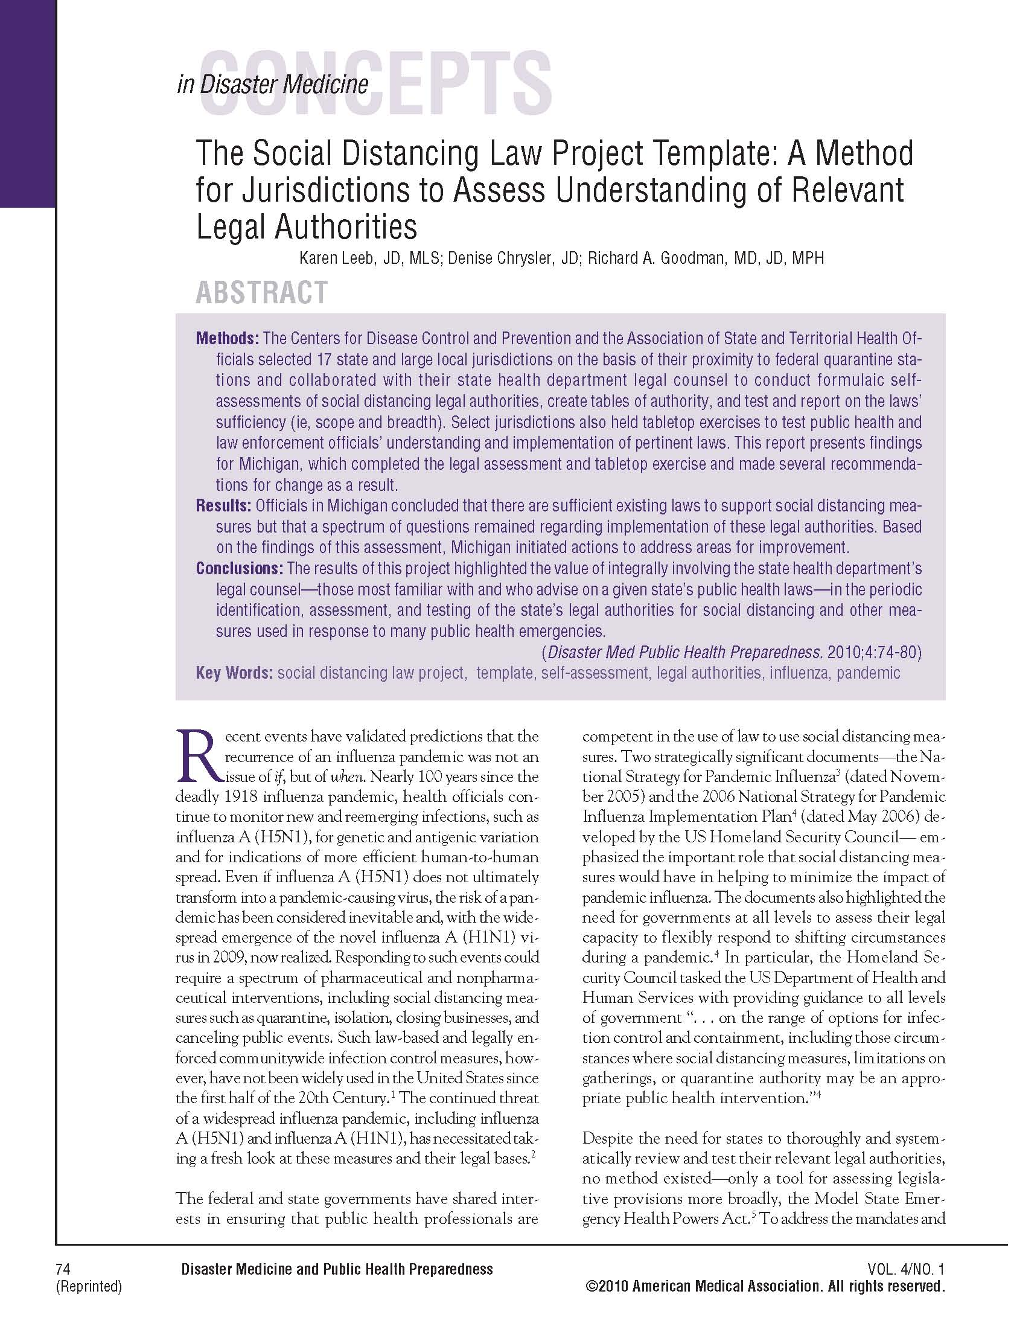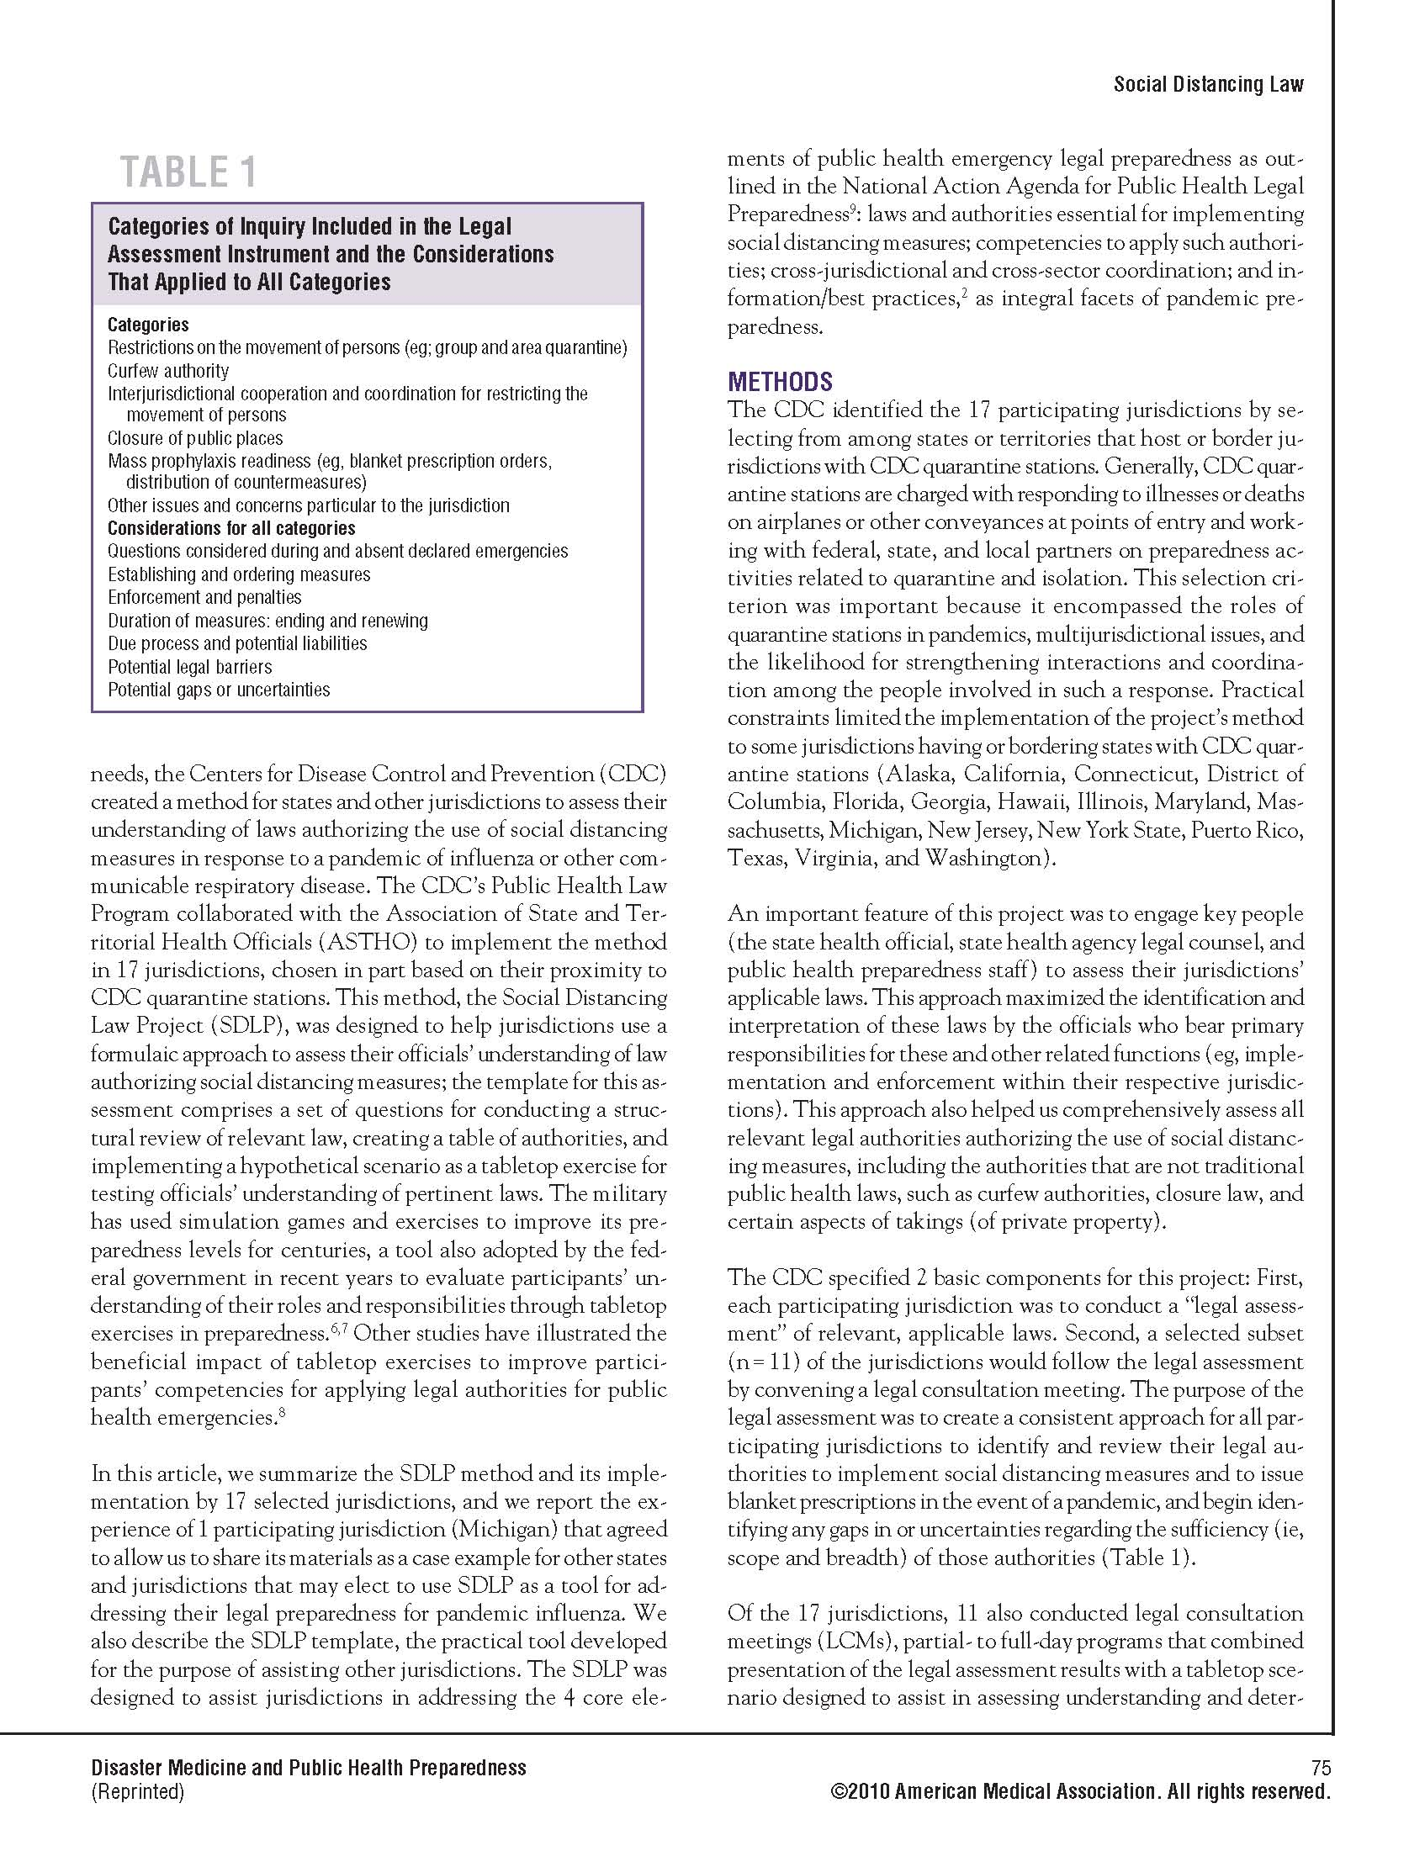

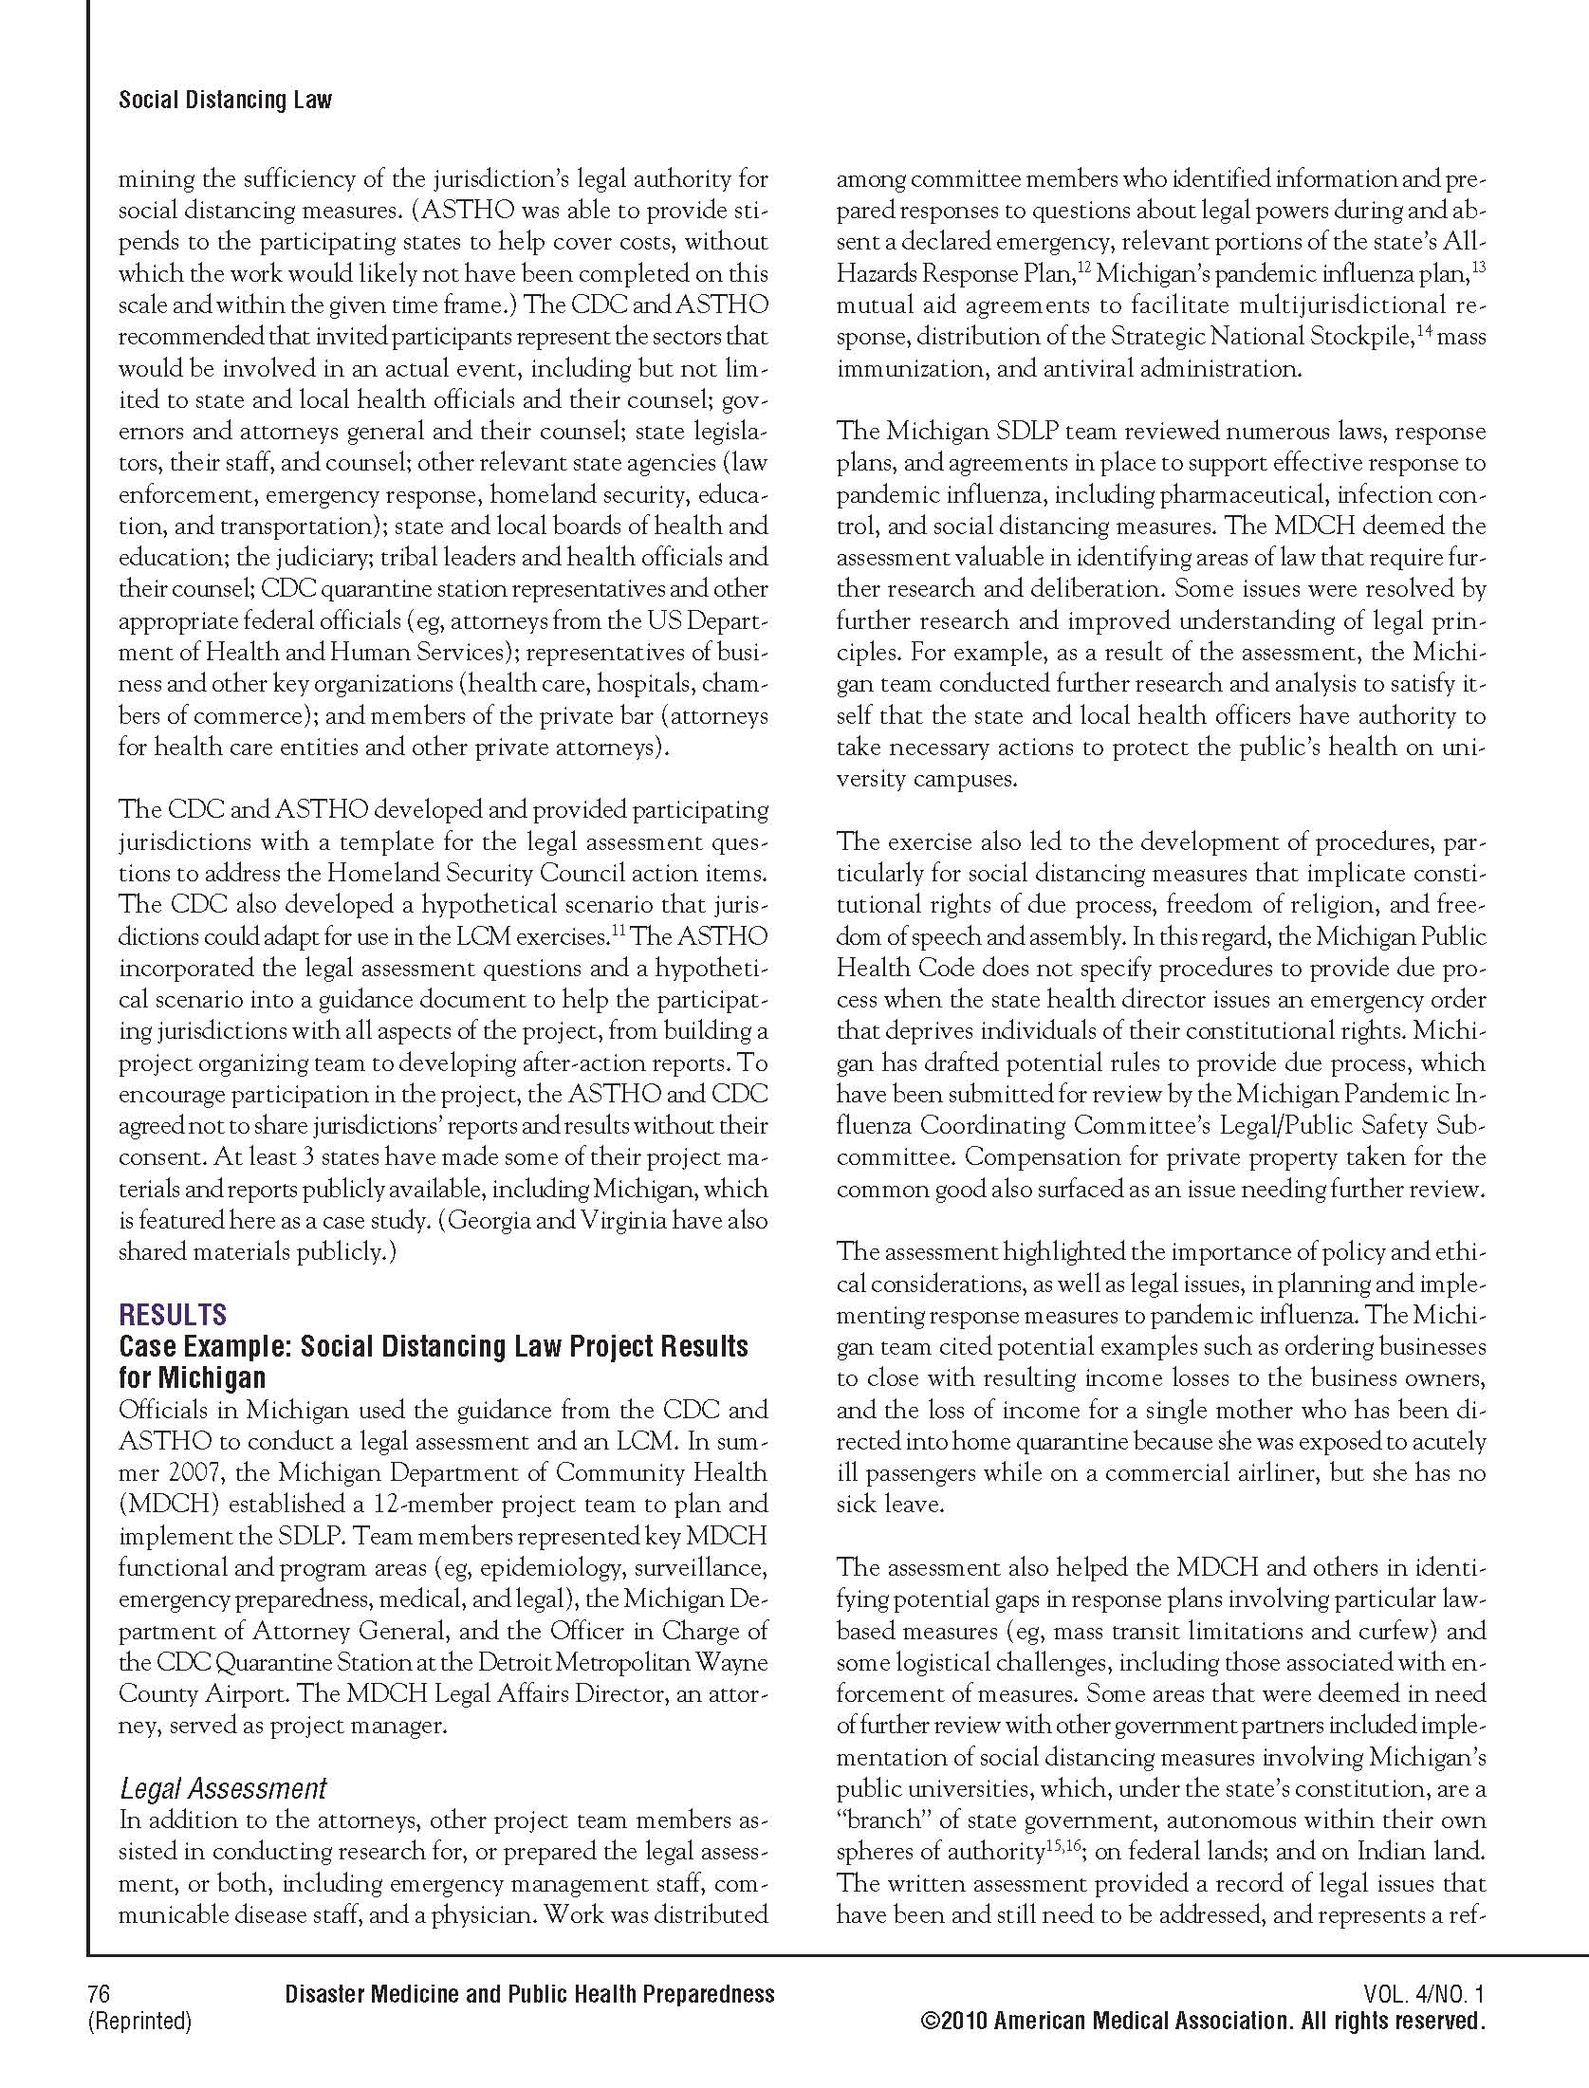

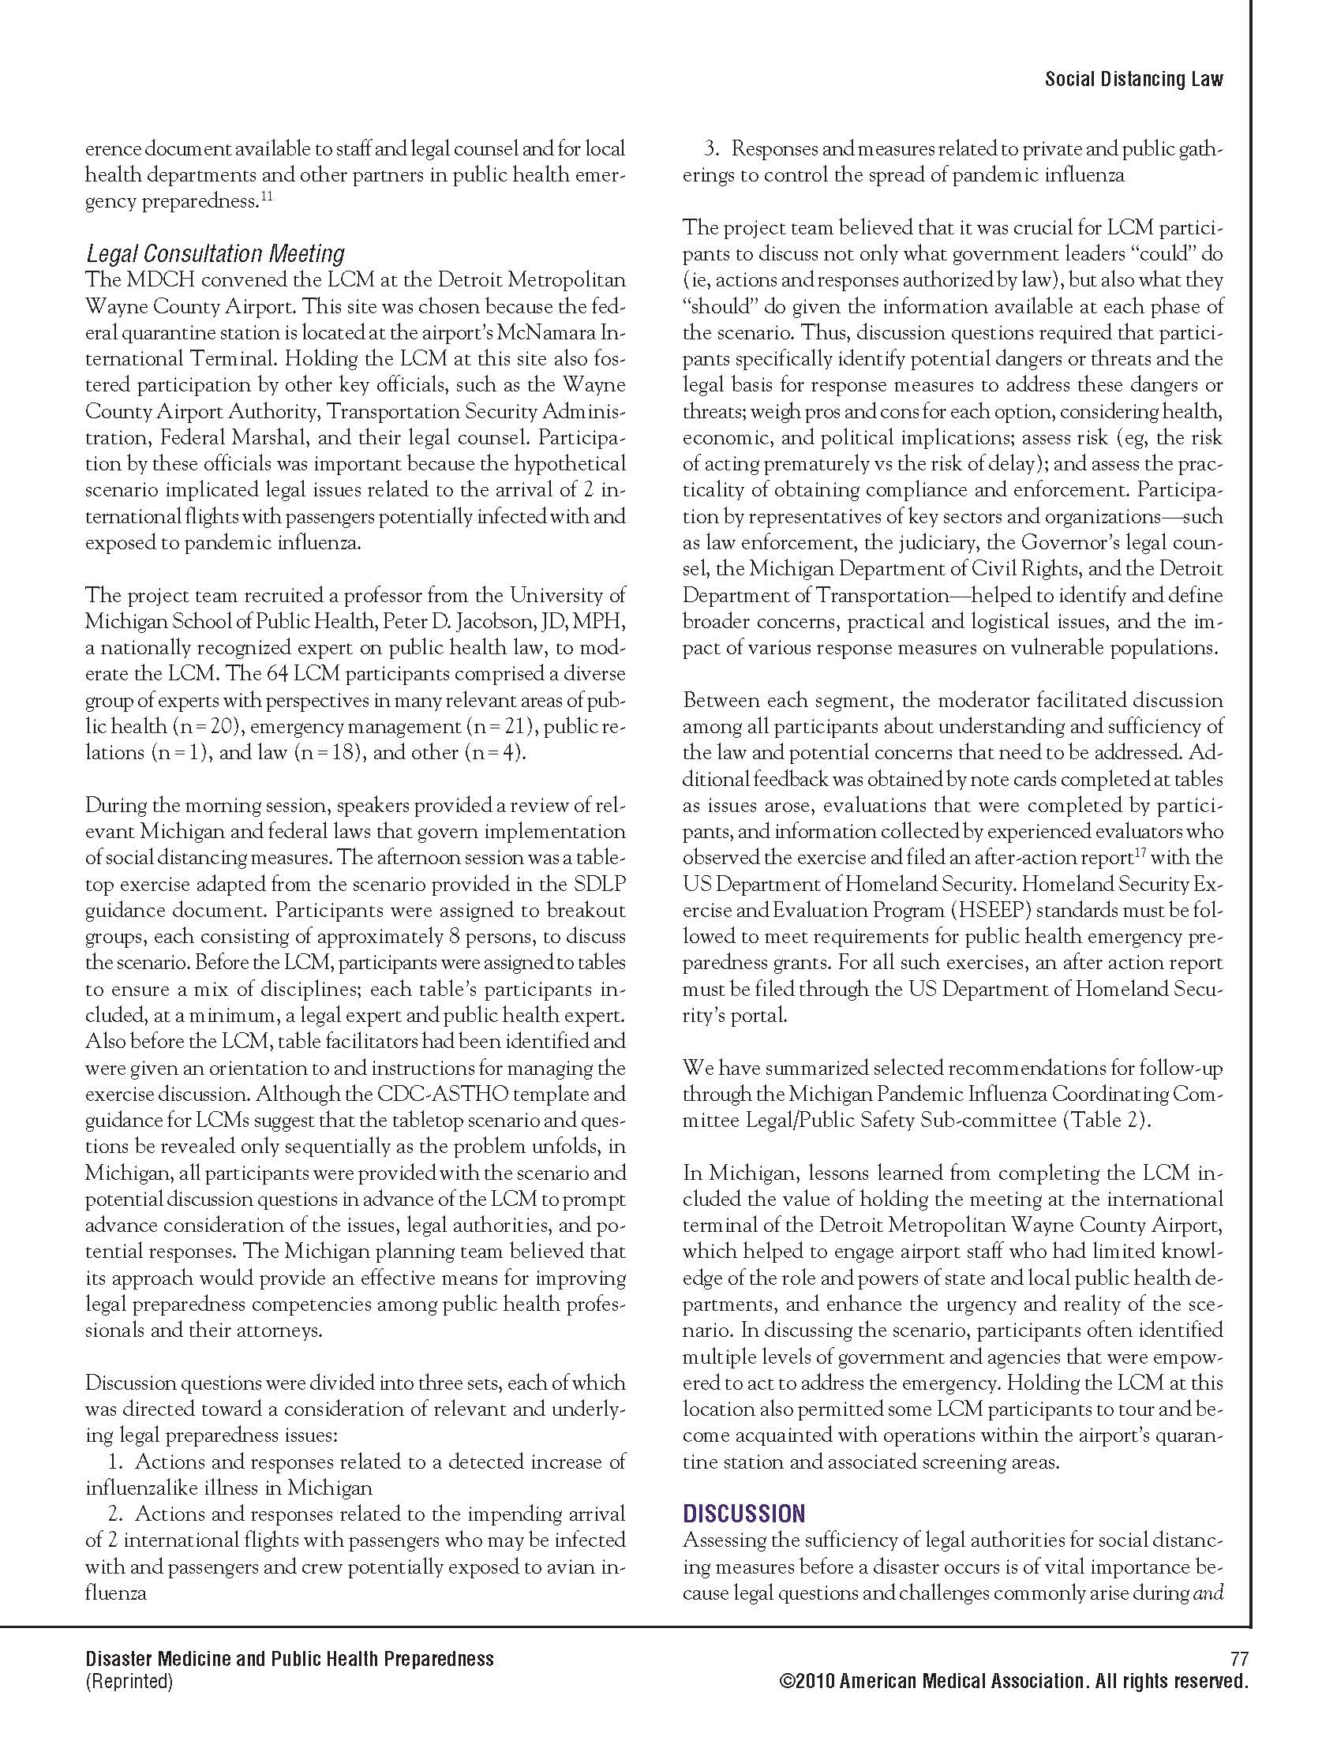

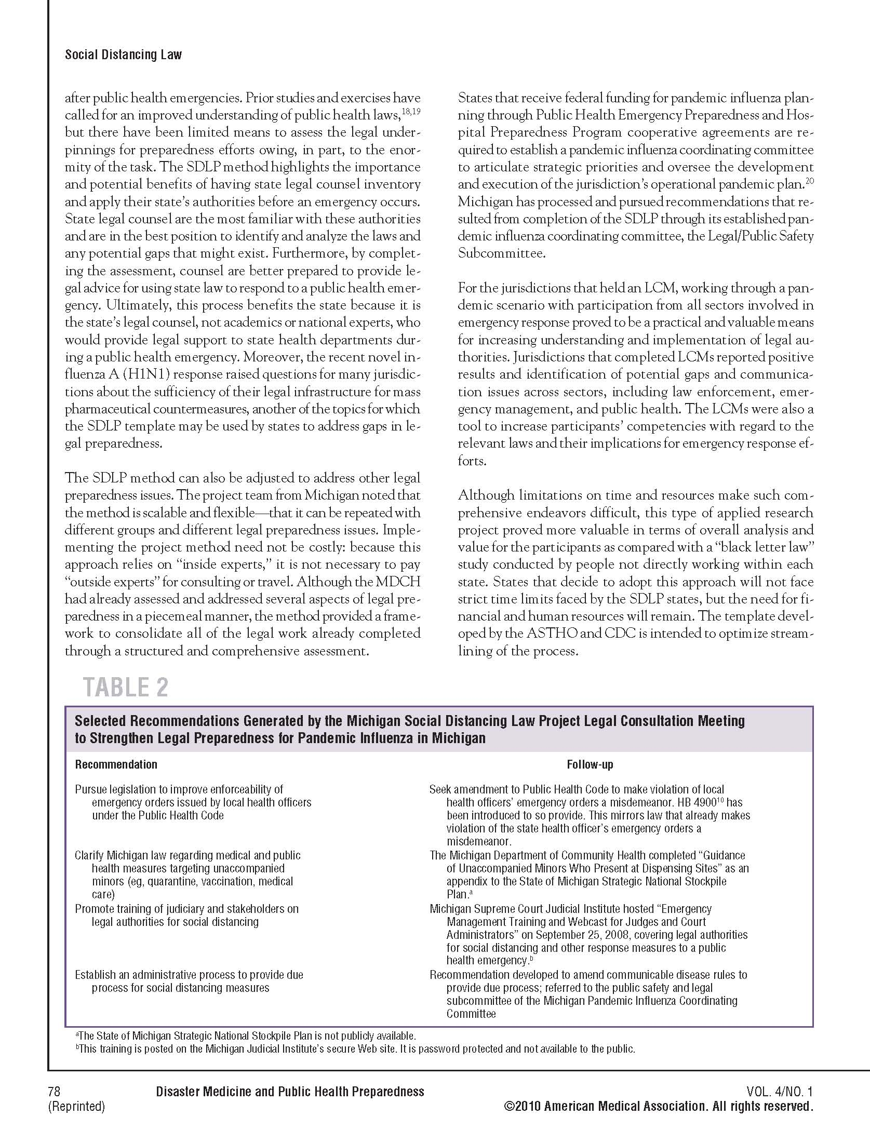

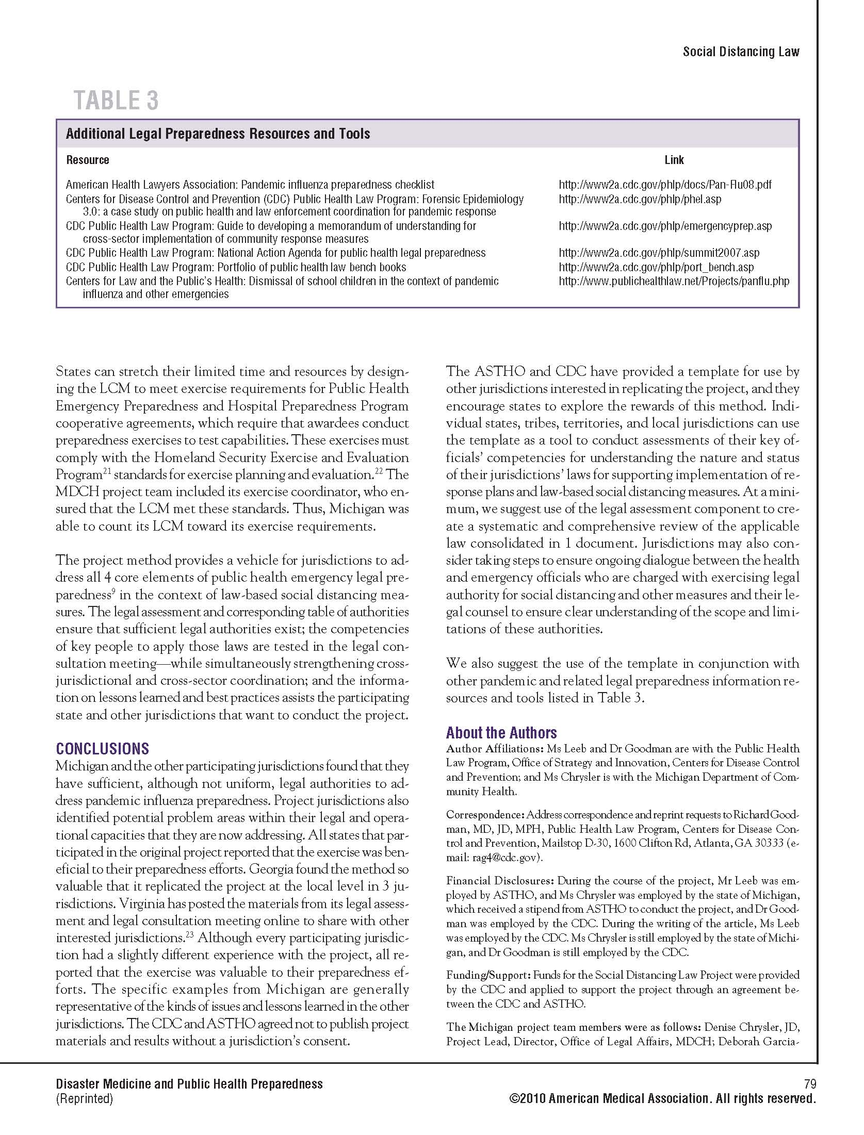

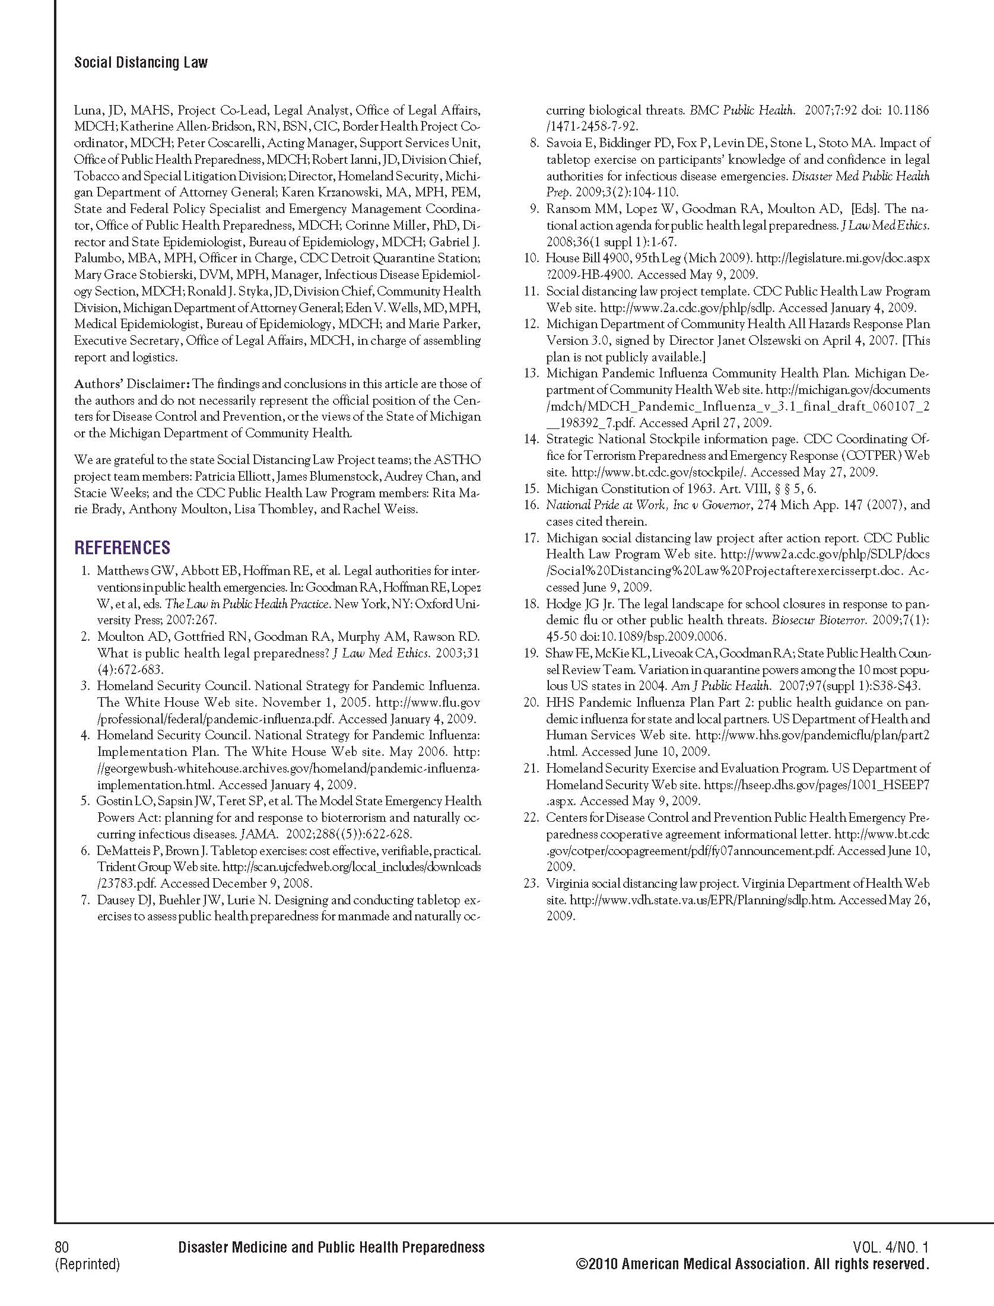

APPENDIX F

Additional Resources

- Resources specifically on legal preparedness for pandemic influenza are available on the website of the CDC Public Health Law Program at http://www.cdc.gov/phlp They include, among others:
- Many resources on the Social Distancing Law Project, including a complete portfolio of the project documents prepared for Michigan’s project and a report on the Virginia project. Following this page is a screen shot of the Social Distancing Law Project section of the website at http://www.cdc.gov/phlp/SDLP.
- “Forensic Epidemiology 3.0,” a training curriculum that contains a unit focused on joint public health-law enforcement implementation of social distancing measures
- The how-to guide “Coordinated Implementation of Community Response Measures (Including Social Distancing) to Control the Spread of Pandemic Respiratory Disease: A Guide for Developing an MOU for Public Health, Law Enforcement, Corrections, and the Judiciary.”
- A checklist for healthcare providers developed by the American Health Lawyers Association, “Community Pan Flu Preparedness Checklist for Key Legal Issues for Healthcare Providers”
- The report Legal Preparedness for School Closures in Response to Pandemic Influenza and other Emergencies, prepared by the Center for Law and the Public’s Health at Georgetown and Johns Hopkins universities, and
- The monthly “CDC Public Health Law News” digest of developments in public health law, with emphasis on public health emergency legal preparedness.

- The federal government’s comprehensive website for information on pandemic influenza is located at http://www.flu.gov and includes such resources as:
- The National Strategy for Pandemic Influenza
- Annual summaries of the implementation plan for the national strategy
- The DHHS Pandemic Influenza Plan
- DHHS pandemic influenza planning updates
- DHHS guidance for state and local governments and for other sectors, and
- Copies of relevant official DHHS documents such as declarations of emergency and emergency use authorizations.

- The Association of State and Territorial Health Officials: http://www.astho.org/ and the National Association of County and City Health Officials: http://www.naccho.org provide additional, law-related resources on pandemic influenza.

Markel H et al. Nonpharmaceutical interventions implemented by US cities during the 1918-1919 influenza pandemic. JAMA. 2007;298(6):644-654.
Matthews, G, Abbott, E, Hoffman, R, Cetron, M. Legal Authorities for Interventions in Public Health Emergencies. In: Goodman R, Hoffman, R, Lopez, W, Matthews, G, Rothstein, M, Foster, K, eds. Law in Public Health Practice, Second Edition. New York, NY: Oxford; 2007:277.
Id.
Matthews, G, Abbott, E, Hoffman, R, Cetron, M. Legal Authorities for Interventions in Public Health Emergencies. In: Goodman R, Hoffman, R, Lopez, W, Matthews, G, Rothstein, M, Foster, K, eds. Law in Public Health Practice, Second Edition. New York, NY: Oxford; 2007:267
National Strategy for Pandemic Influenza (2005), available at http://www.whitehouse.gov/homeland/pandemic-influenza.html.
National Strategy for Pandemic Influenza Implementation Plan (2006), available at http://www.whitehouse.gov/homeland/pandemic-influenza-implementation.html.
Id. pp. 107-109; 113-114.
Id. p.130.
The Center for Law and the Public’s Health: Legal Preparedness for School Closures in Response to Pandemic Influenza and other Emergencies. Available at http://www2a.cdc.gov/phlp/avian.asp.
Moulton, A, Goodman, R, Parmet, W. Perspective: Law and Great Public Health Achievements. In: Goodman R, Hoffman, R, Lopez, W, Matthews, G, Rothstein, M, Foster, K, eds. Law in Public Health Practice, Second Edition. New York, NY: Oxford; 2007:5-6.
See http://www.astho.org.
The states that held Legal Consultation Meetings were: Alaska, Florida, Georgia, Hawaii, Illinois, Massachusetts, Michigan, New Jersey, New York State, Texas, Virginia, and Washington. The District of Columbia and Maryland sent observers to Virginia’s meeting.
National Strategy for Pandemic Influenza Implementation Plan, 2005, p.130, available at http://www.whitehouse.gov/homeland/pandemic-influenza-implementation.html.
Id.
Id.
Id., pp.130-131. The subject of school closure authorities was covered by a separate CDC research project, and was not directly addressed in the 2007 Social Distancing Law Project. The report for the school closure project, entitled Legal Preparedness for School Closures in Response to Pandemic Influenza and other Emergencies, is available at http://www2a.cdc.gov/phlp/avian.asp.
National Strategy for Pandemic Influenza Implementation Plan, 2005, p.131, available at http://www.whitehouse.gov/homeland/pandemic-influenza-implementation.html.
Id.

