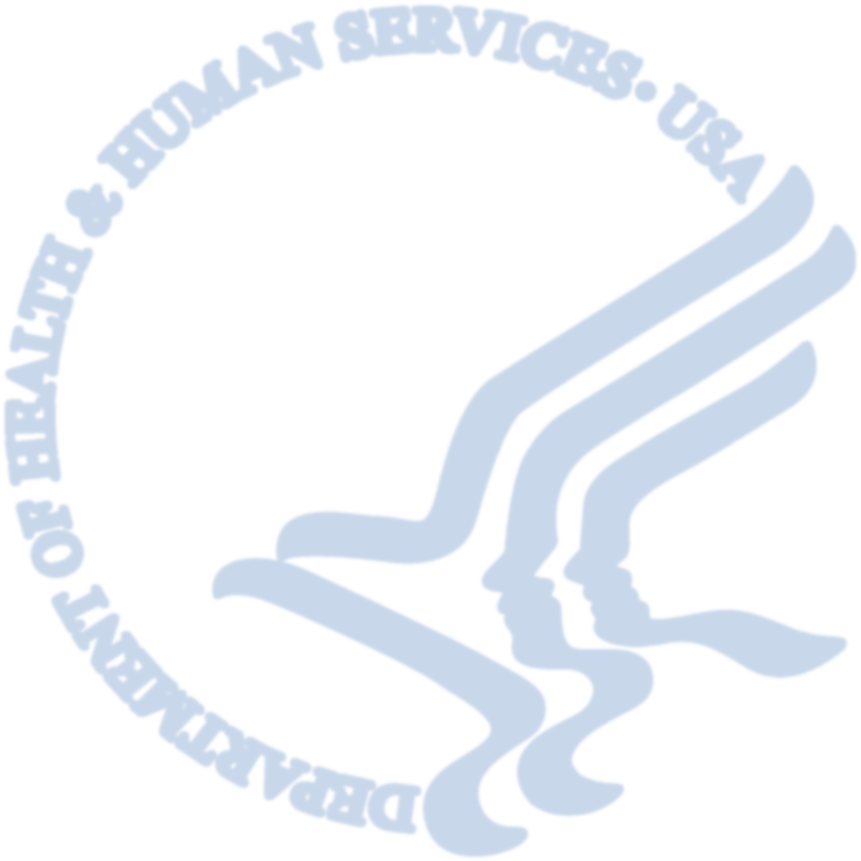

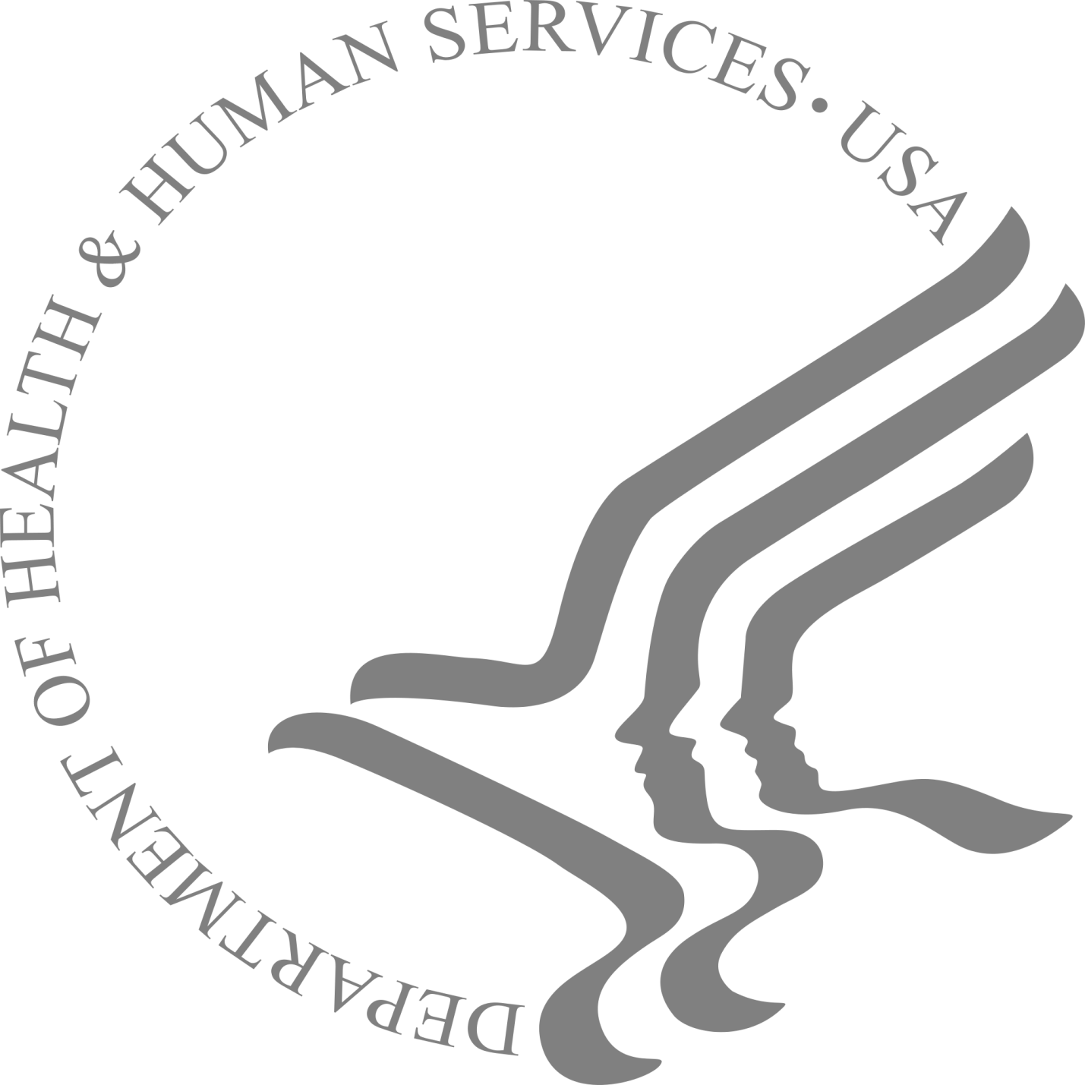

Department of Health and Human Services
2019 Plain Writing Act Compliance Report
Request for Information

Department of Health and Human Services
2019 Plain Writing Act Compliance Report
Request for Information

Background

On October 13, 2010, the Plain Writing Act (Act) was signed into law. The Act requires federal agencies to use “clear Government communication that the public can understand and use.” Communications in plain language are especially important in the context of healthcare and human services. The Department of Health and Human Services (HHS) recognizes that using plain language can help address the needs of those with limited literacy skills, as well as those with limited health literacy skills. Plain language helps people understand health information because the writing style is clear, concise, organized, and jargon-free. Documents written in plain language are less complex and therefore easier for everyone to understand, including people who have limited literacy skills, limited health literacy skills, or both.

In ongoing application and implementation, the Act requires agencies to “[w]rite annual compliance reports and post these reports on its plain language web page.” You can find links to HHS’s previous seven compliance reports here: http://www.hhs.gov/open/plain-writing/

The Department is developing our 2019 compliance report to demonstrate our continued compliance with the requirements of the Act. The report includes sections on accomplishments, best practices, innovations, continuous improvements, and HHS contacts overseeing implementation of plain writing requirements. Please provide information from your division by responding to the questions under section on pages 2-4, and return the completed document through SPS by 5PM Friday, March 22, 2019. If you have any questions, please contact Dr. Ekaterini (Kat) Malliou at Ekaterini.Malliou@hhs.gov.

[Enter your Operating or Staff Division Name Here]

Accomplishments

HHS seeks to reach all Americans with useful health information they can easily understand. To accomplish this goal, HHS regularly reviews new and existing reports, documents, and web content for plain writing to ensure the largest impact on the public.

From March 2018 to March 2019, please describe:

  - The top three plain writing documents your agency published that had the largest impact on the public.
Hurricane Key Messages Team (CPR) - For the successful development of the Preparedness and Safety Messaging for Hurricanes, Flooding, and Similar Disasters. https://www.cdc.gov/disasters/hurricanes/index.html

Zika Campaign Team, Travelers' Health (NCEZID) - For outstanding deployment of a targeted awareness campaign to reach travelers visiting areas with a risk of Zika.
https://wwwnc.cdc.gov/travel/files/zika-travel-brochure-508.pdf
Vital Signs Fact Sheet: Zika in Babies in US Territories (NCBDDD) - For exemplary work in the Vital Signs factsheet "Zika in Babies in US Territories"
https://www.cdc.gov/vitalsigns/zika-territories/index.html

  - The types of documents, and how many of each (estimate is acceptable, please specify,) that your agency wrote in plain writing. Please also specify how many of each were new and how many were substantially revised.
Our CIOs reported 1,300 documents meeting plain language standards. Of those documents, 927 were new and 373 were substantially revised for plain language. Document types include:
o Articles (Internal)
o Blogs
o Campaign messages
o Contract documents
o Briefing documents
o Fact sheets
o Federal register notices
o Frequently Asked Questions (FAQs)
o Funding Opportunity Announcements (FOAs)
o Gov. Delivery Messages
o Guidance documents
o Infographics
o Mobile apps
o Newsletters
o Posters
o PowerPoint presentations
o Press releases
o Reports
o Signs
o Social media messages
o Training materials
o Vital Signs
o Web materials
o Web pages

  - Examples of documents your agency improved through plain writing.
BAM Dining Decisions Mobile Game
https://www.cdc.gov/features/dining-decisions/index.html

CDC’s National Environmental Public Health Tracking Network
https://ephtracking.cdc.gov/docs/National_Fact_Sheet.pdf

New Ads From Former Smokers
https://www.cdc.gov/features/smokers-stories/index.html

  - How your agency updated its website devoted to plain writing, if applicable.
CDC’s agency website for Plain Writing was last updated in April 2018 (http://www.cdc.gov/Other/PlainWriting.html. The website describes what we are doing to use plain writing, and provides links to the Plain Writing Act of 2010, federal plain language guidelines, federal plain language website, the plain writing plan from the Department of Health and Human Services, the 2018 Plain Writing Act Compliance Report, Everyday Words for Public Health Communication and the Clear Communication Index. The website also has information on how users can provide feedback on the use of plain language in documents and materials, as well as examples of public documents CDC programs have created using plain language.

We continue to ask CIOs to launch and maintain their own intranet sites offering key writing resources, links to plain language tools, material development resources, or to refer staff to the Nation Center for Environmental Health’s online clear writing resources and toolkit. OADC maintains an intranet site regularly updated with upcoming plain language training opportunities and plain language promotion materials.

Best Practices

HHS reinforces the plain writing requirements through best practices, such as senior officials promoting plain writing and programs for tracking and measuring plain writing effectiveness.

From March 2018 to March 2019, please describe:

  - How senior officials in your agency reinforced the plain writing requirements through Plain Writing Act-related directives.
CDC reinforces compliance with the Plain Writing Act through Office of the Director level coordination of plain language activities and an agency operational policy. The Office of the Associate Director for Communication (OADC) is in the CDC Office of the Director and coordinates plain language work for the agency. OADC supports 2 positions in health literacy and plain language. OADC led the agency in developing an operational policy to implement the Act at CDC.

Senior agency officials reinforce plain writing by sponsoring and releasing staff for training, requesting briefings, inviting presentations at staff meetings, and reminding staff of the importance of plain language and complying with the law. CDC leadership continually reinforces the importance of complying with the Plain Language Act through the CDC intranet, newsletters, and agency-wide announcements.

  - How you tracked the conversion of existing documents into plain writing.
CIOs report using a variety of electronic systems to track and monitor documents such as: eClearance, Documentum, Sharepoint and Activator. CIOs use these systems to enter Clear Communication Index scores (a number between zero and 100 that indicates how many clear communication criteria the document has addressed), make descriptive notes about plain writing revisions completed or needed, and upload supporting documentation that can be seen by reviewers in clearance roles as the document progresses through the clearance sequence.
CIOs also used the “Plain Language Assessment” service offered by OADC that uses software to analyze text for plain language elements: passive verbs, hidden verbs, and sentence length. The software provides basic suggestions on how to clarify text. OADC then runs a 2nd analysis to determine if the appropriate changes have been addressed by the CIO.

  - How you measured whether covered documents used plain writing.
The Office of the Director and the 11 CIOs include plain language principles in the standard review and clearance criteria applied to public documents before we release them. Each of the 11 CIOs has an Associate Director for Communication Science who is responsible for this communication review. The agency Communication Director may also review sensitive, complex or emergency response public materials and apply plain language criteria.

CDC continued implementing the Clear Communication Index that includes 4 questions and 20 items that research shows affect clear communication. The Index references the Federal Plain Language Guidelines and expands the items we consider for clear communication. Staff use the Index to score documents on a scale of zero to 100. We track document scores and use them to identify steps we can take to increase clarity.

  - How you measured (i) the effectiveness of the plain writing program for your office; and (ii) the effectiveness of your plain writing documents (i.e., whether the public can easily understand and use them.)
We measure effectiveness of the plain writing program through data and feedback from the Associate Directors of Communication Science in the CIOs and the Health Literacy Council. We promote use of a flow chart diagram that shows how our various plain language and clear communications products can be helpful at different stages of developing communication materials. When time and funds allow, we measure effectiveness of our documents through audience testing, such as focus groups, interviews, usability testing, and online surveys on our web site. We use standardized customer satisfaction measures to track user satisfaction with CDC web pages.

  - The obstacles to measuring these aspects of your plain writing program.
Given the large number of documents produced by CDC, a dedicated team of reviewers would be necessary to track the extensive review process and measure writing quality for all documents.

Although testing documents with the intended audience and asking for customer feedback on our plain language use are the ideal ways to measure our plain writing program, these are resource-intensive activities. Individual programs often don’t have enough resources to thoroughly audience-test all documents they produce.

Results from the American Customer Satisfaction Index items provide only general level information about customers’ satisfaction with our website, but we can’t match responses to specific documents or get feedback on plain language use in documents.

Innovations

In the past year, agencies across HHS implemented innovative strategies to promote plain writing, including web banners, webinars, external social media messages, awards, and plain writing skills in position descriptions.

From March 2018 to March 2019, please describe:

  - Any innovative activities you implemented to promote plain writing.
The CDC/ATSDR Health Literacy Council, comprising representatives from across CDC and under the leadership of OADC, met 5 times in 2018 to develop guidance to help Centers, Institutes and Offices (CIOs) comply with the Plain Writing Act and the CDC/ATSDR Health Action Plan to Improve Health Literacy, which supports the use of plain language.

Health Literacy Council Members worked with their local committees to create unique events for CDC colleagues and partners.
  - The Office of the Chief of Staff’s Division of Issues Management, Analysis, and Coordination (IMAC) launched the “Writing Wranglers” campaign. This is an initiative to develop and expand the plain language skills of IMAC's staff.
  - The Office of the Associate Director for Communication hosted a New Communicators Network session on how to build a health literate organization. They also hosted a webinar on “Improving Plain Language Use at CDC” by introducing a new plain language product called Visible Thread.
  - The National Center for Environmental Health/ATSDR used social media to promote health literacy and the importance of using understandable health information.
  - The National Center for Birth Defects and Developmental Disabilities added a “Tips for Health Literacy” section to their thrice-weekly center wide newsletter.
  - The National Center for Environmental Health/ATSDR used their “Writing Tip Wednesday” newsletter to share information about health literacy and plain language. The information included free webinars, training opportunities, health literacy resources, weekly writing tips, and podcasts!
  - The National Center for Emerging and Zoonotic Infectious Diseases hosted a 2018 Clear Communication Showcase.
In 2018 we used a new RedCap system referred to as the “Health Literacy Reporting System” to collect data for a full year. This system standardizes data collection on plain language and health literacy initiatives across divisions and CIOs. Items in this system are directly aligned with the goals and strategies outlined in the CDC/ATSDR Action Plan to Improve Health Literacy. The data collected through this system are compiled into an annual report card to assess progress implementing the CDC/ATSDR Action Plan to Improve Health Literacy, which includes activities promoting plain writing.

- Incentives or rewards you provided to employees to encourage the use of plain writing.
CDC offers a plain language award and an excellence in communication award in the annual agency awards program. Each CIO can nominate one employee or team for these awards. Senior leadership and other supervisors in several CIOs reward staff who demonstrate and promote effective, clear communication and literacy skills through Performance Management Appraisal System (PMAS) ratings, public recognition in senior leadership meetings and All Hands meetings, time off awards, and special CIO awards.

- Whether you included plain writing skills in relevant job descriptions (i.e., employees who draft, edit, or clear any document.) Please provide examples.
Yes, our CIOs include plain writing ability in relevant job descriptions, and assess clear communication and health literacy skills of new federal employee hires and contract hires, who will be involved in drafting, editing, or clearing public health and safety information for the four audiences CDC serves. Some CIOs ask job candidates to provide samples of plain language materials they have produced.

- The documents your agency nominated for recognition as recipients of ClearMark Awards by the Center for Plain Language.
NCCDPHP- Unfit to Serve: Obesity Is Impacting National Security-https://centerforplainlanguage.org/wp-content/uploads/2018/04/unfit-to-serve.pdf

NCEH/ATSDR/OD – Hearing Loss Website

NCEH/ATSDR/OD – Hearing Loss Infographic

ATSDR - Division of Community Health Investigations (DCHI) – DCHI 2016 Annual Report

ATSDR - DCHI – Choose Safe Places for Early Care and Education

Continuous Improvement

HHS carries out a wide array of training activities to ensure that our employees fully understand the importance of plain writing and how to do it effectively. While agencies are given the necessary flexibility to tailor their particular training programs for their individual needs, HHS does offer a Department-wide training—the U.S. Department of Health and Human Services Plain Language Training—that agencies can use. This basic plain writing training is accessed on the HHS Learning Management System (LMS) learning portal and the HHS intranet.

Most HHS divisions require employees to complete the LMS online training, but many agencies supplement this training with agency specific trainings. In addition to online plain language trainings, some agencies offer a variety of in-person classes and training documents.

Many agencies encourage the use of plain language for both internal and external communication. Such agencies also developed trainings and materials to educate stakeholders and the general public on plain writing.

From March 2018 to March 2019, please describe:

- The number of your employees completing plain writing training.
In 2018 CIOs identified 639 employees that completed plain language training.

- The feedback you received from those who already completed the training.
No feedback.

- The plain writing training programs you used.
In-Person Agency Wide Training: Basic Plain Language Skill & Clear Communication Index Training- https://lms.learning.hhs.gov/Saba/Web/Main/goto/GuestCourseDetailURL?otId=cours000000000504439&callerPage=/learning/offeringTemplateDetails.xmlExternal
Online Training Video- Basic Plain Language Skills & Clear Communication Index Training – Dr. Cynthia Baur
This is a 3 hour live training conducted by Dr. Cynthia Baur. 1.5 hours of plain language training and 1.5 hours of clear communication index training.

- Examples of trainings and materials you developed to educate stakeholders and the general public on plain writing.
Plain Language – Communication your audience understands the first time- PDF training document
https://www.cdc.gov/healthliteracy/pdf/checklist-H.pdf

Guideline, Laws & Standards Webpage- https://www.cdc.gov/healthliteracy/guidelines.html

Plain Language Materials & Resources Webpage- https://www.cdc.gov/healthliteracy/developmaterials/plainlanguage.html

- Ways in which you improved or focused your plain writing efforts.
  - We sample and conduct independent document reviews for clear communication. In 2018, we helped CIOs create their own review teams and health literacy work plans to expand the number of documents getting independent review. At the beginning of 2019, CIOs were asked to create health literacy and plain language resolutions that will be assed throughout the year.

  - We continue to standardize and disseminate the application of plain language and clear communication elements with the Clear Communication Index, a scoring rubric applied to an increasing number of public materials.

  - We emphasize the need for on-going training in plain language. Plain language skills should be periodically refreshed and advanced through on-going training. Specific individuals and types of employees that would benefit from advanced trainings are identified and trained.

  - We recognize staff and programs for effective plain language use. In addition to an agency plain language award, many CIOs offer their own plain language and clear communication awards. Finally, staff skills in plain language are recognized through the ClearMark competition.

Contacts

The Act requires each department to designate one or more senior officials to oversee implementation of plain writing requirements. A list of such HHS agency officials can be found on the HHS website here: https://www.hhs.gov/open/plain-writing/

Please confirm the senior official in your Operating or Staff Division responsible for plain writing.

Name & Title: Dogan Eroglu, Ph.D., Associate Director for Communication Science, Office of the Associate Director for Communication (OADC), CDC
Email: Dogan.eroglu@cdc.hhs.gov
Phone: 404.498.6119

Note: We will include the name and e-mail address of this person on the Department’s plain writing webpage.

