Oak Ridge Associated Universities (ORAU) provides innovative scientific and technical solutions to advance national priorities in science, education, security and health. Through specialized teams of experts, unique laboratory capabilities and access to a consortium of more than 100 major Ph.D.-granting institutions, ORAU works with federal, state, local and commercial customers to advance national priorities and serve the public interest. A 501(c)(3) nonprofit corporation and federal contractor, ORAU manages the Oak Ridge Institute for Science and Education (ORISE) for the U.S. Department of Energy (DOE). Learn more about ORAU at www.orau.org.

Pandemic Influenza Electronic Exercise Tool
September 2017

[This page is intentionally blank]

Acknowledgments
The Centers for Disease Control and Prevention Healthcare Preparedness Activity and the Oak Ridge Institute for Science and Education developed the Pandemic Influenza Electronic Exercise Tool with the support of the organizations listed below.
U.S. Department of Health and Human Services
Assistant Secretary for Preparedness and Response
Office of Emergency Management
Hospital Preparedness Program
Office of Policy and Planning
Division of Health Systems Policy
Centers for Disease Control and Prevention
Office of Public Health Preparedness and Response
Division of Emergency Operations
Division of State and Local Readiness
Division of Strategic National Stockpile
National Center for Immunization and Respiratory Diseases
Influenza Coordination Unit
——— ◄► ———
Nonfederal Partners
Oak Ridge Associated Universities
Association of State and Territorial Health Officials
National Association of County and City Health Officials
Planners and Responders, Champaign and Urbana, Illinois
Multnomah County Health Department, Oregon
University of Nebraska Medical Centers, College of Public Health,
Center for Biosecurity, Biopreparedness, and Emerging Infectious Diseases

[This page is intentionally blank]

Table of Contents
Introduction 1
Background 1
What is the Electronic Exercise Tool? 1
Reasons to Consider an Electronic Exercise Format 2
Target Audience of the Tool 3
Applicability and Scope 3
Assumptions 3
Issues/Barriers to Consider 4
Components of the Tool 4
How to Use This Tool 5
Final Thought 6
Section 1 – Getting Started: Assembling Your Team 7
Overview 7
What This Section Covers 7
Definitions 7
How to Assemble Your Team 8
Planning Committee 8
Exercise Controllers 8
Exercise Evaluators 9
Trusted Agents 10
Self-Evaluation 10
Section 2 – Designing an Electronic Exercise 11
Overview 11
What This Section Covers 11
Definitions 11
How to Design an Electronic Exercise for Pandemic Influenza 12
Determine Exercise Parameters 12
Establish Exercise Goals 13
Identify Core Capabilities to Be Tested 13
Establish Exercise Objectives 17
Determine Participation Level 19
Identify Exercise Players 22
Determine Exercise Duration 23
Create an Exercise Scenario 24
Model the Effects of an Influenza Pandemic 25
Develop Scenario Injects to Drive Exercise Play 26
Develop Exercise Documentation 27
Self-Evaluation 31
Section 3 – Making it an Electronic Exercise 33
Overview 33
What This Section Covers 33
Definitions 33
How to Make It an Electronic Exercise 33
Designate an Exercise-Specific E-mail Account 33
Set Up E-mail Groups Corresponding to Sectors Participating in the Exercise 34
Explain the Exercise Format to Exercise Participants 37
Conduct a Test of the E-mail Platform 37
Self-Evaluation 37
Section 4 – Conducting an Electronic Exercise 39
Overview 39
What This Section Covers 39
Definitions 40
How to Conduct an Electronic Exercise 40
Review the Exercise MSEL 40
Establish a Baseline for the Community Response 41
Compile Situation Reports 44
Disseminate Scenario Updates and Injects 44
Conduct Conference Calls with Exercise Players 47
Update Daily Situation Reports 47
Modify Scenario Updates and Injects 47
Document Nonaligning Sector Responses 48
Conduct a Post-exercise Hot Wash 48
Self-Evaluation 49
Section 5 – Evaluating an Electronic Exercise 53
Overview 53
What This Section Covers 53
Definitions 54
How to Evaluate an Electronic Exercise 54
Plan for Exercise Evaluation 54
Observe the Exercise and Collect Exercise Data 55
Analyze Exercise Data 55
Report Exercise Outcomes 56
Develop an Improvement Plan 56
Self-Evaluation 57
Section 6 – Conclusion 59
Finishing Up 59
The Preparedness Cycle 59
Appendix A – Situation Manual Template 61
Overview 61
Introduction 62
Attachment 1: Participant List Template 67
Attachment 2: Exercise Timeline Template 69
Attachment 3: Frequently Asked Questions 71
Appendix B – Sample Exercise Scenario 73
Appendix C – Simple Modeling Tool 75
Overview 75
Creating a Simple Model 75
Another Option: Working with Trusted Agents to Determine Number of Patients 77
Factors to Consider When Modeling an Exercise 77
Appendix D – Sample Scenario Injects 79
Beginning of Exercise 81
Intended Player: Ambulatory Care (Urgent Care Centers, Pharmacy Clinics, Private Clinics) 81
Intended Player: 9-1-1 Call Center 88
Intended Player: Emergency Management 93
Intended Player: Emergency Medical Services/Fire 98
Intended Player: Hospitals 104
Intended Player: Public Health 107
Intended Player: Skilled Nursing Facilities 115
Intended Player: Colleges/Universities 119
Intended Player: Local and State Government 121
Intended Player: Mental Health 123
Intended Player: Fatality Management 125
Intended Player: Pharmacy 127
Middle of Exercise 129
Intended Player: Ambulatory Care (Urgent Care Centers, Pharmacy Clinics, Private Clinics) 129
Intended Player: Other Call Centers 132
Intended Player: Emergency Management 133
Intended Player: Public Health 138
Intended Player: Local and State Government 140
Intended Player: Pharmacy 141
End of Exercise 144
Intended Player: Ambulatory Care (Urgent Care Centers, Pharmacy Clinics, Private Clinics) 144
Intended Player: Colleges/Universities 146
Appendix E – Sample Master Scenario Events List 148
Appendix F – Sample Inject Response Report 161
Appendix G – Sample Situation Report 163
Appendix H – Participant Feedback Form 167
Appendix I – Abbreviations and Acronyms 173
Appendix J – Resources 175

Introduction

Background
Relationship between Exercises and Plans
The main purpose of an exercise is to evaluate a formal, written emergency response plan on which responders have been trained and for which they have an understanding of their roles and responsibilities. If your community does not have a formal, written plan to be exercised, you may find some benefit in using the results of the exercise to develop or improve plans.
The Centers for Disease Control and Prevention (CDC) Healthcare Preparedness and Response Team (HPRT) and the Oak Ridge Associated Universities (ORAU) hosted a Workshop on Community Partnerships for Pandemic Influenza Planning in 2008. At this workshop, CDC-HPRT and ORAU helped the Champaign Urbana Public Health District (CUPHD) and its partner agencies and organizations develop a community model of care (MOC) plan for an influenza pandemic. The plan describes how patients with influenza-like illness (ILI) symptoms enter into and move through the Champaign-Urbana points of healthcare delivery (e.g., primary care providers, urgent care clinics) to keep hospitals from becoming overwhelmed with patients.
In August, 2010, CDC-HPRT supported the Champaign-Urbana community in conducting an exercise to evaluate the 2008 MOC plan. Rather than use traditional, in-person methods, CDC-HPRT and ORAU used e-mail as an electronic platform to conduct the exercise. This platform was used to transmit initial exercise data, scenario injects, scenario updates, and situation reports to participating agencies and organizations during the CUPHD MOC exercise. Injects, updates, and reports were sent out on 6 separate days over a 3-week period. Participants e-mailed their response to these injects and situations to a pre-established, dedicated e-mail address maintained by ORAU. Exercise evaluators compared responses to the simulated scenario to the MOC plan at the end of the exercise to determine gaps in planning or issues needing resolution.

What is the Electronic Exercise Tool?
The Pandemic Influenza Electronic Exercise Tool (hereafter referred to as the Tool) is designed to help exercise planners from communities with limited resources to develop and conduct a pandemic influenza exercise. The Tool provides community planners with an easy-to-use format for developing and conducting an exercise using e-mail or other electronic format. It also is designed to provide a method for increasing exercise participation through a platform that can be more favorable to participants than a traditional, in-person exercise.

Reasons to Consider an Electronic Exercise Format
The e-mail format allowed participating agencies and organizations to take part in the exercise from various locations with limited interruption to their daily work routine. Additionally, conducting the exercise during a 3-week timeframe provided a sense of realism to the exercise, allowing the participants to respond in "real time". The e-mail format for the exercise was well received by participants in the CUPHD MOC exercise, in part because of these benefits.
Other benefits of electronic exercise formats include
- Increased partner participation – An electronic exercise can allow partners who would not normally participate in community planning efforts to take part in these efforts. Regional partners also may find it easier to engage in the exercise since they will not have to travel to the exercise location.
- More realistic partner responses – In a formal exercise, the short time available requires responses to be given immediately, usually by an individual. An electronic exercise can allow participants time to think through responses to scenario updates or injects and to collaborate with coworkers or other agencies/organizations.
- Less cost than formal exercises – An electronic exercise does not require meeting space, participant travel, or food/beverage costs. Additionally, as mentioned above, an electronic exercise allows for participation from work, thus reducing an agency's or organization's lost-work hours.
- Exercise data that are easier to track and record – The electronic format allows exercise planners to easily document player actions and responses thus making the evaluation of the exercise easier to perform.
- A method to help communities' complete HPP/PHEP requirements – As with a formal exercise, an electronic exercise may help community planners meet Hospital Preparedness Program (HPP) and Public Health Emergency Preparedness (PHEP) requirements. The community planners should engage HPP and PHEP project officers to ensure they approve of using the electronic exercise to meet these requirements.

Target Audience of the Tool
Key Assumption
A key assumption made in this document is that the user has at least basic knowledge and understanding of exercise concepts and terminology. Those well versed in exercises can advance to sections of the Tool they will find helpful in developing their exercises.
While the Tool can be used by any community emergency preparedness and response planner, it is particularly targeted to assist communities that have limited human and financial resources dedicated to developing and conducting exercises.

Applicability and Scope
- The Tool is designed to be used as a discussion-based exercise, such as a tabletop exercise (see Section 1 – An Overview of Exercises for more information). The Tool cannot be used to replace an operations-based, such as a functional or full-scale, exercise because these require physical presence and activity by the players and actors.
- The Tool provides the materials necessary to develop and conduct a pandemic influenza exercise using an e-mail platform. Community planners could use these materials as a guide for exercising other scenarios likely to impact their community, but must modify some components to make them applicable to these other scenarios.

Assumptions
- Community planners and other community partners who use this tool have at least basic knowledge and understanding of exercise concepts and terminology (i.e., they are familiar with exercise concepts and terminology even if they have not actually developed an exercise).
- The community has a core exercise planning committee including, but not limited to, representatives of public health departments, healthcare agencies and organizations, emergency medical services (EMS)/fire departments, and emergency management agencies.
- Community planners who use the Tool have developed a pandemic influenza response plan for their community (i.e., a plan is in place to be exercised using the Tool).
- Because the design of the Tool follows Homeland Security Exercise and Evaluation Program (HSEEP) guidelines, community planners also will follow these guidelines.

Issues/Barriers to Consider
- Some community partners may be resistant to trying a new approach to exercising.
- Some community partners may have secure platforms that prevent them from using business e-mail to participate in this type of exercise. In such cases, personal e-mail addresses will need to be used.
- Though some communities may choose to use a form of social media or blogs to pass on information, these platforms are seldom secure.
- The exercise format in the Tool relies on timely responses by exercise players. Some exercise players may not respond in a timely fashion or may forget to respond.
- Exercise coordinators will need to factor in enough time to test the communications systems and assist partners who may not be able to use the chosen electronic format.

Components of the Tool
Specific topics covered in the Tool include the following:
- Section 1 – Getting Started: Assembling Your Team – This section provides the user with criteria to use to select members of your exercise team: trusted agents, exercise controllers, and exercise evaluators.
- Section 2 – Designing an Exercise for Pandemic Influenza – This section describes how to create the exercise materials that a planner would need to develop an exercise tailored specifically to his/her community.
- Section 3 – Making It an Electronic Exercise – This section focuses on the "electronic logistics" a planner needs to consider when using an e-mail platform.
- Section 4 – Conducting an Electronic Exercise – The community planner is instructed in this section on how to use the e-mail platform to send out and receive exercise materials, such as scenario injects and situation reports.
- Section 5 – Evaluating an Electronic Exercise – Evaluating an electronic exercise is slightly different from evaluating an in-person exercise. This section explains the difference and provides recommendations on how to evaluate an electronic exercise.
- Appendices – The appendices contain examples of exercise materials and templates the exercise planner can use to conduct an electronic exercise.

How to Use This Tool
As noted above, the Tool is divided into five sections followed by 11 appendices. The sections can be subdivided into four task phases as shown below. Each phase must be completed before moving on to the next phase. Suggested timeframes for completing each task phase also are shown below.
Subdivisions of the Tool
Task Phase | Sections of the Tool Involved | Suggested Timeframe
Preparation | Section 1 – Getting Started: Assembling Your Team | 1 month
Design | Section 2 – Designing an Exercise for Pandemic Influenza  Section 3 – Making It an Electronic Exercise | 1 to 2 months  (Depends on the scope of the exercise)
Execution | Section 4 – Conducting an Electronic Exercise | 2 weeks to 2 months  (Depends on the scope of the exercise)
Evaluation | Section 5 – Evaluating an Electronic Exercise | 1 to 2 months  (Depends on the scope of the exercise)
In the first task phase, the user assembles the team of subject matter experts necessary to complete the design phase of the Tool. Next, this team goes about the tasks of designing an electronic exercise and then adding the technology. Once the design task phase has been completed, the community conducts the exercise. This phase is followed by the evaluation phase—an important step that will lead to a review and revision of plans, retraining, and future exercises. The timeframe for completing task phases two through four is dependent on the scope of the exercise.

Final Thought
CDC-HPRT strives to improve the tools it develops for use by communities. After you and your planning team have worked through the Tool, we would appreciate your feedback so that we can improve it. This feedback can be sent to healthcareprepared@cdc.gov.

Section 1 – Getting Started: Assembling Your Team

Overview
One of the assumptions made in the Tool is that the community has a core exercise planning committee, including but not limited to representatives of public health departments, healthcare agencies and organizations, EMS/fire departments, and emergency management agencies. In addition, three other groups of people need to help design and conduct an electronic exercise: exercise controllers, exercise evaluators, and trusted agents. In this document, these groups when combined with your exercise planning committee are referred to as exercise planners or the planning team.

What This Section Covers
This section covers the main task for assembling your team, which is to ensure that your planning committee is in place and ready to identify, contact, and secure the participation of
- Exercise controllers
- Exercise evaluators
- Trusted agents

Definitions
Exercise controller A person who plans and manages the conduct of the exercise. This person does not participate in the exercise unless absolutely necessary.
Exercise evaluator A person who evaluates the outcome of the exercise. This person does not participate in the exercise unless absolutely necessary. Exercise controllers also can serve as evaluators.
Planning committee A core group of stakeholders that provides oversight and direction of the exercise process. This committee is responsible for assembling the planning team.
Planning team A group of stakeholders assembled to prepare for, design, conduct, and evaluate an exercise.
Trusted agent A subject matter expert who helps plan the exercise and is trusted not to reveal the details prior to its conduct. A person who helps to develop exercise materials that are plausible, realistic, and accurate. This person does not participate in the exercise unless absolutely necessary.

How to Assemble Your Team

Planning Committee
You should have assembled a core exercise planning committee prior to undertaking the task of conducting an electronic exercise in your community. If possible, members of the planning committee who are going to participate in the exercise should not be designated as exercise controllers, exercise evaluators, or trusted agents because they have complete knowledge of the design of the exercise.
Ensure everyone on the planning team knows who is on the planning committee along with their organization, contact information, and the sector they represent.

Exercise Controllers
Exercise controllers plan and manage the conduct of the exercise. Exercise controllers do not participate in the exercise unless absolutely necessary. Exercise controllers have distinct, time-intensive responsibilities in an electronic exercise, such as
- Leading the development of exercise materials, such as the exercise scenario, Master Scenario Events List (MSEL), scenario injects, and the Situation Manual (SitMan). These materials are explained in detail in Section 3 – Designing an Electronic Exercise. Trusted agents will assist the exercise controllers with this task.
- Managing the conduct of the exercise (see Section 5 – Conducting an Electronic Exercise), which includes the following subtasks:
  - E-mailing scenario updates, scenario injects, and situation reports (SITREP) to exercise participants as scheduled in the exercise MSEL.
  - Receiving e-mail responses from sector representatives participating in the exercise and using these responses to compile a daily SITREP.
  - Setting up and facilitating conference calls with exercise participants, as needed.
  - Making adjustments to the exercise MSEL, scenario, and injects, as needed.
- Making the exercise suitable to conduct using an electronic format. This topic is covered in Section 4 – Making It an Electronic Exercise.
- Assisting with the evaluation of the exercise. This topic is covered in Section 5 – Evaluating an Electronic Exercise.
- Taking the lead in conducting post-exercise briefings and meetings.
You should have a minimum of two exercise controllers because of the amount of work involved and the need for a backup controller(s). You may need to add more controllers as the scope of your exercise increases.
Use the following criteria to help you and your planning committee determine if a person you have identified as a potential exercise controller is suited for the position.
Suggested Criteria for Choosing Exercise Controllers, Evaluators, and Trusted Agents
The person has the time to devote to the task.
The person has the support of his/her management to serve in this capacity.
The person has acted as an exercise controller, exercise evaluator, or a trusted agent in previous exercises in the community.
The person is knowledgeable about exercise concepts and terminology.
The person is knowledgeable about your pandemic influenza response plan.
The person is knowledgeable about the operations of and interactions among public health, healthcare, EMS/fire departments, and emergency management.
The person's participation as a trusted agent/exercise controller/exercise evaluator will not adversely affect the outcome of the exercise (i.e., the person would be more valuable to the exercise as a player because of his/her subject matter expertise).
Collect the names, organizations, phone numbers and e-mail addresses of the exercise controllers for your electronic exercise.

Exercise Evaluators
As the name suggests, exercise evaluators evaluate the outcome of the exercise. (See Section 6 – Evaluating an Electronic Exercise for more information.) Like exercise controllers, exercise evaluators do not participate in the exercise unless absolutely necessary. The people you select to be exercise controllers also can serve as evaluators.

You should have a minimum of two exercise evaluators because of the amount of work involved and the need for a backup evaluator(s). You may need to add more if the scope of your exercise requires a more detailed evaluation. Use the same criteria (above) you used for choosing your exercise controllers to help determine if potential exercise evaluators are suited for the position. Then collect the names, organizations, phone numbers and e-mail addresses of these evaluators.
Once selected, exercise evaluators should review Section 5 – Evaluating an Electronic Exercise to help them prepare for the exercise evaluation from the very beginning of the design process.

Trusted Agents
Trusted agents are subject matter experts who help plan the exercise and are trusted not to reveal the details prior to its conduct. Trusted agents will help develop exercise materials that are plausible and realistic, but more importantly, accurate. Because they are so heavily involved in the design and development of the exercise, trusted agents do not participate in the exercise unless absolutely necessary. Therefore, you should not ask key decision makers from your community's sectors to be trusted agents because their participation in your exercise is needed.
At the very least, you will need to assemble a group of trusted agents who are familiar with the operations of and interactions between the public health, healthcare, EMS/fire, and emergency management sectors. You may need to add other subject matter expertise to meet the demands of your electronic exercise.
Use the same criteria for choosing exercise controllers (see page 9) to choose your trusted agents. Then collect the names, sector they are representing, organizations, phone numbers and e-mail addresses of the trusted agents for your electronic exercise.

Self-Evaluation
Use the checklist below to confirm that all tasks in this section have been completed.
Task | Complete?
A core exercise planning committee is in place and ready to help with the exercise.
Exercise controllers have been identified and have agreed to help with the exercise.
Exercise evaluators have been identified and have agreed to help with the exercise.
Trusted agents have been identified and have agreed to help with the exercise.

Section 2 – Designing an Electronic Exercise

Overview
The 2013 HSEEP guidelines provide a set of guiding principles and a sound approach for designing an exercise. While the focus of the HSEEP guidelines is on developing discussion-based or operations-based exercises, this section of the Tool adapts the HSEEP approach into a method for designing an electronic exercise for pandemic influenza.

What This Section Covers
This section covers the 10 tasks required to design an electronic exercise:
- Determine exercise parameters
- Establish exercise goals
- Identify core capabilities to be tested
- Establish exercise objectives
- Determine participation level
- Identify exercise players
- Determine exercise duration
- Create an exercise scenario
- Develop scenario injects to drive exercise play
- Develop exercise documentation

Definitions
Core capabilities Distinct, critical elements needed to achieve the exercise goal(s).
Exercise parameters Limits or boundaries on what the exercise will cover. They guide the design of an exercise and keep the planner focused on what will be included in the exercise.
Master scenario events list A MSEL is a chronological listing of the events that drive exercise play, such as scenario injects and updates. It is not distributed to exercise participants. It is intended to be used only by exercise controllers to drive exercise play towards achievement of exercise objectives.
Scenario A narrative description of a pandemic influenza event that enables exercise objectives and core capabilities to be addressed. It sets the stage for exercise play.
Scenario inject A simulated event that drives exercise play towards achievement of exercise objectives. Can be directed to all exercise players or targeted to a particular facility (e.g., "General Hospital") or a sector (e.g., public health).
Scenario update Additional information provided to exercise participants over the duration of the exercise to drive exercise play and enable exercise objectives to be addressed.
Situation manual Commonly referred to as a SitMan. Provided to all exercise participants. Includes exercise scope, objectives, and core capabilities; assumptions and artificialities; instructions for exercise participants; exercise format/structure; and appropriate appendices, such as response plans or procedures.
Situation report Commonly referred to as a SITREP. It provides a report on the exercise situation at a certain period of time in the exercise.

How to Design an Electronic Exercise for Pandemic Influenza
Each of the 10 tasks listed above is covered in detail below.

Determine Exercise Parameters
HSEEP states that "exercise parameters clearly outline what should be included in an exercise scenario based on the objectives and scope, and what should not be exercised." The Tool is designed for use with a pandemic influenza scenario, so one parameter is that the exercise will involve an influenza pandemic in your community. Another parameter could be a focus on patient surge on the healthcare system or the use of points of dispensing (PODs) for providing medical countermeasures to your community during a pandemic.
Another parameter to consider is the mission areas your exercise will incorporate. These three mission areas are applicable to an influenza pandemic:
- Mitigation – Lessening the impact of the pandemic and reducing the loss of life.
- Response – Taking the actions necessary to save lives and protect the health and well-being of the community during the pandemic.
- Recovery – Providing the resources necessary to assist those affected by the pandemic to recover effectively.
The main point to remember is that you should stay focused on what you want to accomplish with the exercise and how it will benefit your community.

Establish Exercise Goals
About Goals and Objectives
The goals of your exercise are the outcomes you want to achieve. The objectives of your exercise are the strategies you will implement to achieve your goals. Goals are not specific; objectives are specific.
What outcome do you want to achieve through your electronic exercise? Another way to frame this question is to ask yourself and your planning team, "Why do we need to exercise?" The answer to this question will help you to establish your exercise goal(s). Examples of exercise goals are provided below:
- Evaluate the community pandemic influenza plan to identify strengths and areas for improvement.
- Improve understanding of the role of state government in the response to an influenza pandemic at the local level.
- Enhance coordination between public health, healthcare, EMS/fire, and emergency management agencies and organizations during the response to an influenza pandemic.
You can establish one goal for your exercise or multiple goals. Remember though that goal(s) are the starting point of exercise design. Each goal will broaden the scope of the exercise and the amount of time and effort you will need to devote to the exercise.

Identify Core Capabilities to Be Tested
Sources for Capabilities
The National Response Framework (NRF) lists 14 core capabilities, HPP lists eight, and PHEP lists 15. Many of these capabilities are similar across NRF, HPP, and PHEP. Some capabilities will be applicable to your exercise; some will not. See the listing on the next page for capabilities most likely to be applicable to your exercise.
FEMA notes that core capabilities are the "distinct critical elements needed to achieve the goal" of the exercise. The U.S. Department of Homeland Security states that core capabilities are "the activities that generally must be accomplished in incident response regardless of which levels of government are involved." HSEEP notes that the exercise planning team should align each exercise objective to one or more core capabilities.
You have established your exercise goal(s) and now the planning team should identify core capabilities to be tested. Naturally, you cannot test every capability in your exercise because doing so would prove burdensome for planners and participants alike. You should focus on a select few that will allow you to achieve your stated goal(s). For example, here are core capabilities that align with the three example goals on the previous page:
- Evaluate the community pandemic influenza plan to identify strengths and areas for improvement:
  - NRF – Planning, Operational Coordination, Public Health and Medical Services.
  - HPP – Foundation for Health Care and Medical Readiness, Health Care and Medical Response Coordination, Continuity of Health Care Service Delivery, Medical Surge.
  - PHEP – Community Preparedness, Emergency Operations Coordination, Fatality Management, Information Sharing, Medical Countermeasure Dispensing, Medical Surge, Volunteer Management.
- Improve understanding of the role of state government in the response to an influenza pandemic at the local level:
  - NRF – Operational Coordination, Operational Communications.
  - HPP – Foundation for Health Care and Medical Readiness, Health Care and Medical Response Coordination.
  - PHEP – Emergency Operations Coordination, Information Sharing, Medical Materiel Management and Distribution, Public Health Laboratory Testing, Volunteer Management.
- Enhance coordination among public health, healthcare, EMS/Fire, and emergency management agencies and organizations during the response to an influenza pandemic:
  - NRF – Operational Coordination, Operational Communications, Situational Assessment.
  - HPP – Health Care and Medical Response Coordination.
  - PHEP – Emergency Operations Coordination, Information Sharing.
At first glance, this listing of capabilities may appear to be overwhelming, but when looking more closely, you can see that many of these capabilities overlap or are similar to each other.
Because you are dealing with an influenza pandemic scenario, you should let the public health, healthcare, and EMS/fire representatives on your planning committee take the lead in identifying core capabilities. These entities will be the lead responders to an actual pandemic event. Therefore, they will know from experience which capabilities to test in your exercise.
A checklist is provided on the next page that lists core capabilities taken from NRF, HPP, and PHEP that might be applicable to your electronic exercise. Note that not all 14 NRF capabilities are applicable to pandemic influenza. Place a checkmark next to the capabilities you and your planning team want to test and to which you will align your exercise objectives.

List of Applicable Core Capabilities
National Response Framework Capabilities
Capability | Capability
- Fatality Management Services | - Planning
- Infrastructure Systems | - Public Health and Medical Services
- Mass Care Services | - Public Information and Warning
- Operational Communications | - Situational Assessment
- Operational Coordination | This cell is intentionally blank

Hospital Preparedness Program Capabilities
Capability | Capability
- Foundation for Health Care and Medical Readiness | - Health Care and Medical Response Coordination
- Continuity of Health Care Service Delivery | - Medical Surge

Public Health Emergency Preparedness Capabilities
Capability | Capability
- Community Preparedness | - Medical Materiel Management and Distribution
- Community Recovery | - Medical Surge
- Emergency Operations Coordination | - Non-Pharmaceutical Interventions
- Emergency Public Information and Warning | - Public Health Laboratory Testing
- Fatality Management Services | - Public Health Surveillance and Epidemiological Investigation
- Information Sharing | - Responder Safety and Health
- Mass Care | - Volunteer Management
- Medical Countermeasure Dispensing | This cell is intentionally blank

Establish Exercise Objectives
Capability-Based Objectives
Without well written and clearly defined objectives, the exercise participants, to include the players, controllers and evaluators, have no way to determine if a capability has been successfully demonstrated. Clearly defined objectives provide the emergency preparedness and response community the means to structure their own efforts towards the accomplishment of the objective and acceptable achievement of the desired capabilities.
Texas Department of State Health Services
Writing Capability-Based Exercise Objectives
Your next step is to establish your exercise objectives. FEMA notes that "an objective is a description of the performance you expect from participants to demonstrate competence. Objectives are specific and performance based. A small exercise can have as few as two or three objectives; a large, national exercise can have as many as 100. For an average exercise, 10 or fewer objectives are recommended."
As stated previously, HSEEP suggests that the exercise planning team should align each exercise objective to one or more core capabilities. You identified the core capabilities to test in the checklist in the previous section. Now you have to write exercise objectives that align with them. First, you need to look at the SMART approach to writing exercise objectives.
SMART is an acronym that stands for the key aspects of a good objective. These aspects are explained in more detail below.
Simple/Specific A good objective is simple and clearly phrased. It is brief and easy to understand. A good objective also is detailed and well defined so you know where you are going and what to expect when you get there.
Measurable The objective should set the level of performance so that results are observable, and you can tell when the objective has been achieved. This aspect does not mean that you have to set a quantifiable standard. It just means that people can agree on whether they succeeded.
Achievable The objective should not be too difficult to achieve. For example, achieving it should be within the resources that the organization is able to commit to an exercise.

Realistic The objective should present a realistic expectation for the situation. Even though an objective might be achievable, it might not be realistic for the exercise.
Task-oriented The objective should focus on a behavior or procedure. With respect to exercise design, each objective should focus on an individual emergency function.
Examples of SMART objectives are shown below using the three example goals provided earlier in this section. These example objectives also show how the objective aligns with the identified core capability explained in the previous section.
First Example Objective
- Goal – Evaluate the community pandemic influenza plan to identify strengths and areas for improvement.
- Core Capability – Medical surge.
- Objective – Review the triggers and decision-making process for implementing alternate care systems.
Second Example Objective
- Goal – Improve understanding of the role of state government in the response to an influenza pandemic at the local level.
- Core Capability – Emergency Operations Coordination.
- Objective – Outline changes to operations allowable under a state declaration of a public health emergency.
Third Example Objective
- Goal – Enhance coordination between public health, healthcare, emergency medical services, and emergency management agencies and organizations during the response to an influenza pandemic.
- Core Capability – Information Sharing.
- Objective – Implement communications plan for the opening of local points of dispensing for the distribution of influenza vaccine.

Now that you have the goal(s), core capabilities, and exercise objectives set, you will look at who to involve in your exercise.

Determine Participation Level
Optimally, you want each agency or organization in your community that has a role in meeting exercise goal(s) and objectives to participate in the exercise. These agencies and organizations would include those that provide for the delivery of healthcare in the community and those that support the provision of care. Inclusivity is the ultimate goal, but keep in mind that the involvement of too many agencies or organizations can become overwhelming for exercise planners and controllers because of the increased time needed to develop and process exercise information.
Use the checklists below to determine the agencies or organizations in your community you want to participate in your exercise.
Participating Agency/Organization Checklist
Place a checkmark next to the agencies or organizations you want to participate in your exercise.
Public Health Agencies/Organizations | Participating?
Local public health department
Public health clinics
State public health department
Other: _______________________________

Healthcare Agencies/Organizations | Participating?
EMS
Federally Qualified Health Centers/free clinics
Home health providers
Hospice care providers
Hospitals
Long-term care/skilled nursing/assisted living providers
Mental health providers
Outpatient/retail clinics
Palliative care providers
Pharmacies
Primary care providers
School clinics
Urgent care centers
VA medical centers
Other: _______________________________

Emergency Management Agencies/Organizations | Participating?
9-1-1 call center
Emergency management agency
Emergency operations center
Fire departments
Law enforcement
Public affairs/public information officers
Other: _______________________________

Government Agencies/Organizations | Participating?
Local government
State government
Other: _______________________________

Support Services Agencies/Organizations | Participating?
Community services organizations
Faith-based organizations
Fatality management services
Medical examiner/coroner
Schools
Volunteer organizations
Other: _______________________________

Identify Exercise Players
Once you have identified these participating agencies and organizations, you will need to identify who will represent them in the exercise. Since an exercise focuses on the response to a given scenario, you want people participating who have the authority to direct their agency's or organization's response. Having these key personnel participating in the exercise will help to provide an accurate picture of how an agency or organization will respond to a given event.
Please note that most discussion-based exercises require physical space in which to conduct the exercise. As a result, the number of people who can participate is limited. In an electronic exercise, the number of people who can participate is not limited. However, an important recommendation is to identify one or two points of contact for each agency or organization participating in the exercise and have them be the spokesperson for that agency or organization. These points of contact can then involve other people in their agency/organization in the exercise without placing a burden on the exercise controllers and evaluators.
Collect information on the agency/organization, names, titles, and e-mail addresses of exercise players as you go through the process of identifying them.

Determine Exercise Duration
Discussion-based exercises generally last for a few hours to a full day. An electronic exercise can last for days or weeks, depending on the objectives. The electronic exercise conducted in Champaign-Urbana, Illinois, took place on 6 exercise days over a 3-week time period. Several factors determine the length of time you will need to conduct your electronic exercise:
- The goals and objectives of the exercise – The goals and objectives will influence the number of scenario injects and scenario updates needed to accomplish the objectives.
- The amount of time you want to allow between electronic transmissions – The exercise days for the Champaign-Urbana exercise were Tuesdays and Thursdays. Exercise controllers learned quickly that allowing 1 day between electronic transmissions was not sufficient because more time was needed to collect, synthesize, and redistribute exercise information. When deciding the amount of time you want to allow between electronic transmissions, consider these factors:
  - The number of agencies or organizations participating in the exercise – This number will dictate the amount of time dedicated to transmitting and receiving exercise information and developing SITREPs (see Section 4 – Conducting an Electronic Exercise). The more participating, the more time needed to process information.
  - Contingency planning for interruptions – Real-life emergencies may occur that will delay an agency or organization from responding to an exercise transmission. Building in a cushion of time may help to accommodate such interruptions.
  - Debriefing sessions – The participants in the Champaign-Urbana electronic exercise stated that they wished they had time between exercise days to conduct a conference call involving all participants. The purpose of the call would be to question other participants about their response to a given situation.
  - Exercise fatigue – The longer the exercise timeframe, the more likely that exercise participants will get tired of participating. A fine balance between the number of exercise days and the amount of time between them needs to be established.

- The time of year for which the exercise is planned – The time of year could have an impact on exercise duration. Try to avoid conducting your exercise when such things as year-end audits, budget cycles, and grant requests will require the attention of your exercise participants. Additionally, do not try to conduct a pandemic influenza exercise during influenza season when many of your exercise players may be responding to an actual influenza outbreak in your community.

Create an Exercise Scenario
Confidentiality
The exercise scenario is a sensitive document that should not be divulged to exercise players until the exercise design calls for it to be divulged. "Leaking" the scenario could invalidate exercise results.
The scenario in an electronic exercise evolves over the course of the exercise. The initial scenario that is distributed to exercise participants on the first day of the exercise sets the stage for exercise play (see Appendix B for the scenario that was used in the Champaign-Urbana exercise). It provides a narrative and a timeline for the evolution of an influenza pandemic and describes the current state of events in a community, state, and country. The scenario is updated each exercise day as needed by exercise planners.
Exercise planners should develop scenarios that enable core capabilities and exercise objectives to be addressed. Additionally, they should develop scenarios that are realistic, plausible, and challenging; however, designers must ensure the scenario is not so complicated that it overwhelms exercise participants.

The Scenario Foundation*
A scenario is an outline or a model of the simulated event or sequence of events for the exercise that drives participant action. Exercise planners should develop the scenario so that the exercise will meet its objectives. Your scenario should be realistic and plausible.
A scenario consists of three basic elements: (1) the general context or comprehensive story, (2) the conditions that allow players to demonstrate their ability to meet the exercise objectives, and (3) the technical details necessary to accurately depict scenario conditions and events (e.g., date and time of event, specific information about damage resulting from the event).
The planning team must ensure that the design process is not characterized by a fixation on scenario development; rather, the scenario facilitates achievement of exercise objectives, which are the foundation of exercise design.
For all scenarios, the date and time affect exercise play. Many organizations have different demographics on weekdays, weekends, and holidays, as well as at night and during special events. These changes may affect players' expected actions and can be incorporated into the scenario. For example, when a major sporting event is held at a stadium, it may temporarily increase a community's population and change traffic patterns—evacuation routes or response times may be affected.
*Adapted from City & County of San Francisco Department of Emergency Management, Exercise Toolkit

Model the Effects of an Influenza Pandemic
Related to developing the scenario is determining what effect the influenza pandemic will have on the population and the community. The scenario sets the conditions for the start of the exercise; modeling is used to predict the spread and severity of the disease. Modeling aids planners in anticipating the surge on the healthcare system by providing an accurate description of how many people have been infected by or died from the influenza pandemic described in the exercise scenario. Modeling can simulate a pandemic wave over the course of the exercise, showing participants a realistic increase in ILI and deaths from influenza. A simple modeling tool is provided in Appendix C on page 75.

Develop Scenario Injects to Drive Exercise Play
Sample Scenario Inject
A multiple-vehicle accident has occurred on the local interstate highway. The incoming patients will require emergency care and some will require care in the intensive care unit.
A scenario inject represents a simulated event that drives exercise play towards achievement of exercise objectives by causing exercise players to take action. Scenario injects can be directed to all exercise players or targeted to a particular agency/organization (e.g., "General Hospital"), a sector (e.g., public health), or a subsector (e.g., all long-term care agencies). The sample inject in the box to the right probably would be issued to exercise players representing EMS and hospitals as well as the fatality management sector if it involved deaths.
One point to remember is that scenario injects need to be specific. For example, the sample scenario inject above might seem to be satisfactory at first glance, but it is missing several pieces of important information, such as the agency/organization or sector for which it is intended, the ages of the injured people, and the extent of their injuries. All of this information may be needed for exercise players to make a decision on their response actions.
Another point to remember is that injects do not necessarily need to focus on the scenario incident. For example, this sample inject has nothing to do with an influenza pandemic. However, one of your objectives may be to determine your community hospitals' ability to manage patient surge. Therefore, this scenario inject represents a surge of patients into the healthcare system. As a result, exercise players representing EMS and hospitals will have to determine how to coordinate patient transport and to which hospital patients will be delivered.
Remember to focus on the core capabilities and exercise objectives when developing scenario injects. Also, remember to keep the scenario injects for your exercise plausible and realistic. For example, if you live in a rural community without much vehicular traffic, a multiple vehicle accident is less likely to occur, making this inject less plausible or realistic.
A revised version of the sample inject above is shown on page 105 in a template designed for use with the Tool. It now has the additional information including the exercise player(s) and secondary players, a suggested time in exercise play to inject the situation, and a detailed description of the situation. This template also lists sets of questions that should be asked of the exercise players (these questions are explained in Section 5 – Conducting an Electronic Exercise) and provides space for information important to the evaluation of the exercise. Sample scenario injects in this format are separated by sector and provided in Appendix D.

Develop Exercise Documentation
Discussion-based and operations-based exercises can require up to nine key design and development documents, such as manuals, plans, and guides. Fortunately, an electronic exercise only requires three forms of exercise documentation: the SitMan, the MSEL, and a participant feedback form.
Situation Manual
The SitMan is given to all exercise participants to provide them the information they need about the exercise. The SitMan in an electronic exercise should include the following:
- Purpose
- Participating agencies/organizations
- Exercise goals, core capabilities, and objectives
- Assumptions and artificialities
- Instructions for exercise participants
- Exercise format
- Participant list
- Appropriate appendices, such as response plans or procedures
Appendix A – Situation Manual Template will help you to put together the SitMan for your electronic exercise.
Master Scenario Events List
The MSEL contains exercise messages/updates and scenario injects in a table that specifies the exercise day that the messages/updates/injects are to be delivered and to whom (agency/organization) they are sent. The MSEL also lists standard or specific discussion questions to be addressed by representatives of the agency/organization in relation to the messages/updates/injects sent to them. It further lists expected outcomes for the exercise day as an aide in exercise evaluation.
The MSEL is not distributed to exercise participants. It is intended to be used only by exercise controllers to drive exercise play towards achievement of exercise objectives. Because an electronic exercise occurs over several days or weeks, a MSEL is a useful tool for showing exercise planners how their exercise will unfold. Additionally, it will help them plan for scenario updates and injects over the course of the exercise for each sector (and agency/organization within the sector) participating in the exercise.
A portion of the MSEL used for the Champaign-Urbana exercise is shown below and on the next page. (The MSEL used for the first 3 days of the Champaign-Urbana exercise is provided in Appendix E on page 153.) This format gives a good "snapshot" of events occurring across multiple sectors during a single exercise day. You may choose to use another format for your electronic exercise MSEL.
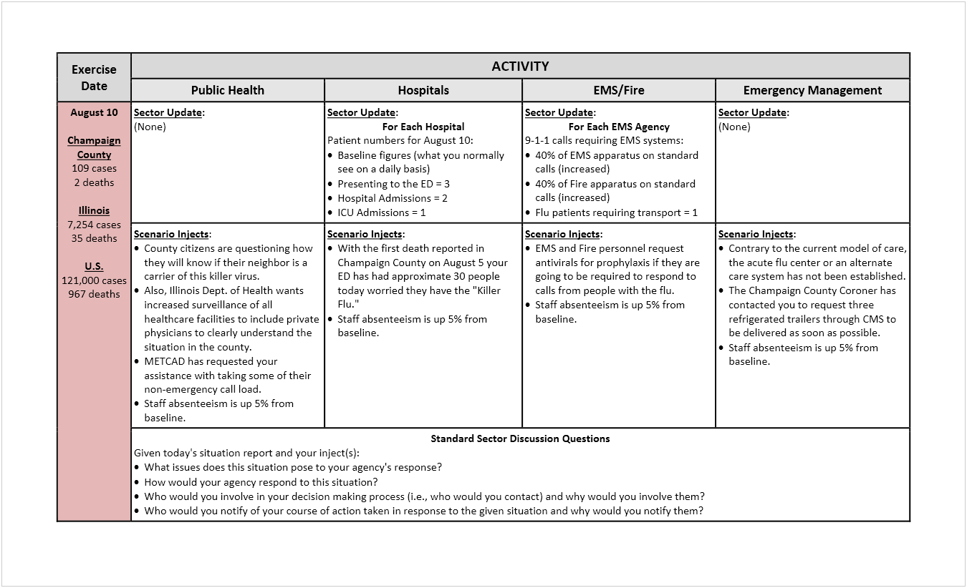

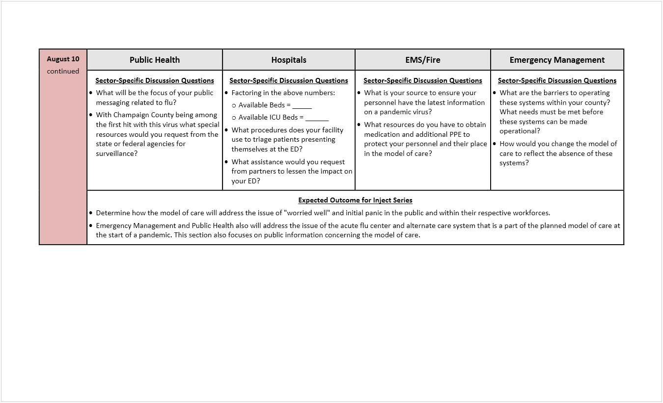

Here is a description of each section of the MSEL shown on the previous page and above:
- Exercise Date – The left-hand column identifies the exercise date and, more importantly, provides a flu report for that date. Flu report data (cases and deaths) for the county, state, and United States will come from the simple modeling tool (Appendix C) or another modeling tool that you may choose to use. This flu report data will be provided to exercise participants each exercise day.
  - Flu report data should increase each exercise day to match the predicted impact of an influenza pandemic on your county and state. If you will continue your exercise through the recovery phase, then the flu data will mirror a pandemic wave, peaking and then beginning to decrease each exercise day.
- Sector Name – Each sector participating will have a dedicated column in the MSEL. In this example, you see columns for the Public Health, Hospitals, EMS/Fire, and Emergency Management sectors. Because you will probably have more sectors involved in the exercise than you can fit on a single MSEL page, you may need to develop more than one MSEL. For example, exercise planners for the Champaign-Urbana exercise developed a MSEL for major sectors (public health, hospitals, fire/EMS, emergency management, ambulatory care, and call centers) and a MSEL for other sectors (long-term care/skilled care/assisted living, schools, government, fatality management, and additional sectors [mental health, pharmacy]).
- Sector Update – This section is similar to a scenario inject in that the information contained in the section will be provided to the sector representatives participating in the exercise. Sector updates are targeted toward those sectors that manage patients, such as ambulatory care, EMS, and hospitals. This section is used to update the number of patients requiring medical attention by the sector (e.g., 60 additional people presenting to the facility on that day).
  - When developing sector updates, remember to take into consideration the flu report data for that particular exercise day and try to mirror realistically the expected impact on the sector from the influenza pandemic.
- Scenario Injects – In this section, you will list the sector-specific scenario inject(s) that will be sent to sector participants on that day.
  - As you did with sector updates, remember to consider the flu report data for that particular exercise day when developing injects that are flu-specific.
- Standard Discussion Questions – As the name implies, this section contains a set of questions that are applicable to all participating sectors in the exercise. These questions will be disseminated to participants along with sector updates and scenario injects.
- Sector-specific Discussion Questions – This section represents sector-specific questions that you want sector representatives to discuss and answer.
- Expected Outcome for Inject Series – As the title of the section implies, you will describe the outcome(s) you expect from the sector updates and scenario injects.
The exercise MSEL is the blueprint for your exercise. You will need to work closely with your trusted agents to develop all of the pieces of the MSEL to ensure that you put together an effective exercise.
Participant Feedback Form
Soliciting participant feedback on the exercise is part of the evaluation process. It allows participants to identify strengths and areas for improvement in the exercise. This feedback is incorporated into the exercise after-action report (AAR) and improvement plan (IP) (see Section 6 – Evaluating an Electronic Exercise for more information). A participant feedback form template is provided in Appendix H.

Self-Evaluation
Use the checklist below to confirm that all tasks in this section have been completed.
Scope
Task | Complete?
Participation level in the exercise has been determined.
Exercise players have been identified and contacted to participate in the exercise.
The duration of the exercise has been determined.
Exercise parameters have been determined.
Goals, Capabilities, and Objectives
Task | Complete?
Exercise goals have been established.
Core capabilities to be tested have been identified.
Exercise objectives have been established.
Scenario
Task | Complete?
An exercise scenario has been created.
Scenario modeling has been completed to show community morbidity and mortality over the course of the influenza pandemic.

Scenario Injects
Task | Complete?
Scenario injects have been developed.
Scenario inject templates have been completed.
Exercise Documentation
Task | Complete?
The exercise SitMan has been developed.
The exercise MSEL has been developed.
The participant feedback form has been developed.

Section 3 – Making it an Electronic Exercise

Overview
Putting together a formal, discussion-based exercise involves many logistical considerations, such as securing physical space and audio/video resources to conduct the exercise, providing facilitators to run the exercise, and designating note takers to capture exercise discussions. None of these tasks, however, are needed to put together an electronic exercise, which is one of the main benefits of the electronic format.

What This Section Covers
This section covers the four tasks required to make your exercise electronic:
- Create an exercise-specific e-mail account.
- Set up e-mail groups corresponding to sectors participating in the exercise.
- Explain the exercise format to participants.
- Conduct a test of the e-mail platform.

Definitions
No new definitions are introduced in this section.

How to Make It an Electronic Exercise
Listed below are the critical steps necessary to making your exercise an electronic exercise.

Designate an Exercise-Specific E-mail Account
A key step in setting up an electronic exercise is for exercise controllers to create an exercise-specific e-mail account (e.g., PanFluExercise@city.gov or PanFluExercise@public.com) or designate one controller's account to receive exercise material. This e-mail account will be the "central hub" for sending out exercise materials and receiving responses from exercise players. Here are several points to consider related to this exercise-specific e-mail account:
- The e-mail account will be managed by your exercise controllers. They will be responsible for sending out exercise information and receiving player responses through this account. As a result, they need to have complete access to the account.

- Some exercise players may feel uncomfortable sending information to an e-mail account that derives from a public domain (e.g., Yahoo, Gmail) because of concerns for the security of potentially confidential information.
- Hosting the e-mail account on a private domain (e.g., government agency) provides for an information technology support network to help set up and monitor the account as well as troubleshoot any problems that may arise. However, hosting the account on a private domain also requires the use of the agency's human resources department and equipment to set up the account, and the agency will not be reimbursed financially for this effort.

Set Up E-mail Groups Corresponding to Sectors Participating in the Exercise
Exercise controllers have three options for sending injects, scenario updates, and situation reports to exercise players:
- Option 1 – Send the exercise information to all agencies/organizations within a sector (e.g., public health, hospitals, emergency management). For example, you may have three hospitals operating in the community and each hospital may be similar in patient capacity and healthcare delivery. Therefore, they would get the same scenario injects. You will need to set up a Hospitals Group in your exercise-specific e-mail account and then add the e-mail addresses of representatives of these three hospitals into the group. As a result, you only will have to send one e-mail to the Hospitals Group. That e-mail then will be routed to all of the hospital representatives participating in the exercise. Figure 1 on the next page provides a visual description of this option.
Figure 1. E-mail Option 1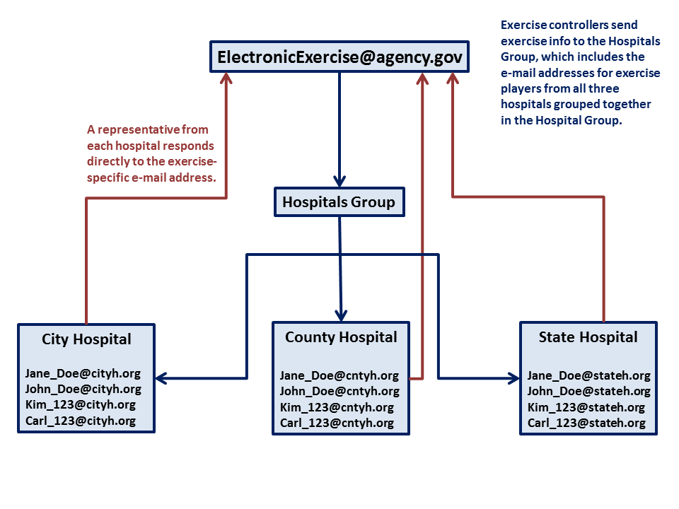

- Option 2 – Send the exercise information to each agency/organization within a sector. Using the example presented in Option 1, these three hospitals may differ in patient capacity and healthcare delivery. For example, you may have a Level I, Level II, and Level III trauma center in your community. As a result, you may want to match your scenario injects to the capabilities of each hospital, which means that each hospital will get different scenario injects whereas those in Option 1 all received the same inject.
In Option 2, you will need to set up a Hospital Group for each of these three hospitals. Figure 2 provides a visual description of this option.
Figure 2. E-mail Option 2
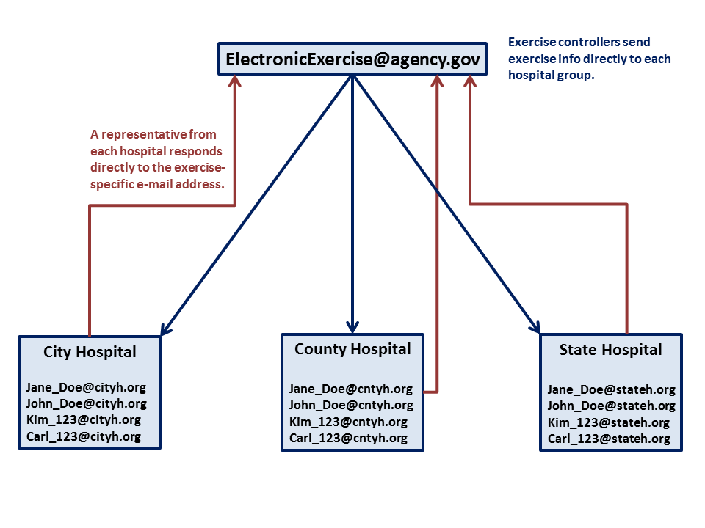
- Option 3 – Send some exercise information to similar agencies/organizations within a sector, such as hospitals with similar capabilities and capacities. Send some information to agencies/organizations that are not similar. In other words, combine Options 1 and 2.
You will note that, in all of these options, a representative from each hospital replies directly to the exercise-specific e-mail address (i.e., the exercise controllers) though they may also include other hospitals in this reply to improve information sharing.

Explain the Exercise Format to Exercise Participants
As mentioned in the previous section, one of the issues to consider when using an electronic format for exercising is that some community partners may be resistant to trying this new approach. As a result, you and your exercise planning team will need to provide exercise participants with an overview of the exercise and instructions on how they will participate in it. This information will be provided in your exercise SitMan. See Appendix A for a SitMan template. In addition to providing this information to exercise participants, you may want to conduct a conference call with all participants to answer any questions or address any reservations they have about the exercise.

Conduct a Test of the E-mail Platform
Another critical step to take to set up an electronic exercise is to test the e-mail platform that you established for the exercise. Your exercise planning team can conduct this test internally or you can involve all or part of the exercise participants. One suggestion is to use this platform to disseminate the SitMan that you developed in the previous step and then follow up with a conference call to answer questions or address issues.

Self-Evaluation
Use the checklist below to confirm that all tasks in this section have been completed.
Task | Complete?
An exercise-specific e-mail account has been created.
E-mail groups have been set up in the e-mail account to correspond to similar entities participating in the exercise.
The exercise format has been explained to exercise participants.
The e-mail platform has been tested to confirm it performs to expectations.

[This page is intentionally blank]

Section 4 – Conducting an Electronic Exercise

Overview
Key Assumptions
Two assumptions are made at this point: (1) you have tested your e-mail platform with both your exercise planners and players and (2) exercise players fully understand how this exercise will be conducted. Both of these items were covered in Section 3 and need to be completed before you try to conduct your electronic exercise.
Up to this point in the Tool, you have assembled your team, including your core planning committee, trusted agents, exercise controllers, and exercise evaluators. Next, you and your planning team identified exercise players, determined a timeline for the exercise, created an exercise-specific e-mail account, and set a launch date. Following that, you designed your electronic exercise, which included determining the scope, establishing objectives, creating a scenario, and developing scenario injects and exercise documentation. You have now arrived at the point where you put all of these pieces together to actually conduct your electronic exercise.

What This Section Covers
This section covers the nine tasks required to conduct your electronic exercise:
- Review the exercise MSEL to determine what information gets disseminated, to whom it gets disseminated, and when it gets disseminated.
- Disseminate the initial scenario to establish the baseline response of the community up to that point in the scenario.
- Receive responses from exercise players and compile them in a daily situation report.
- Disseminate scenario updates and injects as provided for in the exercise MSEL.
- Conduct conference calls with exercise players between exercise days to discuss the exercise situation to date and to answer any questions from exercise players.
- Update daily situation reports based on modified or new information coming out of these conference calls.
- Modify the exercise scenario or injects as needed to drive exercise play to meet established objectives.
- Document sector responses that do not align with what is prescribed in the community's pandemic influenza or situations that are not covered in the plan.
- Conduct a post-exercise hot wash with exercise players.

Definitions
Exercise disclaimer A statement added to all exercise materials being sent electronically (injects, scenario updates, situation reports) to identify the materials as being part of an exercise. Usually denoted by "This is an Exercise" at the beginning and end of the material being sent out electronically.

How to Conduct an Electronic Exercise

Review the Exercise MSEL
Exercise controllers will be required to disseminate a lot of information in an electronic exercise to many different agencies and organizations representing your community's sectors. The exercise MSEL, which contains a chronological listing of the events that drive exercise play, will help these controllers plan each day's activities. Below is a guide on the information that is disseminated each day and to whom it should be sent:
What is being e-mailed? | To whom is it e-mailed?
Initial scenario, scenario updates | All exercise players
Situation reports | All exercise players
Scenario injects | Specific players or sectors identified on the exercise MSEL or inject form
Discussion questions | Specific players or sectors identified on the exercise MSEL or inject form

Establish a Baseline for the Community Response
Influenza pandemics do not suddenly appear in a community. Normally, a pandemic starts when a novel influenza virus to which humans have little or no immunity and for which a vaccine does not exist is detected. The virus spreads at an increasing rate, and illness and death increase at the same rate. As the disease spreads, public health alerts are issued along with emergency declarations to help public health and healthcare officials respond to the threat. More importantly, as the pandemic becomes imminent, these officials take steps to prepare their response.
Your exercise scenario likely will start at the beginning of an influenza pandemic. Therefore, the initial scenario you create will need to provide the background of the pandemic and the status of the disease in your community or in your state. After you disseminate this scenario to your exercise players, you will need to find out what preparations or response activities they would have taken up to that point in the scenario.
The initial scenario disseminated to exercise players in the Champaign-Urbana exercise is shown on the next page. Please notice how this scenario begins with the history of the novel influenza virus and describes how it has spread across the United States. It then brings the reader to the current date, and with that, the exercise gets started.

Example Initial Scenario*
History
Novel influenza A H7N7 virus originated in Canada in early July, 2010. The virus spreads in the same way that regular seasonal influenza viruses spread, mainly through the coughs and sneezes of people who are sick with the virus, but it may also be spread by touching infected objects and then touching the nose or mouth. This novel influenza virus causes a wide range of flu-like symptoms, including fever, cough, sore throat, body aches, headache, chills, and fatigue. In some instances, it causes severe conjunctivitis.
By the middle of July, H7N7 had been transmitted to children and adults at the Neighbors Summer Camp held in New York State by infected Canadian citizens attending the camp.
On July 20, 2010, cases of H7N7 were confirmed in American children and adults who had attended the Neighbors Summer Camp. These cases were spread across Midwestern United States (U.S.), including Illinois and Indiana. Initially, three H7N7 cases (two children and one adult) were confirmed in the Chicago area, and five cases (three children and two adults) were confirmed in the east central Illinois area.
On July 28, 2010, the World Health Organization (WHO) sent out warnings to all nations that they were receiving indicators of a worldwide acceleration of an H7N7 influenza pandemic. Over the next week, influenza-like illness (ILI) cases increased rapidly, and the U.S. Department of Health and Human Services (HHS) confirmed sustained human-to-human transmission in the U.S. As a result, HHS declared a Public Health Emergency on August 2, 2010.
Over the next few days, ILI cases continued to increase rapidly worldwide. On August 5, 2010, WHO declared an H7N7 influenza pandemic. On the same day, U.S. President Obama declared a National Emergency.
Today, August 5, 2010
Today, August 5, 2010, the U.S. reports 47,224 confirmed and suspect ILI cases and 378 deaths. Illinois reports 2,833 cases and 14 deaths. Champaign County reports 43 cases and its first death.
With regard to Champaign County, one adult and one child from the northern sector of the county were exposed to H7N7 when participating in the Neighbors Summer Camp. They were among the first of the confirmed U.S. cases. The child had a history of severe asthma and was hospitalized** on July 31, moved to the intensive care unit (ICU) on August 2, and passed away today. The adult was hospitalized with severe conjunctivitis on August 1 and was released from the hospital on August 4.
Today, the Centers for Disease Control and Prevention (CDC) reports that their field teams and state and local public health departments have determined that 47 states, Guam, and the District of Columbia (DC) have reported that ILI is accelerating.
* Names of places and agencies are fictional.
** General Hospital and County Hospital each should assume these patients were hospitalized in their facility.

Exercise Disclaimer
Whenever distributing exercise materials to exercise players or whenever exercise players are disseminating information to exercise controllers, always make sure that the words This is an Exercise appear at the beginning and at the end of the communication. Doing so prevents outsiders from mistaking these communications as official documents.
This initial scenario served as the starting point for the Champaign-Urbana exercise, but exercise controllers needed to determine what preparations exercise players would have made prior to the exercise date. As a result, the sector discussion questions shown in the MSEL example below were disseminated to exercise players along with the initial scenario. Player responses to these questions served as the basis for the first situation report (shown on the next page).

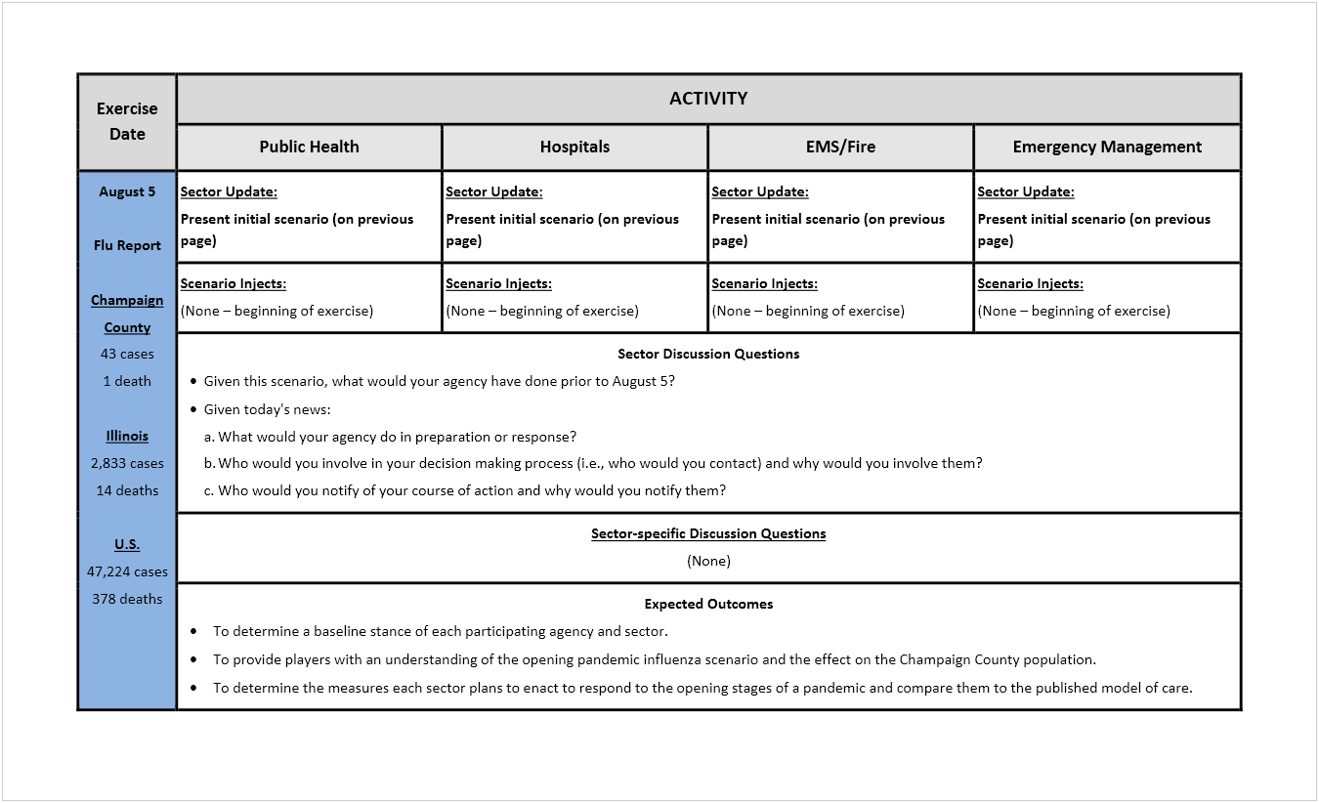
When you start your exercise, regardless of what point in an influenza pandemic the exercise scenario begins, you will need to determine a baseline stance for each participating agency/organization or sector. In other words, you will need to find out what they would have done in terms of preparation for the pandemic up to that point in time.

Compile Situation Reports
Sample Situation Report
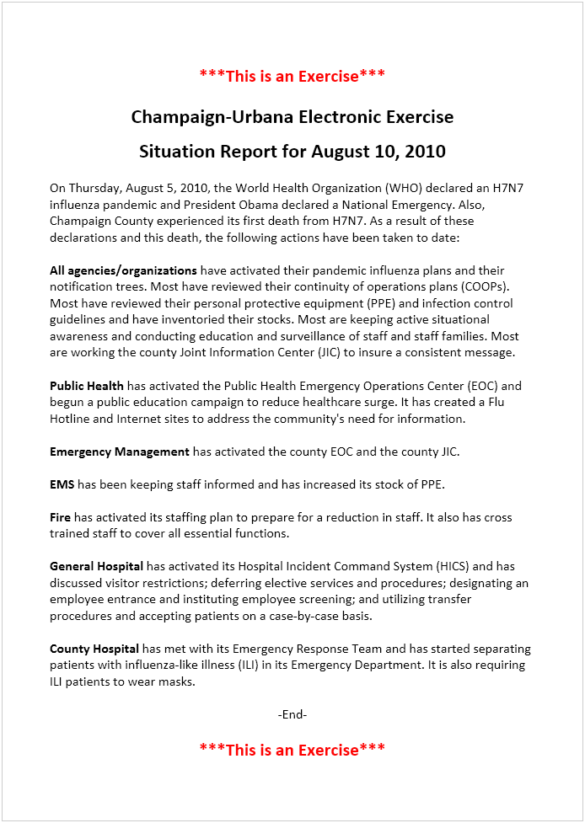
A situation report, as the name indicates, provides a report on the exercise situation at a certain point in time. Exercise situation report formats vary from jurisdiction to jurisdiction. The situation report on the right shows the format used for the Champaign-Urbana exercise. You may choose to use another format for your exercise.
Regardless of the format you use, you should make sure to include the information exercise players need in order to maintain awareness of what other agencies/organizations or sectors in the community are doing to respond to the pandemic. Having this awareness helps them in their response to the situation.
The sample situation report shown on this page was compiled from exercise player responses to the initial scenario and sector discussion questions shown on the previous pages. Although the report was compiled from responses to information disseminated on the initial exercise day (August 5), the report was disseminated to exercise players on the second exercise day (August 10) to update them on what had taken place previously. This report was disseminated along with a scenario update and injects for Day 2 of the exercise. This process was repeated for each exercise day.

Disseminate Scenario Updates and Injects
Scenario updates and injects are disseminated along with situation reports each exercise day. As was mentioned earlier, scenario updates are sent to all exercise players whereas scenario injects are agency/organization- or sector-specific, as shown on the exercise MSEL or the inject form.

The first scenario update sent out to exercise players in the Champaign-Urbana electronic exercise is shown below. It shows the spread of the influenza virus in the county, state, and United States. Note that this update also lists assumptions that are made for this exercise day. These assumptions arose from questions that exercise players had about the availability of a specific vaccine for the virus and the seasonal flu vaccine as well as questions about the virus and the county's acute flu center.

Sample Scenario Update
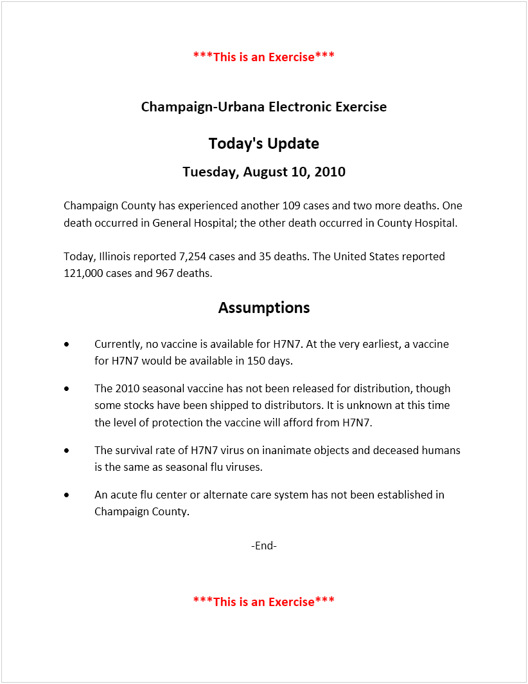

A sample scenario inject for the hospitals participating in the exercise is shown below. If you have more than one hospital in your community, as was the case in Champaign-Urbana, you might want to send the same scenario inject to each hospital to see how they differ in their responses or you might want to send different injects to each hospital to see how they might coordinate with each other. The similarities or differences between hospitals will help exercise controllers determine how best to include hospitals (or other agencies or organizations) in the exercise. A community with a pediatric hospital may review the coordination necessary to assist when general hospitals see a surge in pediatric patients.

Sample Scenario Inject
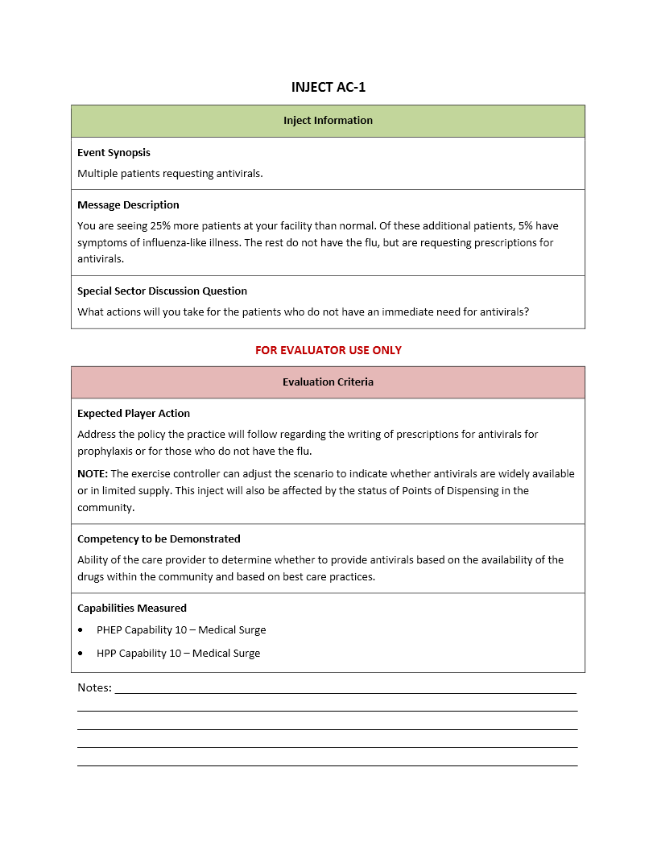

Conduct Conference Calls with Exercise Players
Rationale
Exercise controllers send exercise information to players via e-mail using the account developed for the exercise. Players reply to this e-mail and include the information requested by the controllers, but do not always include other players (outside of their agency/organization) in their response. Having exercise players communicate across all sectors via e-mail would make tracking these e-mails in order to evaluate the exercise difficult for exercise evaluators. Adding a conference call between exercise days would take the place of, or augment, this cross-sector communication.
A key observation from the Champaign-Urbana exercise was that exercise players wished they could have participated in conference calls between exercise days to question other participants about their response to a given situation. Naturally, adding these conference calls to the exercise schedule will increase the length of the exercise, but the benefits of these calls should offset the burden of the added time.
In addition to providing time for exercise players to question their peers, conducting conference calls will provide exercise controllers with an opportunity to clarify issues that have arisen with a particular agency's or organization's response to a scenario update or scenario inject. The calls also will give exercise controllers insight into the overall impact of the simulated scenario on the community and, thus, allow them to make adjustments to the scenario or scenario injects as needed.

Update Daily Situation Reports
Discussions during the conference calls between exercise days may reveal information that was not captured through the e-mail platform. Exercise controllers should document this new information for purposes of updating SITREPs and also to aid in evaluating the exercise.

Modify Scenario Updates and Injects
As noted above, discussion during conference calls with exercise players may show that exercise controllers need to modify the scenario or scenario injects. Other situations that may justify modification of the scenario or scenario injects is an obvious need to increase or decrease the impact of the influenza pandemic on exercise players. For example, the simulated scenario may not place a burden on responders. As a result, disease morbidity and mortality or staff absenteeism may need to be increased. On the other hand, if exercise players cannot manage the burden placed on them by the exercise scenario and injects, disease morbidity and mortality or staff absenteeism may need to be decreased.

Document Non-aligning Sector Responses
One purpose of exercises, regardless of the format, is to compare responses to a given situation to responses to the same situation prescribed in formal, written plans. Therefore, exercise controllers should document any responses during the course of exercises that do not align with the community's written pandemic influenza plan. This documentation will help exercise evaluators with their evaluation of the exercise.

Conduct a Post-exercise Hot Wash
A hot wash is the "after-action" discussions and evaluations of an agency's (or multiple agencies') performance following an exercise, training session, or major event. It is a term picked up in recent years by the emergency preparedness community (likely as a result of Homeland Security and other agencies' involvement in disaster planning). A hot wash serves as a form of briefing for all involved to analyze what worked well, what needs improvement, what person or agency is responsible for said improvements, and the assignments and timelines for the noted corrective and proactive improvements to be put in place.
Exercise controllers should conduct an exercise hot wash with exercise players. A face-to-face meeting is preferred because it is a more effective way to capture post-exercise information. This meeting serves as a transition to the evaluation phase as described in the text box on the next page.
Listed below are suggested agenda items for the post-exercise hot wash:
- List three strengths of the overall community response to the scenario presented during the exercise.
- List three areas for improvement in the overall community response to the scenario presented during the exercise.
- List three strengths of the e-mail format for the exercise.
- List three areas for improvement in the e-mail format of the exercise.
- Provide other remarks or comments about the exercise.

About Hot Washes*
Hot washes are important because they mark the transition from actual exercise play to the evaluation phase where lessons learned and corrective actions are documented. It is important to conduct the hot wash at the end of the exercise while all participants are still present and the day's discussions are still fresh in their minds.
The hot wash is generally the last agenda item during a tabletop exercise and occurs once the scenario and discussion questions have been thoroughly explored. The facilitator guides the hot wash and asks each participant to share his or her personal thoughts about strengths and areas for improvement that were identified. The facilitator will also ask for potential action items for the organization to implement moving forward.
A note taker from the exercise planning team should capture the insights and suggestions offered by participants during the hot wash. This information will factor into evaluation activities after the exercise and should be used to improve processes, plans, and policies, as required.
The exercise planning team can also collect written feedback from participants as part of the hot wash. One simple approach is to provide participants with a simple feedback form or blank note cards on which to document their thoughts about issues raised during the exercise and potential solutions.
*From FEMA's Homeland Security Exercise and Evaluation Program (HSEEP)

Self-Evaluation
Use the checklist below to confirm that all tasks in this section have been completed.
General
Task | Complete?
The exercise MSEL has been reviewed.
Exercise controllers have organized exercise information to get it ready to send out.

Initial Scenario
Task | Complete?
The initial exercise scenario has been e-mailed to exercise players along with sector discussion questions.
Player responses have been received.
A conference call has been conducted with exercise players to answer questions or address issues.
SITREP #1 has been compiled from player responses and conference call discussion.
Exercise Day 1
Task | Complete?
Scenario Update #1 has been e-mailed to exercise players.
SITREP #1 has been e-mailed to exercise players.
Scenario injects, sector discussion questions, and special sector discussion questions have been e-mailed to exercise players.
Player responses have been received.
A conference call has been conducted with exercise players to answer questions or address issues.
SITREP #2 has been compiled from player responses and conference call discussion.

Exercise Day 2
Task | Complete?
Scenario Update #2 has been e-mailed to exercise players.
SITREP #2 has been e-mailed to exercise players.
Scenario injects, sector discussion questions, and special sector discussion questions have been e-mailed to exercise players.
Player responses have been received.
A conference call has been conducted with exercise players to answer questions or address issues.
SITREP #3 has been compiled from player responses and conference call discussion.
Hot Wash
Task | Complete?
Last SITREP has been e-mailed to exercise players.
The exercise planning team has met with exercise players to conduct a post-exercise hot wash.
Participant feedback forms have been disseminated to all exercise players.
Each exercise player has completed a participant feedback form and returned it to the exercise controllers.

[This page is intentionally blank]

Section 5 – Evaluating an Electronic Exercise

Overview
The first page of the Tool contains a sentence stating that "the main purpose of an exercise is to evaluate a formal, written emergency response plan," which is your community's pandemic influenza response plan. You have worked through the previous four chapters to design and conduct an exercise to provide you with the information necessary to perform a thorough evaluation of this plan. This section of the Tool describes how to conduct this evaluation.
Before you begin work on this section, you need to understand that evaluating an electronic exercise differs from evaluating an in-person exercise. Below is a description of the similarities and differences.
Similarities
Exercise evaluators prepare for any exercise by first reviewing available plans that are pertinent to the exercise. They also help identify exercise goals and core capabilities, develop exercise objectives, and manage the exercise itself. Additionally, exercise evaluators put together all of the pieces of the exercise necessary to provide for a good evaluation, such as scenario updates and injects and the exercise MSEL.
Differences
During an in-person exercise, observers and evaluators can see the interplay between the participants and identify issues that may not be apparent in a written response to an inject. Moreover, the writing style/ability of a player or the unwillingness of a player to write a detailed response to scenario updates or injects may lead to misinformation, which could affect how other sectors respond. However, a benefit to an e-mail response is the evaluator has a written record of how a sector will respond to certain situations.

What This Section Covers
This section covers the five tasks required to evaluate your electronic exercise:
- Plan for exercise evaluation.
- Observe the exercise and collect data during exercise conduct.
- Analyze collected data to identify strengths and areas for improvement.
- Report exercise outcomes in a draft AAR.
- Develop an IP.

Definitions
After-action report A report compiled after an exercise to document the scope of the exercise, an analysis of observed outcomes, and recommendations for improvements in response plans.
Improvement plan A companion document to the AAR that takes the recommendations for improvement listed in the report and assigns responsibilities and timelines for completing these improvements.

How to Evaluate an Electronic Exercise

Plan for Exercise Evaluation
Evaluation planning should begin with the exercise planning and design process. For example, exercise goals, core capabilities, and exercise objectives are all evaluation tools, as is the exercise MSEL. These tools describe what you want to achieve and what you expect to occur during the exercise. Comparing what you expected to occur to what actually occurred is the basis of your exercise evaluation.
Tools that exercise evaluators can use to plan for exercise evaluation are the HSEEP exercise evaluation guides (EEGs). HSEEP notes that "EEGs help evaluators collect and interpret relevant exercise observations. EEGs provide evaluators with information on what tasks they should expect to see accomplished during an exercise, space to record observations, and questions to address after the exercise as a first step in the analysis process. In order to assist entities in exercise evaluation, standardized EEGs have been created that reflect capabilities-based planning tools. The EEGs are not meant to be report cards. Rather, they are intended to guide an evaluator's observations so that the evaluator focuses on capabilities and tasks relevant to exercise objectives to support development of the AAR/IP.",

Critical Step: Data Analysis
The goal of data analysis is to evaluate the ability of exercise participants to perform core capabilities and to determine if exercise objectives were met. During data analysis, the evaluation team consolidates the data collected during the exercise and determines whether participants performed critical tasks and met capability targets. Evaluators consider participant performance against all targets to determine the overall ability to perform core capabilities. Additionally, the evaluation team takes notes on the course of exercise play, demonstrated strengths, and areas for improvement. Data analysis provides the evaluators with not only what happened, but also why events happened.
From HSEEP 2013
HSEEP goes into more detail about exercise evaluation planning than is possible in this Tool. Your exercise evaluators should review this information prior to the conduct of your electronic exercise.

Observe the Exercise and Collect Exercise Data
This task highlights the main difference between an electronic exercise and an in-person exercise: you cannot observe exercise players in an electronic exercise. Instead, your observation will be of the written responses players provide to scenario updates and injects. However, as mentioned previously, a benefit to this type of observation is that you have a written record of exercise responses.
Exercise evaluators also will be able to note conversations between players during the scheduled conference calls between exercise days. You should make sure to document these conversations, particularly looking for issues occurring within or between sectors that indicate a gap in planning (i.e., an area for improvement).
The data should be sorted by facility (e.g., "General Hospital") and then by sector (public health, healthcare). Sorting will help exercise evaluators look at individual strengths and areas for improvement as well as collective group strengths and areas for improvement.

Analyze Exercise Data
This task highlights the value of developing sound exercise goals, identifying the right set of core capabilities, and developing good exercise objectives. If these exercise components are vague or even incorrect, then a proper exercise evaluation will not be possible.
As stated in the text box above, the goal of your analysis is to determine if players responded in the manner expected. For those areas where the response was less than expected, you should look for the cause of this less-than-satisfactory performance, which will help you to identify gaps in planning or areas for improvement. Here are some recommendations:
- Prior to the exercise, review sector plans and note where scenario updates or injects will cause exercise players to follow actions outlined in the plans.
- Note where exercise players took actions that were different than those outlined in the plans and be prepared to discuss what effect these actions had on the response.
- Identify sectors that do not have plans and track sections of the exercise where a plan may benefit the sector.
- Identify sections in the exercise where communications were conducted or were needed to help improve communication plans.
- Observe the effectiveness of the operational control by the Emergency Operations Center and other control centers.
- Determine where exercise players conducted operations that were standard across sectors and make recommendations regarding standard operating procedures.
When you have completed your analysis, your final task is to document what you have done in an AAR and then develop an IP, as described below.

Report Exercise Outcomes
HSEEP notes that "the AAR is the document that summarizes key information related to evaluation. The length, format, and development timeframe of the AAR depend on the exercise type and scope." HSEEP provides an AAR template on its website. HSEEP also provides recommendations for sharing your exercise AAR with participating agencies/organizations as well as with elected or appointed officials in your community. You should review this material and then decide the extent of your distribution of the AAR.

Develop an Improvement Plan
HSEEP recommends that representatives of the agencies/organizations participating in the exercise reach a consensus on identified strengths and areas for improvement. HSEEP also recommends that, once this consensus is reached, a set of improvements that directly address core capability gaps be developed. These improvements are documented in the exercise IP.
Your IP will document needed improvements, identify the agency with primary responsibility for making the improvement, and a timeline for completing the improvement. As with the AAR, HSEEP provides an IP template on their website and makes recommendations on sharing the IP with exercise players and community stakeholders. You should review this material and then decide the extent of your distribution of the IP.

Self-Evaluation
Use the checklist below to confirm that all tasks in this section have been completed.
Task | Complete?
Exercise evaluators have planned for exercise evaluation.
Exercise evaluators have "observed" the exercise and collected exercise data during the conduct of the exercise.
Exercise evaluators have analyzed collected data to identify strengths and areas for improvement.
Exercise evaluators have developed a draft AAR.
Exercise evaluators have developed a draft IP.

[This page is intentionally blank]

Section 6 – Conclusion

Finishing Up
Congratulations! By the time you reach this section of the Tool, you have planned for, designed, conducted, and evaluated your electronic exercise. You have identified strengths and areas for improvement. You have developed an IP to address these needed improvements. So, what is next? The overall community pandemic influenza response plan needs to be amended to incorporate the recommendations of the AAR/IP. After that, the preparedness cycle starts over.

The Preparedness Cycle
Preparedness Cycle
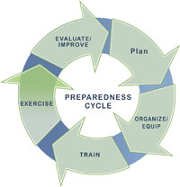
The National Incident Management System (NIMS) defines the preparedness cycle as "planning, training, equipping, exercising, evaluating, and taking action to correct and mitigate." The preparedness cycle (shown to the right) is similar to a continuous improvement cycle:
- It starts with the identification of a need for emergency preparedness and response planning.
- Once this need has been identified, plans are developed, and those entities having roles and responsibilities prescribed in the plan are organized and trained on the plan.
- When this training is complete, the plan is then exercised to evaluate not only this training, but also the effectiveness of the plan in meeting the need that was identified at the beginning of the preparedness cycle.
- After the exercise, the plan is evaluated and improved, when necessary, and the preparedness cycle starts over.

The Benefits of Exercises
The identification of strengths, areas for improvement, and corrective actions that result from exercises help organizations build capabilities as part of a larger continuous improvement process.
HSEEP 2013
By working through the Tool, you and your planning team have completed the last two components of the preparedness cycle: exercise and evaluate/improve. Now comes the time to update your community's pandemic influenza response plan, organize and train people on the contents, and then conduct another exercise. This process allows you and your planning team to improve your community's plan on a continuous basis and, more importantly, community response capabilities.

Appendix A – Situation Manual Template
<Exercise Name>
Situation Manual

Overview
Preface
The [Exercise Name] is sponsored by [Sponsor Agency]. This Situation Manual (SitMan) was produced with input, advice, and assistance from the [Exercise Name] Exercise Planning Team, which followed guidance set forth by the U.S. Department of Homeland Security (DHS) Homeland Security Exercise and Evaluation Program (HSEEP).
The [Exercise Name] SitMan provides exercise participants with all the necessary tools for their roles in the exercise. It is tangible evidence of [Jurisdiction]'s commitment to ensure public safety through collaborative partnerships that will prepare it to respond to any emergency.
The [Exercise Name] is an unclassified exercise. Control of exercise information is based on public sensitivity regarding the nature of the exercise rather than actual exercise content. Some exercise material is intended for the exclusive use of exercise planners, facilitators, and evaluators, but players may view other materials that are necessary to their performance. All exercise participants may view the SitMan.
All exercise participants should use appropriate guidelines to ensure proper control of information within their areas of expertise and protect this material in accordance with current jurisdictional directives. Public release of exercise materials to third parties is at the discretion of the [Exercise Name] Exercise Planning Team.
Handling Instructions (use items 2 and 3 only if the SitMan contains sensitive information)
- The title of this document is the [Exercise Name] Situation Manual (SitMan).
- Information gathered in this SitMan is designated as For Official Use Only (FOUO) and should be handled as sensitive information that is not to be disclosed. This document should be safeguarded, handled, transmitted, and stored in accordance with appropriate security directives. Reproduction of this document, in whole or in part, without prior approval from [Sponsor Agency] is prohibited.
- At a minimum, the attached materials will be disseminated strictly on a need-to-know basis and, when unattended, will be stored in a locked container or area that offers sufficient protection against theft, compromise, inadvertent access, and unauthorized disclosure.
- For more information about the exercise, please consult the following points of contact (POCs): (insert contact information).

Introduction
Background
(Describe the rationale for putting this exercise together to test the overall community response to an influenza pandemic.)
Purpose
The purpose of this exercise is to provide an opportunity to evaluate current response concepts, plans, and capabilities for a response to an influenza pandemic in [Jurisdiction].
Goals
The goals of this exercise are to (list the goals developed in Section 3 – Designing an Electronic Exercise).
Core Capabilities
The Federal Emergency Management Agency (FEMA) describes core capabilities as "the distinct critical elements needed to achieve the goal" of the exercise. The DHS states that core capabilities are "the activities that generally must be accomplished in incident response regardless of which levels of government are involved." The exercise planning team has determined that the following core capabilities will be tested during this exercise: (list the core capabilities identified in Section 3 – Designing an Electronic Exercise)
Exercise Objectives
FEMA notes that "an objective is a description of the performance you expect from participants to demonstrate competence." The exercise planning team has developed the following objectives for this exercise: (list the exercise objectives developed in Section 3 – Designing an Electronic Exercise).

Participants
- Players – Players respond to the situation presented, based on expert knowledge of response procedures, current plans and procedures, and insights derived from training.
- Exercise Controllers – Exercise controllers plan and manage the conduct of the exercise. They do not participate in the exercise (i.e., they are not a player).
- Exercise Evaluators – Exercise evaluators evaluate the outcome of the exercise. They do not participate in the exercise (i.e., they are not a player).
- Trusted Agents – Trusted agents are subject matter experts who help plan the exercise and are trusted not to reveal the details prior to its conduct. They do not usually participate in the exercise (i.e., they are not a player).
Participating Agencies/Organizations
(List the participating agencies/organizations by sector [e.g., public health, healthcare].)
Exercise Format
This exercise is different from the traditional in-person tabletop exercise in which you may have participated. Instead of using a facilitator to facilitate conversation, exercise controllers will use e-mail to disseminate exercise information, such as scenario updates, scenario injects, and situation reports. Exercise players will use e-mail to provide their response to these updates or injected information. Additionally, unlike a single-day exercise, this exercise will take place over the course of (insert timeframe [i.e., number of days or weeks]).
Exercise controllers have created an exercise-specific e-mail address to disseminate information to exercise players: (list the e-mail address here). Exercise controllers also have created e-mail groups for each of the participating agencies/organizations listed above. For example, the e-mail addresses for the exercise players from City Hospital (fictitious name) are listed in the City Hospital group. The e-mail addresses for the players from County Hospital (fictitious name) are listed in the County Hospital group. Exercise controllers may e-mail the same exercise information to both hospitals or they may e-mail different exercise information to each hospital.
Players from each participating agency/organization should appoint one person in their group to be the "spokesperson" for the agency/organization. That person will be responsible for providing the agency's/organization's response to the information the exercise controllers sent to them. This appointed person will respond to the exercise controllers using the exercise-specific e-mail address.
Time will be provided between exercise days for players to come together in a conference call to discuss what has occurred to date in the exercise and to allow time for players to ask questions of other players or the exercise controllers. Conference calls also will be used to address any issues that exercise controllers or players have encountered during exercise play.
An exercise hot wash will take place at the end of the exercise. The purpose of this hot wash will be to give players an opportunity to identify strengths and areas for improvement with regard to the community's preparedness for responding to an influenza pandemic. Strengths and areas for improvement with regard to the exercise format also will be discussed. This hot wash will be conducted at (list the address or provide a conference call phone number) on (insert date and time).
Attachment 3: Frequently Asked Questions on page 71 lists a set of frequently asked questions about the exercise format.
Exercise Guidelines
- This exercise will be conducted in an open, low-stress, no-fault environment. Varying viewpoints, even disagreements, are expected.
- Please respond on the basis of your knowledge of current plans and capabilities (i.e., you may use only existing assets) and insights derived from your training.
- Decisions are not precedent setting and may not reflect your agency's or organization's final position on a given issue. This exercise is an opportunity to discuss and present multiple options and possible solutions.
- Issue identification is not as valuable as suggestions and recommended actions that could improve response and preparedness efforts. Problem-solving efforts should be the focus.

Assumptions and Artificialities
In any exercise, assumptions and artificialities may be necessary to complete play in the time allotted. During this exercise, the following apply:
- The scenario is plausible, and events occur as they are presented.
- No hidden agenda and no trick questions will be a part of the exercise.
- All players will receive information at the same time.

[This page is intentionally blank]

Attachment 1: Participant List Template
Sector/Subsector | Agency/Organization | Participant Name | Title | E-mail Address
9-1-1 Call Center | To be filled in | To be filled in | To be filled in | To be filled in
Emergency Management | To be filled in | To be filled in | To be filled in | To be filled in
Emergency Medical Services (EMS)/ Fire | To be filled in | To be filled in | To be filled in | To be filled in
Hospitals | To be filled in | To be filled in | To be filled in | To be filled in
Local Government | To be filled in | To be filled in | To be filled in | To be filled in
Long-term Care/ Skilled Care/ Assisted Living | To be filled in | To be filled in | To be filled in | To be filled in
Mental Health | To be filled in | To be filled in | To be filled in | To be filled in
Fatality Management | To be filled in | To be filled in | To be filled in | To be filled in
Other Call Centers | To be filled in | To be filled in | To be filled in | To be filled in
Outpatient/ Walk-in Clinic | To be filled in | To be filled in | To be filled in | To be filled in
Pharmacy | To be filled in | To be filled in | To be filled in | To be filled in
Public Health | To be filled in | To be filled in | To be filled in | To be filled in
Schools | To be filled in | To be filled in | To be filled in | To be filled in
State Agencies/ Government | To be filled in | To be filled in | To be filled in | To be filled in
VA Health Centers | To be filled in | To be filled in | To be filled in | To be filled in

Attachment 2: Exercise Timeline Template
Exercise Item | Date and Time
Test of e-mail format | To be filled in
Pre-exercise conference call | To be filled in
Exercise Day 1 (start of exercise) | To be filled in
Day 1 Conference call | To be filled in
Exercise Day 2 | To be filled in
Day 2 Conference call | To be filled in
Exercise Day 3 | To be filled in
Day 3 Conference call | To be filled in
Exercise Day 4 | To be filled in
Day 4 Conference call | To be filled in
Exercise Day 5 | To be filled in
Day 5 Conference call | To be filled in
Exercise Day 6 | To be filled in
Day 6 Conference call | To be filled in
Exercise Day 7 | To be filled in
Day 7 Conference call | To be filled in
Exercise Day 8 | To be filled in
Day 8 Conference call | To be filled in
Exercise Day 9 | To be filled in
Day 9 Conference call | To be filled in
Exercise Day 10 | To be filled in
Day 10 Conference call | To be filled in
Exercise hot wash | To be filled in

[This page is intentionally blank]

Attachment 3: Frequently Asked Questions
How will the exercise begin?
Using an exercise-specific e-mail address, exercise controllers will e-mail an initial pandemic influenza scenario to exercise players on the first day of the exercise. This scenario will come with a set of questions to gauge each agency's/organization's response stance to the given scenario. Designated representatives from each agency/organization will e-mail their response back to the exercise controllers at the exercise-specific e-mail address.
What happens after that?
Exercise controllers will prepare a Day 1 situation report (referred to as a SITREP) that describes each agency's/organization's response stance to the initial scenario. This Day 1 SITREP will be e-mailed to exercise players prior to the Day 1 conference call. Players will discuss the Day 1 SITREP on the conference call and will ask questions of other players or exercise controllers. The Day 1 SITREP will be amended as needed based on conference call discussions. It will be e-mailed to exercise players on the second exercise day along with other exercise information.
What information do exercise controllers e-mail to players for the remaining exercise days?
Exercise controllers will e-mail scenario updates, SITREPs, and one or more scenario injects to you by 9:00 am on each exercise day. A series of questions (usually six or less) will be included for you to answer. Your agency's/organization's designated player will reply to the exercise controllers with the answers to these questions.
NOTE: If you need more time, please contact (provide a name, phone number, and e-mail address).

What is the exercise schedule?
The timeline for the exercise is shown in Attachment 2 to this SitMan. After Day 1 of the exercise, players will receive the following exercise information: scenario update, a SITREP, and a set of questions to answer for that exercise day. Some players also will receive scenario injects with accompanying questions. After all players have responded, players will participate in a conference call scheduled by the exercise team. Exercise information will be modified as needed based on this conference call and the process will be repeated for each exercise day.
What if I do not receive a scenario inject?
All participants will receive the initial scenario, scenario updates, and periodic situation reports; however, some participants may not receive injects. In these situations, we will ask the participant what role their agency or organization could play in helping other agencies or organizations respond to the given situation.
How will I be able to identify the exercise e-mail?
All e-mail sent to you for this exercise will identify the exercise and what is being sent in the subject line, such as "_____ Exercise – Initial Scenario – This is an Exercise" or "_____ Exercise – Situation Report #1/Inject #1 – This is an Exercise."
Can other people from my agency or organization participate in the exercise?
Other people who work for your agency or organization are welcome to participate in the exercise, particularly if they have roles and responsibilities prescribed in your agency's/organization's pandemic influenza response plan. You also may consult others in your agency or organization as needed, even if they do not officially participate in the exercise. However, we ask that you collaborate with your coworkers to provide a single e-mail response to scenario updates, scenario injects, and situation reports. We will let you and your coworkers decide who will provide the e-mail response.
What if I have questions or need help?
Please contact any one of the following people for questions or help with an issue involving the scenario, scenario injects, or situation reports presented to you: (list names, phone numbers, and e-mail addresses of exercise controllers and trusted agents).

Appendix B – Sample Exercise Scenario
***This is an Exercise***
Initial Scenario
History
Novel influenza A H7N7 virus originated in Canada in early July, 2010. The virus spreads in the same way that regular seasonal influenza viruses spread, mainly through the coughs and sneezes of people who are sick with the virus, but it may also be spread by touching infected objects and then touching the nose or mouth. It causes a wide range of flu-like symptoms, including fever, cough, sore throat, body aches, headache, chills, and fatigue. In some instances, it causes severe conjunctivitis.
By the middle of July, H7N7 had been transmitted to children and adults at the Neighbors Summer Camp held in New York State by infected Canadian citizens attending the camp.
On July 20, 2010, cases of H7N7 were confirmed in American children and adults who had attended the Neighbors Summer Camp. These cases were spread across Midwestern United States (U.S.), including Illinois and Indiana. Initially, three H7N7 cases (two children and one adult) were confirmed in the Chicago area, and five cases (three children and two adults) were confirmed in the east central Illinois area.
On July 28, 2010, the World Health Organization (WHO) sent out warnings to all nations that they were receiving indicators of a worldwide acceleration of an H7N7 influenza pandemic. Over the next week, influenza-like illness (ILI) cases increased rapidly, and the U.S. Department of Health and Human Services (HHS) confirmed sustained human-to-human transmission in the U.S. As a result, HHS declared a Public Health Emergency on August 2, 2010.
Over the next few days, ILI cases continued to increase rapidly worldwide. On August 5, 2010, WHO declared an H7N7 influenza pandemic. On the same day, U.S. President Obama declared a National Emergency.

Today, August 5, 2010
Today, August 5, 2010, the U.S. reports 47,224 confirmed and suspect ILI cases and 378 deaths. Illinois reports 2,833 cases and 14 deaths. Champaign County reports 43 cases and its first death.
With regard to Champaign County, one adult and one child from the northern sector of the county were exposed to H7N7 when participating in the Neighbors Summer Camp. They were among the first of the confirmed U.S. cases. The child had a history of severe asthma and was hospitalized* on July 31, moved to the intensive care unit (ICU) on August 2, and passed away today. The adult was hospitalized with severe conjunctivitis on August 1 and was released from the hospital on August 4.
Today, the Centers for Disease Control and Prevention (CDC) reports that their field teams and state and local public health departments have determined that 47 states, Guam, and the District of Columbia (DC) have reported that ILI is accelerating.
* Representatives for each hospital participating in the exercise should assume these patients were hospitalized in their facility.
Sector Discussion Questions
Given this scenario, what would your agency have done prior to August 5?
Given today's news:
- What would your agency do in preparation or response?
- Who would you involve in your decision-making process (i.e., who would you contact) and why would you involve them?
- Who would you notify of your course of action and why would you notify them?
-End-
***This is an Exercise***

Appendix C – Simple Modeling Tool

Overview
Understanding the characteristics of a pandemic influenza virus helps in understanding how a population is affected and how the various sectors and subsectors of a community's healthcare system are impacted based on the severity of the disease. Exercise planners often use models to gain this understanding. This appendix provides information on how to model the effects of an influenza pandemic on your community and its healthcare system. Also included are examples of simple models for how a pandemic might affect a community of 50,000 people. You can make adjustments to these simple models to reflect the numbers that might impact your community.

Creating a Simple Model
To help with modeling, the following characteristics can be used to determine how an influenza virus may impact a population:
- Reproductive Number (R₀) – The number of secondary cases from a single infection.
- Incubation period (IncP) – The time (in this case, days) from initial exposure to onset of symptoms.
- Infectious period (InfP) – The time (in days) that an infected person can infect others.
- Case hospitalization proportion (CHP) – The ratio of those infected who will require hospitalization.
- Mean hospitalization duration (MHD) – The average number of days that hospitalized patients will remain in a hospital.
- Case fatality rate (CFR) – The proportion of those infected who will die.
An example of how to use these characteristics when modeling a severe pandemic in your community is shown below. The following characteristics could be observed if no action is taken by the government or individuals to mitigate the disease:
R₀ | IncP | InfP | CHP | MHD | CFR
~1.8 | 1 to 2 days | ~3 days | ~5% | ~12 days | ~1.75%

Assuming you are modeling a sample of 100 people, your planning team can translate these data into more understandable numbers of how the disease may impact your community and its healthcare system:
- During the course of an illness, each victim will infect nearly two others (R₀).
- It may take 1 to 2 days for a person who is exposed to exhibit symptoms (IncP).
- An infected person can infect others for approximately 3 days, even if they do not exhibit symptoms (InfP).
- Approximately five people out of every 100 people with influenza will require hospitalization and will remain in a hospital for an average of 12 days (CHP and MHD).
- Nearly two out of every 100 people with the disease will die (CFR).
Next, you can use these characteristics to look at the impact to your community over the course of your electronic exercise, which in the example below is 10 days for a community of 50,000. On Day 1, if 10 infectious people were to come into your community, you would experience a rise in the number of people who are either infectious, hospitalized, seen by a doctor, or die as a result of influenza over the course of 10 days if no interventions are initiated. These numbers are cumulative; approximations were derived from the table above.
Status | Day 1 | Day 2 | Day 3 | Day 4 | Day 5 | Day 6 | Day 7 | Day 8 | Day 9 | Day 10
Infectious | 10 | 16 | 26 | 40 | 62 | 96 | 150 | 235 | 369 | 584
Hospitalized | 1 | 1 | 1 | 2 | 3 | 5 | 7 | 12 | 18 | 29
Seen by a doctor | 6 | 10 | 15 | 24 | 37 | 58 | 90 | 141 | 222 | 350
Die | 0 | 0 | 0 | 1 | 1 | 2 | 3 | 4 | 6 | 10
Once you have calculated these numbers, you can plug them into your master scenario events list (MSEL) (see page 27 and Appendix E on page 153) to help you and your exercise planning team design your exercise scenario (see page 24 and Appendix B on page 73) and exercise injects (see page 26 and Appendix D on page 79).

Another Option: Working with Trusted Agents to Determine Number of Patients
Though you can use a simple model to determine how many patients will present themselves at each point in your community's healthcare delivery system, you might also work with your trusted agents (see page 10) to establish the numbers of people infectious, hospitalized, seen in a clinic, or dead for your exercise scenario and injects. Please note that the numbers developed by your trusted agents should be realistic, but still large enough to cause a surge of patients that requires activation of medical surge plans across the community.

Factors to Consider When Modeling an Exercise
Regardless of whether you use simple modeling or your trusted agents to determine numbers of impacted people for your exercise scenario and injects, you should consider other factors that might influence the number of people who will present to each point in the healthcare system. These factors and their impacts are listed in Table 1 below.
Table 1. Factors to consider when modeling an exercise
Factor | Impact
How many of those feeling the onset of the illness will call an information line for advice or report to their primary care provider? | The number of people calling information lines and the number visiting primary care clinics may increase.
How many of those feeling the onset of the illness are already in the healthcare system in a long-term care or are receiving regular home health visits? | Long-term care and home health agencies may need to care for increased numbers of ill people or send them to other healthcare facilities for care.
How many who are ill do not have insurance and will report to a hospital emergency department or free clinics for care? | Those without insurance will put an extra burden on emergency departments and free clinics.
How will ill people seek care after primary care clinics are closed? | After primary clinics close, the number of people who report to a hospital ED or to urgent care centers may increase.
How many people will determine they are ill enough to need emergency care? | The number of people who call 9-1-1, need EMS assistance, and present at the hospital ED may increase.
What are the baseline numbers of those seeking care for other illnesses at each point of care? | Patients go to points of care for a variety of reasons, and those affected by the flu will add to their patient load.
How many of those who think they may have the flu or are seeking antivirals for prophylaxis will report to their pharmacist, primary care provider, urgent care center, or hospital ED? | The number of people for which these points of care will need to triage or provide some type of healthcare service may increase.
How many patients currently undergoing psychiatric treatment will require a higher level of care and how many will enter psychiatric treatment because of events related to the pandemic? | The number of people who will require mental health treatment, a higher level of care, or interventions from police and fire services may increase.
How will staff absenteeism affect various points of care in the healthcare system? | Staff absenteeism may require some points of care to close or to limit the services provided.
What certain demographics, such as children under 18, or populations with chronic diseases may be more susceptible to influenza? | The number of people who seek care for influenza may increase based on how the virus is affecting these populations.

Appendix D – Sample Scenario Injects
The scenario injects in this appendix are samples from which you may choose to use in your electronic exercise. You are not required to use them. Additionally, you may customize them to fit with your exercise scenario and local resources.
The following Standard Sector Discussion Questions can be used with each scenario inject.
Standard Sector Discussion Questions
Given today's situation report and your inject(s)
- What issues does this situation pose to your agency's response?
- How would your agency respond to this situation?
- Who would you involve in your decision-making process (i.e., who would you contact) and why would you involve them?
- Who would you notify of your course of action taken in response to the given situation and why would you notify them?
The template on the next page includes a description of the information blocks and evaluation criteria used for the scenario injects in this appendix.

INJECT NAME
Inject Information
Event Synopsis
A short description of the injected situation.
Message Description
The scenario inject that will be e-mailed to the intended player.
Special Sector Discussion Questions
A set of questions that are specific to the intended player, the sector, or the agency/organization.
FOR EVALUATOR USE ONLY
Evaluation Criteria
Expected Player Action
The expected outcome from the scenario inject (i.e., how the intended player is expected to respond).
Competency to be Demonstrated
Desired proficiency or ability to be demonstrated by the intended player.
Capabilities Measured
HPP and PHEP capabilities addressed by the scenario inject.
Scenario injects in this appendix are grouped by their suggested timing to be delivered to the intended player: Beginning of Exercise, Middle of Exercise, or End of Exercise. Then, within each grouping, scenario injects are separated by their intended player, the primary sector or agency/organization targeted to receive the scenario inject.
Secondary players, when applicable, are listed on each individual inject. Secondary players are sectors or agencies/organizations that would be notified of the injected situation by the intended player, and sectors or agencies/organizations that would assist in the response to the injected situation. Secondary players do not receive the scenario inject. They are only listed because they should be in a notification chain or called on for assistance by the intended player.

Beginning of Exercise

Intended Player: Ambulatory Care (Urgent Care Centers, Pharmacy Clinics, Private Clinics)
INJECT AC-1
Inject Information
Event Synopsis
Multiple patients requesting antivirals.
Message Description
You are seeing 25% more patients at your facility than normal. Of these additional patients, 5% have symptoms of influenza-like illness. The rest do not symptoms but are requesting prescriptions for antivirals.
Special Sector Discussion Question
What actions will you take for the patients who do not have an immediate need for antivirals?
FOR EVALUATOR USE ONLY
Evaluation Criteria
Expected Player Action
Address the policy that the practice will follow regarding the writing of prescriptions for antivirals for prophylaxis or for those who do not have the flu.
NOTE: The exercise controller can adjust the scenario to indicate whether antivirals are widely available or in limited supply. This inject will also be affected by the status of Points of Dispensing in the community.
Competency to be Demonstrated
Ability of the care provider to determine whether to provide antivirals based on the availability of the drugs within the community and based on best care practices.
Capabilities Measured
- HPP Capability 4 – Medical Surge
- PHEP Capability 10 – Medical Surge
Notes: ________________________________________________________________________
______________________________________________________________________________
INJECT AC-2
Inject Information
Event Synopsis
Increased call volume.
Message Description
Your office is receiving an increased number of calls from people wanting to know how to protect themselves from the flu and where they can get antivirals. The call volume is such that patients cannot reach your practice to make an appointment or receive information regarding prior visits.
Special Sector Discussion Questions
- What actions will you take to provide callers with the information they seek and reduce call volume or improve access to the receptionist?
- What information will your messaging include?
FOR EVALUATOR USE ONLY
Evaluation Criteria
Expected Player Action
Begin use of automated phone messaging or text messaging to patients with information regarding care instructions and locations where they can receive antivirals, if available.
Competency to be Demonstrated
Plans in place to help route calls away from the reception desk to avoid a heavy call volume.
Capabilities Measured
- HPP Capability 4 – Medical Surge
- PHEP Capability 4 – Public Information and Warning
- PHEP Capability 10 – Medical Surge
Notes: ________________________________________________________________________
________________________________________________________________________________________________________________________________________________________________________________________________________________________________________________________________________________________________________________________

INJECT AC-3
Inject Information
Event Synopsis
Providing services on weekends.
Message Description
Patient volume is such that you have to consider remaining open on weekends to care for your usual patients.
Special Sector Discussion Questions
- How will you work with staff to make it possible to remain open on weekends?
- How will you communicate the change to your patients?
FOR EVALUATOR USE ONLY
Evaluation Criteria
Expected Player Action
Review of considerations necessary to remain open on weekends to include staff issues and communicating the change to current patients.
NOTE: Include this inject only if the facility is not typically open on a weekend. Consider if the office can stay open and, if not, where they are going to send patients.
Competency to be Demonstrated
Consideration to remain open on weekends to help reduce the volume of patients at other points within the community healthcare system.
Capabilities Measured
- HPP Capability 4 – Medical Surge
- PHEP Capability 4 – Public Information and Warning
- PHEP Capability 10 – Medical Surge
Notes: ________________________________________________________________________
__________________________________________________________________________________________________________________________________________________________________________________________________________________________________________

INJECT AC-4
Inject Information
Event Synopsis
Availability of flu testing.
Message Description
Patients who come in with symptoms of influenza are anxious about catching the "incurable" version of the flu and want to be assured they do not have the novel version.
(NOTE: The rapid test is not yet available for this virus.)
Special Sector Discussion Questions
- What partners in the community can you work with to develop messages regarding testing?
- What information will you provide regarding the effectiveness of antivirals?
FOR EVALUATOR USE ONLY
Evaluation Criteria
Expected Player Action
Facility employees will develop messaging for patients informing them that a way to test for the disease is not currently available. The message should also include statements regarding the best available prophylaxis or treatment for the novel version of the flu.
Competency to be Demonstrated
Messaging to patients regarding testing and treatment.
Capabilities Measured
- HPP Capability 4 – Medical Surge
- PHEP Capability 4 – Public Information and Warning
- PHEP Capability 10 – Medical Surge
Notes: ________________________________________________________________________
______________________________________________________________________________________________________________________________________________________________________________________________________________________________________________________________________________________________________________________________________________________________________________________________________
INJECT AC-5
Inject Information
Event Synopsis
Billing staff calls in sick.
Message Description
The personnel responsible for inputting billing information to insurance companies have called in sick and will likely be out for at least a week.
Special Sector Discussion Questions
- Does your facility have someone cross-trained in coordinating payments or agreements with other facilities to assist in coordinating payments?
- Do personnel have a way to telecommute if they are not too sick?
FOR EVALUATOR USE ONLY
Evaluation Criteria
Expected Player Action
Facility management will implement a business continuity plan or develop a method to ensure patient payment methods are captured.
Competency to be Demonstrated
Ability to maintain financial viability.
Capabilities Measured
- HPP Capability 4 – Medical Surge
- PHEP Capability 10 – Medical Surge
Notes: ________________________________________________________________________
____________________________________________________________________________________________________________________________________________________________________________________________________________________________________________________________________________________________________________________________________________________________________________________________________________________________________________________________________________________

[This page is intentionally blank]

Intended Player: 9-1-1 Call Center
INJECT CC-1
Inject Information
Secondary Players
Other Call Centers (e.g., 2-1-1 and nurse triage lines).
Event Synopsis
Increase in non-emergency calls.
Message Description
Your call volume has increased by 100% with most of the increase due to callers who want to get antivirals or report that their neighbor has "the killer flu".
Special Sector Discussion Questions
- What procedures do you have for increasing staff and call lines?
- How do you provide information to those who do not have an emergency but simply want information?
FOR EVALUATOR USE ONLY
Evaluation Criteria
Expected Player Action
Describe procedures in place to add lines or redirect calls to other call centers.
NOTE: Redirecting calls is only possible if the other call centers are not also experiencing a high call volume.
Competency to be Demonstrated
Ability to adjust for an increased volume of both emergency and non-emergency calls.
Capabilities Measured
- HPP Capability 2 – Develop and Coordinate Health Care Organization and Health Care Coalition Response Plans
- HPP Capability 4 – Medical Surge
- PHEP Capability 3 – Emergency Operations Coordination
- PHEP Capability 6 –Information Sharing
- PHEP Capability 10 – Medical Surge

INJECT CC-2
Inject Information
Secondary Players
Emergency medical Services (EMS), Mental Health, Faith-Based Organizations, & Other Call Centers (e.g., 2-1-1 and nurse triage lines).
Event Synopsis
Increase in non-emergency calls.
Message Description
For 3 days your center has received multiple calls from a man stating that he is dying from the flu. EMS has transported him on 3 occasions. The hospital staff has determined he is not ill and not in need of treatment and has released him. He has called again, saying that he is "really dying this time."
Special Sector Discussion Question
How do you handle frequent callers such as this person, especially in this time when the call volume is very high?
FOR EVALUATOR USE ONLY
Evaluation Criteria
Expected Player Action
Make a determination on whether the protocol followed requires the operator to pass the call on to EMS.
Competency to be Demonstrated
Flexible protocols to use that will prioritize limited assets during a severe pandemic.
Capabilities Measured
- HPP Capability 4 – Medical Surge
- PHEP Capability 10 – Medical Surge
Notes: ________________________________________________________________________
________________________________________________________________________________________________________________________________________________________________________________________________________________________________________________________________________________________________________________________
INJECT CC-3
Inject Information
Secondary Players
EMS and Law Enforcement.
Event Synopsis
Critically ill care-taker.
Message Description
You receive a call from a young child who says that her father has been sleeping all day and will not get up. She also says that her baby brother has been crying a lot. She states that the three of them are the only ones in the house and their neighbors live far away.
Special Sector Discussion Questions
- How do you manage this caller?
- Is your protocol different because you are dealing with a child?
- What actions do you take to assist her and her father?
FOR EVALUATOR USE ONLY
Evaluation Criteria
Expected Player Action
Call local police or fire as well as child services.
Competency to be Demonstrated
Protocols and contacts in place to handle situations such as this one.
Capabilities Measured
- HPP Capability 4 – Medical Surge
- PHEP Capability 10 – Medical Surge
Notes: ________________________________________________________________________
__________________________________________________________________________________________________________________________________________________________________________________________________________________________________________

[This page is intentionally blank]

Intended Player: Emergency Management
INJECT EM-1
Inject Information
Secondary Players
Fatality Management and Law Enforcement.
Event Synopsis
Cold storage for fatalities.
Message Description
The county coroner/medical examiner has contacted the emergency operations center and requested three refrigerator trucks to be delivered as soon as possible for storage of remains.
Special Sector Discussion Question
How do you arrange for cataloging the remains and providing security and backup power for the refrigerator trucks?
FOR EVALUATOR USE ONLY
Evaluation Criteria
Expected Player Action
The EOC will coordinate with the coroner/medical examiner to determine the exact requirements.
NOTE: Coordinate this inject with the trusted agent for this sector to ensure the community plan does not have some other method for storing an overflow of fatalities.
Competency to be Demonstrated
Coordination of fatality management operations.
Capabilities Measured
- HPP Capability 4 – Medical Surge
- PHEP Capability 5 – Fatality Management
- PHEP Capability 10 – Medical Surge
Notes: ________________________________________________________________________
______________________________________________________________________________

INJECT EM-2
Inject Information
Secondary Players
Public Health and Local Government.
Event Synopsis
Large community event.
Message Description
A local entertainment venue has a concert scheduled for the weekend that is expected to have 1,000 in attendance. The coordinators of the event want to ensure the concert will be allowed to continue.
Special Sector Discussion Question
What methods are in place to educate and engage local leaders with regard to situations like this one?
FOR EVALUATOR USE ONLY
Evaluation Criteria
Expected Player Action
The player will coordinate with public health and community leaders to determine what action they recommend. Additionally, this situation may involve input from the legal office.
Competency to be Demonstrated
Ability of EOC to coordinate issues regarding social distancing.
Capabilities Measured
- HPP Capability 2 – Health Care and Medical Response Coordination
- PHEP Capability 3 – Emergency Operations Coordination
- PHEP Capability 11 – Non-Pharmaceutical Interventions
Notes: ________________________________________________________________________
________________________________________________________________________________________________________________________________________________________________________________________________________________________________________________________________________________________________________________________
INJECT EM-3
Inject Information
Secondary Players
Local Government and Call Centers.
Event Synopsis
Increase in calls regarding community events.
Message Description
Citizens are calling city hall and other government offices to find out about cancelled events, rescheduling court cases, and what the government is doing to get them medicines to fight the flu. Roughly 20% of these callers state they do not have access to the Internet.
Special Sector Discussion Question
How are decisions made in collaboration with local government and public health advisors?
FOR EVALUATOR USE ONLY
Evaluation Criteria
Expected Player Action
Review the policies for communicating with the public and with community partners.
Competency to be Demonstrated
Plan to coordinate communications between partners.
Capabilities Measured
- HPP Capability 2 – Health Care and Medical Response Coordination
- HPP Capability 4 – Medical Surge
- PHEP Capability 3 – Emergency Operations Coordination
- PHEP Capability 4 –Emergency Public Information and Warning
- PHEP Capability 6 – Information Sharing
- PHEP Capability 10 – Medical Surge
Notes: ________________________________________________________________________

[This page is intentionally blank]

Intended Player: Emergency Medical Services/Fire
INJECT EMS-1
Inject Information
Secondary Players
Public Health.
Event Synopsis
Employee request for prophylaxis.
Message Description
Emergency medical services (EMS) and Fire department personnel request antivirals for prophylaxis if they are going to be required to respond to calls from people with the flu.
Special Sector Discussion Questions
- What community partners will you work with to help leaders determine if they will support this action?
- What issues are involved in providing antivirals to private EMS agencies?
FOR EVALUATOR USE ONLY
Evaluation Criteria
Expected Player Action
EMS players should determine if they can legally provide antivirals to their employees. They also should discuss with their partners how to support this action and what effect it will have on those sectors not receiving prophylaxis.
Competency to be Demonstrated
Plans regarding prophylaxis or acknowledgement of the various issues in deciding to issue antivirals for prophylaxis.
Capabilities Measured
- HPP Capability 4 – Medical Surge
- PHEP Capability 14 – Responder Safety and Health
Notes: ________________________________________________________________________
______________________________________________________________________________

INJECT EMS-2
Inject Information
Secondary Players
Hospitals.
Event Synopsis
Care and transport of multiple pediatric patients.
Message Description
Emergency medical services (EMS) receives two unrelated calls from different locations in a short time frame, both requesting care and transport of a total of five pediatric patients at each location. All patients are seriously ill.
Special Sector Discussion Question
What information is shared with partners in the community regarding the ability and capacity to care for pediatric patients?
FOR EVALUATOR USE ONLY
Evaluation Criteria
Expected Player Action
The EMS company will review the assets best able to transport pediatric patients. If none are available, they will determine the best way to care for and transport the patients. This situation may involve coordination with pediatric hospitals in the area.
Competency to be Demonstrated
Ability to provide care for pediatric patients during a surge.
Capabilities Measured
- HPP Capability 4 – Medical Surge
- PHEP Capability 10 – Medical Surge
Notes: ________________________________________________________________________
________________________________________________________________________________________________________________________________________________________________________________________________________________________________________________________________________________________________________________________

INJECT EMS-3
Inject Information
Secondary Players
Law Enforcement, Hospitals, and EOC.
Event Synopsis
Transport of prisoners.
Message Description
Emergency medical services (EMS) receives a call from the county jail requesting the transportation of three very ill prisoners to the hospital emergency department. These prisoners are all considered to be a flight risk.
Special Sector Discussion Questions
- What measures are taken to protect EMS employees while transporting prisoners?
- With which partners in the community will you coordinate?
FOR EVALUATOR USE ONLY
Evaluation Criteria
Expected Player Action
Coordinate for as many vehicles as needed to transport the patients and any security that may be necessary.
Competency to be Demonstrated
Ability to coordinate with outside agencies to provide care for prisoners.
Capabilities Measured
- HPP Capability 2 – Health Care and Medical Response Coordination
- HPP Capability 4 – Medical Surge
- PHEP Capability 3 – Emergency Operations Coordination
- PHEP Capability 10 – Medical Surge
- PHEP Capability 14 – Responder Safety and Health
Notes: ________________________________________________________________________

INJECT EMS-4
Inject Information
Secondary Players
Local Government, State Government, and Call Centers.
Event Synopsis
Non-emergency calls and treatment at the location.
Message Description
Emergency medical services (EMS) staff report a rise in the number of patients who do not have life-threatening emergencies, but insist upon being transported to the emergency department. Your transport resources are at near capacity. The staff has requested guidance on whether they can treat the patient at the location rather than transport to a hospital.
Special Sector Discussion Questions
- What partners are involved in making these decisions?
- How are these decisions communicated to partners and the public?
FOR EVALUATOR USE ONLY
Evaluation Criteria
Expected Player Action
The player will review policies regarding treatment of patients at a location by the EMS crew and legalities regarding refusal to transport. The decisions will be communicated as necessary.
Competency to be Demonstrated
Ability to adjust protocols to provide appropriate care at an appropriate location.
Capabilities Measured
- HPP Capability 2 – Health Care and Medical Response Coordination
- HPP Capability 4 – Medical Surge
- PHEP Capability 3 – Emergency Operations Coordination
- PHEP Capability 10 – Medical Surge
Notes: ________________________________________________________________________

INJECT EMS-5
Inject Information
Secondary Players
EOC.
Event Synopsis
Transportation of morbidly obese patient.
Message Description
An EMS crew receives a call and, when arriving at the location, finds a patient who has a life-threatening emergency and who weighs in excess of 700 pounds. The crew does not believe they can get the patient out the door of the apartment because of the patient's size and weight.
Special Sector Discussion Questions
- What partners in the community will you coordinate with to get the patient transported?
- What legal issues result if you have to cause damage to the residence?
FOR EVALUATOR USE ONLY
Evaluation Criteria
Expected Player Action
Coordinate for assistance from other services (fire/police) to extricate the patient and determine how Emergency medical services (EMS) will transport the patient (a special vehicle may be needed).
Competency to be Demonstrated
Ability to coordinate for assistance and make decisions regarding the transport of patients requiring special considerations.
Capabilities Measured
- HPP Capability 2 – Health Care and Medical Response Coordination
- HPP Capability 4 – Medical Surge
- PHEP Capability 3 – Emergency Operations Coordination
- PHEP Capability 10 – Medical Surge
Notes: ________________________________________________________________________

[This page is intentionally blank]

Intended Player: Hospitals
INJECT Hospitals-1
Inject Information
Secondary Players
EOC, JIC, Call Centers, and Public Health.
Event Synopsis
Increase in non-ill patients reporting to the emergency department.
Message Description
After the first flu death in your community, the number of people reporting to the emergency department wanting drugs to stop what they call "The Killer Flu" increases by 10%.
Special Sector Discussion Question
What partners will you work with to help decrease the number of people coming to the emergency department seeking antivirals?
FOR EVALUATOR USE ONLY
Evaluation Criteria
Expected Player Action
Coordinate with public health and the Joint Information Center to ensure information on the disease and methods of care are disseminated to the public.
Competency to be Demonstrated
Ability of partners to work together to develop solutions to route the public to the appropriate level of care.
Capabilities Measured
- HPP Capability 2 – Health Care and Medical Response Coordination
- HPP Capability 4 – Medical Surge
- PHEP Capability 3 – Emergency Operations Coordination
- PHEP Capability 4 – Emergency Public Information and Warning
- PHEP Capability 6 – Information Sharing
- PHEP Capability 10 – Medical Surge

INJECT Hospitals-2
Inject Information
Secondary Players
Public Health and Local Government.
Event Synopsis
Cluster of pediatric patients.
Message Description
The personnel in the emergency department report a sudden increase in the number of pediatric patients ranging in age from 1 to 4 admitted with the flu. According to parents, most of the children being seen attend the Happy Times and Tiny Toddler's Day Care facility.
Special Sector Discussion Question
What partners in the community will you notify regarding this potential cluster of patients and what information can you provide?
FOR EVALUATOR USE ONLY
Evaluation Criteria
Expected Player Action
Report the cluster of cases from the day care facility to public health authorities. This action may lead to a discussion with local leaders regarding the possibility of closing the facility and the facility's responsibility to notify parents of the increased illness.
Competency to be Demonstrated
Ability to report pertinent health surveillance data to the appropriate agency.
Capabilities Measured
- HPP Capability 4 – Medical Surge
- PHEP Capability 6 – Information Sharing
- PHEP Capability 10 – Medical Surge
Notes: ________________________________________________________________________

INJECT Hospitals-3
Inject Information
Secondary Players
Law Enforcement and EMS.
Event Synopsis
Patients with multiple types of infectious diseases.
Message Description
The county jail called and is bringing in two inmates who have multidrug-resistant tuberculosis (MDR-TB) for treatment. Upon examination, one must be admitted to the Intensive Care Unit (ICU) and the other inmate must be admitted to the general ward.
Special Sector Discussion Question
How will your facility manage these patients given the special circumstances and the already increased volume of patients in the hospital?
FOR EVALUATOR USE ONLY
Evaluation Criteria
Expected Player Action
Identify considerations necessary for incorporating these infectious patients into the ICU and general ward.
Competency to be Demonstrated
Ability to consider special circumstances in the midst of a surge of patients within the hospital.
Capabilities Measured
- HPP Capability 4 – Medical Surge
- PHEP Capability 10 – Medical Surge
Notes: ________________________________________________________________________
________________________________________________________________________________________________________________________________________________________________________________________________________________________________________________________________________________________________________________________

INJECT Hospitals-4
Inject Information
Secondary Players
Fatality Management, JIC, Law Enforcement, and Mental Health.
Event Synopsis
Patient dies in the Emergency Department waiting room.
Message Description
With the wait times increasing in the emergency department, a patient who did not seem terribly ill when he went through triage dies while sitting in the waiting room. He came in alone and his death is discovered by a fellow patient in the waiting room. All in the room awaiting treatment become quite agitated when one person states that the deceased had the "Killer Virus".
Special Sector Discussion Question
What procedures are in place to review the cause of death in this case and to provide physical and mental health care to the other patients in the waiting room?
FOR EVALUATOR USE ONLY
Evaluation Criteria
Expected Player Action
Describe the current or recommended procedures for handling a situation such as this one. These procedures may include a complete review of the care provided before the event and a review of video records.
Competency to be Demonstrated
Ability to respond to different situations within the hospital.
Capabilities Measured
- HPP Capability 4 – Medical Surge
- PHEP Capability 5 – Fatality Management
- PHEP Capability 10 – Medical Surge
Notes: ________________________________________________________________________

INJECT Hospitals-5
Inject Information
Secondary Players
EMS.
Event Synopsis
Patients from a vehicle accident.
Message Description
You receive five patients in critical condition from a vehicle accident. They have multiple lacerations and two have spinal cord injuries and crushed ribs. The spinal cord injuries will require surgery and Intensive Care Unit (ICU) beds; the three others will require emergency care before being released.
Special Sector Discussion Questions
- What procedures are in place to rapidly triage these patients versus flu patients?
- What considerations, if any, will personnel take to segregate flu or non-flu patients?
- Which patients will you segregate? Flu or non-flu?
FOR EVALUATOR USE ONLY
Evaluation Criteria
Expected Player Action
Describe the various procedures in place.
Competency to be Demonstrated
Ability to differentiate non-flu patients from flu patients during medical surge.
Capabilities Measured
- HPP Capability 4 – Medical Surge
- PHEP Capability 10 – Medical Surge
Notes: ________________________________________________________________________
________________________________________________________________________________________________________________________________________________________________________________________________________________________________________________________________________________________________________________________

[This page is intentionally blank]

Intended Player: Public Health
INJECT PH-1
Inject Information
Secondary Players
JIC.
Event Synopsis
Communication with the public.
Message Description
Community citizens are questioning how they will know if their neighbor is a carrier of the "Killer Virus."
Special Sector Discussion Question
How will you communicate relevant information about the disease to the public, including those who have limited English proficiency or no access to the Internet?
FOR EVALUATOR USE ONLY
Evaluation Criteria
Expected Player Action
Coordinate with the JIC to develop or implement the communication plan.
Competency to be Demonstrated
Ability to disseminate information to the public.
Capabilities Measured
- HPP Capability 2 – Health Care and Medical Response Coordination
- HPP Capability 4 – Medical Surge
- PHEP Capability 4 – Emergency Public Information and Warning
- PHEP Capability 6 – Information Sharing
- PHEP Capability 10 – Medical Surge
Notes: ________________________________________________________________________
INJECT PH-2
Inject Information
Secondary Players
EOC, Hospitals, Clinics, and Ambulatory Care.
Event Synopsis
Increased disease surveillance.
Message Description
Officials at the state health department want to expand the information received regarding how many cases of the flu are identified each week. They want to determine what capability exists at clinics and private care providers to test for this particular strain of the flu and what mechanisms health departments have to collect data on how many cases are discovered each week.
Special Sector Discussion Question
Is this information you can routinely ask your partners for and what mechanisms might you put in place to collect it?
FOR EVALUATOR USE ONLY
Evaluation Criteria
Expected Player Action
Review laboratory capabilities of clinics and private care providers and determine methods in which to share data.
Competency to be Demonstrated
Ability to identify issues related to flu strain testing and information sharing.
Capabilities Measured
- HPP Capability 2 – Health Care and Medical Response Coordination
- HPP Capability 4 – Medical Surge
- PHEP Capability 3 – Emergency Operations
- PHEP Capability 6 – Information Sharing
- PHEP Capability 10 – Medical Surge
- PHEP Capability 12 – Public Health Laboratory Testing
Notes: ________________________________________________________________________
INJECT PH-3
Inject Information
Secondary Players
EOC, Hospitals, and Clinics.
Event Synopsis
Distribution of antivirals.
Message Description
The first allocation of antiviral medication from the state has arrived and your department has 10,000 doses.
Special Sector Discussion Question
How will you prioritize these antiviral stocks for distribution and delivery?
FOR EVALUATOR USE ONLY
Evaluation Criteria
Expected Player Action
Discuss the distribution plan with partners.
Competency to be Demonstrated
Ability to coordinate the receipt and distribution of antivirals.
Capabilities Measured
- HPP Capability 2 – Health Care and Medical Response Coordination
- HPP Capability 4 – Medical Surge
- PHEP Capability 3 – Emergency Operations
- PHEP Capability 8 – Medical Countermeasure Dispensing
- PHEP Capability 9 – Medical Materiel Management and Distribution
- PHEP Capability 10 – Medical Surge
Notes: ________________________________________________________________________
____________________________________________________________________________________________________________________________________________________________

INJECT PH-4
Inject Information
Secondary Players
Social Services and Hospital.
Event Synopsis
Homeless family ill with the flu.
Message Description
Staff report to work and find a homeless family (1 adult and 2 children) at the front door of the health department. The two children are obviously suffering from influenza like illness and in need of emergency care.
Special Sector Discussion Questions
- Who will you call to coordinate care for the sick children?
- Who will you coordinate with to ensure the family has a place to stay until the children recover?
FOR EVALUATOR USE ONLY
Evaluation Criteria
Expected Player Action
Since the children are in need of emergency care, the staff likely will coordinate with EMS and discuss with social services how to provide a place to stay when the children have received care.
NOTE: If the public health department has a clinic, this inject could be modified to describe children who are less ill in which case the clinic would provide care and social services would be contacted to provide a place to stay.
Competency to be Demonstrated
Ability to provide care and services for special populations.
Capabilities Measured
- HPP Capability 2 – Healthcare and Medical Response Coordination
- HPP Capability 4 – Medical Surge
- PHEP Capability 1 – Community Preparedness
- PHEP Capability 3 – Emergency Operations Coordination
- PHEP Capability 10 –Medical Surge

INJECT PH-5
Inject Information
Secondary Players
Animal Control and Local and State Government (e.g., Department of Agriculture).
Event Synopsis
Unexplained animal deaths.
Message Description
A woman calls the department of health and states that she is trying to take care of her brother's chicken farm while he is in the hospital with the flu. She has noticed that a lot of chickens are dying and she does not know enough about chicken farming to understand why.
Special Sector Discussion Question
Who would the health department coordinate with to investigate this situation?
FOR EVALUATOR USE ONLY
Evaluation Criteria
Expected Player Action
Coordinate with local animal control to investigate the situation at the farm and, if local animal control does not have the capability to test the animals, coordinate with the state department of agriculture.
Competency to be Demonstrated
Ability to coordinate with outside agencies to identify issues that may impact human health.
Capabilities Measured
- HPP Capability 2 – Health Care and Medical Response Coordination
- PHEP Capability 3 – Emergency Operations
- PHEP Capability 6 – Information Sharing
- PHEP Capability 13 – Public Health Surveillance and Epidemiological Investigation
Notes: ________________________________________________________________________
______________________________________________________________________________
INJECT PH-6
Inject Information
Secondary Players
Hospitals, EOC, JIC, and State Government.
Event Synopsis
Approval of 1135 waivers.
Message Description
The Health and Human Services Secretary has waived or modified requirements under section 1135 of the Social Security Act. The waiver is similar to the one given for a previous influenza pandemic (H1N1) in 2009.
Special Sector Discussion Question
How can this waiver effect how care is delivered in the community and how does public health work with hospitals to submit plans for the waivers?
FOR EVALUATOR USE ONLY
Evaluation Criteria
Expected Player Action
Coordinate with community hospitals to determine the need and the process for requesting 1135 waivers in the community.
Competency to be Demonstrated
Ability to implement alternate care systems to expand points of care within the community.
Capabilities Measured
- HPP Capability 2 – Health Care and Medical Response Coordination
- HPP Capability 4 – Medical Surge
- PHEP Capability 3 – Emergency Operations
- PHEP Capability 6 – Information Sharing
- PHEP Capability 10 – Medical Surge

INJECT PH-7
Inject Information
Secondary Players
Clinics, Hospitals, and Call Centers.
Event Synopsis
Food Poisoning.
Message Description
A local call center is receiving a high volume of calls. Interspersed with flu-related calls are people reporting symptoms that may indicate they have food poisoning.
Special Sector Discussion Question
Are the personnel in your office cross-trained to investigate different outbreaks when other personnel are out sick?
FOR EVALUATOR USE ONLY
Evaluation Criteria
Expected Player Action
Implement the protocols for investigating foodborne outbreaks and ensure personnel are available to conduct the investigation.
Competency to be Demonstrated
Ability to prioritize missions and staff.
Capabilities Measured
- HPP Capability 2 – Health Care and Medical Response Coordination
- PHEP Capability 6 – Information Sharing
- PHEP Capability 13 – Public Health Surveillance and Epidemiological Investigation
Notes: ________________________________________________________________________
__________________________________________________________________________________________________________________________________________________________________________________________________________________________________________

[This page is intentionally blank]

Intended Player: Skilled Nursing Facilities
INJECT SNF-1
Inject Information
Event Synopsis
Visitation policies.
Message Description
Family members are calling and demanding to know what you are doing about stopping sick people from bringing the flu into your facility.
Special Sector Discussion Question
What actions will you take to ensure the staff does not come to work with the flu?
FOR EVALUATOR USE ONLY
Evaluation Criteria
Expected Player Action
Address any changes to visitation and staff policies and ensure these changes are communicated to staff, families, and visitors.
Competency to be Demonstrated
Ability to make changes to policy that improves social distancing.
Capabilities Measured
- HPP Capability 2 – Health Care and Medical Response Coordination
- PHEP Capability 6 – Information Sharing
- PHEP Capability 11 – Non-Pharmaceutical Interventions
Notes: ________________________________________________________________________
____________________________________________________________________________________________________________________________________________________________________________________________________________________________________________________________________________________________________________________________________________________________________________________________________________________________________________________________________________________

INJECT SNF-2
Inject Information
Secondary Players
Public health and hospitals.
Event Synopsis
First cases among resident populations.
Message Description
You see the first two patients with symptoms of an influenza-like illness. When examined by a medical doctor they are both diagnosed with the new strain of flu and prescribed antivirals.
Special Sector Discussion Question
What actions will you take to protect other residents and staff?
FOR EVALUATOR USE ONLY
Evaluation Criteria
Expected Player Action
Provide a summary of policies or procedures the staff will enact to improve infection control procedures.
Competency to be Demonstrated
Understand and implement infection control procedures in the facility.
Capabilities Measured
- HPP Capability 4 – Medical Surge
- PHEP Capability 6 – Information Sharing
- PHEP Capability 10 – Medical Surge
Notes: ________________________________________________________________________
__________________________________________________________________________________________________________________________________________________________________________________________________________________________________________

INJECT SNF-3
Inject Information
Event Synopsis
Multiple patients contracting the flu.
Message Description
Despite best efforts, over 50% of the residents have been diagnosed with the new strain of the flu. The staff report they are having difficulty providing care for all those who need special attention.
Special Sector Discussion Questions
- What measures can you take to increase available staff?
- Can you use nonmedical staff or family members to perform functions that do not require medical training?
FOR EVALUATOR USE ONLY
Evaluation Criteria
Expected Player Action
Address the policy and procedures for increasing staff and allowing volunteers to provide some services.
Competency to be Demonstrated
Ability to adjust staffing to meet the demands of the emergency.
Capabilities Measured
- HPP Capability 4 – Medical Surge
- PHEP Capability 6 – Information Sharing
- PHEP Capability 10 – Medical Surge
Notes: ________________________________________________________________________
______________________________________________________________________________________________________________________________________________________________________________________________________________________________________________________________________________________________________________________________________________________________________________________________________
INJECT SNF-4
Inject Information
Secondary Players
Fatality Management.
Event Synopsis
Inability of the coroner/medical examiner to transport patient remains.
Message Description
Two residents of your facility have passed away during the night. The coroner/medical examiner stated that he/she does not have the capability to transport the remains for at least 24 hours.
Special Sector Discussion Question
What special considerations would you take to care for the remains and ensure the remaining residents are not adversely affected by your decisions?
FOR EVALUATOR USE ONLY
Evaluation Criteria
Expected Player Action
Describe measures the staff will take to isolate the remains until the coroner can send a team. Also describe measures the staff takes to interact with other residents.
Competency to be Demonstrated
Ability to handle and store fatalities when pick-up is not immediately available.
Capabilities Measured
- HPP Capability 4 – Medical Surge
- PHEP Capability 5 – Fatality Management
Notes: ________________________________________________________________________
______________________________________________________________________________________________________________________________________________________________________________________________________________________________________________________________________________________________________________________________________________________________________________________________________

Intended Player: Colleges/Universities
INJECT CU-1
Inject Information
Event Synopsis
Outbreak in dormitory.
Message Description
Over 25% of the population in one dormitory is exhibiting symptoms of an influenza-like illness. Roughly 20% of these students are too sick to make it to the dining hall for meals.
Special Sector Discussion Questions
- What systems or plans does your organization have to check on students in the dormitories and provide any assistance they may require?
- Are plans in place for what to do during an infectious disease outbreak?
FOR EVALUATOR USE ONLY
Evaluation Criteria
Expected Player Action
Provide details on plans for responding to infectious disease outbreaks in school facilities and provide recommended methods for assisting sick students.
Competency to be Demonstrated
Ability to develop methods to care for the student population.
Capabilities Measured
- HPP Capability 4 – Medical Surge
- PHEP Capability 7 – Mass Care
- PHEP Capability 10 – Medical Surge
Notes: ________________________________________________________________________
__________________________________________________________________________________________________________________________________________________________________________________________________________________________________________

INJECT CU-2
Inject Information
Event Synopsis
Significant staff and student absenteeism.
Message Description
Personnel reports indicate that 25% of the faculty and nearly 30% of students are out sick. Complaints are also coming in from students who state their professors are sick and still holding class. Some students and parents are asking if the school will close and if they will get the money back for tuition.
Special Sector Discussion Question
What actions will you take to communicate decisions to staff, students, and parents?
FOR EVALUATOR USE ONLY
Evaluation Criteria
Expected Player Action
Outline policies and procedures the organization would likely follow in this situation and how they would communicate to stakeholders.
Competency to be Demonstrated
Ability to make decisions to reduce the number of personnel exposed to the flu.
Capabilities Measured
- HPP Capability 2 – Health Care and Medical Response Coordination
- PHEP Capability 6 – Information Sharing
- PHEP Capability 11 – Non-Pharmaceutical Interventions
Notes: ________________________________________________________________________
____________________________________________________________________________________________________________________________________________________________________________________________________________________________________________________________________________________________________________________________________________________________________________________________________________________________________________________________________________________

Intended Player: Local and State Government
INJECT Gov-1
Inject Information
Event Synopsis
Volunteers calling to help.
Message Description
Volunteers are calling local offices wanting to help those affected by the flu or help staff offices to replace sick people.
Special Sector Discussion Questions
- What measures are in place to coordinate volunteers?
- What agency is responsible for vetting volunteers who might work with children or in sensitive areas?
FOR EVALUATOR USE ONLY
Evaluation Criteria
Expected Player Action
Address the measures in place to coordinate volunteers, which may include coordination with the emergency operations center. The measures to vet volunteers also will be identified.
Competency to be Demonstrated
Ability of the government to coordinate volunteer services and support the vetting of volunteers.
Capabilities Measured
- HPP Capability 3 – Health Care and Medical Response Coordination
- PHEP Capability 3 – Emergency Operations Coordination
- PHEP Capability 15 – Volunteer Management
Notes: ________________________________________________________________________
__________________________________________________________________________________________________________________________________________________________________________________________________________________________________________

[This page is intentionally blank]

Intended Player: Mental Health
INJECT MH-1
Inject Information
Event Synopsis
Available mental health assets.
Message Description
As the threat of a serious pandemic looms, the emergency operations center director requests a list of what mental health assets can be mobilized to help with grief and stress counseling.
Special Sector Discussion Question
What partners in the community can help provide services on a volunteer basis?
FOR EVALUATOR USE ONLY
Evaluation Criteria
Expected Player Action
Provide to other sectors a list of the assets available during a pandemic response.
Competency to be Demonstrated
Provide mental health services during a disaster.
Capabilities Measured
- HPP Capability 4 – Medical Surge
- PHEP Capability 10 – Medical Surge
Notes: ________________________________________________________________________
____________________________________________________________________________________________________________________________________________________________________________________________________________________________________________________________________________________________________________________________________________________________________________________________________________________________________________________________________________________

[This page is intentionally blank]

Intended Player: Fatality Management
INJECT FM-1
Inject Information
Secondary Players
Emergency Management.
Event Synopsis
Fire in decedent storage area.
Message Description
A fire in the area where the deceased are stored has caused this area to be unusable for several weeks.
Special Sector Discussion Question
What public relations issues do you foresee when you implement your alternate plan for storing the deceased?
FOR EVALUATOR USE ONLY
Evaluation Criteria
Expected Player Action
The player will begin coordination for other resources to store the deceased and will have to communicate with partners to inform them of a delay in handling the deceased.
Competency to be Demonstrated
Ability to retain or regain business continuity.
Capabilities Measured
- HPP Capability 4 – Medical Surge
- PHEP Capability 5 – Fatality Management
Notes: ________________________________________________________________________
__________________________________________________________________________________________________________________________________________________________________________________________________________________________________________

[This page is intentionally blank]

Intended Player: Pharmacy
INJECT Rx-1
Inject Information
Secondary Players
Public Health.
Event Synopsis
Shortage of vaccine.
Message Description
The demand for the flu vaccine has far exceeded the supply and distributors have identified that they are also seeing a reduction in the supply.
Special Sector Discussion Question
How will you communicate decisions to the public?
FOR EVALUATOR USE ONLY
Evaluation Criteria
Expected Player Action
Engage organization leadership, public health, joint information center, and local leaders in developing a prioritized list of who to vaccinate. The decisions then would be crafted into a communications message.
Competency to be Demonstrated
Ability to prioritize the population who will receive this limited resource.
Capabilities Measured
- HPP Capability 2 – Health Care and Medical Response Coordination
- PHEP Capability 3 – Emergency Operations
- PHEP Capability 6 – Information Sharing
Notes: ________________________________________________________________________

[This page is intentionally blank]

Middle of Exercise

Intended Player: Ambulatory Care (Urgent Care Centers, Pharmacy Clinics, Private Clinics)
INJECT AC-6
Inject Information
Event Synopsis
Increasing incidents involving patients with severe symptoms.
Message Description
Wait times at the local emergency departments are increasing and some of your patients have made the decision to report to your facility even though their symptoms are severe.
Special Sector Discussion Questions
- What procedures do you have in place to identify patients with severe symptoms when they arrive?
- Do you have the ability to coordinate with local emergency departments to have your patients rapidly screened and cared for when they arrive?
- Do you have alternate means of transporting patients if they cannot drive themselves and EMS is not available?
FOR EVALUATOR USE ONLY
Evaluation Criteria
Expected Player Action
Describe initial triage procedures for patients arriving at the facility and procedures in place to communicate with the local emergency departments. Describe any procedures to possibly transport patients who cannot transport themselves.
Competency to be Demonstrated
Consideration of triage protocols to help ensure patients requiring a higher level of care are identified immediately and the ability to receive that care as soon as possible.
Capabilities Measured
- HPP Capability 4 – Medical Surge
- PHEP Capability 6 –Information Sharing
- PHEP Capability 10 – Medical Surge
Notes: ________________________________________________________________________

INJECT AC-7
Inject Information
Event Synopsis
Shortage of personal protective equipment (PPE).
Message Description
Personnel are reporting that they are running out of gloves and respirators. Your normal vendor does not have the items you need in stock since they also provide materiel to other facilities in your area.
Special Sector Discussion Question
Do you have an alternate supply vendor identified?
FOR EVALUATOR USE ONLY
Evaluation Criteria
Expected Player Action
Identify plans to receive supplies from alternate vendors.
Competency to be Demonstrated
Plans on how to receive supplies from alternate sources.
Capabilities Measured
- HPP Capability 4 – Medical Surge
- PHEP Capability 10 – Medical Surge
Notes: ________________________________________________________________________
__________________________________________________________________________________________________________________________________________________________________________________________________________________________________________________________________________________________________________________________________________________________________________________________________________________________________________________________________________________________________________________________________________________________________
[This page is intentionally blank]

Intended Player: Other Call Centers
INJECT CC-4
Inject Information
Secondary Players
EOC and Public Health.
Event Synopsis
Increased out-of-state and out-of-county calls.
Message Description
The public health hotline and hospital information lines are receiving 40% out-of-state or out-of-county calls. These callers cannot get information from their local call centers. This increased volume is impacting the services provided for local residents.
Special Sector Discussion Question
Are agreements in place with surrounding communities regarding information service lines?
FOR EVALUATOR USE ONLY
Evaluation Criteria
Expected Player Action
Coordinate with the EOC and public health and ask them to contact other jurisdictions. The request would be for increased communication in their jurisdictions to ensure their communities have information and services.
Competency to be Demonstrated
Coordination among jurisdictions.
Capabilities Measured
- HPP Capability 2 – Health Care and Medical Response Coordination
- HPP Capability 4 – Medical Surge
- PHEP Capability 3 – Emergency Operations Coordination
- PHEP Capability 6 –Information Sharing
- PHEP Capability 10 – Medical Surge
Notes: ________________________________________________________________________

INJECT CC-5
Inject Information
Secondary Players
EOC.
Event Synopsis
Power outage.
Message Description
The power to the building housing your call center is interrupted and the power company anticipates repairing the system will take up to 6 hours.
Special Sector Discussion Questions
- Do you have backup power for your computer and phone systems?
- Who will you notify concerning the interruption?
- How will you notify them?
- If you do not have a back-up system, what happens to the people who call you?
FOR EVALUATOR USE ONLY
Evaluation Criteria
Expected Player Action
If the sector has a backup system, they should check to ensure it will last for 6 hours and take appropriate action if it will not. The player should notify EMS and the EOC of the interruption and the effect it will have on systems.
Competency to be Demonstrated
Continuity of operations plan and a plan to keep partners informed of changes in status.
Capabilities Measured
- HPP Capability 2 – Health Care and Medical Response Coordination
- HPP Capability 4 – Medical Surge
- PHEP Capability 3 – Emergency Operations Coordination
- PHEP Capability 6 –Information Sharing
- PHEP Capability 10 – Medical Surge
Notes: ________________________________________________________________________

Intended Player: Emergency Management
INJECT EM-4
Inject Information
Secondary Players
Hospital, Law Enforcement, EMS, and Public Health.
Event Synopsis
Increased illness at the county jail.
Message Description
The county jail is seeing an increase in prisoners with flu-like symptoms. They do not have the medical staff, transportation, or security personnel to care for them or transport them to medical facilities.
Special Sector Discussion Question
If you are keeping prisoners in the hospital overnight, how would you arrange for the safety of other patients and staff?
FOR EVALUATOR USE ONLY
Evaluation Criteria
Expected Player Action
Coordinate to ensure county prisoners receive care.
Competency to be Demonstrated
Partner coordination in this situation.
Capabilities Measured
- HPP Capability 3 – Health Care and Medical Response Coordination
- HPP Capability 4 – Medical Surge
- PHEP Capability 3 – Emergency Operations Coordination
- PHEP Capability 10 – Medical Surge
Notes: ________________________________________________________________________
______________________________________________________________________________

INJECT EM-5
Inject Information
Secondary Players
Hospitals, Public Health, EMS, Law Enforcement, and Local Government.
Event Synopsis
Opening of an alternate care system – care site for recovering, non-critical patients.
Message Description
Hospitals and other healthcare organizations in your community are burdened with more seriously ill patients every day and have requested your assistance in activating an alternate care system (ACS).
Special Sector Discussion Question
Which sector is responsible for leading the setup and running of the ACS?
FOR EVALUATOR USE ONLY
Evaluation Criteria
Expected Player Action
The designated agency lead will coordinate with various organizations and agencies in the community to resource the implementation of an ACS.
NOTE: This inject is dependent on the community or agencies in the community having an alternate care system included in plans.
Competency to be Demonstrated
Ability to coordinate the space, staff, and stuff necessary to implement an ACS.
Capabilities Measured
- HPP Capability 3 – Health Care and Medical Response Coordination
- HPP Capability 4 – Medical Surge
- PHEP Capability 3 – Emergency Operations Coordination
- PHEP Capability 10 – Medical Surge

INJECT EM-6
Inject Information
Secondary Players
All.
Event Synopsis
Severe weather effects on response.
Message Description
Severe weather typical for the area is moving in and likely will affect the infrastructure and the ability of partners to accomplish their mission.
Special Sector Discussion Question
Vulnerable populations are put at greater risk during severe weather events and will be even more at risk with the addition of a pandemic. What measures have been taken to identify those at greater risk and ensure they receive proper care?
FOR EVALUATOR USE ONLY
Evaluation Criteria
Expected Player Action
The EOC will warn partners of the impending severe weather and identify and coordinate efforts to mitigate the effects and ensure partners can continue to care for the public.
Competency to be Demonstrated
Ability to coordinate the response to severe weather with care for the public during a pandemic.
Capabilities Measured
- HPP Capability 3 – Health Care and Medical Response Coordination
- HPP Capability 4 – Medical Surge
- PHEP Capability 3 – Emergency Operations Coordination
- PHEP Capability 10 – Medical Surge
Notes: ________________________________________________________________________
______________________________________________________________________________

[This page is intentionally blank]

Intended Player: Public Health
INJECT PH-8
Inject Information
Secondary Players
Local Government, Emergency Management, Colleges/Universities.
Event Synopsis
Decision to close schools.
Message Description
The increase in school absenteeism has some parents and school officials asking for advice about closing the schools until the crisis is over.
Special Sector Discussion Question
What partners will you involve in the decision making process to attempt to capture all the issues related to this situation and what might some of those issues be?
FOR EVALUATOR USE ONLY
Evaluation Criteria
Expected Player Action
The primary sector personnel will discuss the decision-making process community leaders will use to arrive at a decision regarding school closures.
Competency to be Demonstrated
Ability to coordinate partners to make decisions that affect the community.
Capabilities Measured
- HPP Capability 2 – Health Care and Medical Response Coordination
- PHEP Capability 3 – Emergency Operations
- PHEP Capability 6 – Information Sharing
- PHEP Capability 13 – Public Health Surveillance and Epidemiological Investigation
- PHEP Capability 11 – Non-Pharmaceutical Interventions
Notes: ________________________________________________________________________
______________________________________________________________________________

[This page is intentionally blank]

Intended Player: Local and State Government
INJECT Gov-2
Inject Information
Event Synopsis
Illnesses having an effect on court cases.
Message Description
Judicial employees and major participants in court cases have been calling in sick and requesting that court cases be rescheduled.
Special Sector Discussion Question
Can court cases be tried over electronic media to increase social distancing?
FOR EVALUATOR USE ONLY
Evaluation Criteria
Expected Player Action
Review the policies regarding cancellation and rescheduling of court cases along with procedures to use electronic measures.
Competency to be Demonstrated
Ability to adjust required services in the community.
Capabilities Measured
PHEP Capability 11 – Non-Pharmaceutical Interventions
Notes: ________________________________________________________________________
________________________________________________________________________________________________________________________________________________________________________________________________________________________________________________________________________________________________________________________________________________________________________________________________________________________________________________________________________________________________________________________________________________________________________________________________________________________________________________

INJECT Gov-3
Inject Information
Secondary Players
All.
Event Synopsis
Uninsured having an impact on local businesses.
Message Description
Multiple hospitals and clinics have been caring for uninsured patients, but have informed your office that they cannot continue to do so without seriously impacting their financial situation.
Special Sector Discussion Questions
- What measures can your office take to reach the uninsured and review options for getting them enrolled in programs?
- What measures will you take to reach the undocumented population that is not able to be enrolled in government programs?
FOR EVALUATOR USE ONLY
Evaluation Criteria
Expected Player Action
Review the policies regarding enrolling people in Medicare and Medicaid and determine methods to improve outreach to those populations. Coordinate with partners to determine methods to care for other populations.
Competency to be Demonstrated
Ability to expand outreach and provide services in the community.
Capabilities Measured
- HPP Capability 2 – Health Care and Medical Response Coordination
- HPP Capability 4 – Medical Surge
- HPP Capability 15 – Volunteer Management
- PHEP Capability 3 – Emergency Operations Coordination
- PHEP Capability 10 – Medical Surge
- PHEP Capability 15 – Volunteer Management

Intended Player: Pharmacy
INJECT Rx-2
Inject Information
Secondary Players
Public Health.
Event Synopsis
Shortage of pediatric doses of antivirals.
Message Description
Your facility is seeing a shortage in pediatric doses of antivirals creating a requirement to compound adult doses or provide patients with compounding instructions.
Special Sector Discussion Questions
- If you are compounding the drugs in your facility, how much time is being added to your business day if an average of 25% of your patients requires a pediatric dose?
- Do you have compounding instructions for parents? If so, are they in languages to meet the demographics of your community?
FOR EVALUATOR USE ONLY
Evaluation Criteria
Expected Player Action
Factor the increased time into the response and communicate the delay in providing services to partners. Arrange for translation of compounding information if necessary.
Competency to be Demonstrated
Ability to consider requirements for vulnerable populations when shortages of drugs for the response are experienced.
Capabilities Measured
- HPP Capability 4 – Medical Surge
- PHEP Capability 10 – Medical Surge
Notes: ________________________________________________________________________

[This page is intentionally blank]

End of Exercise

Intended Player: Ambulatory Care (Urgent Care Centers, Pharmacy Clinics, Private Clinics)
INJECT AC-8
Inject Information
Secondary Players
Public Health, School Clinic, EOC, and Local Government.
Event Synopsis
Trend in patient activities.
Message Description
Throughout the course of the past 2 days, you have noticed that a large percentage of your patients attend the same school. They indicate that most of their friends also are sick.
Special Sector Discussion Question
Having noticed this trend, with whom within your community will you share the information?
FOR EVALUATOR USE ONLY
Evaluation Criteria
Expected Player Action
Gather data that may indicate the trends regarding patients from the same school and report the information to the EOC or public health.
NOTE: The description can be changed to include members of the same sports team or other large gathering.
Competency to be Demonstrated
Knowledge of who to contact regarding possible clusters of disease.
Capabilities Measured
- HPP Capability 4 – Medical Surge
- PHEP Capability 10 – Medical Surge
- PHEP Capability 13 – Public Health Surveillance and Epidemiological Investigation
INJECT AC-9
Inject Information
Secondary Players
Fatality Management, Law Enforcement, and EOC (JIC).
Event Synopsis
Death of individual in parking lot.
Message Description
A patient informs the receptionist that a man is in a car outside and he does not look well and is not responding to a knock on the window. Upon checking on the man, a nurse determines that he does not have a pulse and is not breathing.
Special Sector Discussion Questions
- Who do you call regarding this incident?
- How do you handle securing the scene?
- Who is authorized to pronounce this person’s death?
- What procedures do you follow if the coroner/medical examiner cannot retrieve the body immediately?
FOR EVALUATOR USE ONLY
Evaluation Criteria
Expected Player Action
Identify the agencies that will need to be contacted regarding the death and outline the processes that will be followed to care for the body until it can be picked up.
Competency to be Demonstrated
Action plan and contacts in case a patient dies at the facility.
Capabilities Measured
- HPP Capability 4 – Medical Surge
- PHEP Capability 5 – Fatality Management
Notes: ________________________________________________________________________

Intended Player: Colleges/Universities
INJECT CU-3
Inject Information
Event Synopsis
Death of student in dormitory.
Message Description
Campus security receives a report that a student has been sick and has not been seen for a day. When a security guard opens the student's room door, the student is found to have passed away in his room. In calling emergency medical services and the coroner/medical examiner, campus security staff are told these services have no ability to transport the body for at least 24 hours.
Special Sector Discussion Question
What actions will you take to secure the body and contact the next of kin?
FOR EVALUATOR USE ONLY
Evaluation Criteria
Expected Player Action
Provide recommendations for handling the situation.
Competency to be Demonstrated
Ability to handle fatality management when other agencies cannot respond.
Capabilities Measured
- HPP Capability 4 – Medical Surge
- PHEP Capability 5 – Fatality Management
Notes: ________________________________________________________________________
____________________________________________________________________________________________________________________________________________________________________________________________________________________________________________________________________________________________________________________________________________________________________________________________________________________________________________________________________________________

[This page is intentionally blank]

Appendix E – Sample Master Scenario Events List
CHAMPAIGN-URBANA TABLETOP EXERCISE – MODULE 1
MAJOR SECTOR MSEL
Exercise Dates - August 5–23, 2010
Topic | Description
Purpose | The purpose of this exercise is to provide a mechanism for the Champaign-Urbana Public Health District and partner healthcare sectors to evaluate the model of care for pandemic influenza they developed in a 2008 workshop. In addition, the purpose is to evaluate implementation of Illinois' Essential Healthcare Services priorities for pandemic influenza identified in 2010.
Objectives | The objectives of this follow-up exercise are twofold:  - To evaluate the effectiveness of the Champaign-Urbana Model of Care in determining the entry points and appropriate care sites for patients within the community.  - To identify gaps in plans and procedures for implementing the Champaign-Urbana Model of Care.
Goal | The goal of this follow-up exercise is, through a 3-week period of time, to sufficiently stress the Champaign-Urbana healthcare community to the point where they use all aspects of their model of care, culminating in a rapid increase in mortality and morbidity requiring them to implement Illinois' Essential Healthcare Services priorities.
Format | This exercise will be a one-day exercise (approximately 6 hours) and will be Homeland Security Exercise Evaluation Program (HSEEP) compliant. It is scheduled to take place in August, 2010.  Three weeks prior to the exercise, the Centers for Disease Control and Prevention (CDC) Healthcare Preparedness and Response Team (HPRT) and the Oak Ridge Associated Universities (ORAU) will send participating sectors an initial pandemic influenza scenario similar to scenarios CDC used in past exercises to set the opening stages of a pandemic. For the next 2 weeks, these participants will receive sector-specific injects that show a surge in number of cases and number of deaths in the community. Injects will be sent every other day for the 2-week period (Monday-Wednesday-Friday-Tuesday-Thursday) for a total of five injects. Sectors will review their inject and report by the end of the day on their response to the inject and what issues, if any, they would encounter with the given response. In the days between injects, CDC-HPRT and ORAU will prepare a situation report and injects for the following day.  A one-week break follows the two-week inject period to give CDC-HPRT and ORAU time to compile the information collected from participating sectors and to prepare for the evaluation exercise.  The first hour of the evaluation exercise will recap the two-week inject period and serve as a starting point for the rest of the exercise. The remainder of the exercise will be devoted to providing more sector-specific injects that show a surge in number of cases and number of deaths in the community, with the goal to trigger the implementation of Illinois' Essential Healthcare Services. Group discussion will follow each inject.  A Hot Wash will be conducted at the end of the exercise.
Major Sectors | This MSEL covers the following major sectors in the Champaign-Urbana community:  - Emergency Management – One agency  - Emergency Medical Services (EMS)/Fire – Two agencies  - Hospitals – Two hospitals  - Public Health – One agency
Scenario – Part 1 | History  Novel influenza A H7N7 virus originated in Canada in early July, 2010. The virus spreads in the same way that regular seasonal influenza viruses spread, mainly through the coughs and sneezes of people who are sick with the virus, but it may also be spread by touching infected objects and then touching the nose or mouth. This novel influenza causes a wide range of flu-like symptoms, including fever, cough, sore throat, body aches, headache, chills, and fatigue. In some instances, it causes severe conjunctivitis.  By the middle of July, H7N7 had been transmitted to children and adults at the Neighbors Summer Camp held in New York State by infected Canadian citizens attending the camp.  On July 20, 2010, cases of H7N7 were confirmed in American children and adults who had attended the Neighbors Summer Camp. These cases were spread across Midwestern United States (U.S.), including Illinois and Indiana. Initially, three H7N7 cases (two children and one adult) were confirmed in the Chicago area, and five cases (three children and two adults) were confirmed in the east central Illinois area.  On July 28, 2010, the World Health Organization (WHO) sent out warnings to all nations that they were receiving indicators of a worldwide acceleration of an H7N7 influenza pandemic. Over the next week, influenza-like illness (ILI) cases increased rapidly, and the U.S. Department of Health and Human Services (HHS) confirmed sustained human-to-human transmission in the U.S. As a result, HHS declared a Public Health Emergency on August 2, 2010.  Over the next few days, ILI cases continued to increase rapidly worldwide. On August 5, 2010, WHO declared an H7N7 influenza pandemic. On the same day, U.S. President Obama declared a National Emergency.
Scenario – Part 2 | Today, August 5, 2010  Today, August 5, 2010, the U.S. reports 47,224 confirmed and suspect ILI cases and 378 deaths. Illinois reports 2,833 cases and 14 deaths. Champaign County reports 43 cases and its first death.  With regard to Champaign County, one adult and one child from the northern sector of the county were exposed to H7N7 when participating in the Neighbors Summer Camp. They were among the first of the confirmed U.S. cases. The child had a history of severe asthma and was hospitalized* on July 31, moved to the intensive care unit (ICU) on August 2, and passed away today. The adult was hospitalized with severe conjunctivitis on August 1 and was released from the hospital on August 4.  Today, the Centers for Disease Control and Prevention (CDC) reports that their field teams and state and local public health departments have determined that 47 states, Guam, and the District of Columbia (DC) have reported that ILI is accelerating.  *Each hospital representative should assume these patients were hospitalized in their facility.

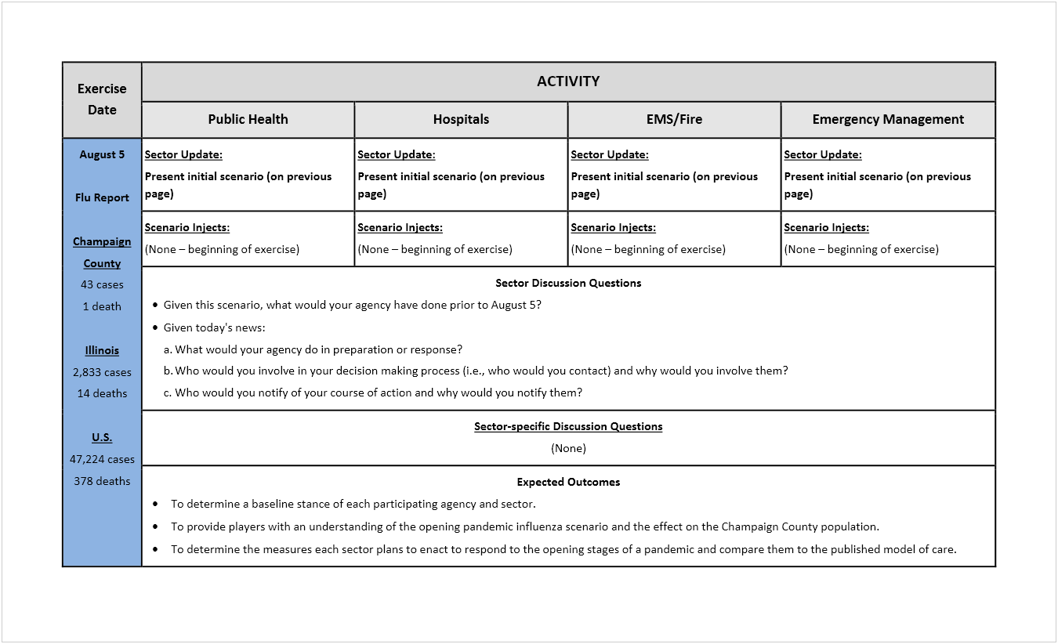

[This page is intentionally blank]

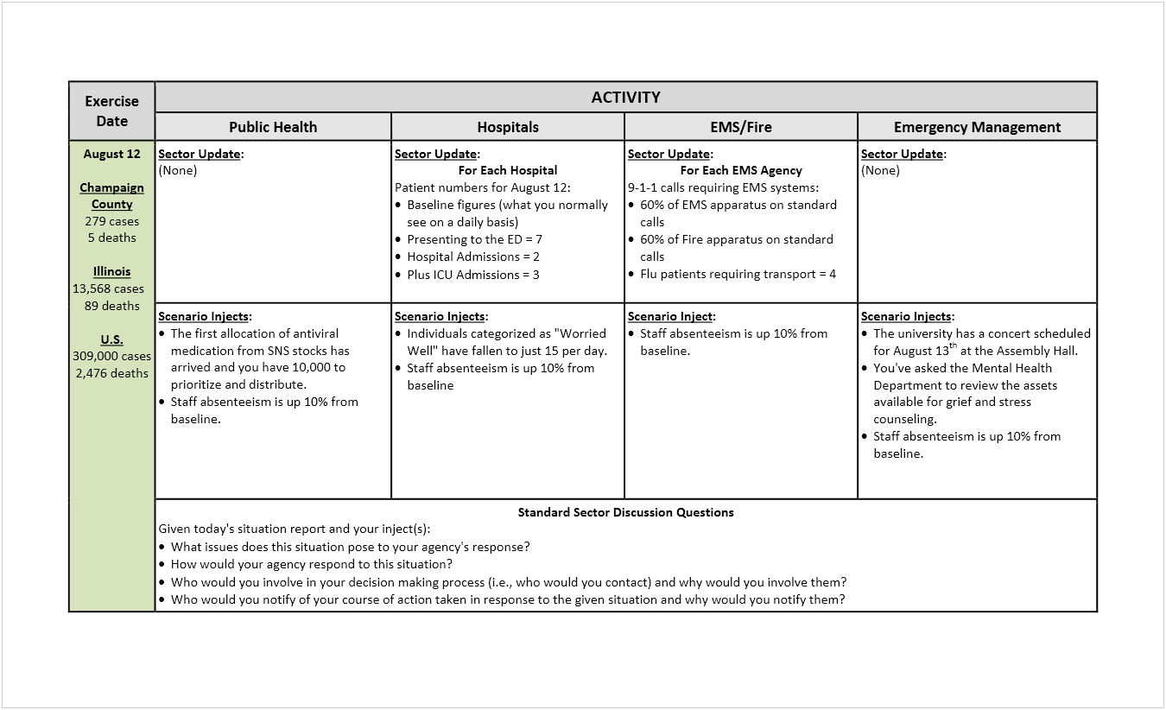

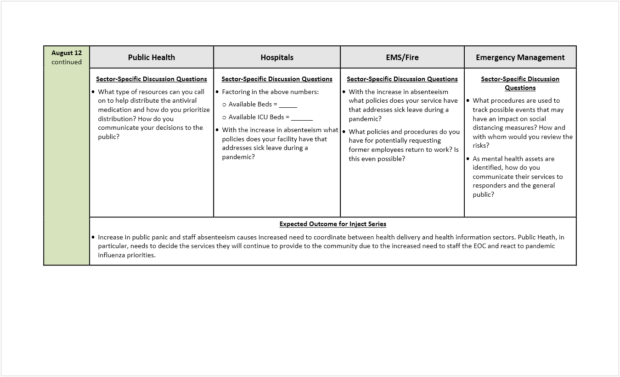

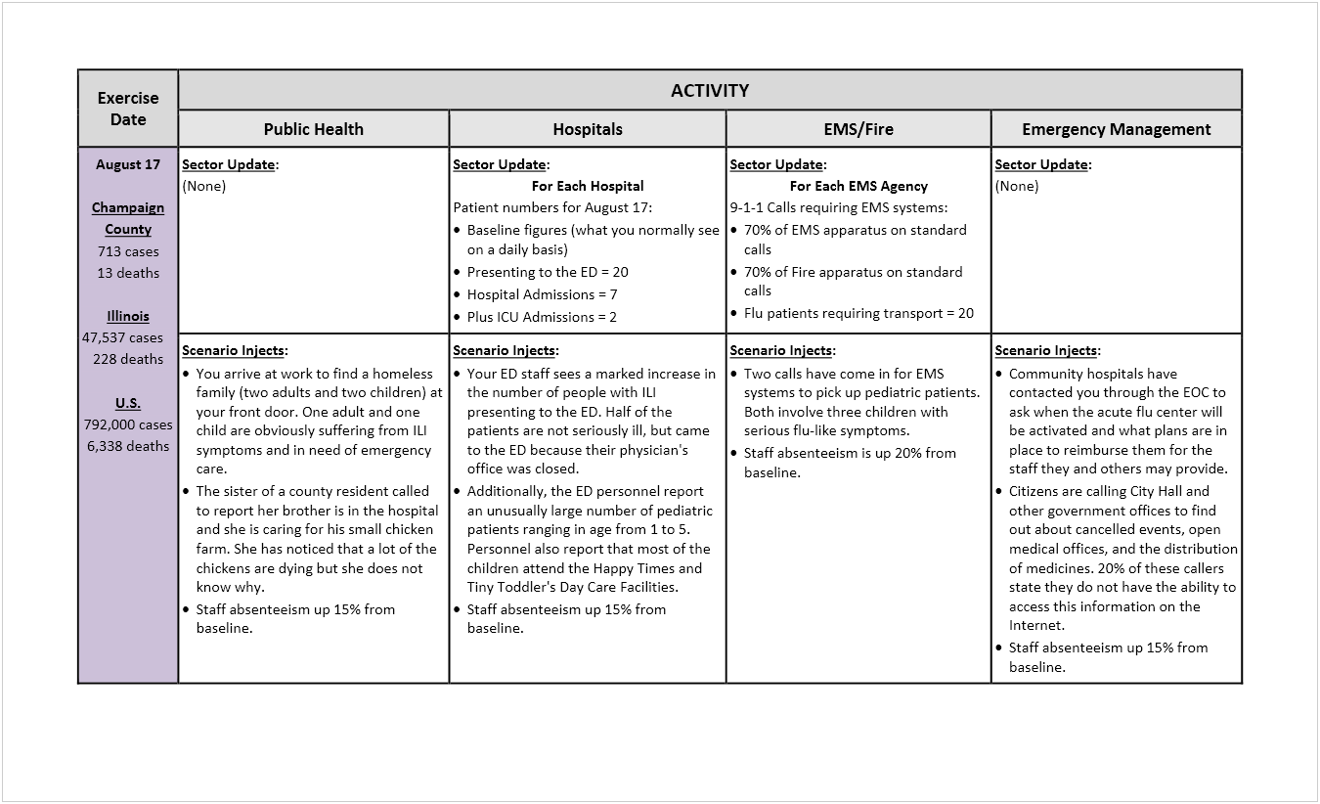

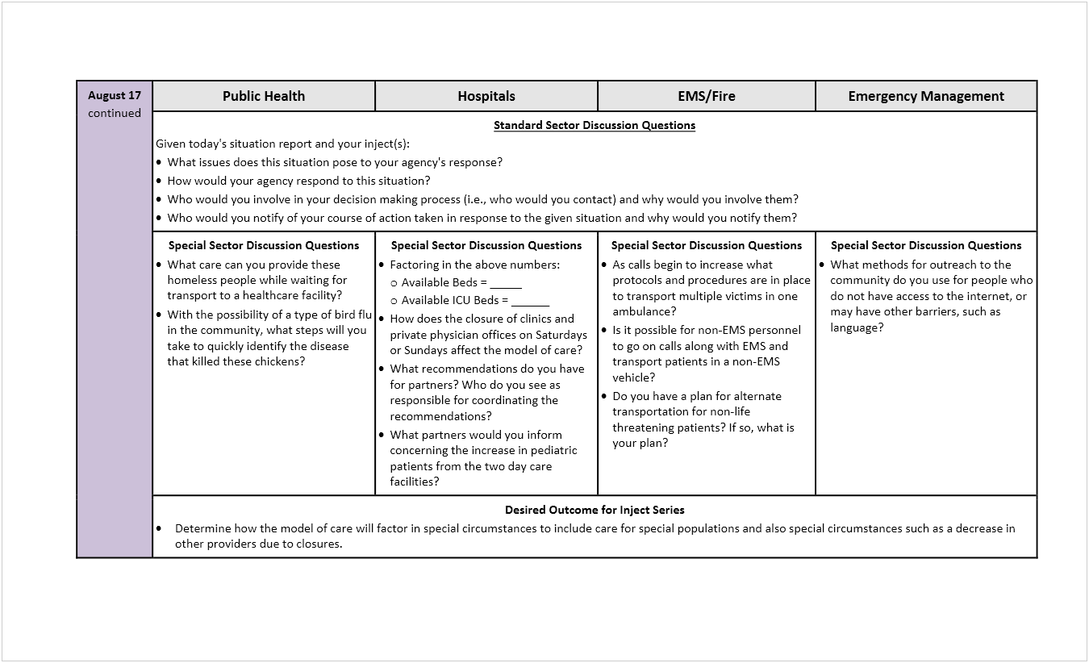

Appendix F – Sample Inject Response Report
This inject response report was compiled from the responses the Public Health sector provided as a response to the August 17 scenario inject shown in Appendix E on pages 159 and 160.
***This is an Exercise***
Public Health Responses to Day 3 Scenario Inject
Sector Inject
You arrive at work to find a homeless family (two adults and two children) at your front door. One adult and one child are obviously suffering from ILI symptoms and in need of emergency care.
The sister of a county resident called to report her brother is in the hospital and she is caring for his small chicken farm. She has noticed that a lot of the chickens are dying but she does not know why.
What issues do these situations pose to your organization's/agency's response?
- Homeless family: Immediate need would be to isolate the sick individuals and quarantine the exposed family members. The family will be provided masks, and isolated while EMS is called.
- Public Health (PH) will provide messages to the media informing ill individuals to follow the community plan. Do not present at PH. PH does not provide care.
- Absenteeism: PH will activate the Medical Reserve Corps, call in standby personnel, and call the Red Cross to help staff phones and assist with operations.
- Additional staff will be trained in Vital Records and trained as Deputy Registrars.
How would your organization/agency respond to these situations?
- Homeless family: PH will contact 9-1-1 to transport sick individuals to emergency department. PH will contact a taxi to transport the well adult and child to follow the sick individuals to the hospital. PH will provide PPE for cab driver. PH will contact the accepting hospital's social worker to start arranging for shelter for the well family members. A local ministry will be contacted because they have individual rooms.
- PH assumes this instance is the first of many homeless families/individuals that they will encounter during the pandemic. PH will send out staff to Salvation Army and other places that administer to the homeless to assist with isolation/quarantine plans and provide PPE.
- Additional staff will be trained in Vital Records and trained as Deputy Registrars.
Who would you involve in your decision-making process (i.e., who would you contact) and why would you involve them?
Emergency Operation Center, State PH, University of IL Veterinary Medicine, State Veterinarian, Boards of Health. PH will encourage opening Acute Flu Center.
Who would you notify of your course of action taken in response to the given situation and why would you notify them?
PH would contact the media to tell people what to do if they get sick and need medical care. PH would remind the media to stress that PH does not provide primary medical care and NOT to come to our facility if they are sick.
Special Sector Discussion Questions
What care can PH provide these homeless people while waiting for transport to a healthcare facility?
Homeless family: Immediate need would be to isolate the sick individuals and quarantine the exposed family members. The family will be provided masks, and isolated while EMS is called. PH does not provide primary medical care.
With the possibility of a type of bird flu in the community, what steps will you take to quickly identify the disease that killed these chickens?
PH would contact the IL State Veterinarian and the Local University Veterinary Medicine to collect samples. These two entities have animal surveillance. Local University Vet Med will be added to the Emergency Operations Center.
***This is an Exercise***

Appendix G – Sample Situation Report
This situation report was compiled from information supplied by exercise players on Day 3 of the Champaign-Urbana electronic exercise. Names of participating agencies and organizations have been changed to protect their identity. This sample report also has been modified to only show a report for those sectors listed in the sample MSEL in Appendix E.
Please note that the Public Health portion of this report is a narrative description of the Public Health sector's response to the scenario inject it received on August 17 (see Appendix E on pages 159 and 160).
***This is an Exercise***
Champaign-Urbana Electronic Exercise – SITREP #4
Situation Report for August 17, 2010
All agencies/organizations are experiencing a staff absenteeism rate of 15%, with the exception of EMS and Fire, which are experiencing a 20% reduction in staff.
Public Health (PH) arrived at work to find a homeless family (two adults and two children) at their front door. One adult and one child were obviously suffering from influenza-like illness (ILI) symptoms and in need of emergency care. PH isolated the ill family members and quarantined the well family members. PH notified 9-1-1 to transport the ill family members to a hospital and called a taxi to transport the well family members to the same hospital. Personal protective equipment (PPE) was provided to the taxi driver and the well family members. The hospital's social worker was contacted to arrange for shelter for the well family members.
PH assumed that this incident was the first of many in the homeless community. As a result, PH sent out staff to those entities that offer support to the homeless community to assist with isolation/quarantine plans and to provide PPE.
PH also was notified of a small chicken farm on which many chickens were dying. PH contacted the Illinois State Veterinarian and Local University Veterinary Medicine to collect samples. Local University Veterinary Medicine was added to the Emergency Operations Center (EOC).

Emergency Management (EM) has seen an increase in requests for information, which will cause a strain on its abilities to process and coordinate these requests.
EM also received queries as to when the acute flu center would be activated. It will be activated when Hospital #1 and Hospital #2 can no longer handle the incoming patient load. EM would be in discussions with the hospitals about the acute flu center but would not be the agency directly making the decision to open it. With regard to reimbursement of hospital staff working in the acute flu center, EM would have no responsibility for reimbursement. Control of billing and reimbursement would be the responsibility of each hospital or healthcare agency providing staff.
EMS #1 has seen an increase in absenteeism to 20%, but still is managing its workload by holding over full-time staff and cross-training other staff. In anticipation of increased calls to transport from long-term care facilities, EMS #1 would work with those facilities to treat patients in-house to reduce the need for transport. EMS #1 can transport multiple patients as long as they can be secured in the ambulance. EMS#1 also can use its van services to transport patients from the hospital to long-term care facilities or home.
EMS #2 has the same 20% increase in absenteeism, but is seeing minimal impact from it. EMS #2 continues to make sure that it has an adequate supply of PPE for all staff. EMS #2 can transport more than one patient if the patients are going to the same hospital.
Fire #1 has noticed no significant changes since August 12. Fire #1 continues to monitor its influenza-like illness (ILI) case load and its staff illness levels, reporting those levels to PH and EM.
Fire #2 will make no immediate changes based on what has transpired since August 12. However, Fire #2 is making plans to move to a 24-hour on and 24-hour off schedule should staff absenteeism reach 30%.
Hospital #1 has seen an increase in the number of people with ILI symptoms presenting in its Emergency Department (ED). ED personnel are seeing an unusually large number of pediatric patients ranging from 1 to 5 years in age, and these patients attended one of two daycare facilities in Champaign County. Hospital #1 has contacted PH to follow up on these two daycare facilities. Hospital #1 also has recommended to its healthcare partners that all incoming pediatric patients be treated as potentially infectious.
Hospital #1 has begun utilizing its "minimum safe staffing" policy for the staffing of inpatient units. Hospital #1 also has contacted state PH to apply for permission to open its alternate care center.
Hospital #2 is continuing all previous actions and is considering stopping non-essential, minor and screening procedures to conserve staff to work other areas. Hospital personnel also are moving patients (who can tolerate it) out of its critical care unit (CCU). Hospital #2 senior leadership is deciding when to open its flu treatment center.
Today's Update
Thursday, August 19, 2010
Champaign County has experienced another 863 cases and 15 more deaths. Four deaths occurred in Hospital #1, four deaths occurred in Hospital #2, and seven deaths occurred at home.
Today, Illinois reported 57,520 cases and 276 deaths. The United States reported 958,000 cases and 7,669 deaths.
-End-
***This is an Exercise***

[This page is intentionally blank]

Appendix H – Participant Feedback Form
This feedback form is the most recent (April 2013) template offered by the Homeland Security Exercise and Evaluation Program (HSEEP).
Participant Feedback Form
Thank you for participating in this exercise. Your observations, comments, and input are greatly appreciated, and provide invaluable insight that will better prepare our nation against threats and hazards. Any comments provided will be treated in a sensitive manner and all personal information will remain confidential. Please keep comments concise, specific, and constructive.
Part I: General Information
Please enter your responses in the form field or check box after the appropriate selection.
Name:
Agency/Organization Affiliation:
Position Title:
Years of Experience in Present Position:
Number of Exercises Previously Participated in: 0 1 to 5 5 to 10 15+
Exercise Role: Player Facilitator/Controller Observer Evaluator
Location during Exercise:

Part II: Exercise Design
Please rate, on a scale of 1 to 5, your overall assessment of the exercise relative to the statements provided, with 1 indicating strong disagreement and 5 indicating strong agreement.
Assessment Factor | Rating Scale  Strongly Strongly  Disagree Agree
Pre-exercise briefings were informative and provided the necessary information for my role in the exercise. | 1 | 2 | 3 | 4 | 5
The exercise scenario was plausible and realistic. | 1 | 2 | 3 | 4 | 5
Exercise participants included the right people in terms of level and mix of disciplines. | 1 | 2 | 3 | 4 | 5
Participants were actively involved in the exercise. | 1 | 2 | 3 | 4 | 5
Exercise participation was appropriate for someone in my field with my level of experience/training. | 1 | 2 | 3 | 4 | 5
The exercise increased my understanding about and familiarity with the capabilities and resources of other participating organizations. | 1 | 2 | 3 | 4 | 5
The exercise provided the opportunity to address significant decisions in support of critical mission areas. | 1 | 2 | 3 | 4 | 5
After this exercise, I am better prepared to deal with the capabilities and hazards addressed. | 1 | 2 | 3 | 4 | 5

Part III: Participant Feedback
- I observed the following strengths during this exercise (please select the corresponding capability and applicable element related to the strength):
Strengths | Core Capability | Element
[list observed strength] | [list core capability for this exercise] | Planning  Organization  Equipment  Training  Exercise
[list observed strength] | [list core capability for this exercise] | Planning  Organization  Equipment  Training  Exercise
[list observed strength] | [list core capability for this exercise] | Planning  Organization  Equipment  Training  Exercise

- I observed the following areas for improvement during this exercise (please select the corresponding capability and applicable element related to the area for improvement):
Areas for Improvement | Core Capability | Element
[list area for improvement] | [list core capability for this exercise] | Planning  Organization  Equipment  Training  Exercise
[list area for improvement] | [list core capability for this exercise] | Planning  Organization  Equipment  Training  Exercise
[list area for improvement] | [list core capability for this exercise] | Planning  Organization  Equipment  Training  Exercise

- What specific training opportunities helped you (or could have helped you) prepare for this exercise? Please provide specific course names if applicable.
Training | Completed Prior to Exercise? (Y/N)
To be filled in | To be filled in
To be filled in | To be filled in
To be filled in | To be filled in
To be filled in | To be filled in
To be filled in | To be filled in
- Which exercise materials were most useful? Please identify any additional materials or resources that would be useful.
_____________________________________________________________________________________________________________________________________________________________________________________________________________________________________________________________________________________________________________________________________________________________________________________________________________________________________________________________________________________________________________________________________________

- Please provide any recommendations on how this exercise or future exercises could be improved or enhanced.
_____________________________________________________________________________________________________________________________________________________________________________________________________________________________________________________________________________________________________________________________________________________________________________________________________________________________________________________________________________________________________________________________________________

[This page is intentionally blank]

Appendix I – Abbreviations and Acronyms
AAR after-action report
ASPR Office of the Assistant Secretary for Preparedness and Response
CDC Centers for Disease Control and Prevention
CFR case fatality rate
CHP case hospitalization proportion
CUPHD Champaign Urbana Public Health District
DSLR Division of State and Local Readiness
EEG exercise evaluation guide
EMS emergency medical services
FEMA Federal Emergency Management Agency
HHS U.S. Department of Health and Human Services
HPP Hospital Preparedness Program
HPRT Healthcare Preparedness and Response Team
HSEEP Homeland Security Exercise and Evaluation Program
ILI influenza-like illness
IncP incubation period
InfP infectious period
IP improvement plan
MDR-TB multidrug-resistant tuberculosis
MHD mean hospitalization duration
MIP mean infectious period
MOC model of care
MSEL master scenario events list
NIMS National Incident Management System
NRF National Response Framework
OPHPR Office of Public Health Preparedness and Response
ORAU Oak Ridge Associated Universities
ORISE Oak Ridge Institute for Science and Education
PHEP Public Health Emergency Preparedness
POD point of dispensing
R₀ reproductive number
SitMan situation manual
SITREP situation report
U.S. United States
WHO World Health Organization

Appendix J – Resources
Exercise Toolkit
http://www.sfdem.org/index.aspx?page=217
The City & County of San Francisco, Department of Emergency Management, designed this website to provide San Francisco departments, agencies, businesses, and communities the tools and resources that are necessary to plan and execute organized and productive emergency preparedness exercises.
Healthcare Preparedness Program (HPP)
http://www.phe.gov/PREPAREDNESS/PLANNING/HPP/Pages/default.aspx
The Healthcare Preparedness Program (HPP) is managed by HHS-ASPR. HPP provides leadership and funding through grants and cooperative agreements to states, territories, and eligible municipalities to improve surge capacity and enhance community and hospital preparedness for public health emergencies. This funding is used to support programs to help strengthen public health emergency preparedness.
Homeland Security Exercise Evaluation Program (2013)
https://www.preptoolkit.org/web/hseep-resources
The Homeland Security Exercise and Evaluation Program (HSEEP) doctrine consists of fundamental principles that frame a common approach to exercises. Applying these principles to both the management of an exercise program and the execution of individual exercises is critical to the effective examination of capabilities.
National Response Framework (Second Edition, May 2013)
http://www.fema.gov/media-library/assets/documents/32230?id=7371
The National Response Framework (NRF) is a guide to how the nation responds to all types of disasters and emergencies. It is built on scalable, flexible, and adaptable concepts identified in the NIMS to align key roles and responsibilities across the Nation. This framework describes specific authorities and best practices for managing incidents that range from the serious but purely local to large-scale terrorist attacks or catastrophic natural disasters.

Public Health Emergency Preparedness (PHEP) Cooperative Agreement
http://www.cdc.gov/phpr/coopagreement.htm
The Centers for Disease Control and Prevention, Office of Public Health Preparedness and Response, Division of State and Local Readiness administers funds for preparedness activities to state and local public health systems through the PHEP cooperative agreement. Through the PHEP, CDC helps public health departments strengthen their abilities to respond to all types of public health incidents and build more resilient communities.

See Section 3 – Designing an Electronic Exercise for definitions of these terms.
Reading through Appendix A – Situation Manual Template will help the user of the Tool gain an understanding of how an electronic exercise is designed and conducted.
HPP is managed by the U.S. Department of Health and Human Resources (HHS) Office of the Assistant Secretary for Preparedness and Response (ASPR). HPP provides leadership and funding through grants and cooperative agreements to states, territories, and eligible municipalities to improve surge capacity and enhance community and hospital preparedness for public health emergencies. This funding is used to support programs to help strengthen public health emergency preparedness.
CDC's Office of Public Health Preparedness and Response (OPHPR), Division of State and Local Readiness (DSLR), administers funds for preparedness activities to state and local public health systems through the PHEP cooperative agreement. Through the PHEP, CDC helps public health departments strengthen their abilities to respond to all types of public health incidents and build more resilient communities.
The HSEEP doctrine consists of fundamental principles that frame a common approach to exercises. For more information, go to https://www.preptoolkit.org/web/hseep-resources.
The user can read through all sections of the Tool ahead of time to gain an understanding of the overall process prescribed by the Tool. However, each task phase must be completed in the order presented above because each phase builds upon the work of the previous phase.
For the purposes of the Tool, the scope of an exercise refers to the who, what, when, why, and how of the exercise. Specifically, it refers to who will be participating in the exercise, what will be exercised, when will it be exercised and for how long, why the exercise is being conducted (purpose), and how the exercise will be conducted.
As defined by the Federal Emergency Management Agency (FEMA).
HSEEP, April 2013.
See National Response Framework, Second Edition, May 2013, at http://www.fema.gov/media-library/assets/documents/32230?id=7371.
The number of capabilities for each program may change with the publication of the FY17 guidance.
FEMA Core Capabilities at http://www.fema.gov/core-capabilities.
National Response Framework, Second Edition, May 2013.
HPP Capabilities at https://www.phe.gov/Preparedness/planning/hpp/reports/Documents/2017-2022-healthcare-pr-capablities.pdf.
PHEP Capabilities at https://www.cdc.gov/phpr/readiness/capabilities.htm.
FEMA Emergency Management Institute Training Course IS-139: Exercise Design, Unit 4: Exercise Design Steps.
Texas Department of State Health Services, Writing Capability-Based Exercise Objectives: A Short Guide for Exercise Planners, dated Jan, 2012 found at https://www.dshs.texas.gov/WorkArea/linkit.aspx?LinkIdentifier=id&ItemID=8589962976.
An exercise day is the 24-hour time period in which exercise controllers e-mail scenario updates, injects, or situation reports to exercise players and exercise players e-mail back their responses to these updates, injects, or situations.
San Francisco Department of Emergency Management (DEM) Exercise Toolkit, undated, found at http://sfdem.org/exercise-toolkit.
The authors of this document consider the terms sectors and subsectors to be different. For example, healthcare is considered to be a sector whereas hospitals, primary care providers, long‐term care agencies, urgent care centers, and similar healthcare providers are considered to be subsectors of the healthcare sector.
An exercise day is the 24-hour time period in which exercise controllers e-mail scenario updates, injects, or situation reports to exercise players and exercise players e-mail back their responses to these updates, injects, or situations.
The dates used in the Champaign-Urbana electronic exercise were actual dates, not simulated dates.
Inject templates in the Tool (see Appendix D) provide information to be sent out to the identified exercise players as well as information for the exercise evaluators. The only information sent out to the exercise players is the message description (i.e., the injected situation), the standard sector discussion questions, and the special sector discussion questions.
See pages 34 and 36 for the three options for disseminating exercise information.
Federal Emergency Management Agency, Homeland Security Exercise and Evaluation Program, April 1, 2014, found at https://www.fema.gov/media-library-data/20130726-1914-25045-8890/hseep_apr13_.pdf.
Unlike the other self-evaluation checklists in this document, this checklist is designed to be used as you conduct your electronic exercise. It is divided into exercise days with each task for the day being listed. Exercise Days 1 and 2 are provided, and planners should copy the six tasks in the Exercise Day as often as needed.
Homeland Security Exercise and Evaluation Program (HSEEP), April 2013 found at https://www.fema.gov/media-library-data/20130726-1914-25045-8890/hseep_apr13_.pdf.
Homeland Security Exercise and Evaluation Program (HSEEP), April 2013 found at https://www.fema.gov/media-library-data/20130726-1914-25045-8890/hseep_apr13_.pdf.
Planners also may develop customized evaluation or data capture tools as EEGs do not always align well with PHEP capabilities and/or public health exercise objectives. For example, in an electronic exercise, you might want to collect specific information about timing and content of responses.
Homeland Security Exercise and Evaluation Program (HSEEP), April 2013 found at https://www.fema.gov/media-library-data/20130726-1914-25045-8890/hseep_apr13_.pdf.
A comprehensive, national approach to incident management.
Homeland Security Exercise and Evaluation Program (HSEEP), April 2013 found at https://www.fema.gov/media-library-data/20130726-1914-25045-8890/hseep_apr13_.pdf.
This template is similar to what was used for the Champaign-Urbana electronic exercise. It also includes components of an HSEEP SitMan template. See HSEEP for a more formal SitMan template.
See Attachment 1 for a list of participants in this exercise. (Use Attachment 1: Participant List Template to compile your participant list.)
See Attachment 2 for a detailed timeline for the exercise. (Use Attachment 2: Exercise Timeline Template to complete your timeline.)
An exercise day is the 24-hour time period in which exercise controllers e-mail scenario updates, injects, or situation reports to exercise players and exercise players e-mail back their responses to these updates, injects, or situations.
Modify this template as needed to add names or agencies/organizations.
Modify this template as needed to match the timeline for your exercise.
A scenario inject is a simulated event that drives exercise play towards achievement of exercise objectives. It can be directed to all exercise players or targeted to a particular facility (e.g., "General Hospital") or a sector (e.g., public health). An example of a scenario inject is "seven of your staff have called to inform you that they have influenza-like illness and will not be reporting to work today."
Exercise controllers may modify how exercise information is identified in e-mail sent to exercise players. The main point to remember is to always list "This is an Exercise" in the subject line.
See information on the H1N1 waiver at https://www.cms.gov/About-CMS/Agency-Information/Emergency/downloads/MedicareFFS-EmergencyQsAs1135Waiver.pdf.
The concept for this system is described in the Community Planning Framework for Healthcare Preparedness at http://www.cdc.gov/phpr/healthcare/documents/cpf-chapter-5.docx. Exercise controllers can tailor this inject to the current plans for the community.

