State User Supplemental Manual*
SEALS Version 1.1

SEALS Version 1.1 is designed to capture, save, and export data for local school sealant programs in your state. Data is saved in a format that allows state-level program administrators (in states with decentralized programs) to use data from sealant programs across their state to generate summary reports at the state-wide level.
SEALS Version 1.2 will include the ability to generate reports, allowing states to assess reach, impact, and efficiency across their programs.

October 2017

*This supplement to the SEALS User Manual is intended for use by State School Sealant Program Coordinators.

TABLE OF CONTENTS

User Roles and Rights of Access | Page 3
Viewing SEALS | Page 3
Accessing SEALS | Page 4
Taskbar Overview | Page 5
Program-Level Management: Adding Programs and Users | Page 6
Add Programs (inputting local school sealant programs) | Page 6
Add Users (inputting program staff) | Page 7
Appendix Section 1: Access Rights for User Types | Page 8
Appendix Section 2: Criteria for High-Needs School | Page 9
Appendix Section 3: Paper Collection Forms | Page 10

USER ROLES AND RIGHTS OF ACCESS

SEALS is designed to capture and store school sealant program (SSP) data in a format that allows multiple users to access that data, and to generate summary reports regarding SSP costs and impact. There are three levels of users: local SSP, state, and CDC. Each user type differs by the information they can input into SEALS, rights of access, and the type of summary reports:

Local SSP users will need to input information on schools served by their program; logistics of sealants delivery; per unit resource costs; and resource use and services delivered at each school sealant event. Local SSP users also have the option to input child-level data, including oral health status and socio-demographic characteristics. Local SSP users can create summary reports on the cost and effectiveness of their SSP and export their data for further analyses. Finally, local SSP users can create accounts for other personnel in their sealant program.

State users will need to create an account for state personnel who can access SEALS and for each sealant program in their state that will input information into SEALS. State users can create summary reports (for an individual SSP and all SSPs combined) generated from data input by sealant programs in their state.

CDC users include project officers and an administrator. Project officers can view SSP reports for all states. The CDC administrator can generate summary reports for a local SSP, a funded state, and all states combined. The CDC administrator can also view and export data for further analyses. In addition, the CDC administrator can create state user and local SSP user accounts.

THIS SUPPLEMENTAL MANUAL IS FOR STATE USERS. More details on user roles and access rights are provided in the Appendix, Section 1, page 8.

VIEWING SEALS

SEALS is designed to operate on desktop computers or laptops. It is not optimized for other mobile devices, such as tablets or cell phones. Viewing SEALS on your desktop is easiest when the resolution is at the higher settings (e.g., 1680x1050). Paper forms to collect information on schools served and each child (where applicable) can be found in the Appendix, Section 2, page 9 of this manual.

ACCESSING SEALS

SEALS is accessed at: https://nccd.cdc.gov/SEALS/Default/Login.aspx

After login with an email address and password, users land on the SEALS Home page. The home page provides contact information for state school sealant program administrators, who act as the first point of contact for SSP personnel with questions about using SEALS.

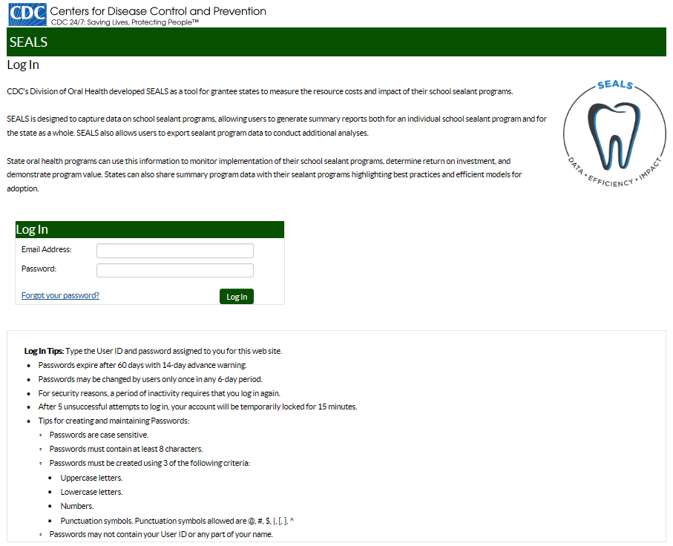

TASKBAR OVERVIEW

SEALS tasks are accessed via taskbars with left side navigation. There are two top-level headings – Program Administration and Program Data. Under Program Administration, there are two tasks types – Program-Level Management and Event-Level Management.

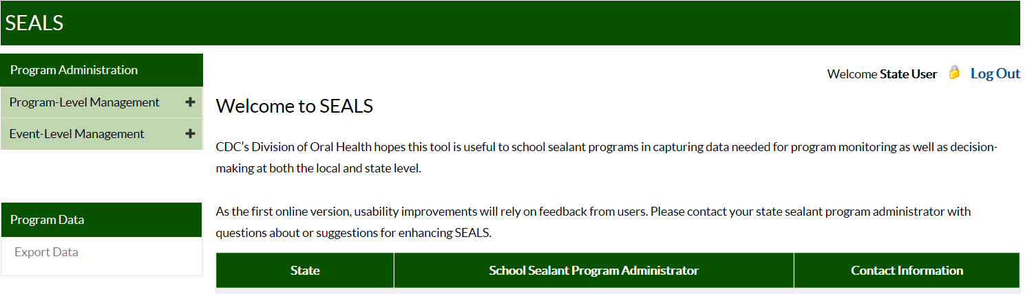

Click on the plus sign to the right of these tasks to open additional taskbars. Taskbars under Program-Level Management allow you to:

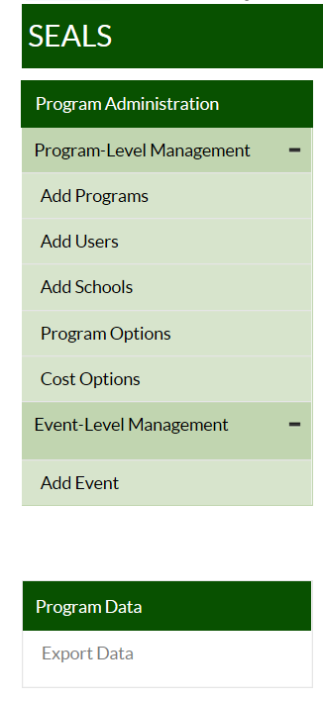
Add Programs (SSPs) and Add Users: Input information for each local program and create user accounts for local programs and state users. After adding a local program, a state user must create an account for at least one local user who can then access the SEALS application and create user accounts for other local staff.

Add Schools: View list of schools served for each program in your state. (Note: State users cannot add schools.)

Program Options and Cost Options: View information on characteristics, delivery logistics, and costs input by each local program in your state.

As a state user, the taskbar under Event-Level Management (“Add Event”) allows you to view information on all school events for each program in your state.

State users cannot currently access the Export Data task under Program Data. However, state users can request an Excel file with complete program data for their state by contacting the SEALS CDC Administrator at SEALS@cdc.gov.

Program-level management: adding programs and users

Add Programs (inputting local school sealant programs)
The Add Programs taskbar allows your state to add local school sealant programs. Clicking on this taskbar, you will see:

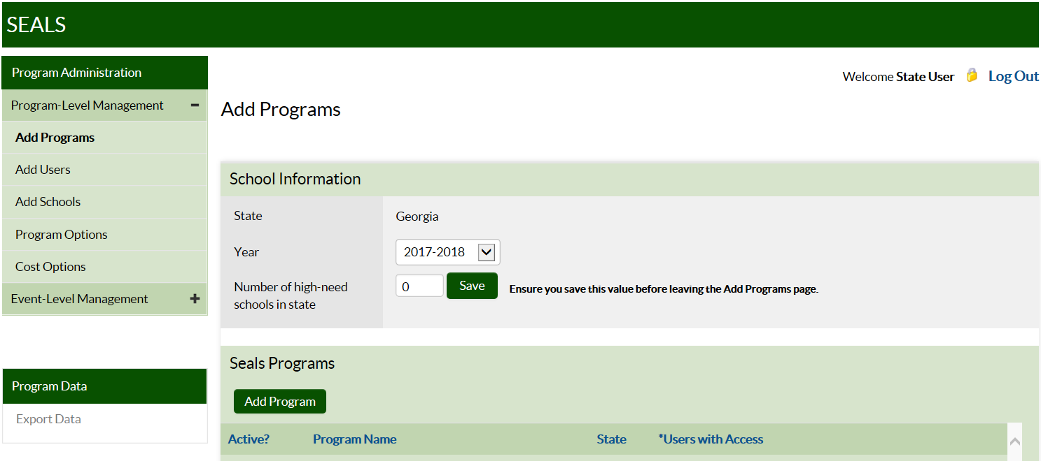

First, select the appropriate school year and then indicate the number of high-need schools in your state (see Appendix, Section 3, page 9). Remember to click ‘Save’ after inputting the number of high-need schools. Local programs in your state will not be able to input school sealant event data, export data or generate reports unless this field has been completed.

Under SEALS Programs, state users can see active programs (i.e., providing data to the state) for the selected school year, as well as the number of local users with access to each sealant program account.

To add a local program (create an account), click on Add Program directly below Seals Programs, enter the name of the school sealant program and click on Add Program to save your entry.

Deactivating a Program
State users can deactivate a program for a given year by going to Add Program and clicking on Edit. A dialogue box will appear with the name of the program and its status. The active status for a program can be changed by clicking on the box next to ‘Active’ to deactivate for a given year. State users can also change the program name by using this feature.

Note: Programs cannot be deleted for a given year; they can only be deactivated.

Add Users (inputting program staff)

As a state user, the Add Users taskbar allows you to add local program staff and state administrative users. Clicking on this taskbar, you will see:

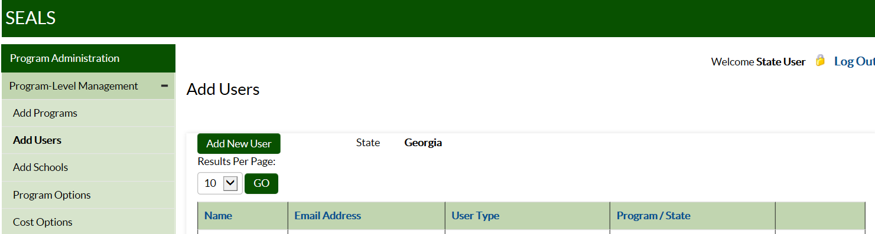

To add program staff:
- Click on Add New User.
- First, under User Type, select Program User (local school sealant program) or State Admin User. Then, add that user’s first and last name and email address. Program users must be assigned to a program name using the Program drop down box. If state user is selected, click on your state name in the State drop down box.
- Click on Add User.

NOTE: SEALS then sends an email to new users with instructions for setting their password.

The remaining tasks–Add Schools; Program Options; Cost Options; and Event Level Management–can only be viewed, not edited by state users. For more information on these tasks, refer to the SEALS User Manual.

APPENDIX

Section 1: Access Rights for Different User Types

School Sealant Program User
Full Access rights (within program)
- Add Users
- Add Schools
- Program Options
- Cost Options
- Event-Level Management
  - Child Detail Data
- CSV Export (Online and PDF Summary Reports)

State User
Full Access rights (within state)
- Add Programs
- Add Users
- Online and PDF Summary Reports (No access to CSV export)
Read Only rights (within state)
- Add Schools
- Program Options
- Cost Options
- Event-Level Management
  - Child Detail Data

CDC User

CDC Administrator
Full Access rights (all states and programs)
- Manage School Years
- Settings
- Add Users
- Add Schools
- Program Options
- Cost Options
- Event-Level Management
  - Child Detail Data
- CSV Export (Online and PDF Summary Reports)

CDC Project Officer
Read Only rights (all states and programs)
- Manage School Years
- Settings
- Add Users
- Add Schools
- Program Options
- Cost Options
- Event-level Management
  - Child Detail Data
- Online and PDF Summary Reports
(No access to CSV Export)

Section 2: Criteria for High-Need School Classification

The determination of high-need in Funding Opportunity Announcement (FOA) – DP13-1307 for schools located in urban and rural areas is as follows:

- In an urban area, a high-need school is defined as having more than 50% of students qualify for the federal or state free and reduced meal program.
- In a rural area, a high-need school is defined as attending a school located in a school district with a median income that is at or below 235% of the poverty line (as defined by 42 U.S.C. 9902(2)). Because some funded states could not determine the median income for school districts within their state, the Division of Oral Health allowed states to develop their own definition for high-need rural schools.

Section 3: Paper Collection Forms

EVENT DATA COLLECTION FORM
State: ___________________________ Program: ________________________________
Event Date(s): ____________________ School: __________________________________
Consent Forms Distributed: _______________________
Labor
 | Dentist | Hygienist | Assistant | Other
Total hours at school
Total hours travelling to and from school
Total miles travelling to and from school³

Vehicles
Number owned/operated by SSP driven to event

Total miles driven per vehicle for event

Services delivered (Only complete if your program will not input child-level data into SEALS)

Number of children screened

Number of children receiving sealants

Number of teeth sealed

Number of children receiving fluoride varnish

Number of children receiving prophylaxis

Detailed Child-Level Data Collection Form (complete one form per child)

Program Name: _____________________ Event (School/dates): ____________________________________
Patient Name: First: _________________ Last: _________________ Age: _________ (4 to 18 years)
ID #: _____________________________ Date: ________________ Grade: _______
Insurance: _________________________

Screening

Chart for program use (D = decayed, F = filled, M = missing due to disease, S = sealant present, PS = prescribe sealant,
RS = recommend reseal, no mark = no treatment recommended)

1 | 2 | 3 | 4 | 5 | 12 | 13 | 14 | 15 | 16 | Sealant Prescriber’s Signature/Date  ___________________________________  Fluoride Prescriber’s Signature/Date  ___________________________________
32 | 31 | 30 | 29 | 28 | 21 | 20 | 19 | 18 | 17

Comments:

Data for SEALS

Sealants Present:  No/Yes | Untreated Decay:  No/Yes | Treated Decay:  No/Yes | Referral:  None  Not urgent  Urgent | Number of decayed/filled 1st molars:  (0 - 4)=_________________

Preventive Services

Chart for program use (Mark with an “S” the teeth where sealants were placed)

1 | 2 | 3 | 4 | 5 | 12 | 13 | 14 | 15 | 16 | Provider’s signature  ________________________
Date

________________________
32 | 31 | 30 | 29 | 28 | 21 | 20 | 19 | 18 | 17

Comments:

Data for SEALS

Number of 1st molars  sealed:  (0 - 8) =_________________ | Number of 2nd molars  sealed:  (0 - 4) =_________________ | Number of other permanent teeth sealed:  (0 - 8) =_________________
Number of primary teeth sealed:  (0 - 8) =_________________ | Fluoride varnish provided:  No/Yes | Prophylaxes provided:  No/Yes

Follow-Up

Chart for program use (Mark with an “R” teeth where sealants were retained)

1 | 2 | 3 | 4 | 5 | 12 | 13 | 14 | 15 | 16 | Evaluator’s Signature  _________________________
Date

_________________________
32 | 31 | 30 | 29 | 28 | 21 | 20 | 19 | 18 | 17

Comments:

Data for SEALS

Number of teeth with a retained sealant

A sealant event is defined as serving the same school for consecutive days.
If SSP uses reusable instruments, hours spent sterilizing instruments offsite should be included in school hours.
Only complete if your SSP reimburses workers for this item.
Delivered with low-speed hand piece or power scaling.
Each child’s ID # must be unique for that event; do not use duplicate ID #’s at any one event.

