User Manual*
SEALS Version 1.1

SEALS Version 1.1 is designed to capture, save, and export data for local school sealant programs in your state. Data is saved in a format that allows state-level program administrators (in states with decentralized programs) to use data from sealant programs across their state to generate summary reports at the state-wide level.
SEALS Version 1.2 will include the ability to generate reports, allowing states to assess reach, impact, and efficiency across their programs.

October 2017

* State users should refer to the State User Supplemental Manual for information relevant to the state user role in SEALS.

TABLE OF CONTENTS
User Roles and Access Rights | Page 3
Viewing SEALS | Page 3
Accessing SEALS | Page 4
Taskbar Overview | Page 5
Taskbars for Inputting Program Data (tasks must be performed in order below) | Page 7
- ADD USERS (inputting program staff) | Page 7
- ADD SCHOOLS (inputting schools served by program) | Page 8
- PROGRAM OPTIONS (inputting program characteristics) | Page 9
- COST OPTIONS (inputting program per unit costs) | Page 12
- EVENT MANAGEMENT (inputting data at each school event) | Page 14
- CHILD DATA (inputting aggregate or detailed child-level data) | Page 15
Exporting Data | Page 19
Example: Practice Using SEALS | Page 20
Appendix: Section 1 – Access Rights and User Roles | Page 21
Appendix: Section 2 – Criteria for High-Need Schools Classification | Page 22
Appendix: Section 3 – Administrative Costs | Page 23
Appendix: Section 4 – Cost for Sealant Materials and Reusable Instruments | Page 27
Appendix: Section 5 – Annual Cost for Durable Goods | Page 28
Appendix: Section 6 – Annual Supply Cost Calculation | Page 29
Appendix: Section 7 – Sealant Event Data Collection Logs | Page 31

USER ROLES AND RIGHTS OF ACCESS

SEALS is designed to capture and store school sealant program (SSP) data in a form that allows multiple users to access that data, and to generate summary reports regarding SSP costs and impact. There are three levels of users: local SSP, state, and CDC. Each user type differs by the information they can input into SEALS, rights of access, and the type of summary reports:

Local SSP users will need to input information on schools served by their program; logistics of sealants delivery; per unit resource costs; and resource use and services delivered at each school sealant event. Local SSP users also have the option to input child-level data, including oral health status and socio-demographic characteristics. Local SSP users can create summary reports on the cost and effectiveness of their SSP and export their data for further analyses. Finally, local SSP users can create accounts for other personnel in their sealant program.

State users will need to create an account for state personnel who can access SEALS and for each sealant program in their state that will input information into SEALS. State users can create summary reports (for an individual SSP and all SSPs combined) generated from data input by sealant programs in their state.

CDC users include project officers and an administrator. Project officers can view SSP reports for all states. The CDC administrator can generate summary reports for a local SSP, a funded state, and all states combined. The CDC administrator can also view and export data for further analyses. In addition, the CDC administrator can create state user and local SSP user accounts.

More details on user roles and access rights are provided in Section 1 of the Appendix (page 21).

VIEWING SEALS

SEALS is designed to operate on desktop computers or laptops. It is not optimized for other mobile devices, such as tablets or cell phones. Viewing SEALS on your desktop is easiest when the resolution is at the higher settings (e.g., 1680x1050). Paper forms to collect information on schools served and each child (where applicable) can be found in the Appendix, Section 7 (page 31) of this manual.

ACCESSING SEALS

SEALS is accessed at: https://nccd.cdc.gov/SEALS/Default/Login.aspx

After an account is created, users can log in with an email address and password and land on the SEALS home page. The home page provides contact information for state school sealant program administrators, who act as the first point of contact for SSP personnel with questions about using SEALS.
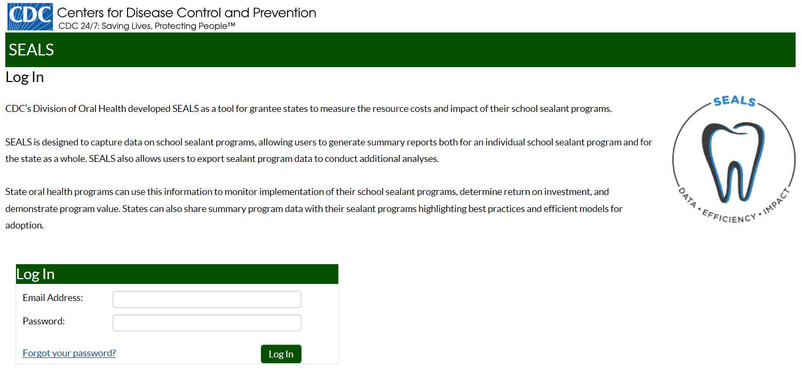

TASKBAR OVERVIEW

SEALS tasks are accessed via taskbars with left side navigation. There are two top-level headings: Program Administration and Program Data. Under Program Administration, there are two tasks types: Program-Level Management and Event-Level Management.

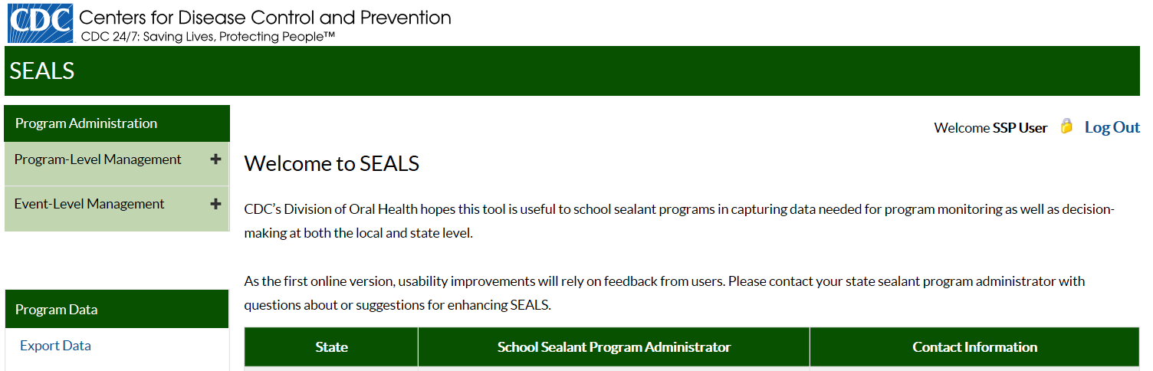

User Tip: Figure 1 (page 6) provides a quick overview of each data entry task and the required order of entry.

Clicking on the plus (+) sign to the right of these tasks opens additional taskbars. Taskbars under Program-Level Management allow you to:
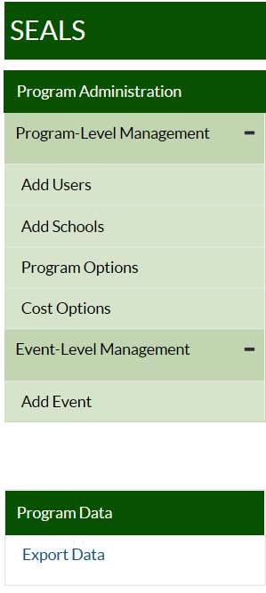
Add Users: input program staff who are authorized to input or export data

Add Schools: Input the name of each school you serve

Program Options: Input information on the characteristics of your program and create a list of schools associated with each school year

Cost Options: Input information (or accept provided values) on the cost of resources used by your program

Under Event-Level Management, the taskbar allows you to:

Add Event: Input data for each sealant event (consecutive days spent delivering sealants at the same school), including child-level data

Under Program Data, clicking on Export Data allows you to create an Excel file containing your program data

Figure 1. Information on when in the school year your program should enter data into the SEALS Cost Calculator.
One Time Entry at Beginning of School Year

- In the ADD USERS taskbar, input the names and email addresses of (any new) program staff needing access to SEALS.
- Next, go to ADD SCHOOLS and input the list of schools your program plans to serve.
- Then, under PROGRAM OPTIONS, input information describing your program and the schools it serves.
- Finally, go to COST OPTIONS to input information on your program’s per unit costs for labor, vehicle mileage, sealant material and stations, and reusable instruments.
Ongoing Entry During the School Year

- After each sealant event, go to ADD EVENT to input information on units of resources used
(e.g., labor hours, vehicle mileage) to deliver services AND if entering aggregate child data, number and types of services delivered OR if entering child-level data, each child’s oral health status, socio-demographic characteristics, and services received.

One-time Entry At End of the School Year

- To finish off your SEALS entry for the school year, go to COST OPTIONS to input information on administrative and supply costs.

PROGRAM-LEVEL MANAGEMENT TASKS

ADD USERS
The Add Users taskbar allows your program to add staff. Clicking on this taskbar you see:

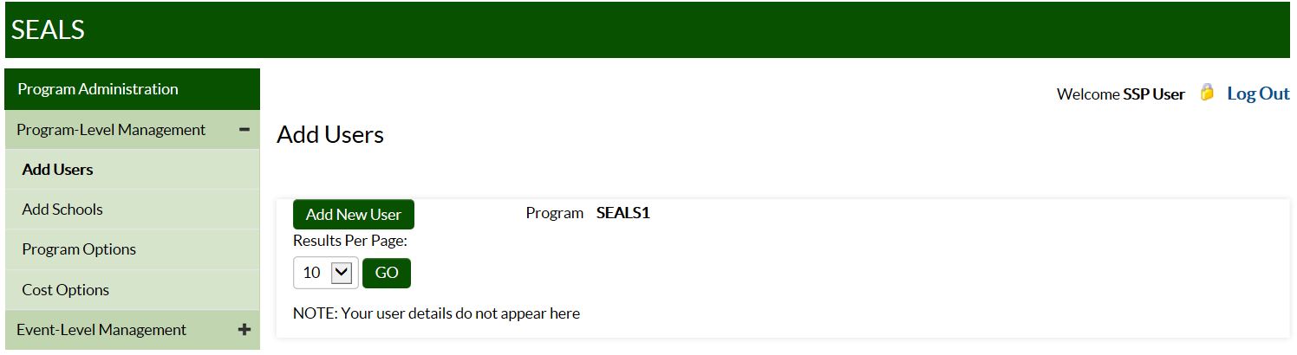

To add program staff:
- Click on Add New User.
- Under User Type, select Program User, then add that user’s first and last name and email address. Under Program, select your program name.
- Click on Add User to save.
NOTE: SEALS will then send an email to new users with instructions on setting their password.

ADD SCHOOLS
The Add Schools taskbar allows your program to add schools that it serves. Clicking on this taskbar you see:

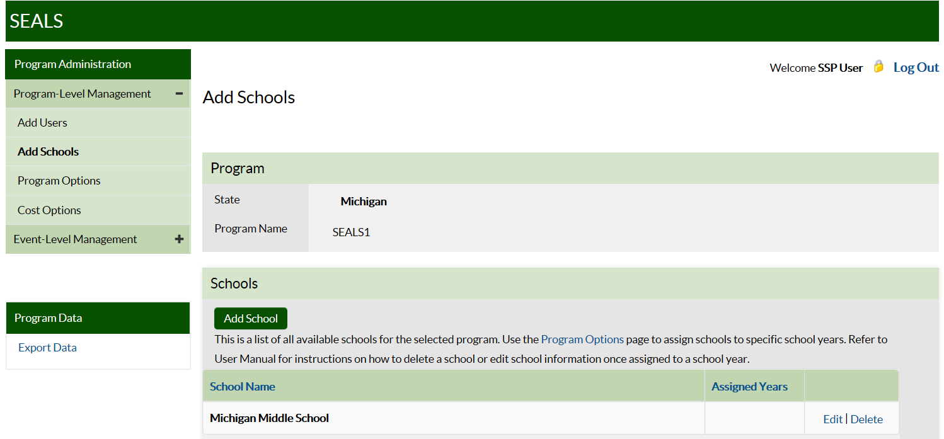

To add a school:
- Click on Add School.
- Enter the school’s name in the dialogue box that appears.
- Click on Add School to save.

Note: Once an SSP inputs a school, it will be available in all future years.

User Tip: Input the full school name so that it can be differentiated from schools with similar names that might be served by your program in future years. Be sure to include in the name whether school is ‘elementary’, ‘middle’ or ‘high school’.

PROGRAM OPTIONS
The Program Options taskbar allows your program to create a list of schools and input information describing your program. Clicking on this taskbar you see:

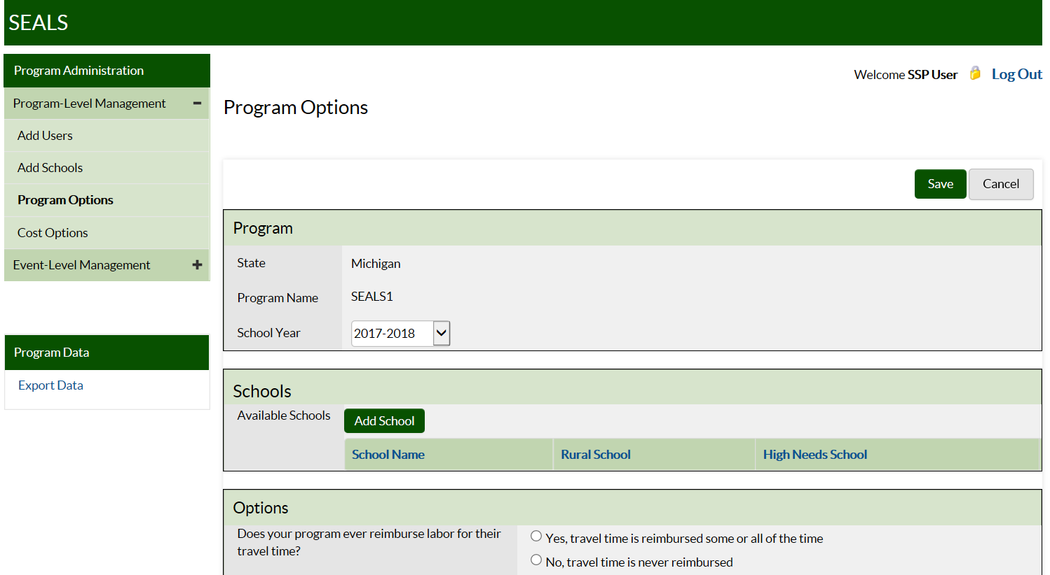

Under Program Options, first select the current school year. Create a school record for each school your program plans to serve during the school year. To create a school record:
- Click on Add School and a dialogue box with a drop down menu of all school names you have entered in Add Schools in the current or past years will appear.
- Select school and specify whether school is rural and whether it is high-need. Criteria for ‘rural’ and ‘high-need’ can be found in Section 2 of the Appendix (page 22).
- Click on Add School to save.
The school will now appear in the section titled Schools.

To remove a school record for the current year, first make sure that there are no child or event records associated with the school. In the far right column of the row where the school you want to remove is located, you should see Edit and Remove. Click on Remove and then confirm this in the dialogue box that appears. Finally, click on Save.

Next, answer the Options questions on specific practices and services delivered:
- Indicate whether your program ever reimburses workers for their time in travelling to and from the sealant event location.
- Indicate whether your program ever reimburses workers for their mileage when they drive their own personal vehicles to the school event.
- Indicate whether program provides fluoride varnish or prophylaxis (other than with a tooth brush) in addition to sealants.
- Indicate whether children are screened and sealed at same seating or different seatings.

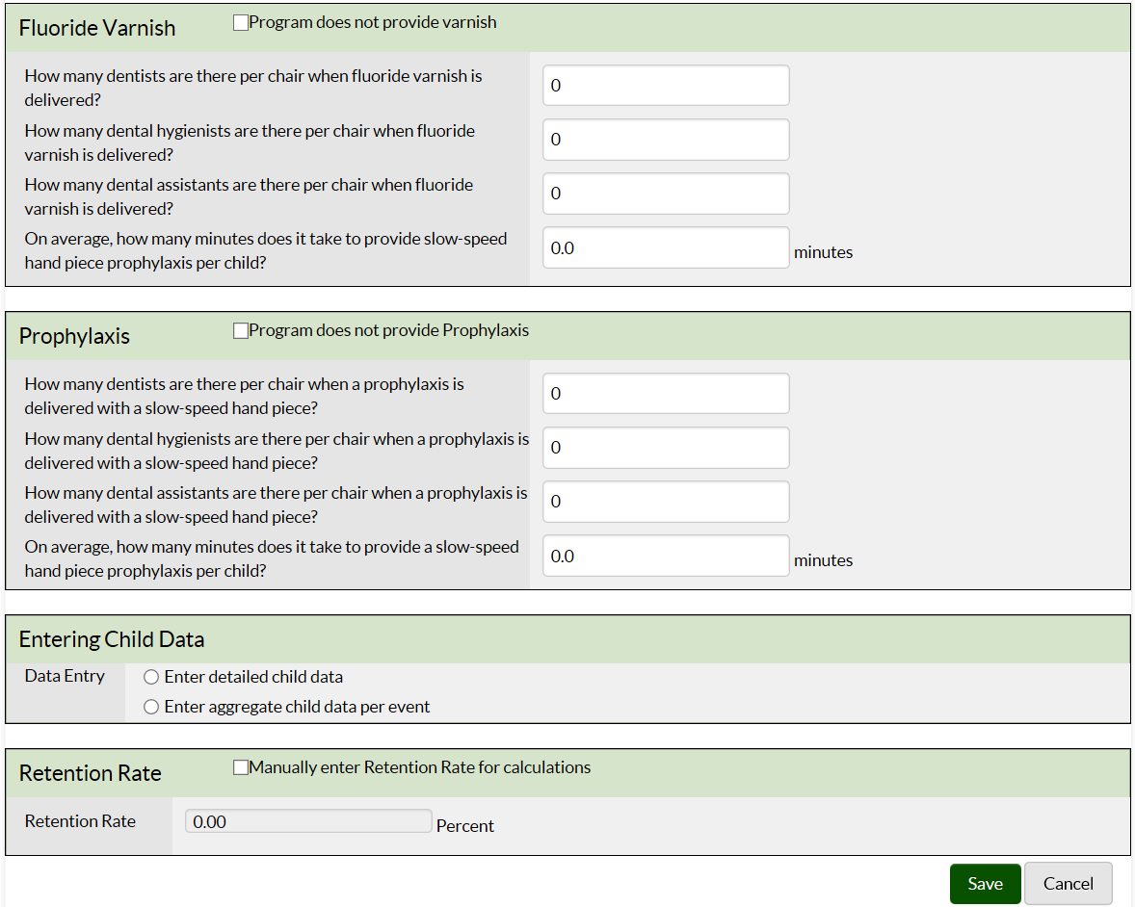

In the Fluoride Varnish section, answer the questions on number of operators (i.e., dentists, hygienists, and assistants) required to deliver 1 fluoride application, as well as the application time in minutes. If your program does not provide varnish, click on the box; this will disable your ability to enter information in these fields.

In the Prophylaxis section, indicate if you provide prophylaxes with a hand piece or power scaling. Please note that cleaning tooth surfaces to be sealed with a toothbrush is not considered an additional service as it is a required step in sealant placement. Input information on number of operators (i.e., dentists, hygienists, and assistants) required2 to deliver 1 prophylaxis, as well as the application time in minutes. If your program does not provide prophylaxis, click on the box; this will disable your ability to enter information in these fields.

In the Entering Child Data box, click the radio button to indicate whether your program will input child level data (e.g., oral health status and services received) or provide aggregate data (e.g., number of children screened).

Finally, input information on annual sealant retention rate (optional). Note that your program should only complete this field if it will not input child level data on number of sealants retained within 9 to 15 months of initial sealant application.

Click Save to complete this page.

COST OPTIONS
The Cost Options taskbar allows your program to input or accept provided values for various costs. Clicking on this taskbar you see:

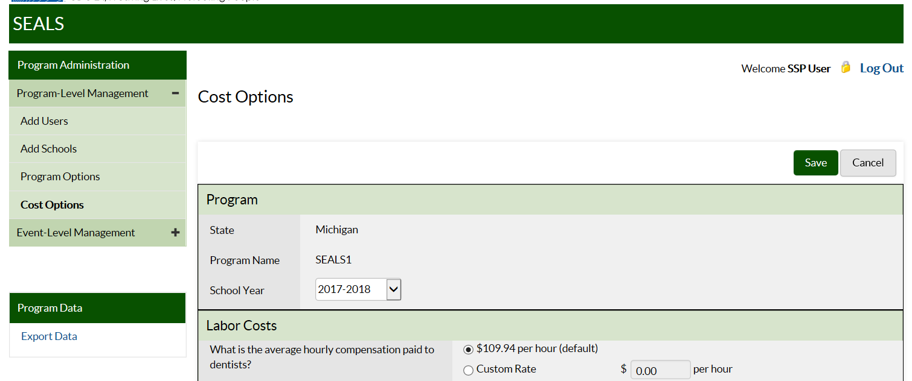

In this section, your program can add information for the various categories of costs. Default costs for the 2017/2018 school year are in 2016 USD. This is because when sealants were delivered in the fall of 2017, 2016 would be the most recent year with annual Consumer Price Index (CPI) data.
(Please note that to input cost information, you should place your mouse cursor to the immediate left of the decimal point).
- LABOR COSTS – input program-specific data for hourly wage for dentists, hygienists, assistants, and non-dental workers, or accept default costs obtained from the US Bureau of Labor Statistics.
- ADMINISTRATIVE COSTS – input actual costs. Note that further details on estimating administrative costs as well as data collection logs are provided in Section 3 of the Appendix (page 23).
- VEHICLE COSTS – input program-specific mileage reimbursement rate, or accept default value. Note that even if your program does not reimburse for mileage, this value will be used to depreciate program vehicles.
- SEALANT – input information on whether you use light-cured sealant, 4-handed delivery (2 operators), and sealant material cost per tooth. Note that costs for commonly used sealant materials are provided in Section 4 of the Appendix (page 27).
- SEALANT STATION – input information on number of sealant stations manufactured by Aseptico, DNTLworks, and other companies, and accept the default annual cost or input program-specific value. Please see Section 5 of the Appendix (page 28) for information on sealant station components, prices, and how annual costs were calculated.
NOTE: If your sealant station is older than 15 years it has been fully depreciated and the annual cost is $0.
- REUSABLE INSTRUMENTS – input information on the number and annual cost per set of instruments. Only count instrument sets that are less than or equal to 7 years old in the number of sets. Note that the cost of instrument sets (mirror and explorer) commonly used by SSP are provided in Section 4 of the Appendix (page 27). This section also provides instructions on how to estimate the annual cost of reusable instruments if your program has a different number of mirrors and explorers. Please note that SEALS assumes a program either uses reusable or disposable instruments exclusively. If you indicate the number of instrument sets is >0 then SEALS will not include the cost of disposable instruments when calculating supply costs.
- Also input information on the annual cost of your autoclaves, or accept default values. If your autoclave is older than 15 years, reject the default value and put in $0 as the cost. If you do not accept the default estimate then you need to divide the price of your autoclave by the annuity factor associated with a useful life of 15 years. Please see section 4 in Appendix (page 27) on how to estimate the annual cost of durable equipment (i.e., lasts more than 1 year).
- SUPPLIES – input your annual cost of supplies, or accept default estimate of supply costs. Calculations for default supply cost estimate are provided in section 6 of Appendix (page 29).

Click Save and you are done.

EVENT-LEVEL MANAGEMENT TASKS

The Add Event taskbar allows you to input information on resources used and services delivered for an event. When you click on this task you see:

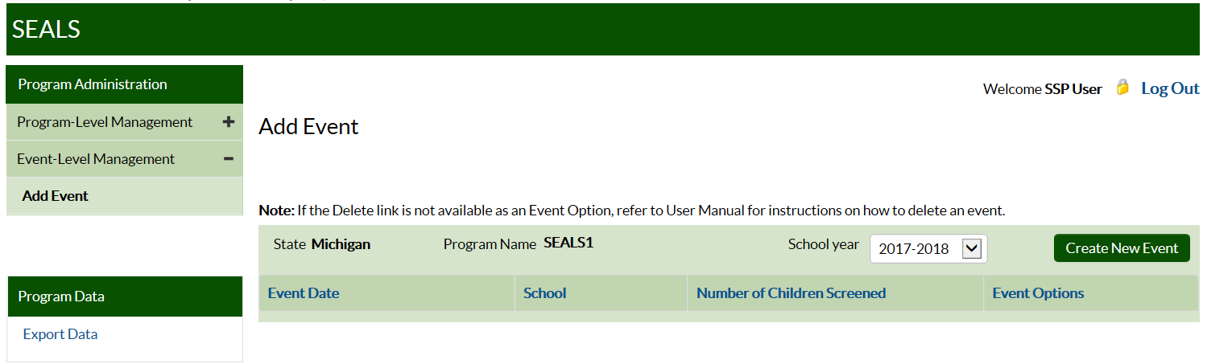

To create an event:
- Click on Create New Event.
- Input information on event date. If an event occurs over more than 1 day, click on the date of the first day, click on date of second day, and continue doing this until you input the last day. If dates are entered manually, be sure to enter a comma in between each date.
NOTE: After you select a date on the calendar, you have to click your mouse outside of the calendar to leave this field.
- Select the school where the event was held from the drop down menu of schools.
- Input information on the number of consent forms distributed.
- Input information on the amount of resources used to deliver services. Resource categories include (Paper log to collect this information at school provided in Section 7 of Appendix (page 31)):
- LABOR: input the total number of hours spent at school for each labor category. For example, if your program sent 2 dental hygienists to a school for 2 days (8 hours per day) then the total number of dental hygienist hours spent at school equals 32. USER TIP: Only input hours for travel time and personal vehicle mileage if your SSP reimburses workers for these items. If your program reimburses workers for their travel time to and from a sealant event, then input total number of travel hours. For example, if each of the 2 dental hygienists in the example above drove his/her car to the sealant event and the travel time each way was 30 minutes, then total travel time for dental hygienists would be 4 hours. Finally, if your program reimburses workers using their own personal vehicles for mileage, then input the total miles for personal vehicles driven to and from that event. Returning to our example, if the sealant event was 45 miles from the SSP office, then total mileage would be 360 miles (45 miles * 2 trips per day * number of hygienists * number of days).
- PROGRAM VEHICLES: input the number of vehicles owned or operated by your SSP that were driven to the event and total mileage per vehicle. For example, if a program owned 1 van and the round trip distance was 20 miles then the number of vehicles is 1 and miles for a 2-day event is 40 (20 * 2 days).
CHILD DATA
- Aggregate child data: If you selected Enter aggregate child data per event in the Entering Child Data item in the Program Options screen, you will be asked to provide the number of children screened, number of children sealed, number of teeth sealed, number of children receiving fluoride varnish, and number of children receiving prophylaxis (provided with hand piece or scaler). Click Done when you’ve finished entering data for this event.
- Detailed child data: If you selected Enter detailed child data in the Entering Child Data item in the Program Options screen, you see Enter Child Data on the bottom right of the screen. Click on Enter Child Data and the following screen will appear:

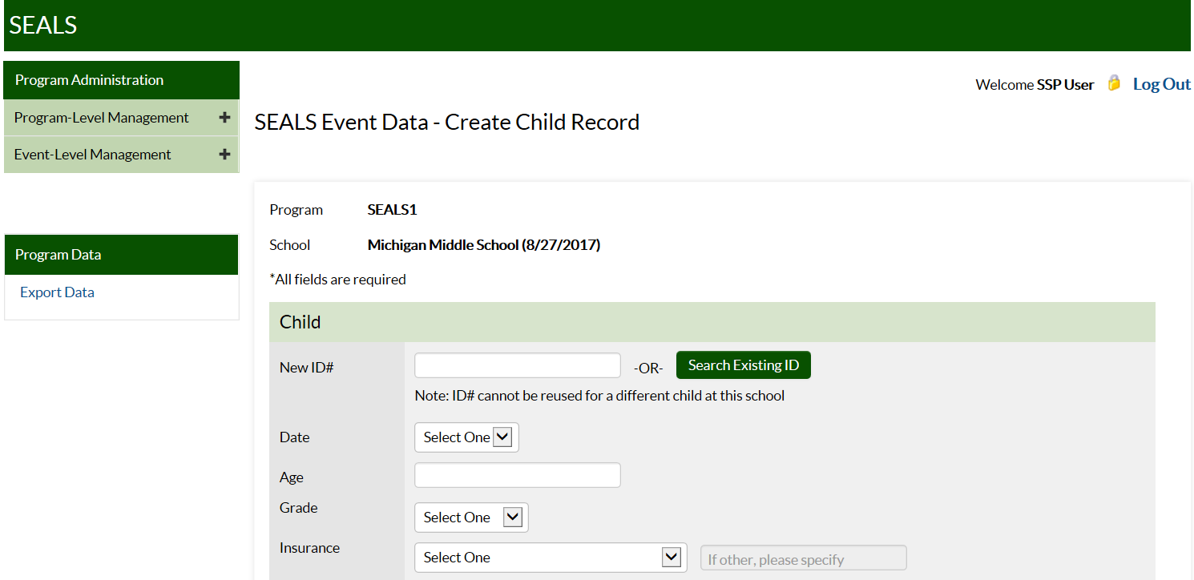

Your program will have to input data for all fields displayed on this page. If your program indicated that it did not provide fluoride varnish and/or prophylaxes, then you will not be able to enter data in these fields. If you mistakenly indicated you did not provide preventive services in addition to sealants, you can go back to the Program Options page and edit the fluoride varnish and/or prophylaxes fields.

User Tip: SEALS allows SSP inputting detailed child data to follow a child during the school year. Figure 2 (page 18) provides a quick overview of how to input data for the same child at initial and follow-up events.
FIRST EVENT
Child Information: The first time your program enters data for a child, you will need to assign a unique identification # that will be associated with this child during the school year and subsequent school years. The identification # can consist of letters and numbers. Please note that each child attending the same school served by your program must have a unique identification # which should not be assigned to a different child in future years. Also, please ensure that the identification # you select could not be used by anyone outside of your program to determine the child’s identity.

You will also need to select the date that the child received services from the menu of dates associated with that event. The first time you see a child, you will also need to input the child’s age (only numbers ranging from 4 to 18 will be accepted) and select the child’s grade and dental insurance status from the drop down menus.

Screening Information: The first time a child is seen, you will need to indicate whether the child had at least 1 tooth with: a) a sealant prior to the program placing sealants, b) untreated decay, c) treated decay (i.e., filling), d) whether child was referred to dentist and urgency of referral, and e) number of permanent 1st molars that had untreated or treated decay.

Preventive Services: Each time a child is seen during the year, you will need to indicate the number of sealants that were placed on permanent 1st molars, permanent 2nd molars, other permanent teeth, and primary molars. You will also need to indicate whether child received a fluoride varnish application and/or prophylaxis.

Once all fields are completed, you can input data for another child (click on Add new child) or save your data by clicking on Done. Once an event is created, it cannot be deleted unless all child records associated with that event are deleted.

Note that if your SSP selects child level data in the Program Option page you will have to input data for each child. If your program decides to switch to aggregate child data during the school year, you will have to delete all child records and input aggregate data for each previous event.

FOLLOW-UP EVENTS
After inputting event information, click on Add new child. On the SEALS Event Data – Create Child Record page, click on Search Existing ID to the right of the Child ID# field. Next, input the child’s identification # into the Existing ID field and click on Search. Indicate whether your program wants to provide additional services and/or conduct a retention check by clicking on appropriate box and then clicking on Select. Information will now appear with the school name, the current event data, and previous dates the child was seen during the current school year and types of services delivered. Note that you can only select the retention box if the current event data is more than 9 months (270 days) and less than 15 months (450 days) since the first time the child was seen during the school year. SEALS only collects information on number of permanent molar sealants retained (i.e., 0 to 8).

User Tip: When inputting retention data you can check how many of the child’s permanent 1st and 2nd molars received sealants from your program if you scroll down.

EDITING EVENT DATA
If your program would like to edit data for an event, click on the SEALS Event Data page. From the list of existing events, locate the event you want to edit and click on Edit. If you would like to add or edit a child record, then click on Add Child and input data for new child or search identification # field for children already seen. Please note that event dates and school name fields cannot be edited once child records have been added to the selected event.

DELETING EVENT DATA
To delete an event, all child records associated with that event must be deleted. To delete a child record, click on the Add Event task bar and then click on the number under Number of Children Screened. A pop-up box will appear with columns containing the child’s ID #, the visit date, and type of services provided (screening, prevention, or screening/retention). If a child received services from your program on more than one day during the event, there will be a separate row for each service date. Click on View/Edit in the right column and a record of the child’s screening data and service history will appear. To delete the record, click on Delete Record on the bottom left of the screen and confirm in the dialogue box. If a child received screening and preventive services on different days, deleting the screening record will result in all other service records being deleted. If you delete a preventive service record, the screening record will remain. Once all child records associated with an event have been deleted, you can delete the event by returning to the Add Event screen and clicking on Delete in the far right column and confirming the change.

Figure 2: Entering Detailed Child Level Data

First Event Where SSP Sees Child

- After an event is created and resource usage information is completed, click on Enter Child Data and complete all data entry fields for child:
  - Child data (ID # and socio-demographic information)
  - Screening information
  - Preventive services delivered

Follow-Up Events at Same School

- After an event is created and resource usage information is completed, click on Enter Child Data and input child’s identification # into Search Existing ID. Indicate whether preventive service, retention check or both were provided. (Note that retention check can only be selected if event data is between 9 and 15 months after first time data was entered for child.)
- Program can only input data on services delivered or retention check information. (Note that child’s screening and socio-demographic data from first visit and past services delivered will appear below preventive services fields.)

Note: To edit child data at first or later events, select relevant event and then click number in number of children screened and a list of the identification #s of all previously seen children will appear. Click on the relevant ID and then edit child’s record.

TASK – EXPORTING DATA

During this phase of development, SEALS only has the capacity to export data into an Excel spreadsheet. To do this, click on the task Export Data, select the year, and then click on export program data.

EXAMPLE: Practice Using SEALS

Let’s get some hands-on practice using SEALS with the following example for a hypothetical school sealant program (SSP) called ABCSeals, which is located in Georgia. Please note that information provided is solely to illustrate how to use the app and is not meant to be representative of an average SSP. In the steps below, we provide information about the ABCSeals program and then ask you to input this information into the app. Note that ABCSeals inputs aggregate child data for their program.

- STEP 1: Use the Add Schools taskbar to create a record for Madison Elementary.
ABCSeals serves 1 school, Madison Elementary.

- STEP 2: Use the Program Options taskbar to input this information for Madison Elementary.
Madison Elementary is a high-need (>50% of students participate in the free/reduced meal program), rural school.

- STEP 3: Use the Program Options taskbar to input this information for ABCSeals.
Characteristics of ABCSeals include:
  - Does not reimburse labor for mileage or travel time to schools.
  - Delivers fluoride varnish in addition to sealants. The program uses 1 dental hygienist and 1 dental assistant per child and it takes 1 minute to apply fluoride.
  - Screens and seals a child at the same seating.
  - Enters aggregate child data per event.

- STEP 4: Use the Cost Options taskbar to input this information for ABCSeals.
ABCSeals pays the following amounts per unit of resource used in delivering sealants:
  - $52.06 per dental hygienist hour.
  - $25.91 per dental assistant hour.
  - $2,500 annually for administrative costs.
  - Depreciates program vehicles used to transport equipment at federal mileage rate of $0.56 per mile.
  - Uses light-cured sealant material applied with two-handed delivery (1 dental hygienist and 1 assistant per station); sealant material costs $1.03 per tooth.
  - ABCSeals has 2 DNTLworks sealant stations less than 15 years old.
  - Uses disposable instruments.

- STEP 5: Use the Add Event taskbar to input this information for ABCSeals.
ABCSeals sent 2 dental teams to Madison Elementary on February 14, 2017. Each team, consisting of 1 DH and 1 DA, drove a van 15 miles to the school and spent 8 hours at the school to set up/break down equipment and deliver services. Services delivered included screening and delivering fluoride varnish to 60 children and delivering 150 sealants to 40 children.
Almost done. Now, let’s export data using the Program Data taskbar.

APPENDIX

Section 1: Access Rights for Different User Types

School Sealant Program User
Full Access rights (within program)
- Add Users
- Add Schools
- Program Options
- Cost Options
- Event-Level Management
  - Child Detail Data
- CSV Export (Online and PDF Summary Reports)

State User
Full Access rights (within state)
- Add Programs
- Add Users
- Online and PDF Summary Reports (No access to CSV export)
Read Only rights (within state)
- Add Schools
- Program Options
- Cost Options
- Event-Level Management
  - Child Detail Data

CDC User

CDC Administrator
Full Access rights (all states and programs)
- Manage School Years
- Settings
- Add Users
- Add Schools
- Program Options
- Cost Options
- Event-Level Management
  - Child Detail Data
- CSV Export (Online and PDF Summary Reports)

CDC Project Officer
Read Only rights (all states and programs)
- Manage School Years
- Settings
- Add Users
- Add Schools
- Program Options
- Cost Options
- Event-level Management
  - Child Detail Data
- Online and PDF Summary Reports (No access to CSV Export)

Section 2: Criteria for High-Need School Classification

The determination of high-need in Funding Opportunity Announcement (FOA) – DP13-1307 for schools located in urban and rural areas is as follows:

- In an urban area, a high-need school is defined as having more than 50% of students qualify for the federal or state free and reduced meal program.
- In a rural area, a high-need school is defined as attending a school located in a school district with a median income that is at or below 235% of the poverty line (as defined by 42 U.S.C. 9902(2)). Because some funded states could not determine the median income for school districts within their state, the Division of Oral Health allowed states to develop their own definition for high-need rural schools.

Section 3. Administrative Costs
(Please note that your program can include other costs that are currently NOT in the SEALS Cost Calculator in this section.)

Administrative Costs per Year
Resource | Cost
Office supplies
Printing
Office rent
Office equipment (computer, phone, printer etc.)
Utilities
(Non-clinician) Administrator salary, if applicable
Labor costs for clinicians performing administrative activities (hours recorded per year)
[Item (f) in Log A]
Labor costs for clinicians performing administrative activities (hours recorded per school)
(from Log B)
Administrative mileage
[Item (d) from Log C below]
Other (Specify)
Other (Specify)
Other (Specify)
Other (Specify)
TOTAL ADMINISTRATIVE

Log A. Labor costs for clinicians performing administrative activities (hours recorded per year)
Staff member | HOURS PER YEAR |  |  |  | Hourly wage (e) | Labor  Cost  [= (d) * (e)]
 | Outreach/ funding/  grant writing (a) | Staff Training (e.g., OSHA compliance, examiner calibration) (b) | Other (specify)  (c) | Total hours (d)  [=(a)+(b)+(c)]
Dental Hygienist
Dental Assistant
Dentist
Other
Other
TOTAL (f)

Log B. Labor costs for clinicians performing administrative activities (hours recorded per school)
Staff member | HOURS PER SCHOOL |  |  |  | Hourly wage (e) | Labor  Cost  [= (d) * (e)]
 | Distributing/managing consents (a) | Administrative follow-up (e.g. billing; data entry) (b) | Other (specify)  (c) | Total hours (d)  [=(a)+(b)+(c)]
Dental Hygienist
Dental Assistant
Dentist
Other
Other
TOTAL (f)

Log C. Administrative mileage log

Date | Administrative activity | Miles driven (a) | Reimbursement rate (b) | Cost (c)  [ = (a) * (b)]
TOTAL (d)

Section 4. Purchase price and cost per unit for sealant material and reusable instruments

Purchase price and cost per tooth for commonly used sealant brands (2016 US$)

Sealant Material | Cost of Product (2016 US$) | Applications per Kit | Cost per Tooth Sealed
Material 1 - light-cured resin | $70.01 | 140.00 | $0.50
Material 2 - light-cured resin | $263.89 | 600.00 | $0.44
Material 3 - light-cured resin | $123.86 | 165.00 | $0.75
Material 4 - light-cured resin | $174.49 | 150.00 | $1.16
Material 5 - light-cured, fluoride release resin | $138.94 | 200.00 | $0.69
Material 6 - autopolymerized glass-ionomer | $254.19 | 150.00 | $1.69
Material 7 - hydrophilic light-cured resin | $88.32 | 100.00 | $0.88

Purchase price and annual cost of reusable instrument sets for various manufacturers

Reusable Mirror/Explorer Set | Purchase Price  (mirror & explorer) | Annualized Per-Set Cost (3% discount rate; 7 year life)
Manufacturer 1 | $18.94 | $2.95
Manufacturer 2 | $20.54 | $3.20
Manufacturer 3 | $29.34 | $4.57
Manufacturer 4 | $38.39 | $5.98
Manufacturer 5 | $50.08 | $7.80

If your program has a different number of mirrors and explorers, then provide the total number of mirrors AND explorers. To estimate the annual cost divide the price of each by 6.42 (annuity factor for 7-year useful life) and then multiply the annual cost of an explorer by the percentage of instruments that are explorers and the annual cost of a mirror by the percentage of instruments that are mirrors. For example, if your program has 20 mirrors (price per unit is $29) and 10 explorers (price per unit is $12) then the cost per set is 20/30 * $21/6.42 + 10/20 *$12/6.42), which equals $3.63.

Section 5. Estimating annual cost of durable goods for different estimates of useful life

Table 1: Purchase Price for Components in Sealant Station (2016 US$)

Manufacturer 1 |  | Manufacturer 2
Description | Price | Description | Price
Express portable dental system | $3,964.75 | Portable sealant unit | $2,700.25
Portable patient chair with case | $1,628.55 | Portable patient chair | $1,593.01
Portable stool with case | $625.25 | Portable operator stool | $661.33
LED portable light with case | $1,017.85 | Halogen light with floor stand | $1,162.17
Portable tray stand | $702.26 | Metal tray with wheeled stand | $232.11
Metal tray | $118.48 | Metal tray | $118.48
LED curing light unit | $999.53 | Patient chair carrying case | $250.96
Instrument/supplies case | $56.01 | Portable stool carrying case | $295.66
Power cord and dolly | $70.01 | Carrying case for halogen light | $187.41
 |  | Portable assistant stool | $812.12
 |  | LED curing light unit | $999.53
 |  | Instrument/supplies case | $56.01
 |  | Power cord and dolly | $70.01

Table 2. Annuity factors for different values of useful life (3% discount rate)

Useful life in years | Annuity Factor
1 | 1
2 | 1.97
3 | 2.91
4 | 3.83
5 | 4.72
6 | 5.58
7 | 6.42
8 | 7.23
9 | 8.02
10 | 8.79
11 | 9.53
12 | 10.25
13 | 10.95
14 | 11.63
15 | 12.30

Section 6. Calculations for annual supply costs

Default cost for once-per-year infection control items (2016 US$)
Items used per year | Per year cost
Eyewash station | $35.37
Blood-borne pathogen spill kit | $10.71
Chemical hazard spill kit | $72.87
First aid kit | $26.79
Sharps container | $5.63
TOTAL | $151.37
Items used once per year per station | Per year cost
Waterline quality testing (2 tests annually) | $51.70
Protective eyewear for child | $4.15
Alligator/bib clips for child | $1.90
TOTAL | $57.75
Items used once per year per operator | Per year cost
Protective eyewear for provider | $4.78

Default cost for infection control items incurred per day

Items used per day per program | Per day cost
Trash liners | $0.48
Hand sanitizer | $0.66
Hand washing soap | $0.40
TOTAL | $1.54
Items used per day per station | Per day cost
Waterline treatment | $1.81
Evacuation/vacuum system cleanser | $3.29
TOTAL | $5.10

Items used per day per operator | Per day cost
Protective clothing | $2.78
Default per child costs for screening/sealant delivery supplies per seating by 2-handed and 4-handed delivery

 | Cost per child screened only, at a given seating | Cost per child sealed
2-handed delivery | $1.15¹ | $1.632
4-handed delivery | $1.15¹ | $2.09³

¹ Estimate includes cost of provider gloves (2 pair: 1 for screening & 1 for cleaning) ($0.31), mask ($0.31), tray cover ($0.03), head rest cover ($0.06), air water syringe tip ($0.19), barrier tape and clear lens wipe ($0.07) and paper towels and disinfectant ($0.19). Only one operator is wearing a mask and gloves. Add $1.59 if disposable instruments used.
2 Estimate includes cost of supplies in footnote 1 plus patient bib ($0.07), saliva ejector ($0.06), dri-angels ($0.08), cotton ($0.04), and toothbrush ($0.23). Add $1.59 if disposable instruments used.
³ Estimate includes cost of supplies in footnote 2, plus an extra mask ($0.31) and pair of gloves ($0.15) for second operator. Add $1.59 if disposable instruments used.

Section 7. Sealant Event Data Collection Form

Event Date(s) __________________________ School ___________________________
Consent Forms Distributed _______________
Labor
 | Dentist | Hygienist | Assistant | Other
Total hours at school
Total hours travelling to and from school
Total miles travelling to and from school²

Vehicles
Number owned/operated by SSP driven to event
Total miles driven for event

Services delivered (Only complete if your program will not input child-level data into SEALS)
Number of children screened
Number of children receiving sealants
Number of teeth sealed
Number of children receiving fluoride varnish
Number of children receiving prophy

Detailed Child-Level Data Collection Form (complete one form per child)

Program Name: _____________________ Event (School/dates): ____________________________________
Patient Name: First: _________________ Last: _________________ Age: _________ (4 to 18 years)
ID #: _____________________________ Date: ________________ Grade: _______
Insurance: _________________________

Screening

Chart for program use (D = decayed, F = filled, M = missing due to disease, S = sealant present, PS = prescribe sealant,
RS = recommend reseal, no mark = no treatment recommended)

1 | 2 | 3 | 4 | 5 | 12 | 13 | 14 | 15 | 16 | Sealant Prescriber’s Signature/Date  ___________________________________  Fluoride Prescriber’s Signature/Date  ___________________________________
32 | 31 | 30 | 29 | 28 | 21 | 20 | 19 | 18 | 17

Comments:

Data for SEALS

Sealants Present:  No/Yes | Untreated Decay:  No/Yes | Treated Decay:  No/Yes | Referral:  None  Not urgent  Urgent | Number of decayed/filled 1st molars:  (0 - 4)=_________________

Preventive Services

Chart for program use (Mark with an “S” the teeth where sealants were placed)

1 | 2 | 3 | 4 | 5 | 12 | 13 | 14 | 15 | 16 | Provider’s signature  ________________________
Date

________________________
32 | 31 | 30 | 29 | 28 | 21 | 20 | 19 | 18 | 17

Comments:

Number of 1st molars  sealed:  (0 - 4) =_________________ | Number of 2nd molars  sealed:  (0 - 4) =_________________ | Number of other permanent teeth sealed:  (0 - 8) =_________________
Number of primary teeth sealed:  (0 - 8) =_________________ | Fluoride varnish provided:  No/Yes | Prophylaxes provided:  No/Yes
Data for SEALS

Follow-Up

Chart for program use (Mark with an “R” teeth where sealants were retained)

1 | 2 | 3 | 4 | 5 | 12 | 13 | 14 | 15 | 16 | Evaluator’s Signature  _________________________
Date

_________________________
32 | 31 | 30 | 29 | 28 | 21 | 20 | 19 | 18 | 17

Comments:

Data for SEALS

Number of teeth with a retained sealant (0 – 8)

Required means that majority of operator’s time is dedicated solely to delivering that service.
2 Required means that majority of operator’s time is dedicated solely to delivering that service.
Default costs are in previous year dollars. For example, for the 2017/2018 school year, default costs will be in $2016 because when the 2017/2018 school year started in July 2017 the most recent annual CPI data available were for 2016.
Annual cost calculations assume 15-year useful life and 3% annual discount rate.
SEALS calculates consent rate by dividing number of children seen by number of consent forms distributed. For each event, the number of consent forms distributed should equal the number of children receiving at least one consent form during the school year.
Equals Log 2B, Item (f) multiplied by number of schools serviced, if one log was completed as representative of all schools; or, equals sum of (f) across all schools, if separate logs were kept for each school.
This is equivalent to the value for TOTAL ADMINISTRATIVE in the example in Table 4.
Add rows as necessary to include all clinical staff performing administrative tasks.
Add rows as necessary to include all clinical staff performing administrative tasks.
Complete one line each time either (1) a program vehicle is used for an administrative task, or (2) personnel perform administrative tasks with their personal vehicles and their mileage is reimbursed. Examples of administrative tasks include such things as dropping off or picking up consent forms at the printer, buying supplies at a brick-and-mortar store, and taking a piece of equipment to a repair shop for maintenance. Do NOT include mileage driven to and from schools for service delivery, since these have been counted in SEALS event data.
To estimate the annual cost of a station or piece of equipment, divide the total cost of the item by the annuity factor that corresponds to the useful life of equipment.
Assumes a program uses 2 liners per day at a cost of $0.24 per liner.
Assumes a program uses 1 gallon of distilled water ($1.17) and 1 tablet where a box of 50 tablets cost $31.97.
Note, if at same school for multiple days, this cost is incurred every 3 days.
For programs that screen and seal separately, this is simply the number of children screened (Log 1, question 5). For programs that screen and seal in one seating, this is the number of children screened/sealed (Log 1, question 5) minus the number that received (a) sealant(s) (Log 1, question 6).
This value is collected in Log 1, question 6.
If SSP uses reusable instruments, hours spent on sterilizing instruments offsite should be included in school hours.
Only complete if your SSP reimburses workers for this item.
Delivered with low-speed hand piece or power scaling.
Each child’s ID # must be unique for that event; do not use duplicate ID #’s at any one event.

