Questions and Answers:
3/17/16 NMI eSHARE Webinar
Overview of NMI Implementation and Technical Assistance Tools

Q: As we just heard, the Association of Public Health Laboratories (APHL) National Notifiable Diseases Surveillance System (NNDSS) Modernization Initiative (NMI) Technical Assistance (TA) team has been integral to the success of the NMI technical assistance efforts. Speaking from your overall experience working with several pilot jurisdictions, what advice would you give to states who are not pilots to prepare themselves now to participate in NMI when it’s available to all?
A: There are several steps that states can take now to begin preparing for NNDSS HL7 case notification message implementation.
- Assess your current infrastructure (i.e., hardware, software, network resources, and related systems) and ensure that you have the minimum requirements to create, generate, validate, and transport HL7 case notification messages.
- Maintain test environments in systems that will be used for case notification messaging that mimic the workflows of the production environments and ensure that that the relationship of the systems in the test environment mirrors those of the production environment.
- Involve key project stakeholders from the start to help ensure a successful, efficient implementation of the HL7 case notification messages. Identify program subject matter experts (SMEs), surveillance system administrators, integration engine (e.g., Rhapsody, Mirth) administrators, network support, and other stakeholders to collaborate on the messaging approach.
- Attend the 4/21/16 NMI eSHARE call to learn more about the NMI onboarding process and understand the requirements that you will need to meet to begin onboarding. Incorporate the onboarding requirements and related documentation into your project plan. (Information about the 4/21/16 eSHARE session may be found on the NMI eSHARE site at https://www.cdc.gov/nndss/trc/onboarding/eshare.html.)

Q: Can someone describe the implementation spreadsheet? This is different from the message mapping guide (MMG), correct?
A: The implementation template compiles information from the PHIN Messaging Guide, NMI HL7 Message Specification, and message mapping guides (generic and condition specific) into one reference. It offers a comprehensive view of the message content and functions as a worksheet for jurisdictions to document local mappings and other implementation notes. For program SMEs, it serves as the worksheet to perform gap analysis (existing data vs. requested data) and map to the local data elements. For IT implementers, it serves as the underlying structure for the integration engine, provides mapping from local to standardized data elements, and links to the bound value set for vocabulary validation.

Q: How much time does it take a jurisdiction or the APHL NMI TA team to build the implementation spreadsheet?
A: The amount of time and effort to build an implementation spreadsheet will vary from state to state, depending on factors such as resource availability, the number of different systems involved, and whether new components are being built for the message route. For states considering technical assistance, APHL terminologists can help alleviate the burden on state resources by building the implementation spreadsheet and reviewing it with state SMEs to ensure that all data are captured correctly.

Q: When will the implementation spreadsheet be available for download on the NMI website?
A: The NMI team anticipates that the implementation spreadsheet for the Generic v2 and Hepatitis MMGs, along with other tools and resources, will be available by late April on the NMI website at http://www.cdc.gov/nndss/.

Q: Will the Rhapsody route RLC file and documentation be available?
A: Yes, the NMI TA team is preparing a template RLC for distribution, which will be available to all sites. This template will be tightly coupled with the Rhapsody development guide and will contain the following:
- A sample database comm point with instructions and example queries.
- A sample mapper filter for generic and Hepatitis that converts XML (auto generated by Rhapsody from a database query) or delimited text files to HL7 messages.
- Lookup table to populate with local values, which is used heavily by the mapper filter.
- Re-usable JavaScript for common functions in the mapper filter.
- Sample database filter to insert the message into PHINMS.

Q: How many hours did implementation take on the jurisdiction side and on the APHL NMI TA team side?
A: The amount of time it takes to implement an HL7 case notification message varies widely based on several factors, including jurisdictional resource levels, staff availability, and surveillance system complexity and level of customization. Subsequent case notification messages may require less time to implement than the initial case notification message implementation. For the NMI TA team, implementation effort ranged between 100 hours to more over 250 hours based on pilot state needs and resources.

Q: Will MAVEN implementation from Minnesota be reusable at other MAVEN jurisdictions?
A: Yes, the goal of the NMI TA team in working with Minnesota was to develop a solution that can be used by other Maven users. The solution uses the jurisdiction’s enterprise relational database (e.g., SQL Server, Oracle, etc.) and integration broker software (e.g., Rhapsody, Mirth, etc.) to create the new HL7 case notification messages outside of the system.

The diagram below depicts what is used in Minnesota. Some modifications may be needed based on the data being collected and question packages used by each jurisdiction.

The NMI TA team plans to schedule a special eSHARE call to discuss the database solutions, such as the ones developed for Maven and Atlas users, in the near future.

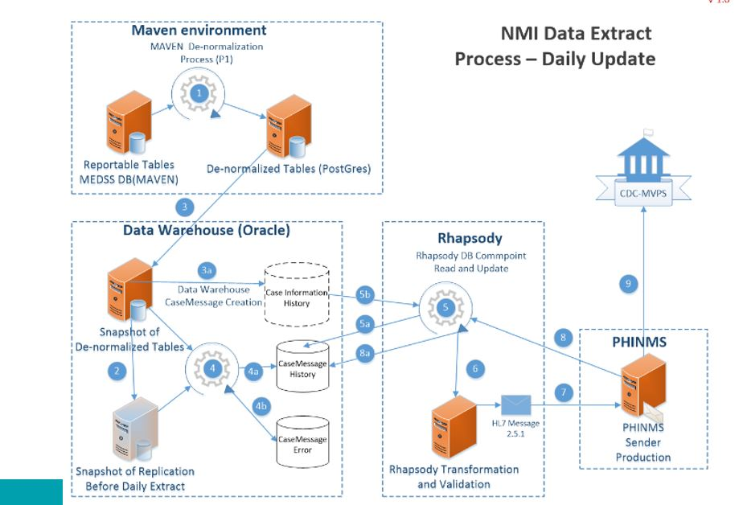

Q: What is the plan to develop message mapping guides—by disease group or individual disease?
A: Whenever possible, the NMI team tries to group conditions so that an MMG addresses a set of diseases with similar data needs. NMI staff work with CDC programs to determine the best strategy.

