Draft Report Template – Public Health Laboratory (PHL) Impact Tool
Overview of report template
This template is provided to help generate a brief report that illustrates a public health laboratory’s contribution to, and impact of, Salmonella diagnostic testing. This template contains a summary of results and screenshots of results tables produced by the Public Health Laboratory Impact tool. Also included is an illustrative example of the impact of Salmonella outbreak response activities, in terms of Salmonella cases averted, hospitalizations and total medical costs averted. Note that if a user of this template wishes to include an illustration of the impact of public health actions to reduce cases of salmonella(e.g., by recall of contaminated produce), then the optional worksheet number 6, Illustrations of Response Impact in the tool must be completed.

The user can remove, add or otherwise alter this report template as needed.
Contents of draft report

- Objective

- Summary of results

- Illustrative example: Impact Salmonella outbreak response activities

- Results tables (in order of appearance in report template):
- Table 1. Salmonella specimens and isolates tested
- Table 2. Medical costs and lab testing costs associated with Salmonella outbreak
- Table 3. Salmonella cases and health outcome
- Table 4. Illustration of Salmonella outbreak response impact

- Methods

- Appendices (optional)

Disclaimers. The numbers contained in this report should be treated as illustrations of what could happen (with unknown probability of actual occurrence). The numbers in this report, therefore, are intended solely as a guide to help public health officials and policymakers plan and prepare.

The findings and conclusions in this report and the accompanying appendices and spreadsheets are those of the author and do not necessarily represent the views of [Jurisdiction X].

This report is considered to represent technical help to the Public Health Laboratory, State or local municipality of Y. It is not considered a publication of any form, nor has it been officially cleared by the author’s agency. The mention of any specific, commercially available product is merely to inform the reader of methods used to produce the results presented. Such mention of specific products does not constitute any endorsement.

Objective
To inform public health laboratory (PHL) decision-makers and funders about the resources needed for nontyphoidal Salmonella diagnostic testing, and PHL impact on nontyphoidal Salmonella, in terms of:

- Annual non-typhoidal Salmonella diagnostic testing throughput;
- Total annual lab testing costs for nontyphoidal Salmonella;
- Average cost of Salmonella laboratory testing per specimen or isolate; and
- Number of cases of Salmonella averted, number of hospitalizations due to active Salmonella cases averted, total direct medical costs averted (illustration).

Summary of Results (Example bullet points are based on average annual level of Salmonella outbreak activity and PHL Impact tool default values)
- PHL tested (in year X) 200 specimens and 800 isolates, costing the lab approximately $368,000 (2019 USD). (Tables 1 and 2)
- Average cost was $320 per specimen tested and $380 per isolate tested. (Table 1)
- In Jurisdiction X, an estimated total of 23,280 Salmonella cases led to 438 hospitalizations, and 9 deaths (year X, adjusted for under-reporting and under-diagnosis). (Table 3)
- Total direct medical costs associated with outbreaks of Salmonella in Jurisdiction X exceeded an estimated $7.0M (year X, adjusted for under-reporting and under-diagnosis). (Table 2)

Illustrative example: Impact Salmonella outbreak response activities
During the 2020 multistate outbreak of Salmonella linked to onions, Jurisdiction X reported 100 cases of Salmonella that were attributed to the estimated 3,000 cases of onions consumed by the public. Working with retailers to discard approximately 2,000 cases of the implicated product, Jurisdiction X directly averted an estimated 67 cases, one hospitalization, and almost $24,000 total in medical costs. (Table 4)
Note: The estimated cases averted for a specific outbreak does not take into account other potential outbreak-related impacts such as preventing future outbreaks from the same strain, informing consumers, or supporting initiatives to prevent the majority of infections that are not associated with outbreaks.

Results: (user copy-pastes tables from Results and Results – Response Illustration tabs in the PHL Impact tool)
Table 1.
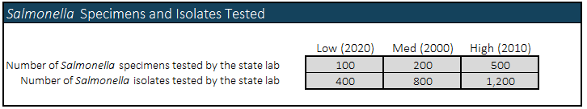

Table 2.
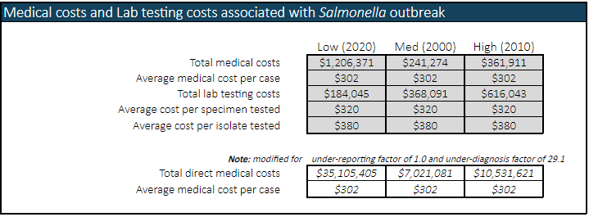

Table 3.
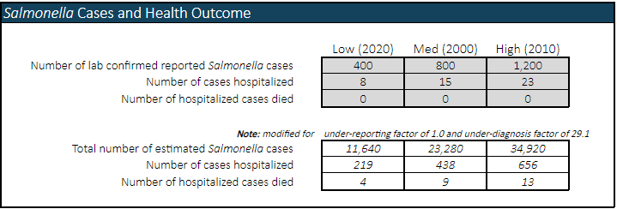

Table 4.
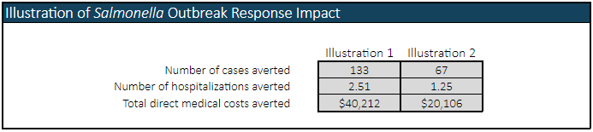

Methods: Used the PHL Impact, a spreadsheet tool to estimate the impact of the public health laboratory in [state] on Salmonella diagnostic testing, and the associated state lab costs. Spreadsheet calculations are similar to those of a standard cost-effectiveness analysis.

For this brief report, the following data sources were used to obtain estimates … user lists data sources or default values used for each of the input tabs list below:

- Epidemiology;
- Medical Costs;
- Lab Testing;
- Lab Costs;
- Response Activities; and
- Response Illustrations (optional).

Appendices (optional)

