Name:

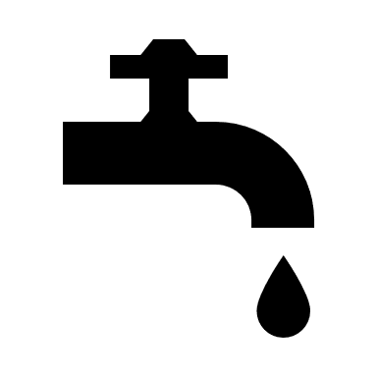 | Making Water Safe  Student Data Collection Sheet

Think About It! Write your answers below:
Understanding Drinking Water | 1. What are some sources of drinking water?
 | 2. Why is clean drinking water important?
 | 3. Why do some communities not have access to clean drinking water?

Safe Water and CDC | 1. Why was it important for cities to sanitize their public water sources?
 | 2. How many people around the world struggle with access to clean water?
 | 3. How does the Safe Water System address global water sanitation issues?
In this step, you share your information. Sharing the information you collect is key. Click the links below to share:
https://observer.globe.gov/do-globe-observer/mosquito-habitats
http://www.citizenscience.us/imp/collectionform.php

Citizen Science | 1. What are the dangers associated with diarrheal diseases?
 | 2. Explain the role communication plays in water safety.
 | 3. How can your efforts support the efforts of CDC?

Engineer a Water Filter
Below, write the steps you took for your water filter procedure. In the blank space provided, include drawings of your containers for each step.

Build a Prototype
Once you have decided on the materials you will use to filter your water, you need to decide the order you want them to go inside the container. Once you have determined your order, draw a diagram with each layer labeled in the container. Paste in photos if you can.

Test the Prototype
- Add up the point values for your filtered water. A good filter will earn at least 5 points. A better filter will earn at least 6 points. A great filter will earn 7 or more points.
- If your prototype scores a 4 or less, think about improvements that could be made. Run the engineering design process again, this time changing the layers you use to filter. This could involve changing the materials themselves, the order of the materials, or both.
- If your prototype scores well, try to replicate the results by building a second prototype of the same kind. Again, repeat the engineering design process.
- For your third prototype, focus either on recovery or filtration. Repeat the engineering design process.
- Record your results for each prototype by highlighting them in the tables below.

Prototype 1: Data Table
Filtration: How  close does your  filtered water  look to the clean  water? | My filtered water  looks like cup A.  1 point | My filtered water  looks like cup B.  2 points | My filtered water  looks like cup C.  3 points | My filtered water  looks like cup D.  4 points
Recovery: How  much water did  your filter let  through? | My filter let none of  the water through.  1 point | My filter let less  than half of the  water through.  2 points | My filter let more  than half of the  water through.  3 points | My filter let all the  water through.  4 points

Prototype 2: Data Table
Filtration: How  close does your  filtered water  look to the clean  water? | My filtered water  looks like cup A.  1 point | My filtered water  looks like cup B.  2 points | My filtered water  looks like cup C.  3 points | My filtered water  looks like cup D.  4 points
Recovery: How  much water did  your filter let  through? | My filter let none of  the water through.  1 point | My filter let less  than half of the  water through.  2 points | My filter let more  than half of the  water through.  3 points | My filter let all the  water through.  4 points

Prototype 3: Data Table
Filtration: How  close does your  filtered water  look to the clean  water? | My filtered water  looks like cup A.  1 point | My filtered water  looks like cup B.  2 points | My filtered water  looks like cup C.  3 points | My filtered water  looks like cup D.  4 points
Recovery: How  much water did  your filter let  through? | My filter let none of  the water through.  1 point | My filter let less  than half of the  water through.  2 points | My filter let more  than half of the  water through.  3 points | My filter let all the  water through.  4 points

Design a Safe Water Practices Infographic
What image did you decide to use? Why? How does your image help to explain each action a person should take?

How did you decide to organize your design? Why?

Paste your infographic below:

Reflections
Now that you have completed this design challenge, think about what you learned from your research and engineering design process. Answer the questions below.
- What is the role sanitation plays in keeping us healthy?

- What are some challenges communities experience with their drinking water?

- Why is it important to raise awareness about global public health?

- What are the effects of unsafe water in the environment?

- Should money from the United States be used to support clean water efforts in other countries? Why or why not?

- Should international health organizations focus only on countries without clean water? Why or why not?

