Name:

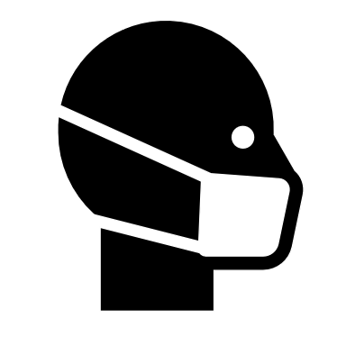 | Masks Against COVID-19  Student Data Collection Sheet

Think About It! Write your answers below:
What is COVID-19? | - How can wearing a mask help stop the spread of viruses?
 | - Are some types of masks better than others? Explain your answer.
 | - What are some steps you could take to protect yourself and your community from COVID-19?

COVID-19  and CDC | - What is the primary way that the SARS-CoV-2 virus spreads from person to person?
 | - If a person’s mask drops below their nose, what happens to their respiratory droplets?
 | - What are some reasons that people might have to choose masks instead of vaccination to protect them from COVID-19?
In this step, you share your information. Sharing the information you collect is key. Click the links below to share:
https://observer.globe.gov/do-globe-observer/mosquito-habitats
http://www.citizenscience.us/imp/collectionform.php

Citizen Science | - According to Dr. Carlson, what are other ways besides respiratory droplets that SARS-CoV-2 can be spread from person to person?
 | - What are some problems you have encountered while wearing a face mask that you might want to fix in your design?
 | - As new variants of COVID-19 emerge, the efficacy rates of vaccines may decrease. How will this affect communities? How might we respond to this change?

Test Face Masks: Data Collection
Mask Material | # of Layers | Reading Test | Singing Test | Blow Test
No Face Mask | 0 | Did candle go out?  Yes No  Candle Movement:  0 1 2  Observations: | Did candle go out?  Yes No  Candle Movement:  0 1 2  Observations: | Did candle go out?  Yes No  Candle Movement:  0 1 2  Observations:
 |  | Did candle go out?  Yes No  Candle Movement:  0 1 2  Observations: | Did candle go out?  Yes No  Candle Movement:  0 1 2  Observations: | Did candle go out?  Yes No  Candle Movement:  0 1 2  Observations:
 |  | Did candle go out?  Yes No  Candle Movement:  0 1 2  Observations: | Did candle go out?  Yes No  Candle Movement:  0 1 2  Observations: | Did candle go out?  Yes No  Candle Movement:  0 1 2  Observations:
 |  | Did candle go out?  Yes No  Candle Movement:  0 1 2  Observations: | Did candle go out?  Yes No  Candle Movement:  0 1 2  Observations: | Did candle go out?  Yes No  Candle Movement:  0 1 2  Observations:
 |  | Did candle go out?  Yes No  Candle Movement:  0 1 2  Observations: | Did candle go out?  Yes No  Candle Movement:  0 1 2  Observations: | Did candle go out?  Yes No  Candle Movement:  0 1 2  Observations:
Candle Movement Key:
0 = no movement 1 = slight movement 2 = significant movement

Design a Better Face Mask: Design Your Mask
Select your face mask material. You can start from scratch with cloth or try to improve the design of an existing disposable mask to improve comfort and fit. Draw a diagram of your face mask below. Label the materials used and any special features you will be adding for comfort or fit. Add a photo if you can.

Design a Better Face Mask: Test Your Mask
What improvements to fit or function did your prototype need? How would you redesign it?

Reflections
Now that you have completed this investigation, think about what you learned from your research and experiments. Answer the questions below.
- How do masks help stop the spread of the virus that causes COVID-19?

- What is the single best way to protect yourself from COVID-19?

- The SARS-CoV-2 virus is only about 100 nanometers in diameter. The holes in your standard cloth or surgical mask are much larger than the size of a coronavirus. Given the way the virus is transmitted, why are masks still so effective at stopping transmission of the virus?

- Carbon dioxide and oxygen molecules are more than 3,000 times smaller than a SARS-CoV-2 virus particle. Based on the information given in the previous question, how effective are masks at blocking these tiny gas molecules from entering/exiting? Explain your answer.

- Describe the results of your candle tests and how you used them to select the material for your mask design.

- Why might some people be reluctant to wear masks? What might you say to convince them that wearing masks is the right thing for them and their communities?

