Name:

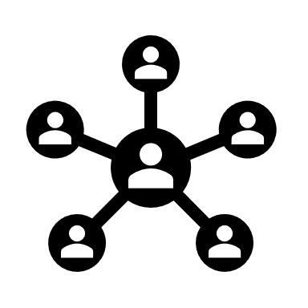 | Contact Tracing  Student Data Collection Sheet

Think About It! Write your answers below:

Understanding Contact Tracing | - What experiences have you had with contact tracing in your community?
 | - What difficulties do you think contact tracers might have when attempting to contact people after a disease diagnosis?
 | - Why might quarantining after a disease exposure be difficult for some people?

Contact Tracing and CDC | - What are some reasons why contact tracing is more difficult in remote areas?
 | - If contact tracers miss one close contact, what are possible consequences?
 | - What skills do you think contact tracers need most?
In this step, you share your information. Sharing the information you collect is key. Click the links below to share:
https://observer.globe.gov/do-globe-observer/mosquito-habitats
http://www.citizenscience.us/imp/collectionform.php

Citizen Science | - During the 2014-16 Ebola outbreak, how did CDC help with contact tracing?
 | - Why do you think the first 2-3 days after infection is the critical window for contact tracing to occur?
 | - How are schools in the United States using contact tracing to keep students safe?

Conduct a Disease Transmission Experiment: Data Collection
Record the results from your contact tracing experiments in the table below.
Person 1 |  | Person 2 |  | Person 3 |  | Person 4 |  | Person 5 |  | Person 6
Round 1 |  | Round 1 |  | Round 1 |  | Round 1 |  | Round 1 |  | Round 1
Round 2 |  | Round 2 |  | Round 2 |  | Round 2 |  | Round 2 |  | Round 2
Round 3 |  | Round 3 |  | Round 3 |  | Round 3 |  | Round 3 |  | Round 3
+ or - |  | + or - |  | + or - |  | + or - |  | + or - |  | + or -
Person 7 |  | Person 8 |  | Person 9 |  | Person 10 |  | Person 11 |  | Person 12
Round 1 |  | Round 1 |  | Round 1 |  | Round 1 |  | Round 1 |  | Round 1
Round 2 |  | Round 2 |  | Round 2 |  | Round 2 |  | Round 2 |  | Round 2
Round 3 |  | Round 3 |  | Round 3 |  | Round 3 |  | Round 3 |  | Round 3
+ or - |  | + or - |  | + or - |  | + or - |  | + or - |  | + or -

Use the results of your activity to identify your initial index cases. Due to the limitations of this experiment, you will not be able to find a single initial index case, but you should be able to narrow it down to 2 individuals.
• Stuck? Cut out the 12 person cards and move them around to help you better visualize it.
• Start by writing your positive pairs in the bottom row and work your way up to the top.
 |  |  |  |  | Index Case
 |  |  |  |  | / |  |  |  |  |  | \
Round 1 Positives
 |  |  | / |  | \ |  |  |  |  |  | / |  | \
Round 2 Positives
 | / |  | \ |  | / |  | \ |  | / |  | \ |  | / |  | \
Round 3 Positives

Plan a Contact Tracing Interview
Based on David’s background information, what questions do you have for him?
What specific recommendations do you have for David based on his background information?

Reflections
Now that you have completed this investigation, think about what you learned from your research and experiments. Answer the questions below.

- What is the main goal of contact tracing?

- How does contact tracing slow the spread of a disease?

- In your two contact tracing activities, what did you find challenging? What were some key understandings that you gained?

- Why is contact tracing often more important for asymptomatic cases of a disease compared to symptomatic cases?

- Which do you think is more important: an individual’s right to withhold their private health information (individualism) or the public health department’s ability to monitor disease in a community (collectivism)?

- Molecular evidence from DNA, RNA, or proteins is used to study outbreaks. How could sequences from different strains of a virus help scientists trace the path of an infection?

