Name:

Get the Lead Out
Student Data Collection Sheet

Think About It! Write your answers below:
Understanding Lead | - What are some common reasons that environmental hazards are not addressed?
 | - What kind of work do you think CDC’s National Center for Environmental Health (NCEH) does to address environmental hazards?
 | - Give two examples of health disparities that might result from environmental hazards.

Lead  and CDC | - Why do you think lead poisoning is a health disparity linked to socioeconomic factors?
 | - How was NHANES data useful in supporting the ban of lead from gasoline and fuel?
 | - Why did the Zamfara team educate the villagers rather than shut down the mine?
In this step, you share your information. Sharing the information you collect is key. Click the links below to share:
https://observer.globe.gov/do-globe-observer/mosquito-habitats
http://www.citizenscience.us/imp/collectionform.php

Public Health | - It took 18 months for the people of Flint, Michigan to convince others that their drinking water was unsafe. Why might this be an example of a health disparity?
 | - Elevated lead levels can affect learning, ability to pay attention, and academic achievement in children. How can these symptoms lead to inequality?
 | - After examining the NCEH website, what environmental health topics surprised you? Why do you think these areas are considered part of public health?

Examine Historical Lead Data
The National Health and Nutrition Examination Survey (NHANES) is a program of studies designed to assess the health and nutritional status of adults and children in the United States. The survey is unique in that it combines interviews and physical examinations. The survey is a major program of the National Center for Health Statistics (NCHS), which is part of CDC. It has the responsibility for producing vital and health statistics for the Nation.

DATA SET 1: BLOOD LEAD LEVELS, 1976-1980

Surveillance (What is the problem?)
The U.S. Environmental Protection Agency (EPA) issued regulations to gradually reduce the amount of tetraethyl lead over time, starting in 1973. CDC responded by adding blood lead level measurements to NHANES to collect surveillance data about its effects. The following data were collected and presented to Congress in hearings regarding the regulation of tetraethyl lead in gasoline. The “Predicted blood lead” line represents the scientists’ prediction for how the blood lead levels of the community would change in response to the reduction of tetraethyl lead in gasoline.
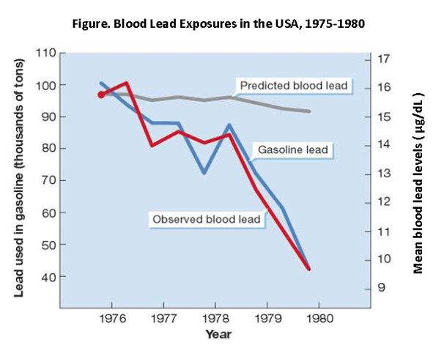

Risk Factor Identification (What is the cause?)
Examine the relationship between gasoline lead and observed blood lead in the surveillance data above. What pattern do you see?

How does the line for predicted blood lead relate to the line for observed lead? What does this mean about the impact of gasoline lead on observed blood lead?

Based on this surveillance data, who is at risk for lead exposure?

Intervention Evaluation (What works?)
As of 2021, CDC recognizes 3.5 μg/dL as the level of concern for lead poisoning. Based on these data, what is the maximum amount of lead that should be in gasoline to reduce blood lead levels so that the entire population is below this level? Justify your answer using data.

Implementation (How did we do it?)
Car manufacturers were ordered to begin building engines to run on unleaded gasoline by 1975, which led to the widespread use of the catalytic converter. Since lead damages catalytic converters, demand for leaded gasoline shrank. In 1996, EPA banned leaded gasoline from all on- road vehicles. The health effects of this ban can be observed through continuing surveillance.

DATA SET 2: BLOOD LEAD LEVELS, 1999-2016

Surveillance (What is the problem?)
Though lead has been removed from both paint and gasoline, there are still other sources in the environment. To monitor environmental lead, NCHS has continued to record blood lead levels in the population through NHANES. The data below show blood lead concentrations for the U.S. population age 1 and older from 1999-2016, broken down by sex, race and ethnicity, and age group.

Risk Factor Identification (What is the cause?)
Exhibit 1. What patterns related to sex do you notice in the graph below? What risk factors may be responsible?
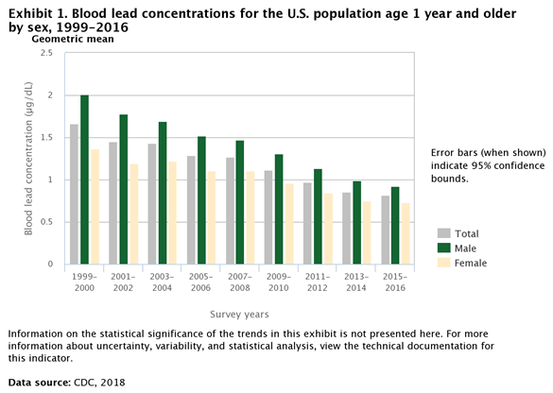

Exhibit 2. What patterns related to race and ethnicity do you notice in the graph below? What risk factors may be responsible?
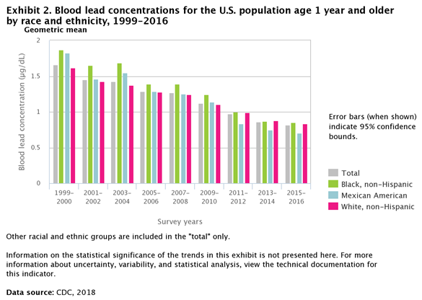

Exhibit 3. What patterns related to age do you notice in the graph below? What risk factors may be responsible?
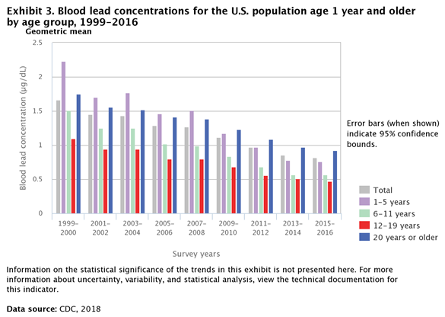

Intervention Evaluation (What works?)
Think about the data and the risk factors you have identified. To improve the health of the public, you should start by addressing these health disparities. What are three interventions you would suggest to address these disparities?

Implementation (How did we do it?)
Choose one intervention strategy that will be the most successful based upon your reading and data analysis. How would you implement this intervention?

What challenges do you anticipate in implementation?

Develop a Plan to Address a Public Health Emergency
Given what occurred with the water in Flint, Michigan, what support does the community need to address the issues brought about by the elevated lead levels in the water? Design a public health intervention strategy that would address the long-term effects of elevated lead levels in Flint’s water. You may find useful resources here: https://www.cdc.gov/nceh/lead

Surveillance (What is the problem?)
What type of data would you like to collect? How will you collect it?
Example: You could conduct phone interviews with people in Flint to assess their needs.

Risk Factor Identification (What is the cause?)
What group would you want to address with your intervention?
Example: You could design an intervention for third graders with low reading or math test scores.

Intervention Evaluation (What works?)
Propose 3-5 intervention strategies that you think could address the issue you have identified.
Example: Provide increased Medicare benefits so that residents of Flint can get medical care.

Implementation (How do we do it?)
Come up with a plan to implement the intervention that you think would be most effective.
Ex: You could secure government funding to open free preschool for all Flint kids.

Reflections
Now that you have completed this investigation, think about what you learned from the information presented. Answer the questions below.
- How have the sources of lead in the environment changed over the last hundred years?

- Why are small children so much more at risk for lead poisoning than adults?

- How has the amount of lead in Americans’ blood changed since the 1970s? Use the data from the graphs provided to justify your answer.

- In interviews with long-term NHANES team members, many cited the blood lead level data as the organization’s proudest achievement. Why do you think this is the case?

- When designing public health interventions, why is it so important to consider the specific needs of the community and the resources available to solve the problem?

- The Clean Air Act of 1976 gave EPA the right to regulate substances whose emission products endanger the public health or welfare. Ethyl Corporation sued for the right to continue producing gasoline with lead after the EPA banned it, claiming that there was no proof of harm from lead. If you were the judge in this case, how would you rule? Why?

