Smear Preparation

Introduction
The process of making a smear preparation is an important skill in the microbiology laboratory and is usually the first step in most staining procedures. The quality of the smear will directly affect the quality of the subsequent staining procedure. The smear preparation differs slightly depending on the specimen or culture.

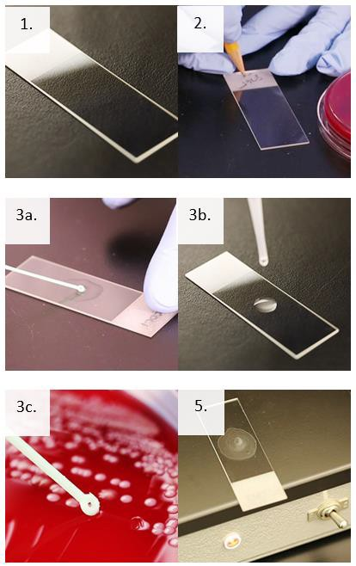Supplies
4a.
4b.
4c.
- Personal protective equipment
- Sharps container
- Biological waste container
- Microscope slides with frosted-edge
- Pencil or wax pencil
- Sterile saline or water
- Sterile pipettes
- Loops or applicator sticks
- Slide warmer, Bunsen burner, or methanol

Instructions
- Be sure to wear appropriate personal protective equipment (PPE) to include gloves, laboratory coat, and face and eye protection, as indicated in your laboratory's SOP and safety manual.
- Obtain a clean microscope slide with a frosted edge.
- Label the frosted edge appropriately with the sample identification.
- Transfer specimen or culture to the center of the slide.
  - Clinical Specimen: Prepare a thin layer of cells on the slide. Refer to your laboratory’s procedure according to different specimen types.
  - Broth Culture: Using a sterile pipette, transfer 1-2 drops to the slide. Spread the drop into a thin, even smear.
  - Culture from solid media: Using a sterile pipette, add one drop of sterile saline or sterile water to
the center of the microscope slide. Aseptically pick a small amount of an isolated colony with a loop and gently mix into the drop of sterile saline or water using circular motions. Mix evenly to make a thin smear.
- Allow the smear to air dry completely.
- Fix the smear to the slide using heat fixation or methanol fixation according to your laboratory’s procedure.
- Allow the slide to cool to room temperature or air dry.
Note: Do not drag the 40X objective through the oil.
This job aid is a component of the free, on-demand CDC training course “Routine Microscopy Procedures.” Find the course at https://www.cdc.gov/labtraining.

