[Insert your agency information here.]

KOH Procedure

Introduction
The KOH (Potassium hydroxide) procedure is a method used to examine specimens for yeast. KOH serves as an enzymatic agent that breaks down debris in a specimen, such as epithelial cells and WBCs, to view yeast or pseudohyphae.

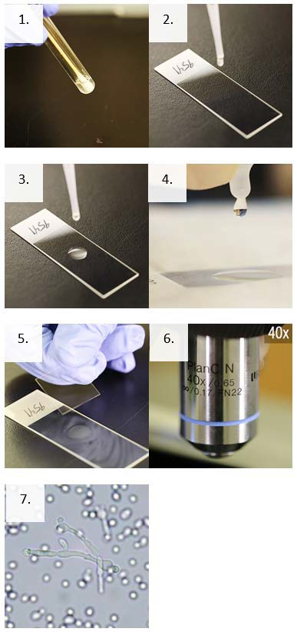
Supplies
- Personal protective equipment
- Sharps container
- Biological waste container and bag
- Sterile microscope slides
- Sterile pipettes
- Glass coverslips
- Potassium hydroxide (KOH)

Instructions
- Mix the specimen well.
- Using a sterile pipette, remove one drop or 10 microliters of the specimen from the tube.
- Place one drop (10 µL) of the specimen on a clean microscope slide with the patient’s identification number.
- Without touching the specimen, add one drop (10 µl) of 10% Potassium hydroxide (KOH) directly to the drop of specimen on the slide.
- Place a coverslip on the drops on the slide.
- Place the slide on a brightfield microscope, focus using low power (10X), and scan at least 10 fields using high dry power (40X).
- Examine for budding yeast or yeast with pseudohyphae.
- Record results based on your laboratory’s criteria.

This job aid is a component of the free, on-demand CDC training course “Routine Microscopy Procedures.” Find the course at https://www.cdc.gov/labtraining.

