Glove Removal Job Aid

Disposable Gloves (latex, vinyl, nitrile)
Disposable gloves reduce hand contamination, prevent cross-contamination, and protect from infection. Gloves should fit properly; not restrict hand coordination; accommodate individual requirements, such as allergy to latex, and meet the requirements of the task being performed. Rings, long fingernails, and fingernail jewelry can make it more difficult to put on the gloves properly and can also cause gloves to tear more easily.
To help prevent allergic reactions to latex gloves
- Do not use oil-based hand creams or lotions when wearing latex gloves.
- Wash hands with a mild soap and dry thoroughly after removing gloves.
- Do not use powdered latex gloves.

For additional latex allergy information: www.cdc.gov/niosh/topics/latex

All employees using disposable gloves must observe the following precautions:
- Cover open sores, dermatitis, cuts, and other lesions with a dressing or bandaging.
- Wash hands before putting on gloves.
- Never wash or reuse disposable gloves.
- Remove gloves after they become contaminated, as well as before leaving the work area.
- Remove contaminated gloves using a procedure that avoids contact with the outer surface of the gloves.
- Dispose contaminated gloves in infectious waste containers in the work area.
- Wash hands immediately, or as soon as possible after the removal of gloves.

Procedure for Removing Gloves Safely
- With the right hand, pinch the palm of the left glove and pull left glove down and off your fingers.

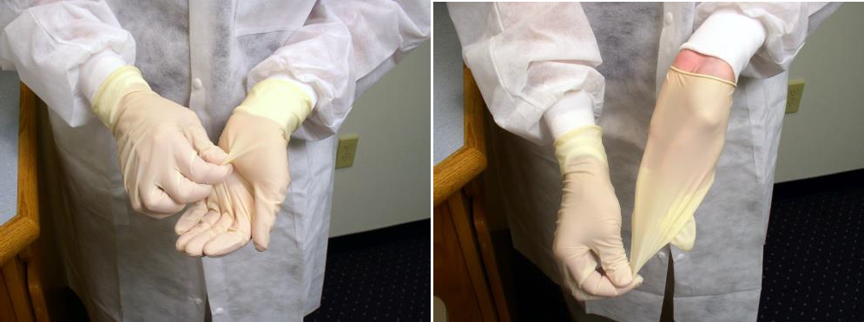

Center for Surveillance, Epidemiology, and Laboratory Services

- Form the left glove into a ball and hold it in the fist of your right hand. Insert two fingers of the left hand under the inside rim of your right glove on the palm side.

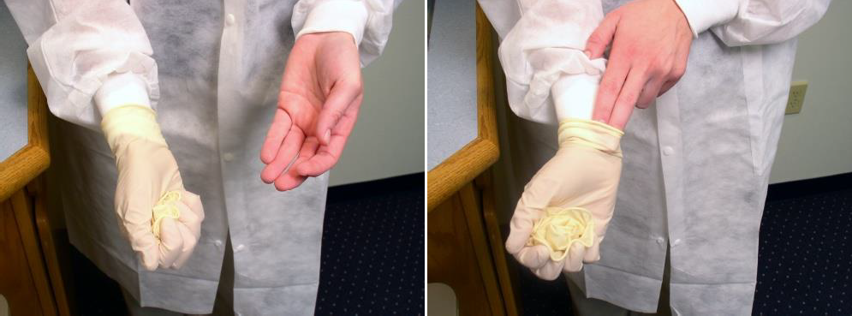

- Push the glove inside out and down onto your fingers and over balled left glove. Grasp the gloves, which are inside out, and together with your left hand, and remove them from your right hand.

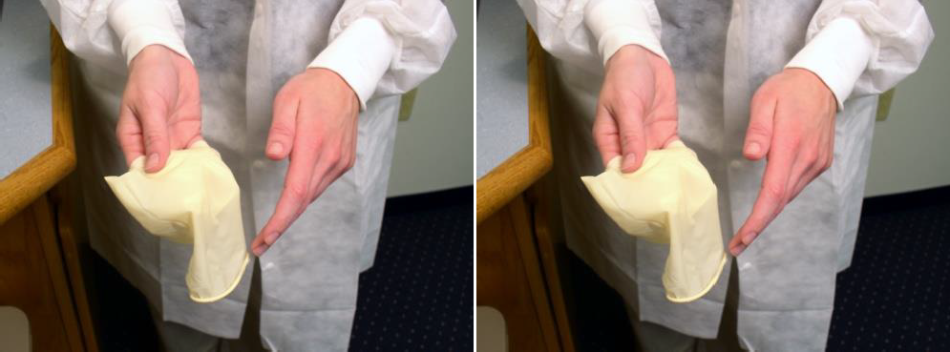

- Discard the gloves into an infectious waste container and wash your hands.

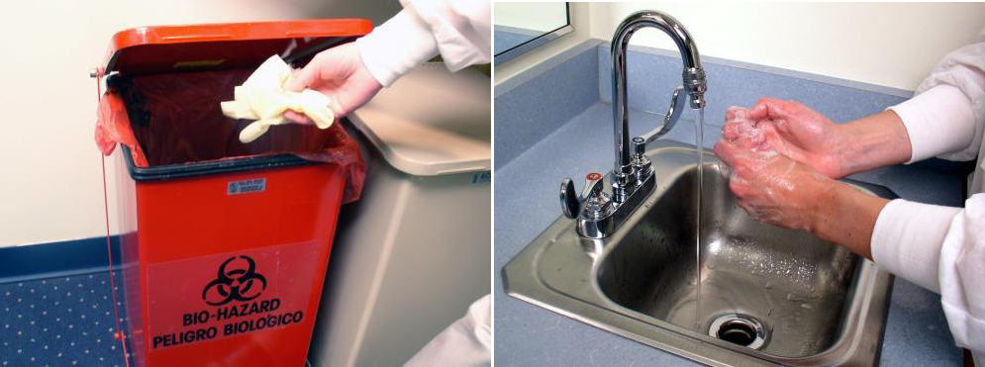

This job aid is a component of the free, on-demand CDC training course “Ready? Set? Test!” Find the course at https://www.cdc.gov/labtraining.

