Step 3: Packing Category A and B and Exempt Human and Exempt Animal Specimens Job Aid

Use the pages below as a reference for packing Category A, B, and Exempt Specimens.

Category A Substance Packaging

NOTE: The packaging is the same for both types (UN 2814 and UN2900) of Category A packaging, only the UN mark and Proper Shipping Names change.

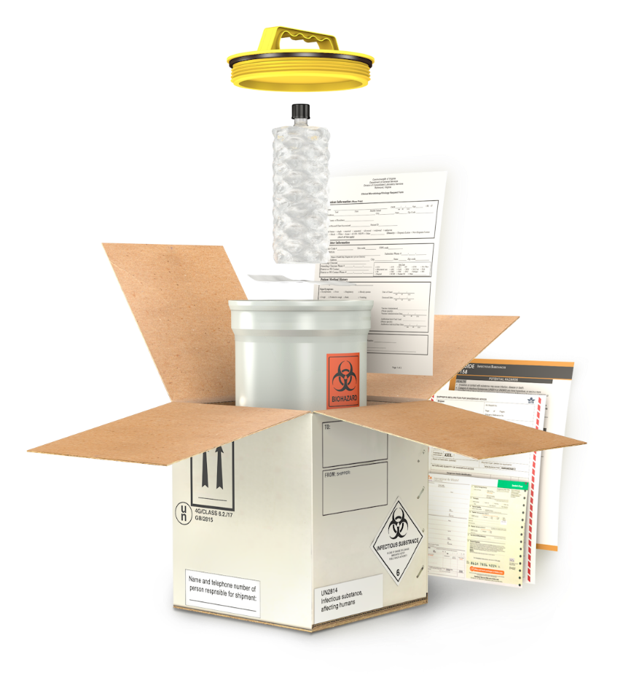
Leakproof/ siftproof primary receptacle
Secondary packaging cap

Documentation

Cushioning materials

Biohazards symbol on primary receptacle or secondary packaging if the substance contains blood or is contaminated with human blood
Absorbent materials

Rigid outer packaging

Leakproof/ siftproof secondary packaging

Documentation

Shipper and consignee identification

Package Orientation label if more than 50 ml of liquid

Division 6.2 infectious substance label
UN specification mark

Responsible person label

Proper Shipping Name

Category A Substance Packaging with Dry Ice

Dry Ice Class 9 label

UN1845 and qty

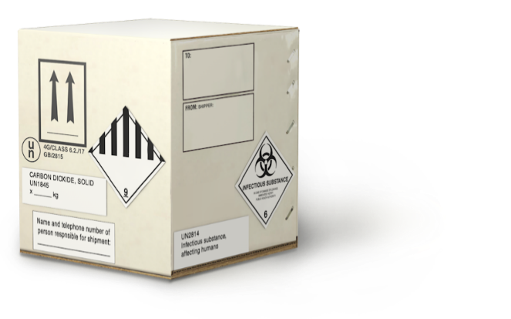

Category B Substance Packaging

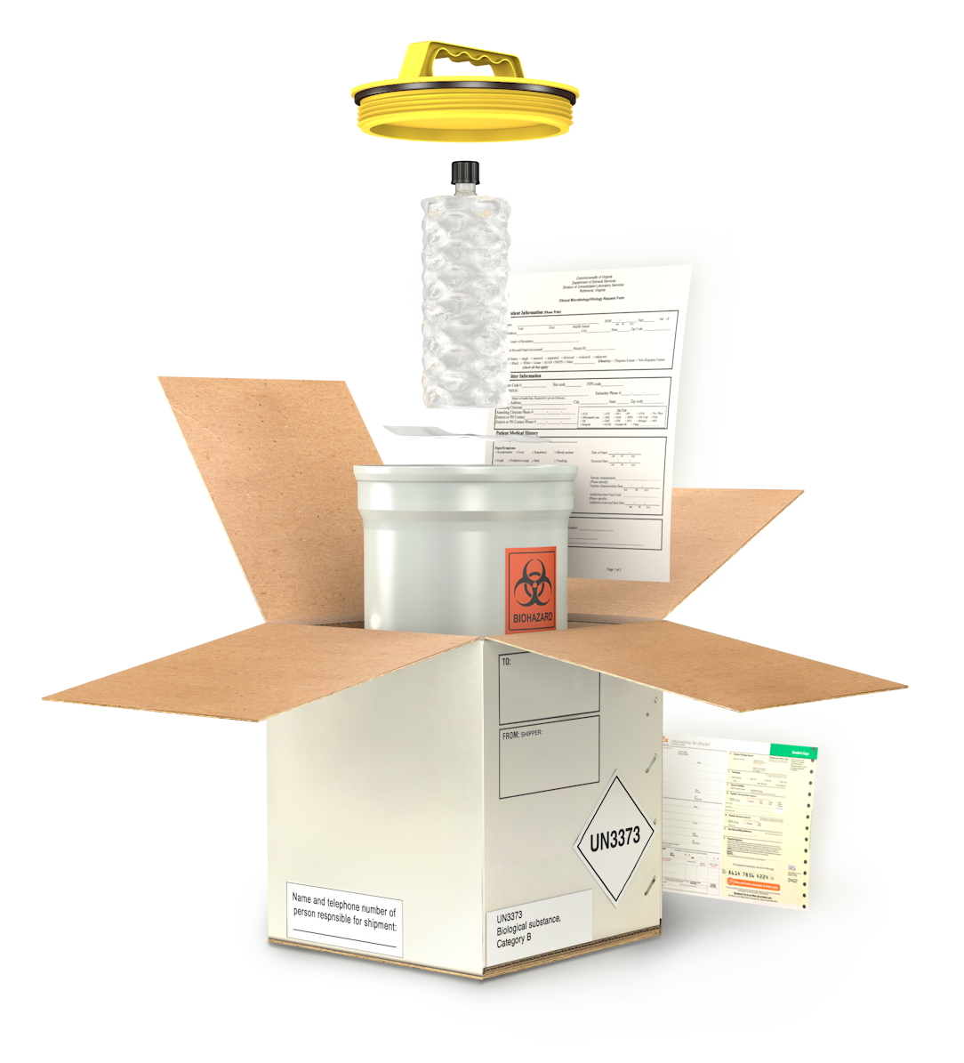
Leakproof/ siftproof primary receptacle

Cushioning materials

Documentation
Absorbent materials

Biohazards symbol on primary receptacle or secondary packaging if the substance contains blood or is contaminated with human blood (must be on secondary for USPS)
Rigid outer packaging

Leakproof/ siftproof secondary packaging

Shipper and consignee information
Responsible person label on outer package for UPS, FedEx, USPS or in documentation for motor vehicle courier

Documentation

UN3373 mark
Proper Shipping Name

Category B Substance Packaging with Dry Ice

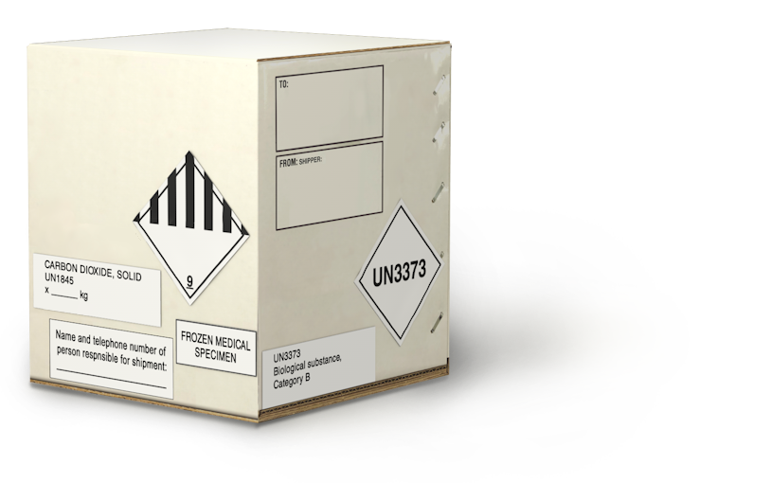

Frozen medical specimens label (motor vehicle couriers only)
Class 9 label

UN1845 and net weight in kg

Exempt Human Specimen or Exempt Animal Specimen Packaging

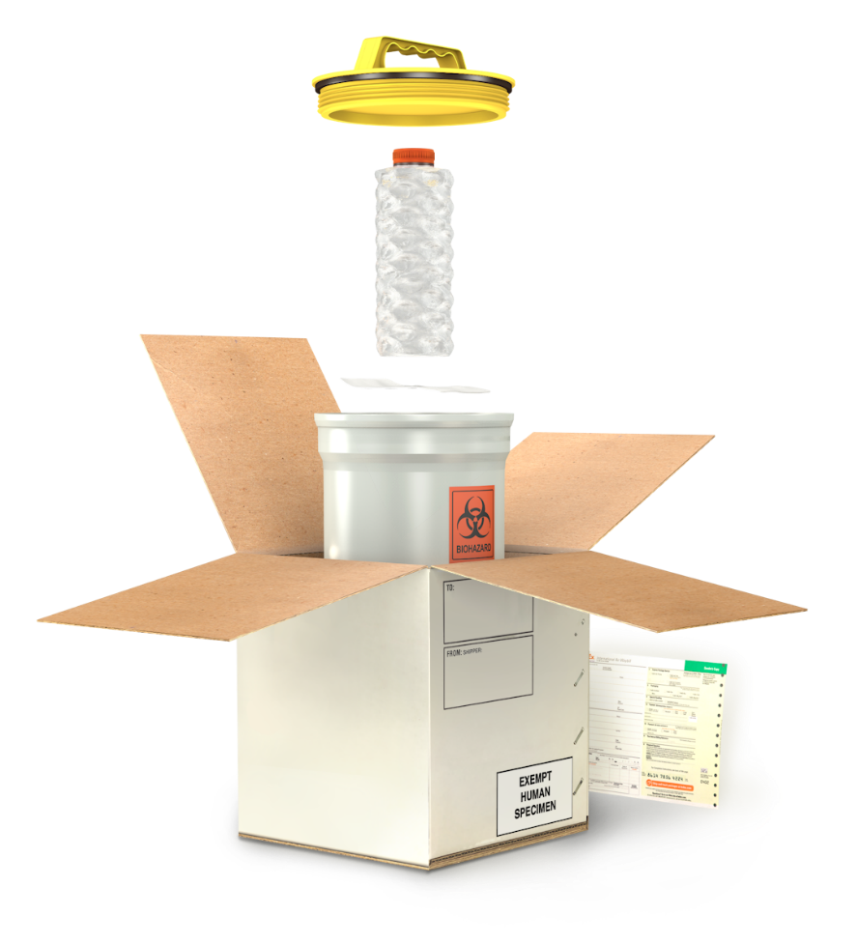
Leakproof/ siftproof primary receptacle

Outer packaging strong enough for capacity, mass, and intended use

Leakproof/ siftproof secondary packaging

Shipper and consignee information
Biohazard symbol (USPS only)

Documentation

Exempt Human Specimen or Exempt Animal Specimen label

Exempt Human Specimen or Exempt Animal Substance Packaging with Dry Ice

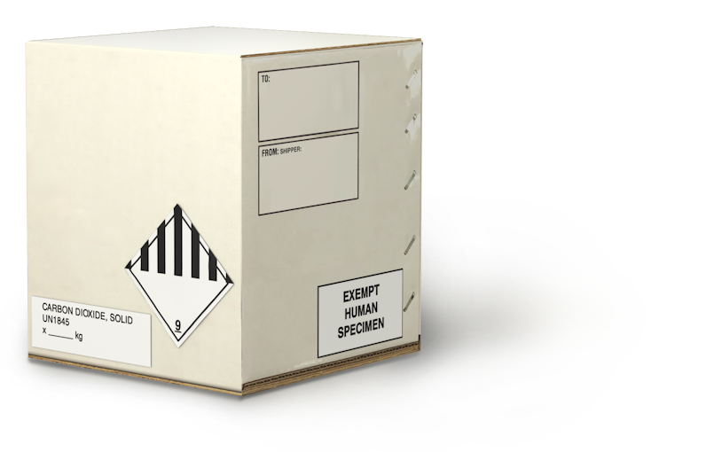

Class 9 label

UN1845 and net weight in kg

This job aid is a component of the free, on-demand CDC training course “Packing and Shipping Dangerous Goods: What the Laboratory Staff Must Know.” Find the course at https://www.cdc.gov/labtraining.

