Step 3: Packing Category A, B, and Exempt Animal Specimens Job Aid
Use the pages below as a reference for packing Category A, B, and Exempt Specimens.

Category A Infectious Substance Packaging
NOTE: The packaging is the same for both types (UN 2814 and UN 2900) of Category A packaging, only the UN mark and Proper Shipping Names change. The shipper and consignee address label can be placed on top of the box, if there is not enough space available on one side. UN hazard labels should not overlap one another.
withstanding without leakage an internal pressure producing a pressure differential of not less than 95 kPa.
For liquid shipments by aircraft, the primary or secondary packaging must be capable of

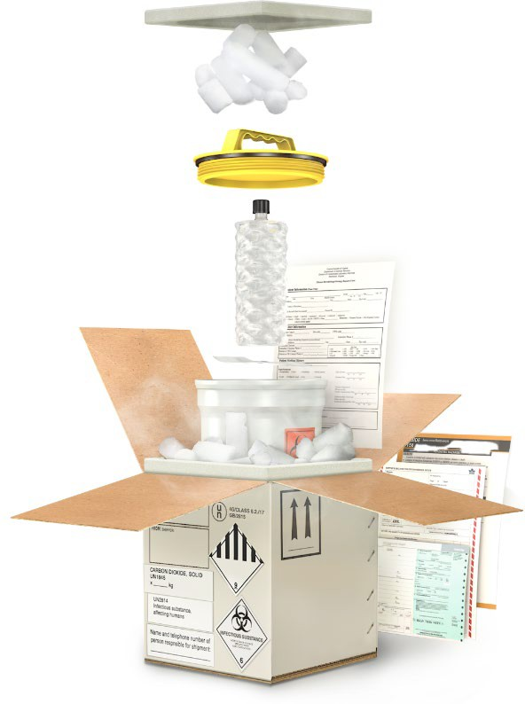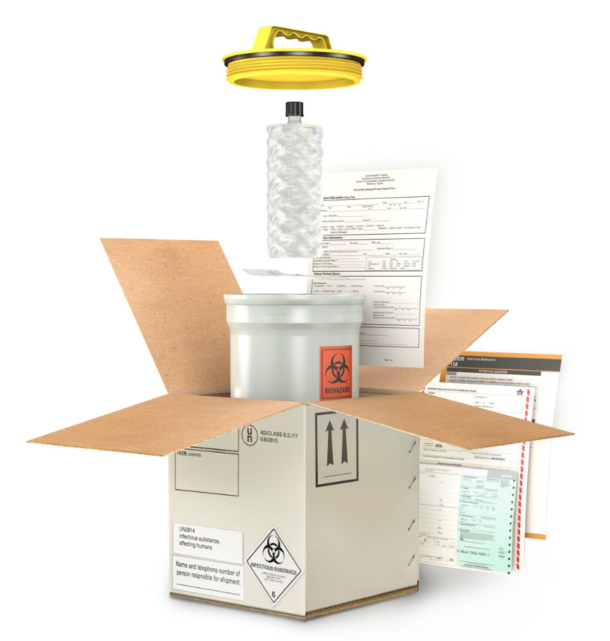Leakproof/ siftproof primary receptacle
Secondary packaging cap

Cushioning materials
Documentation

Absorbent materials Biohazard symbol on
primary receptacle or
secondary packaging if the

Rigid outer packaging

Leakproof/ siftproof secondary packaging

Shipper and consignee identification
UN specification mark
substance, materials, and containers have blood or other potentially infectious materials (OPIM)

Documentation

Packing Orientation labels on opposite faces if more than 50 ml of liquid

Proper Shipping Name

Responsible person label
Division 6.2 infectious substance label

Dry Ice

Category A Infectious Substance Packaging with Dry Ice

Styrofoam cooler/ secondary container

v.312202022
Dry Ice Class 9 label 1
UN1845 and net weight in kg

Category B Infectious Substance Packaging
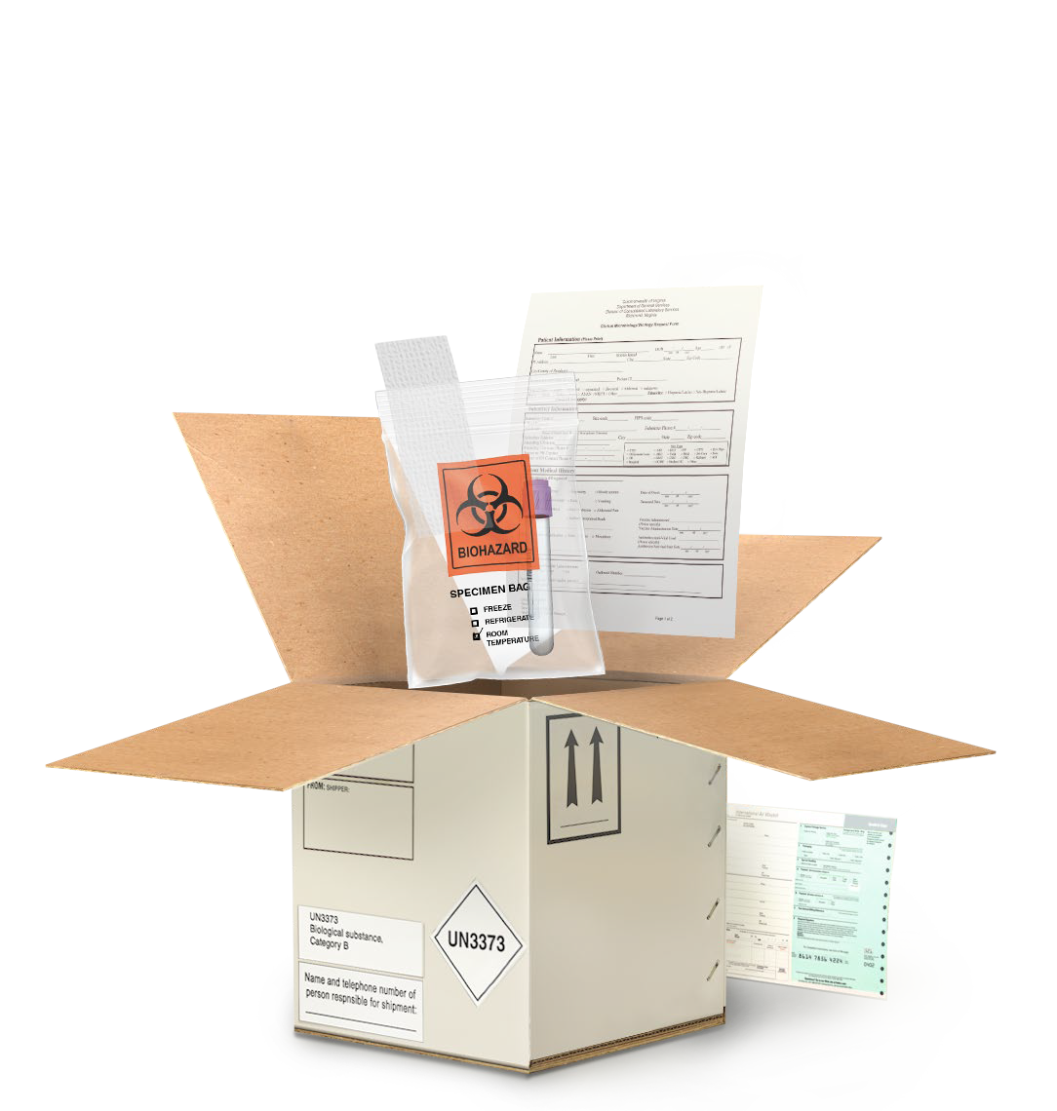NOTE: The shipper and consignee address label can be placed on top of the box, if there is not enough space available on one side. UN hazard labels should not overlap one another. A cylinder or biobag can be used as the
secondary container.
withstanding without leakage an internal pressure producing a pressure differential of not less than 95 kPa.
For liquid shipments by aircraft, the primary or secondary packaging must be capable of
Leakproof/ siftproof primary receptacle
Absorbent materials

Documentation

Rigid outer packaging

Leakproof/ siftproof secondary packaging

Shipper and consignee information

Proper Shipping Name

Responsible person label on outer package for UPS, FedEx, USPS or in documentation for motor vehicle courier

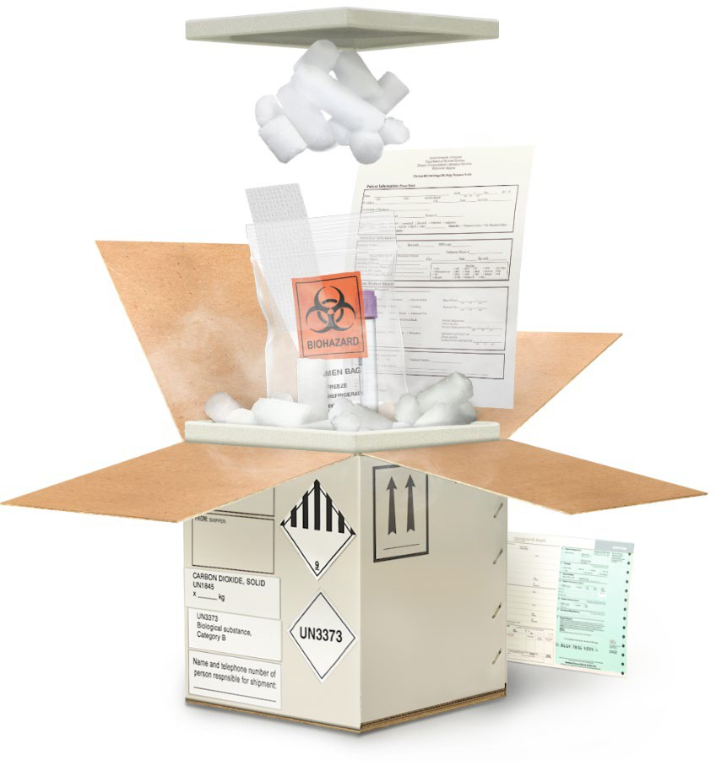UN3373 mark
Biohazard symbol on primary receptacle or secondary packaging if the substance, materials, and containers have blood or other potentially infectious materials (OPIM)

Packing Orientation labels on opposite faces if more than 50 ml of liquid

Documentation

Category B Infectious Substance Packaging with Dry Ice
Dry Ice

Styrofoam cooler/ secondary container

Dry Ice Class 9 label

UN1845 and net weight in kg
2

Exempt Human Specimen or Exempt Animal Specimen Packaging
NOTE: The shipper and consignee address label can be placed on top of the box, if there is not enough space available on one side. UN hazard labels should not overlap one another. A cylinder or biobag can be used as the secondary container.
withstanding without leakage an internal pressure producing a pressure differential of not less than 95 kPa.
For liquid shipments by aircraft, the primary or secondary packaging must be capable of

Outer packaging strong enough for capacity, mass, and intended use
Absorbent materials

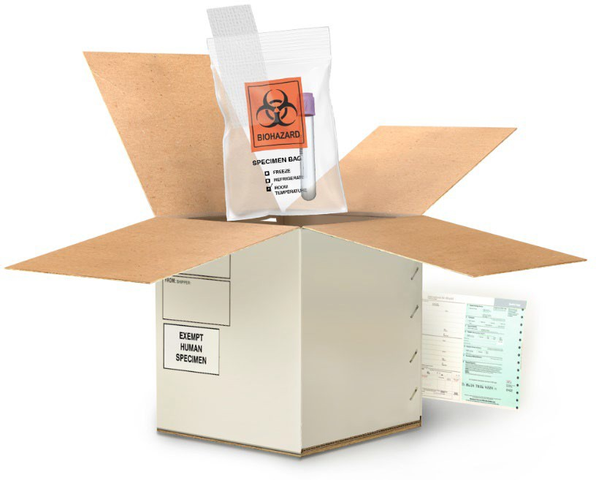Leakproof/ siftproof secondary packaging

Biohazard symbol (USPS only)
Leakproof/ siftproof primary receptacle

Shipper and consignee information
Documentation

Exempt Human Specimen or Exempt Animal Specimen label

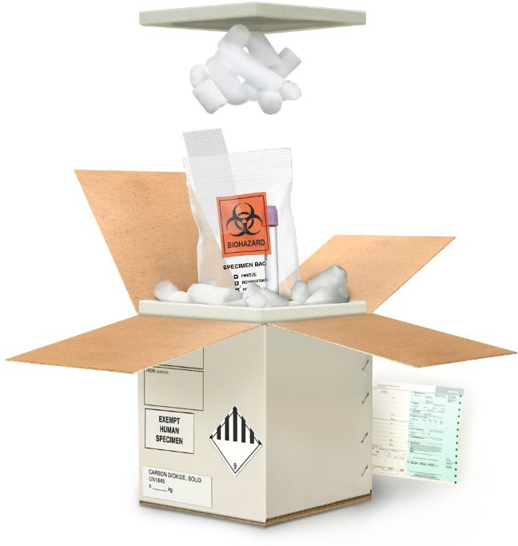Exempt Human Specimen or Exempt Animal Substance Packaging with Dry Ice
Dry Ice

Styrofoam cooler/ secondary container

Dry Ice Class 9 label

UN1845 and net weight in kg

3
This job aid is a component of the free, on-demand CDC training course “Packing and Shipping Dangerous Goods: What the Laboratory Staff Must Know.” Find the course at https://www.cdc.gov/labtraining.

