Laboratory Information Management System (LIMS): “System of Systems” Job Aid
Various information systems can work together as a “system of systems” that function together to fulfill the data and informatics needs of an organization. The laboratory information management system (LIMS) is an example of such a “system of systems.”

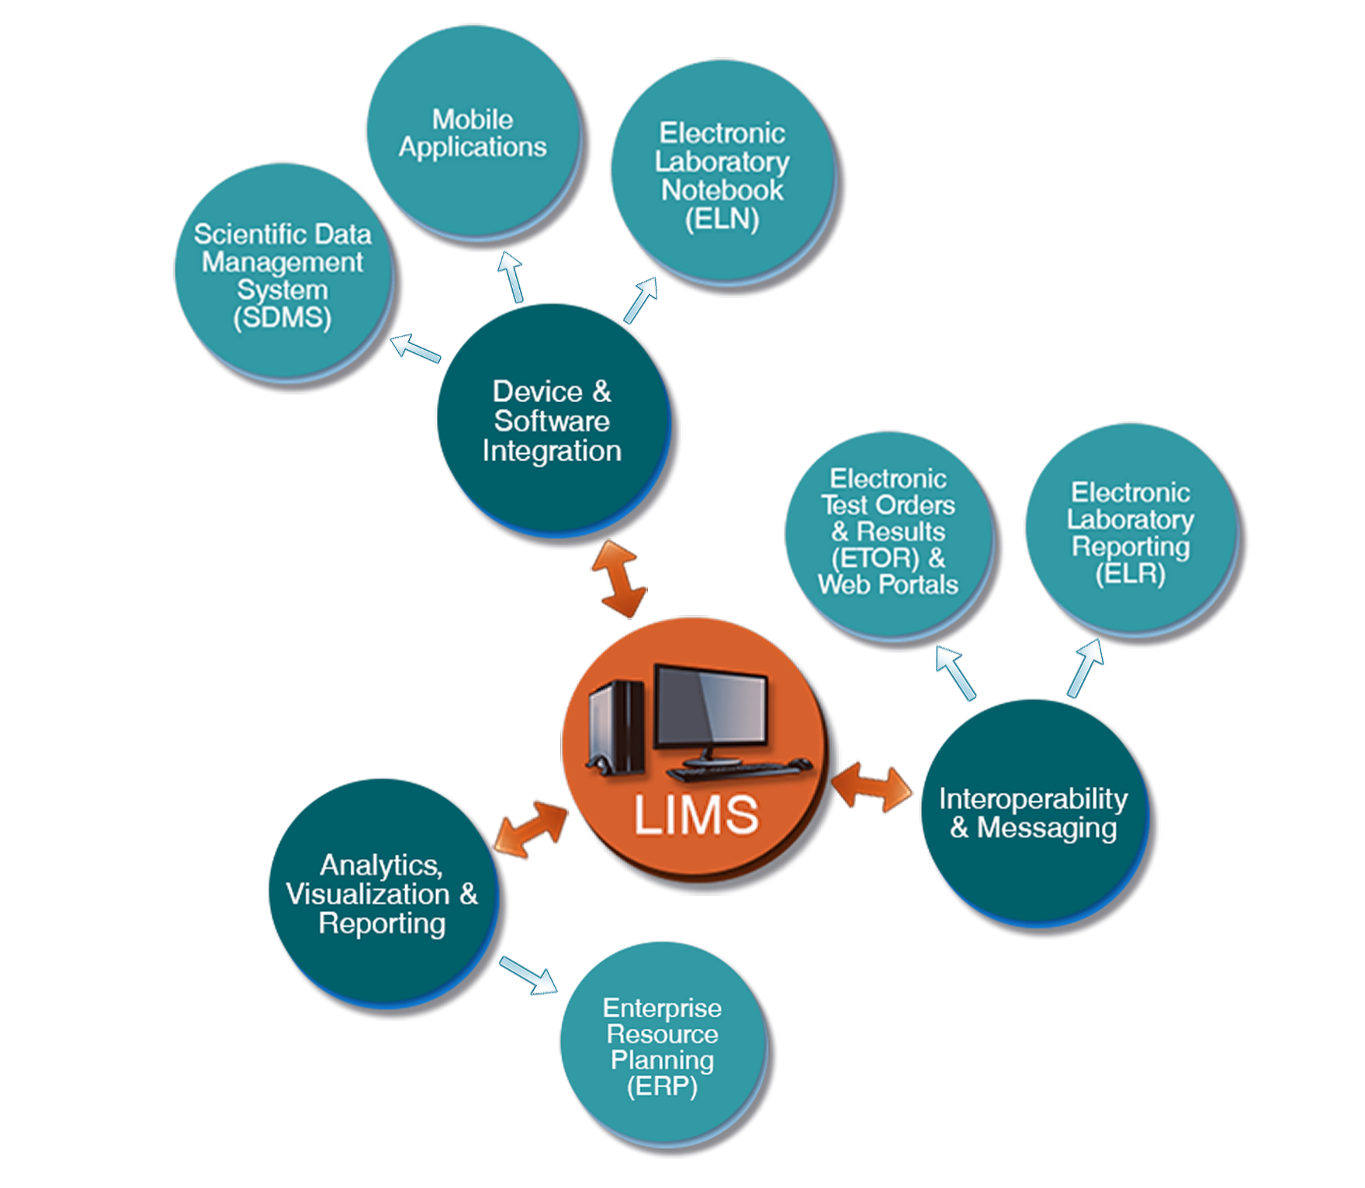
The LIMS as a “System of Systems”:
Device & Software Integration

Device and software integration, also known as interfacing, with a LIMS can be uni-directional or bi-directional. Integration enables faster and more efficient:
- Data and information input/output management
- Workflow management
- Data analysis, visualization, and validation
- Regulatory compliance control

Three examples of device and software integration are:
- electronic laboratory notebook (ELN), which serves as an alternative to paper notebooks
- mobile applications, which allow wirelessly connected devices to securely connect to the LIMS when laboratory staff is in the field or offsite
- scientific data management system (SDMS), which is a data warehouse used for document
management

Interoperability & Messaging

Interoperability: The ability for different information technology systems and software applications, regardless of their varying physical architecture and operating systems, to communicate, exchange data, and use the information that has been exchanged.

LIMS interoperability and messaging help laboratories manage and share data securely with third-party applications and stakeholders, facilitating communication by creating and sending standardized messages through methods such as web portals, electronic test orders and results (ETOR), and electronic laboratory reporting (ELR).

Analytics, Visualization & Reporting

The LIMS can provide numerous analytical, visualization, and reporting capabilities to facilitate:
- communication with patient care and public health partners
- the administrative and managerial functions needed to run the laboratory via enterprise resource planning (ERP)

