B.pseudomallei Characteristics Chart

Gram stain:
• Small, straight, or slightly curved Gram negative rods (1-3 x<2.0µm)
• Smooth form arranged in long, parallel bundles
• Rough form arranged irregularly
• Bipolar staining

Colony morphology:
• Smooth, creamy on Sheep Blood and CHOC agar at 24h; may display
metallic sheen on BAP, CHOC at 48 h; some become either mucoid or
dry and wrinkled after 48-72h; no violet pigment
• Pink on MAC/EMB agar at 24-48h; will become dry and wrinkled after
48-72h
• Resistant to colistin and polymyxin B
• Resistant to penicillin
B.pseudomallei Characteristics Chart
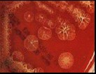
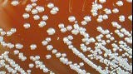
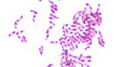
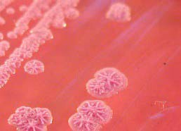
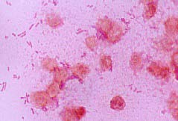
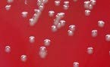
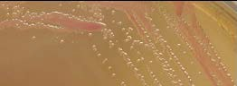
• Susceptible to amoxicillin/clavulanic acid
• No pigment on MH agar
• Distinctive musty or earthy odor

Biochemicals:
• Oxidase,catalase, and arginine
dihydrolase positive
• Indole negative
• Glucose non-fermenter

Motility: Positive

Refer Cultures to your LRN Reference

