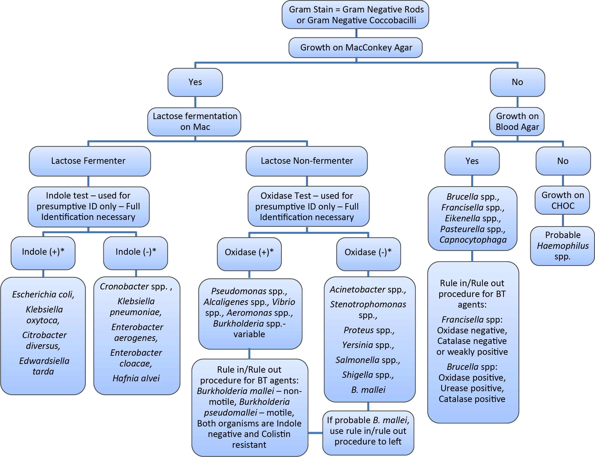
Aerobic Gram-Negative Rods Flowchart

NOTE
Exceptions do exist to these general rules

* = See Biochemical Tests for Gram Negative Organism ID
Job aid for positive and negative result reference.

