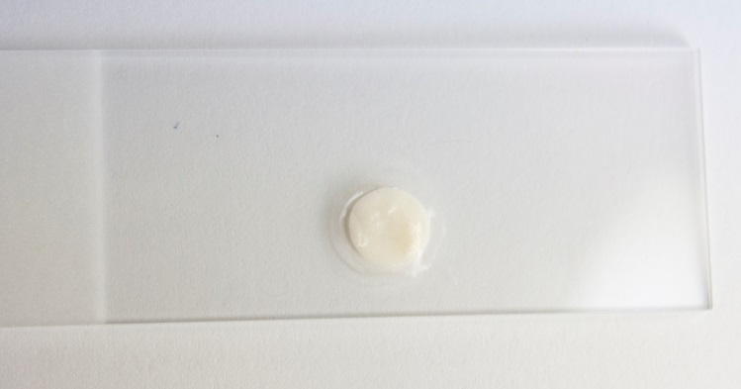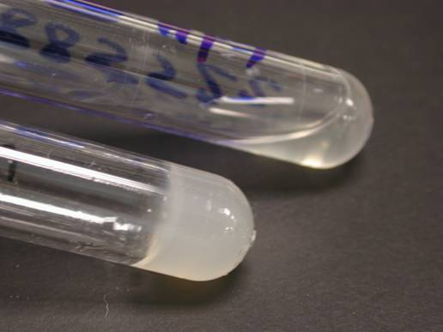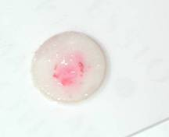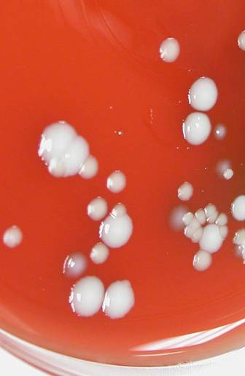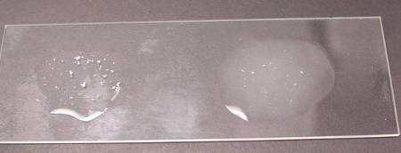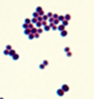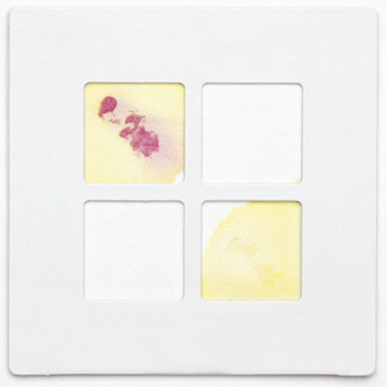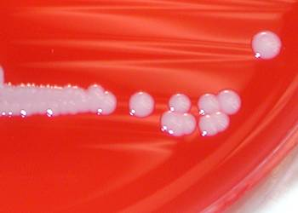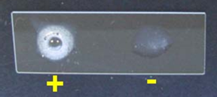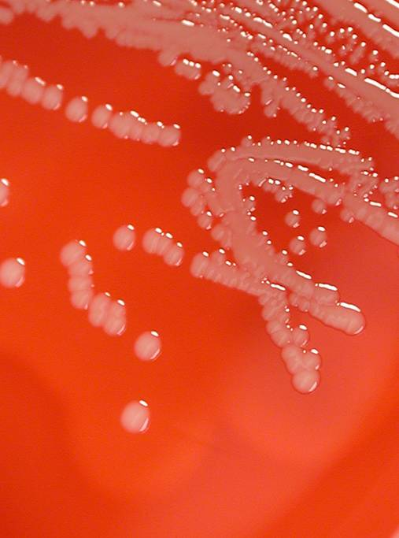

# Staphylococci ID Chart

This job aid is a component of the free, on-demand CDC training course “Biochemicals and Gram Positive Organism Identification.” Find the course at [https://www.cdc.gov/labtraining.](https://www.cdc.gov/labtraining)

**Summary**

**Major pathogen: *Staphylococcus aureus***

**Other species: *S. lugdunensis* found in abscesses and serious wounds; coagulase negative Staphylococci in multiple blood cultures**

**Laboratory Training Branch**