Beta-Hemolytic Streptococci on BAP Identification Chart

Summary

- Major pathogens: Streptococcus pyogenes (group A) & S. agalactiae (group B). In abscesses and body fluids, S. anginosus group (“S. milleri”) also found. All are catalase (-), Gram (+) cocci chains

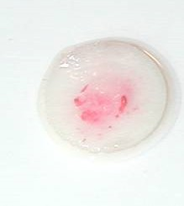
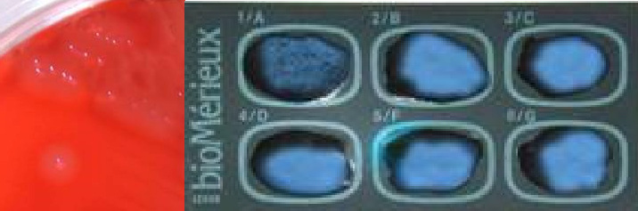
Group A - S. pyogenes
2b.
2a.
1.

Characteristics

  - Colony Morphology and beta-hemolysis around colony
  - a- Group A positive Latex or b- PYR (+)
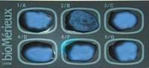
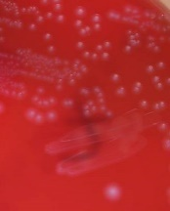

Group B - S. agalactiae
1.
2a.

Characteristics

- Colony Morphology and soft beta-hemolysis under colony
2b.
2b.
- a- Group B positive Latex or b- CAMP (+) and PYR (-)

- anginosus group Characteristics
1.

  - Pinpoint colonies <0.5 mm; Caramel odor (noted but do not sniff plates)
“S. anginosus” group

Note: If none of the above: Beta-strep not A or B

