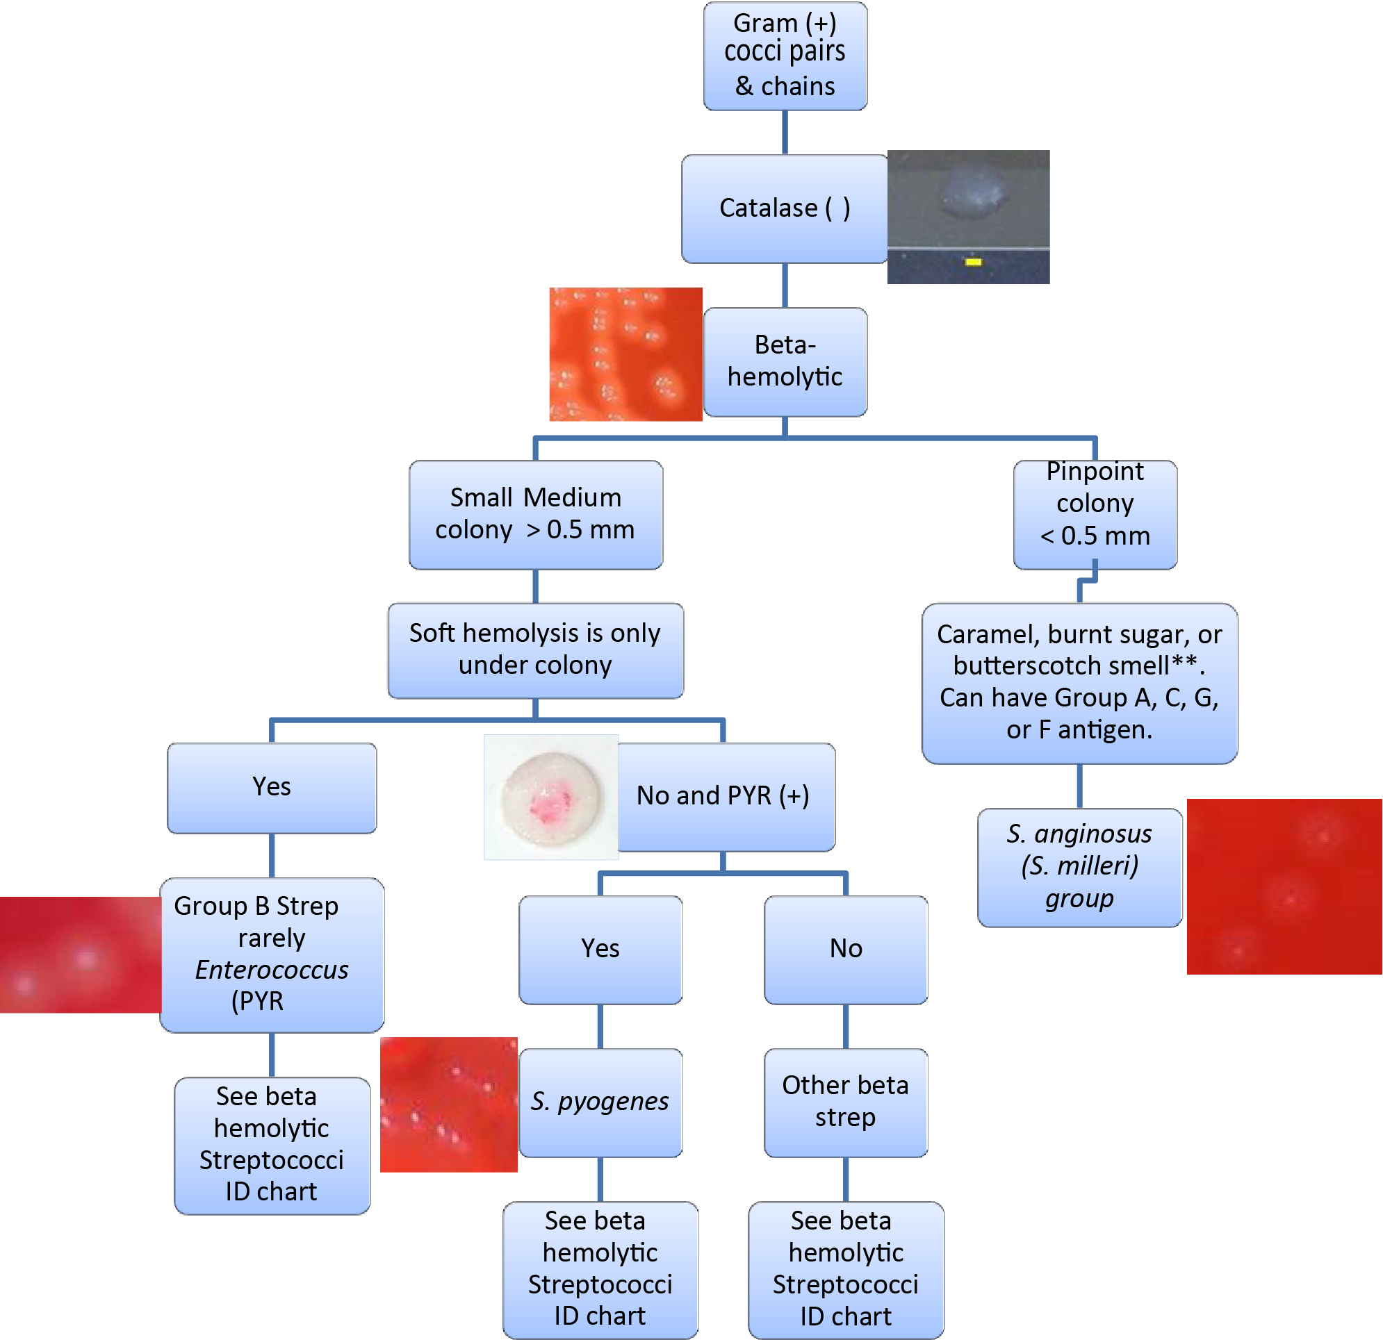
Beta-Hemolytic Streptococci on BAP Flowchart
∗ = Note the odor without sniffing the BAP.
This job aid is a component of the free, on-demand CDC training course “Biochemicals and Gram Positive Organism Identification.” Find the course at https://www.cdc.gov/labtraining.
ratory Training Branch

