Bacillus spp. ID Chart
Summary

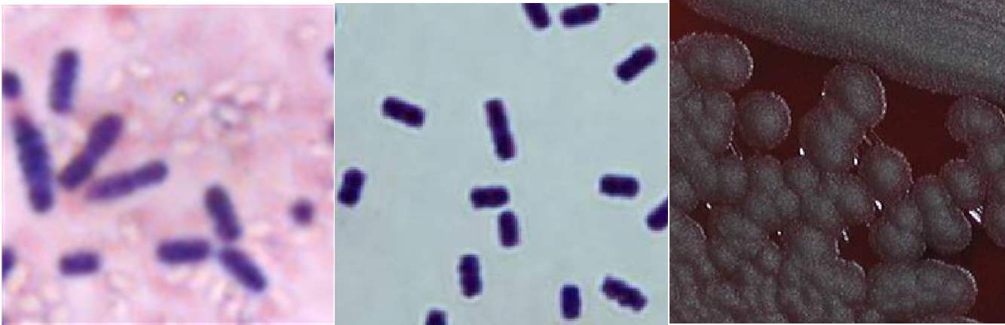
Major pathogen: Bacillus anthracis. Other species only in immunocompromised patients and usually isolated from several blood cultures

Characteristics of Bacillus spp.
1a.
1b. 2a.

- a and b- Regular large Gram positive rods and spores (do not stain)
- a – hemolytic, b - non- hemolytic, c – ground glass, d – large spreading, e – no growth on MacConkey
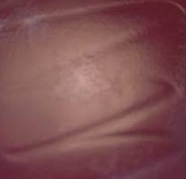
- Catalase (+)

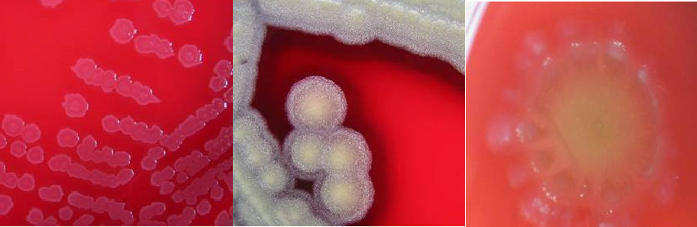
2b.

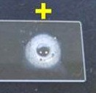
2c. 2d.

2e. 3.

Bacillus anthracis
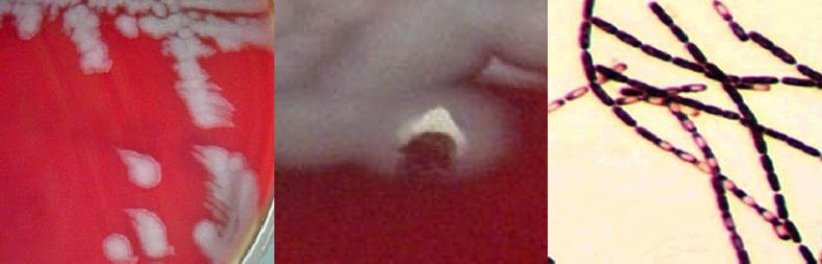

Possible Bacillus anthracis
-Very fast growing
-Non-motile
- a- Medusa head or comma shaped colonies and non- hemolytic
b- Colony sticks together (tenacious colonies)
- B. anthracis from broth – central spores “string of pearls”
This job aid is a component of the free, on-demand CDC training course “Biochemicals and Gram Positive Organism Identification.” Find the course at https://www.cdc.gov/labtraining.

1a. 1b

