Gram Stain

Introduction
The Gram stain is a differential staining procedure used to categorize bacteria as Gram positive or Gram negative based on the chemical and physical properties of their cell’s walls. The bacteria are differentiated through a series of staining and decolorization steps. Gram positive cells will stain purple and Gram-negative cells will stain red to pink.
Supplies and Reagents
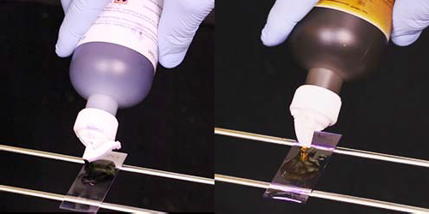
- Personal protective equipment (PPE)
- Slide rack 1. 3.
- Timer
- Absorbent paper, such as bibulous paper
- Water (tap water or deionized)
- Crystal violet
- Gram’s iodine
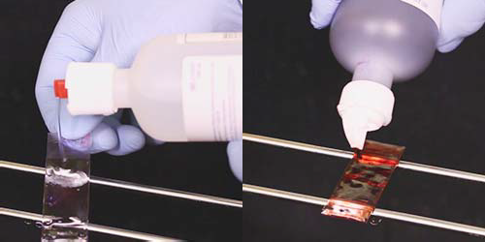
- Decolorizer

- Safranin (or carbol fuchsin)
- Brightfield microscope with 100X objective
- Immersion oil

Instructions
- Use appropriate PPE according to your laboratory’s procedures and safety manual.
- Place the prepared fixed smear on a slide rack then flood the slide with crystal violet.
- Wait at least 15 seconds* then rinse the slide with water.
- Flood the slide with Gram’s iodine.
- After 15 seconds* rinse the slide with water.
- Apply the decolorizer to the slide.
- Rinse the slide immediately with water.
- Flood the slide with counterstain.
- Wait at least 15 seconds* then rinse the slide with water.
- Blot the slide with absorbent paper. Be careful not to wipe the cells off the slide.
- Allow the newly stained slide to air dry completely.
- View the slide under oil using the oil immersion objective for a total magnification of 1000X.
- Record results based on your laboratory’s criteria.
5. 7.

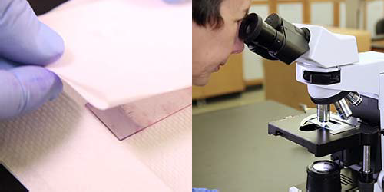
9. 11.
* Be sure to check manufacturer’s instructions for the timing of each step.

