Gram Stain Cell Morphology

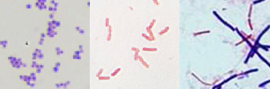
Gram stain results:
1.
2.
3.
- Gram Positive Cocci
- Gram Negative Rods
- Gram Variable Rods
Cell Shape and Arrangements:
Cocci
Rods, or Bacillus

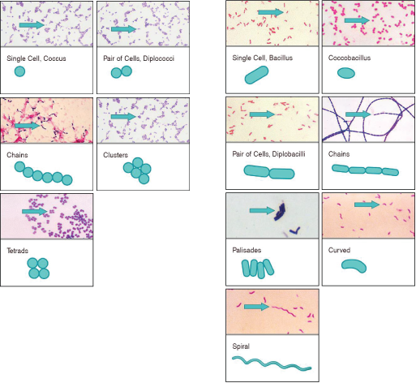

This job aid is a component of the free, on-demand CDC training course “Biochemicals and Gram Negative Organism ID.”
Find the course at https://www.cdc.gov/labtraining.aboratory

