**GNR Stool Pathogens Lactose Positive Flowchart**

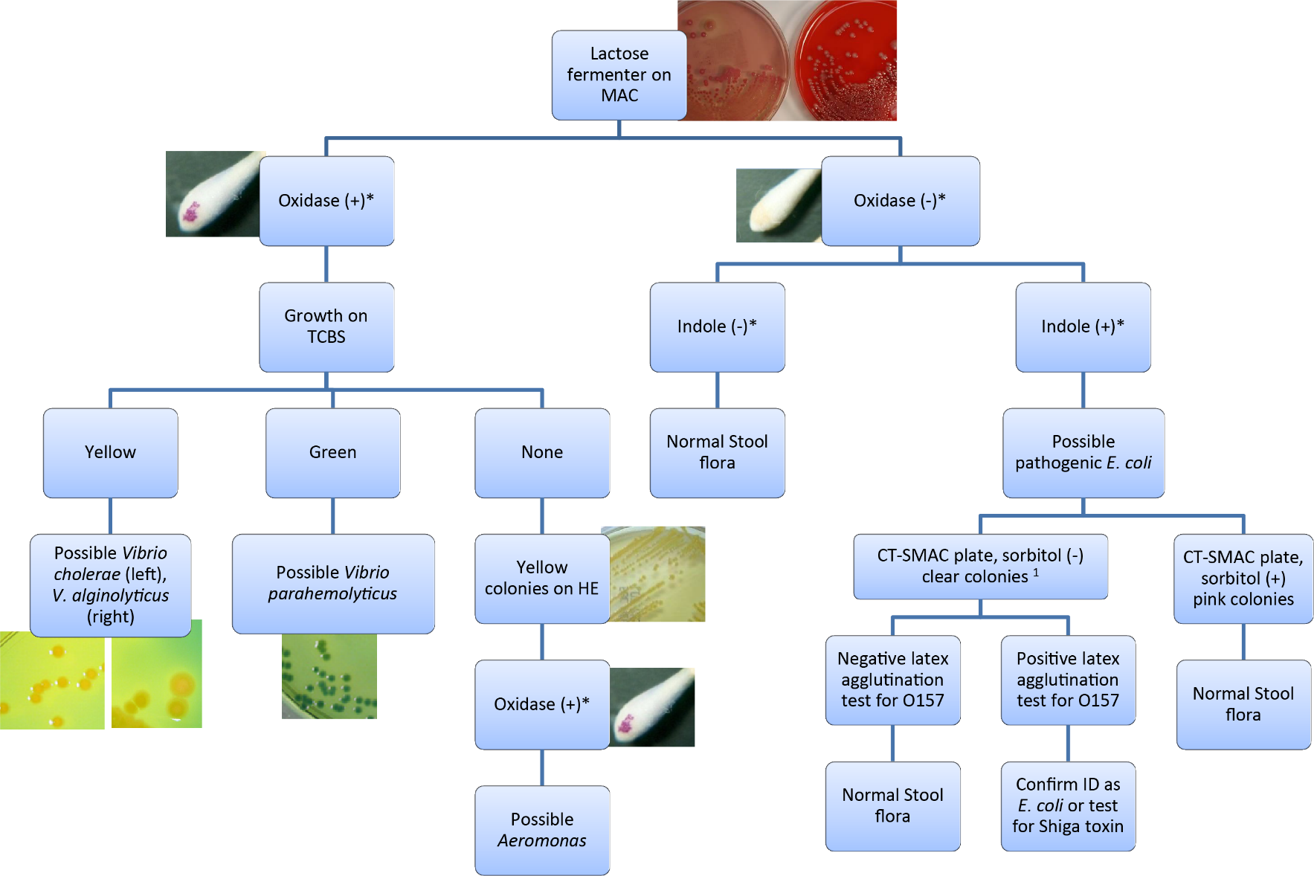

1 = MUG test can be performed. Pick at least

four sorbitol (-) colonies and sub to BAP. If

MUG is negative, screen using 0157 latex

agglutination. Confirm ID. If MUG is

positive, ID as E. coli. (rare strains of 0157

are MUG positive)

* = See Biochemical Tests for Gram   
Negative Organism ID Job aid for positive and negative result reference.