Colonial Characteristics

Introduction

Colony morphology is the visual culture characteristics of a bacterial colony on an agar plate. Observing colony morphology is an important skill used in the microbiology laboratory to identify microorganisms. Colonies need to be well isolated from other colonies to observe the characteristic shape, size, color, surface appearance, and texture. Another important characteristic of a bacterial colony is hemolysis. Hemolysis is the result of the lysis of the blood cells that are a component of Blood Agar.

Colony Morphology Characteristics:

Size:
General Guidelines:
- large (>1mm)
- medium (approximately =1mm)
- small (<1mm)
- pinpoint (<0.5mm)

Surface Appearance:
- smooth
- rough
- glistening
- dull
- wrinkled
- spreading
- mucoid

Color:
- pigmentation (white, pink, purple, etc.)
- opaque
- transparent

Shape:
- Form
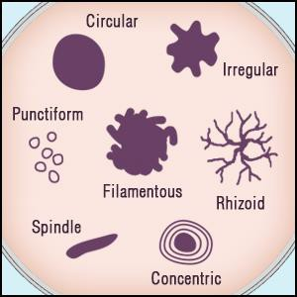

- Hemolysis
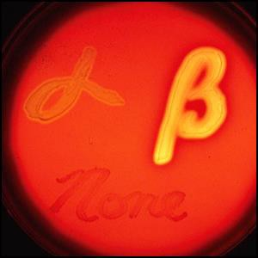
- Margin

Hemolysis:
  - Alpha (α)
  - Beta (β)
  - Gamma (γ)

