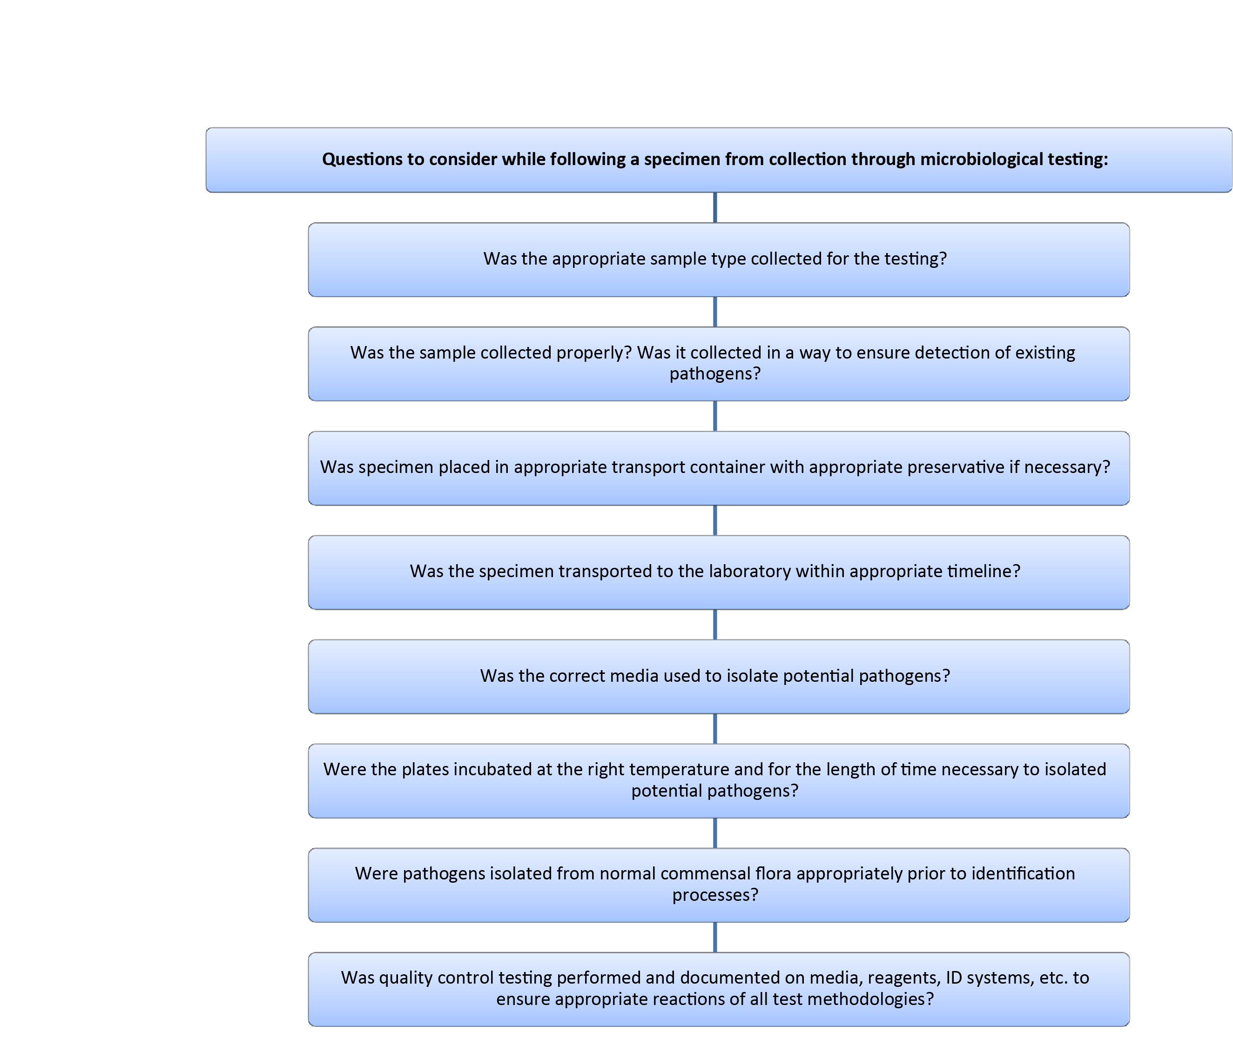**Collection through Testing Questions**

This job aid is a component of the free, on-demand CDC training course “Biochemicals and Gram Negative Organism ID.” Find the course at <https://www.cdc.gov/labtraining>.