**Biochemical Tests for Gram Negative Organism ID**

Catalase Test

-

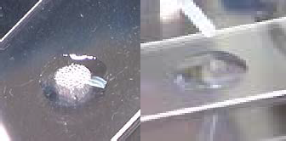

+

Spot Indole

-

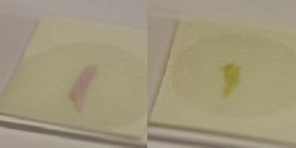

+

Tube Indole

-

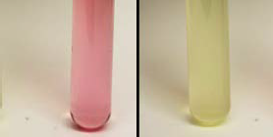

+

Latex Agglutination

-

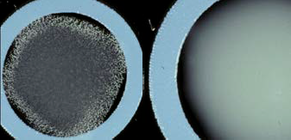

+

MUG Test

+

-

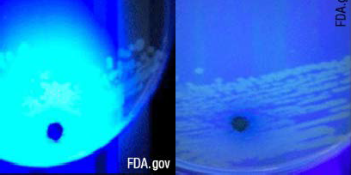Oxidase Test

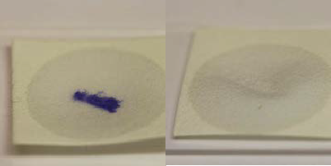

+

-

Urea Test

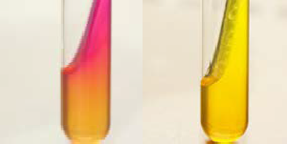

+

-

PYR Test

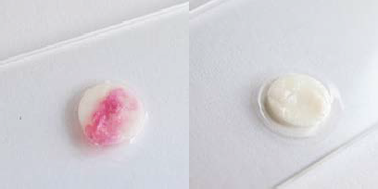

+

-

Hydrogen Sulfide Production: Tube Media

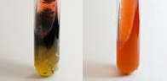

+

-

Plate Media Lead Acetate Strip

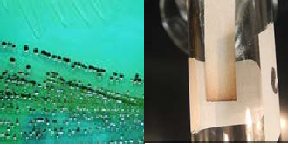 s

+

+

This job aid is a component of the free, on-demand CDC training course “Biochemicals and Gram Negative Organism ID.”

Find the course at <https://www.cdc.gov/labtraining>.**aboratory**

This job aid is a component of the free, on-demand CDC training course “Biochemicals and Gram Negative Organism ID.” Find the course at <https://www.cdc.gov/labtraining>.