Kӧhler Illumination
Introduction
Kӧhler illumination is a method of providing optimum specimen illumination that is uniformly bright and free from glare. The following instructions apply to any microscope which is equipped for transmitted light brightfield illumination. If you do not have a field diaphragm, you will not be able to obtain Kӧhler illumination.
Instructions
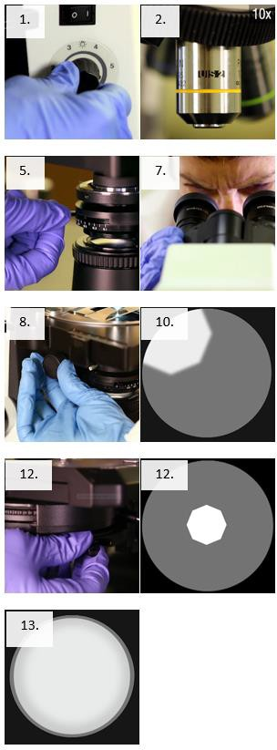
- Plug in the microscope and turn on the light source.
- Rotate the nosepiece so the 10X objective is locked into place.
- Put the specimen slide on the stage and center it under the 10X objective.
- Adjust the intensity of the light to a comfortable level with the light source.
- Open the field diaphragm all the way and close the condenser diaphragm all the way.
- Move up (rack up) the stage to its highest position.
- Adjust the oculars for interpupillary distance so that when looking with both eyes only one circle of light is seen.
- Move the condenser diaphragm as high as possible with the height adjustment knob.
- Close the field diaphragm halfway and focus on the specimen at 10X using the coarse adjustment knob.
- Close the field diaphragm until the diameter of the illuminated image is smaller than the field of view.
- Lower the condenser diaphragm with the positioning knob until a sharp, focused image of the edges of the field diaphragm is achieved.
- Using the centering screws on the side of the condenser diaphragm, center the edges of the image so that the angle of light is centered in the field, increasing the resolution of the object on the stage.
- Open the field diaphragm until the illuminated image is just larger than the field of view.
- Be careful not to open the field diaphragm too much, as this may result in reduced image quality. If more light is needed to view the specimen, adjust the intensity of your light source but not the condenser diaphragm.
- Replace the eyepiece in the microscope.

This job aid is a component of the free, on-demand CDC training course “Basic Microscopy.” Find the course at https://www.cdc.gov/labtraining.

