Focusing the Microscope
Introduction
It is necessary to focus the microscope when viewing specimens. Focusing the microscope is performed by using the fine and the coarse adjustment knobs near the base of the microscope.
Instructions

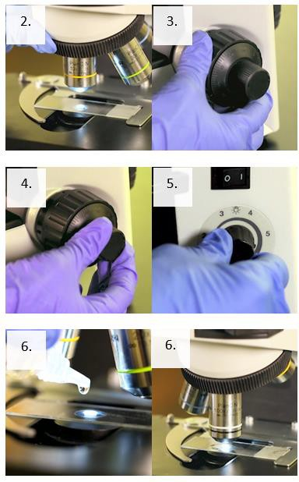
- Put a slide on the microscope stage, with the coverslip side up.
- Bring the 10X or the 40X objective over the slide.
- Using the coarse adjustment knob, raise or lower the stage until you see an object come into view.
- Use the fine adjustment knob to obtain a clearer view of the object.
- Manipulate the light source to obtain the correct amount of light.
- If you are using the 100X (oil immersion) objective to view your specimen, a good practice is to focus on the specimen using the 10X or 40X objective and then move to the 100X oil immersion lens after adding oil.
- If the scope is parfocal, you should only need to use the fine adjustment knob to focus.
Note: Remember to not drag the 40X objective through the oil.

This job aid is a component of the free, on-demand CDC training course “Basic Microscopy.” Find the course at https://www.cdc.gov/labtraining.

