Care and Maintenance of the Microscope
Introduction
Good preventive maintenance includes regular cleaning of oculars, stage, condenser, and objectives. To determine if your oculars are clean, rotate the left, then the right eyepiece between your fingers to identify debris. Never wear eye make-up, particularly mascara, when using your microscope because it can leave debris on the oculars that is difficult to remove. Have your microscope cleaned and maintained annually by a professional service person.

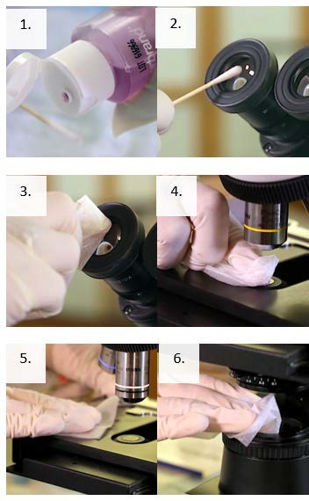
Supplies
- Commercial lens paper, cotton swabs or other soft tissue
- Commercially available lens cleaner

Instructions

- Moisten the tip of a swab or piece of lens paper with lens cleaner.
- Working from the center out, in a circular motion, gently clean oculars and objectives.
- Dry with a clean, dry swab or lens paper.
- Clean the stage of the microscope with a suitable cleaner.
- Thoroughly dry the stage with a new piece of lens paper.
- Wipe off the top of the condenser with a clean lens paper moistened with lens cleaner, then dry the condenser with a dry piece of lens paper.

This job aid is a component of the free, on-demand CDC training course “Basic Microscopy.” Find the course at https://www.cdc.gov/labtraining.

