[Title Goes Here]
[Title Continues Here]

Introduction
Logo goes here

It is essential for laboratories to quickly ramp up when preparing for emergency response. This resource guide will cover available resources for biological, chemical, and radiological emergencies for laboratories to reference during an emergency. It can also help train new laboratory professionals hired to support emergency responses. This resource guide contains links to eLearning, instructor-led courses, job aids, publications, recorded webinars, reference guides, and virtual reality training. Updates will be reviewed annually.

An appendix lists full URL website addresses for printing purposes.

Disclaimer

Add organization disclaimer here.

Table of Contents

Biological Resources
eLearning: Basic Molecular Biology Series………………………………………………………………………………….7
eLearning: Biosafety: Avoiding Laboratory Acquired Infections (LAI)………………………………….……..7
eLearning: Biosecurity for Clinical Laboratories……………………………………………………….………………...7
eLearning: Fundamentals of Centrifuge Safety………………………………………………………….……………….8
eLearning: Fundamentals of Personal Protective Equipment (PPE) in Clinical Laboratories……....8
eLearning: Fundamentals of Working Safely in a Biological Safety Cabinet…………….…………….……8
eLearning: Introduction to Laboratory Risk Management (LRM)………………………………………………..9
eLearning: Microbiology Series………………………………………………………………………………………………….9
eLearning: Packing and Shipping Dangerous Goods: What the Laboratory Staff Must Know……..9
Instructor-Led: Biological Agent Identification and Counterterrorism……………………………………...10
Instructor-Led: Field Identification of Biological Warfare Agents……………………………..……….……..10
Job Aid: Sensitivity and Specificity for Clinical Laboratory Testing…………………………………………….10
Job Aid: Individualized Quality Control Plan (IQCP) ……………………………………………………………..….11
Job Aid: Provider-Performed Microscopy (PPM) Procedures…………………………………….……….…….11
Job Aid: Ready? Set? Test! Patient Testing is Important. Get the Right Results...........................12
Job Aid: Specimen Storage and Shipping Guidance………………………………………………………………….12
Job Aid: To Test or Not to Test?....................................................................................................13
Presentation Slides: Blood Borne Pathogen Training...................................................................13
Publication: Good Laboratory Practices for Waived Testing Sites…………………..……………….…..…..13
Webinar Recording: The Laboratory Risk Assessment Cycle…………………………………………….…..….14
Webinar Recording: Respirator Fit 101 Intro to Quantitative Fit Testing………………...…………...….14
Virtual Reality: Biosafety Cabinet Edition………………………………………………………………………….……..14
Virtual Reality: Personal Protective Equipment (PPE) Edition………………………………….……………….15

Chemical Resources

eLearning: Fundamentals of Chemical Fume Hood Safety Training…………………………….….……..…17
eLearning: Introduction to Chemical Agents……………………………………………………….......................17
Job Aid: CDC Specimen-Collection Protocol for a Chemical-Exposure Incident………….…………..…17
Presentation Slides: Chemical Terrorism Program - Packaging and Shipping of Blood and Urine Samples ………………………………………………………………………………………………………………………………..…18

Radiological Resources

eLearning: Radiation Emergency Training for Poison Center and Public Health Professionals….20
Job Aid: CDC Specimen Collection Protocol for a Radiological Incident………………………..……..…..20
Publication: A Possible Approach to Large-Scale Laboratory Testing for Acute Radiation Sickness after a Nuclear Detonation……………………………………………………………..……………………………………….21

Reference Guide: Radiological Laboratory Sample Analysis Guide for Incidents of National Significance – Radionuclides in Air……………………….………………………………………………………………….21

Reference Guide: Radiological Laboratory Sample Analysis Guide for Incidents of National Significance – Radionuclides in Soil……………………….…………………………………………………………………22

Reference Guide: Radiological Laboratory Sample Analysis Guide for Incidents of National Significance – Radionuclides in Water……………………….…………………………………………………………….22

Appendix

Appendix: Website URL Addresses…………………………………………………………………………………………..23

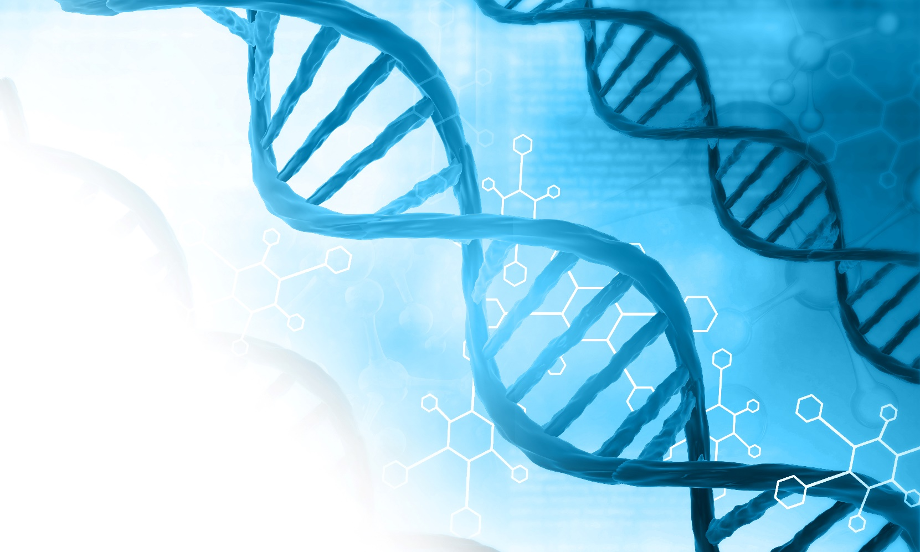

Biological Resources
eLearning: Basic Molecular Biology Series
Centers for Disease Control and Prevention (CDC)

The Basic Molecular Biology Series provides online self-study courses for public health and clinical laboratory professionals. Topics covered include scientific background for molecular diagnosis, the principles of molecular biology laboratory practice, and common methods. The Basic Molecular Biology Series includes five courses: Basic Science, Laboratory Practice, Nucleic Acid Extraction, and PCR and Real-Time PCR.

Registration Information
Basic Molecular Biology Series | CDC

eLearning: Biosafety: Avoiding Laboratory Acquired Infections (LAI)

Institute for Public Health Practice at the University of Iowa

State Hygienic Laboratory at the University of Iowa

This online self-study course provides an overview of laboratory acquired infections. This course is intended for laboratory professionals who handle biological and microbiological samples in clinical, reference, public health, animal, research or teaching laboratories.

Registration Information
Biosafety: Avoiding Laboratory Acquired Infections (LAI) | Prepare Iowa

For questions, please contact: help@training-source.org

eLearning: Biosecurity for Clinical Laboratories

Institute for Public Health Practice at the University of Iowa

This online self-study course provides an overview of biosecurity for clinical laboratories. This course is for clinical laboratory professionals who want to improve their knowledge of biosecurity practices that protect against unauthorized access, loss, theft, misuse, diversion, or intentional release of dangerous biological materials.

Registration Information
Biosecurity for Clinical Laboratories | Prepare Iowa

For questions, please contact: help@training-source.org

eLearning: Fundamentals of Centrifuge Safety
Centers for Disease Control and Prevention (CDC)

This online self-study course provides an overview of the safe use of centrifuges. Topics covered include major parts of a centrifuge, types of centrifuges, potential hazards, how to work safely with a centrifuge, and what to do if there is an emergency.

Registration Information
Fundamentals of Centrifuge Safety | CDC

eLearning: Fundamentals of Personal Protective Equipment (PPE) in Clinical Laboratories
Centers for Disease Control and Prevention (CDC)

This online self-study course provides an overview of personal protective equipment (PPE) in clinical laboratories. This course is designed to assist clinical and public health laboratory professionals with applying risk management strategies to identify hazards, assess, and select appropriate personal protective equipment (PPE) options.

Registration Information
Fundamentals of Personal Protective Equipment (PPE) in Clinical Laboratories | CDC

eLearning: Fundamentals of Working Safely in a Biological Safety Cabinet
Centers for Disease Control and Prevention (CDC)

This online self-study course provides an overview of best practices for working within a biological safety cabinet (BSC). Topics covered include major parts of a BSC, how a BSC works, how to work safely inside a BSC, and what to do if there is an emergency while working in a BSC.

Registration Information
Fundamentals of Working Safely in a Biological Safety Cabinet | CDC

eLearning: Introduction to Laboratory Risk Management (LRM)
Centers for Disease Control and Prevention (CDC)

This online self-study course provides details on applying risk management principles and briefly describes related practices to emphasize the importance of risk management in laboratory settings. Topics covered include risk management goals, terminology, processes, and associated activities.

Registration Information
Introduction to Laboratory Risk Management (LRM) | CDC

eLearning: Microbiology Series
Centers for Disease Control and Prevention (CDC)

The Microbiology Series provides online self-study courses for public health laboratory professionals. Topics covered include basic microbiology laboratory skills and procedures to identify microorganisms from clinical specimens. The Microbiology Series includes five courses: Basic Microscopy, Routine Microscopy Procedures, Basic Culture Media, Biochemicals and Gram Positive Organism ID, and Biochemicals and Gram Negative Organism ID.

Registration Information
Microbiology Series | CDC

eLearning: Packing and Shipping Dangerous Goods: What the Laboratory Staff Must Know
Centers for Disease Control and Prevention (CDC)

This online self-study course provides training on packing and shipping Division 6.2 infectious substances and dry ice. It does not provide certification for transport of dangerous goods. Individuals can only be certified by their employer.

Registration Information
Packing and Shipping Dangerous Goods: What the Laboratory Staff Must Know | CDC

Instructor-Led: Biological Agent Identification and Counterterrorism Training

United States Army Medical Research Institute of Infectious Diseases (USAMRIID)

The Biological Agent Identification and Counterterrorism Training (BAIT) at Fort Detrick provides realistic training scenarios, facilities, and subject matter experts to increase the preparedness of biological threat event responders. Travel may be required for this training.

More Information
Biological Agent Identification and Counterterrorism Training | USAMRIID

For questions, please contact: 301-619-4673

Instructor-Led: Field Identification of Biological Warfare Agents
United States Army Medical Research Institute of Infectious Diseases (USAMRIID)

The Field Identification of Biological Warfare Agents (FIBWA) programs at Fort Detrick provide training to support biological warfare detection and bio-surveillance missions. Travel may be required for this training.

More Information
Field Identification of Biological Warfare Agents | USAMRIID

For questions, please contact: 301-619-4738 ext. 8656

Job Aid: Diagnostic Sensitivity and Specificity for Clinical Laboratory Testing
Centers for Disease Control and Prevention (CDC)

This job aid reviews basic information about diagnostic sensitivity and specificity for clinical laboratory testing. Clinicians and those performing point-of-care tests need to understand the basics of how clinical performance characteristics of laboratory tests help healthcare providers select appropriate tests for clinical needs and interpret test results.

More Information

Diagnostic Sensitivity and Specificity for Clinical Laboratory Testing | CDC

Job Aid: Individualized Quality Control Plan (IQCP)
Centers for Disease Control and Prevention (CDC)

This step-by-step instructional guide walks readers through the process of developing an Individualized Quality Control Plan (IQCP) for one or more test systems.

More Information
Individualized Quality Control Plan Guide | CDC

Additional Resources: Individualized Quality Control Plan (IQCP) | CDC

For questions, please contact: LabExcellence@cms.hhs.gov

Job Aid: Provider-Performed Microscopy (PPM) Procedures
Centers for Disease Control and Prevention (CDC)

This booklet describes recommended practices for physicians, mid-level practitioners, and dentists who perform patient testing under a Clinical Laboratory Improvement Amendments (CLIA) Certificate for Provider Performed Microscopy (PPM) procedures.
More Information
Provider-Performed Microscopy Procedures: A Focus on Quality Practices Booklet | CDC

eLearning: CLIA and Provider-performed Microscopy (PPM) Procedures: An Introduction | CDC

Additional Resources: Provider-Performed Microscopy Procedures | CDC

For questions, please contact: PPMP@cdc.gov

Job Aid: Ready? Set? Test! Patient Testing is Important. Get the Right Results.
Centers for Disease Control and Prevention (CDC)

This booklet describes recommended practices for physicians, nurses, medical assistants, pharmacists, and others who perform patient testing under a Clinical Laboratory Improvement Amendments (CLIA) Certificate of Waiver.
More Information
Waived Test, Ready Set Test Booklet | CDC

eLearning: Ready? Set? Test! Patient Testing is Important. Get the Right Results | CDC

Additional Resources: Waived Testing Resources | CDC

For questions, please contact: WaivedTesting@cdc.gov

Job Aid: Specimen Storage and Shipping Guidance
Centers for Disease Control and Prevention (CDC)

This job aid defines the criteria to properly ship biological specimens to the Centers for Disease Control and Prevention (CDC). Failure to satisfy these criteria will result in the rejection of submitted specimens by CDC.

More Information

Specimen Storage and Shipping Guidance | CDC

Job Aid: To Test or Not to Test?
Centers for Disease Control and Prevention (CDC)

This booklet describes considerations and preparations needed prior to performing waived testing and may assist those who want to implement and oversee waived testing or offer a new test under a Clinical Laboratory Improvement Amendments (CLIA) Certificate of Waiver.
More Information
Test or Not to Test Booklet | CDC

Additional Resources: Waived Testing Resources | CDC

For questions, please contact: WaivedTesting@cdc.gov

Presentation Slides: Bloodborne Pathogen Training
Eau Claire City-County Health Department

This online self-study presentation is an annual compliance training module for all health department staff at risk of coming in contact with bloodborne pathogens.

Registration Information
Bloodborne Pathogens Training | CDC TRAIN

Publication: Good Laboratory Practices for Waived Testing Sites
Centers for Disease Control and Prevention (CDC)
Journal: Morbidity and Mortality Weekly Report (MMWR)

This report contains survey findings from testing sites holding a Certificate of Waiver under the Clinical Laboratory Improvement Amendments of 1988 (CLIA) and recommendations for promoting quality testing.
More Information
Good Laboratory Practices for Waived Testing Sites | CDC

Webinar Recording: The Laboratory Risk Assessment Cycle
Association of Public Health Laboratories (APHL)

This webinar provides attendees with a basic understanding of the risk assessment process to minimize laboratory risks. This webinar recording is available until Friday, December 9, 2022 EST.

Registration Information
The Laboratory Risk Assessment Cycle | APHL

Webinar Recording: Respirator Fit 101 Intro to Quantitative Fit Testing
TSI Incorporated

This webinar provides a basic understanding of quantitative fit testing principles and techniques. This course answers basic questions like, What do fit tests test? Why is fit testing important? Who needs to be tested? How should it be done?

Registration Information
Respirator Fit 101 Intro to Quantitative Fit Testing | CDC TRAIN

Virtual Reality: Biosafety Cabinet Edition
Centers for Disease Control and Prevention (CDC)

This course enables learners to apply knowledge and practice setting up a BSC in a virtual laboratory.

Registration Information
LabTrainingVR: Biosafety Cabinet Edition | CDC

Virtual Reality: Personal Protective Equipment (PPE) Edition
Centers for Disease Control and Prevention (CDC)

This basic-level course is designed to enhance laboratory scientists’ ability to identify how personal protective equipment (PPE) can help reduce the risk of exposure to hazardous materials, prevent transmission of infectious agents, and demonstrate how to don and doff PPE in the correct order to minimize contamination and potential exposures.

Registration Information
LabTrainingVR: Personal Protective Equipment (PPE) Edition | CDC

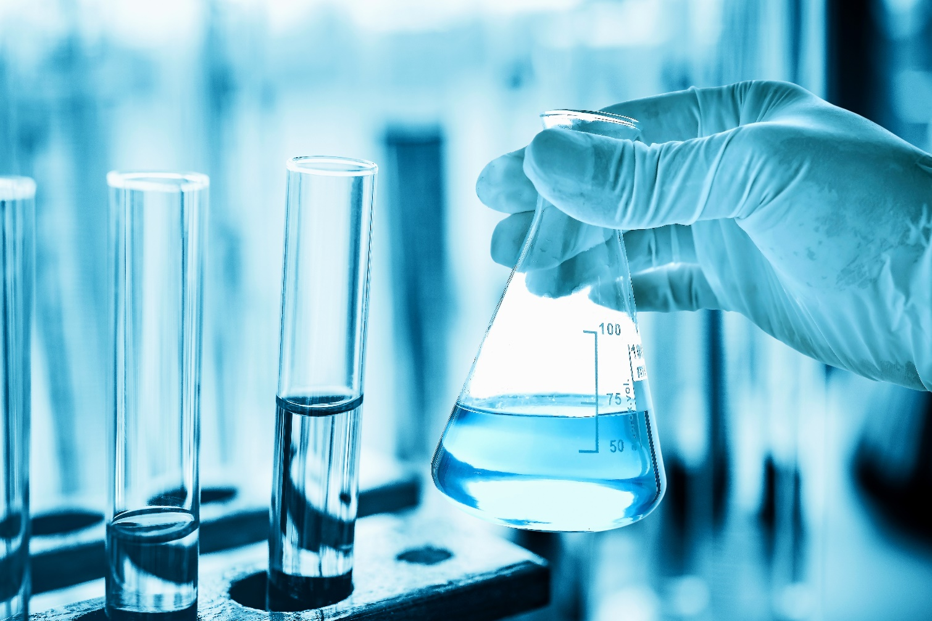

Chemical Resources

eLearning: Fundamentals of Chemical Fume Hood Safety Training
Centers for Disease Control and Prevention (CDC)

This online self-study course provides an essential understanding of the major components of a chemical fume hood and proper practices for its safe and effective operation. Topics include the major components and types of fume hoods and their monitors, maintaining proper airflow, daily use protocols and good fume hood work practices, and what to do if there is an emergency.

Registration Information
Fundamentals of Chemical Fume Hood Safety | CDC

eLearning: Introduction to Chemical Agents
Institute for Public Health

The online self-study course provides a brief overview of the history of chemical agent use, chemical agent characteristics, routes of exposure, routes of dissemination, and chemical agent categories. Chemical agent exposure identification and decontamination for healthcare professionals is also discussed.

Registration Information
Introduction to Chemical Agents | CDC TRAIN

Job Aid: CDC Specimen-Collection Protocol for a Chemical-Exposure Incident
Centers for Disease Control and Prevention (CDC)

This job aid provides step-by-step instructions for collecting a specimen from a person after a chemical exposure incident.

More Information
Specimen-Collection Protocol for Chemical Exposure Incident | CDC

Additional Resources: Laboratory Information for Chemical Emergencies | CDC

Presentation Slides: Chemical Terrorism Program - Packaging and Shipping of Blood and Urine Samples
State Hygienic Laboratory at the University of Iowa

This presentation provides information about the packaging and shipping of blood and urine samples after an act of chemical terrorism.

More Information
Chemical Terrorism Program Presentation | University of Iowa

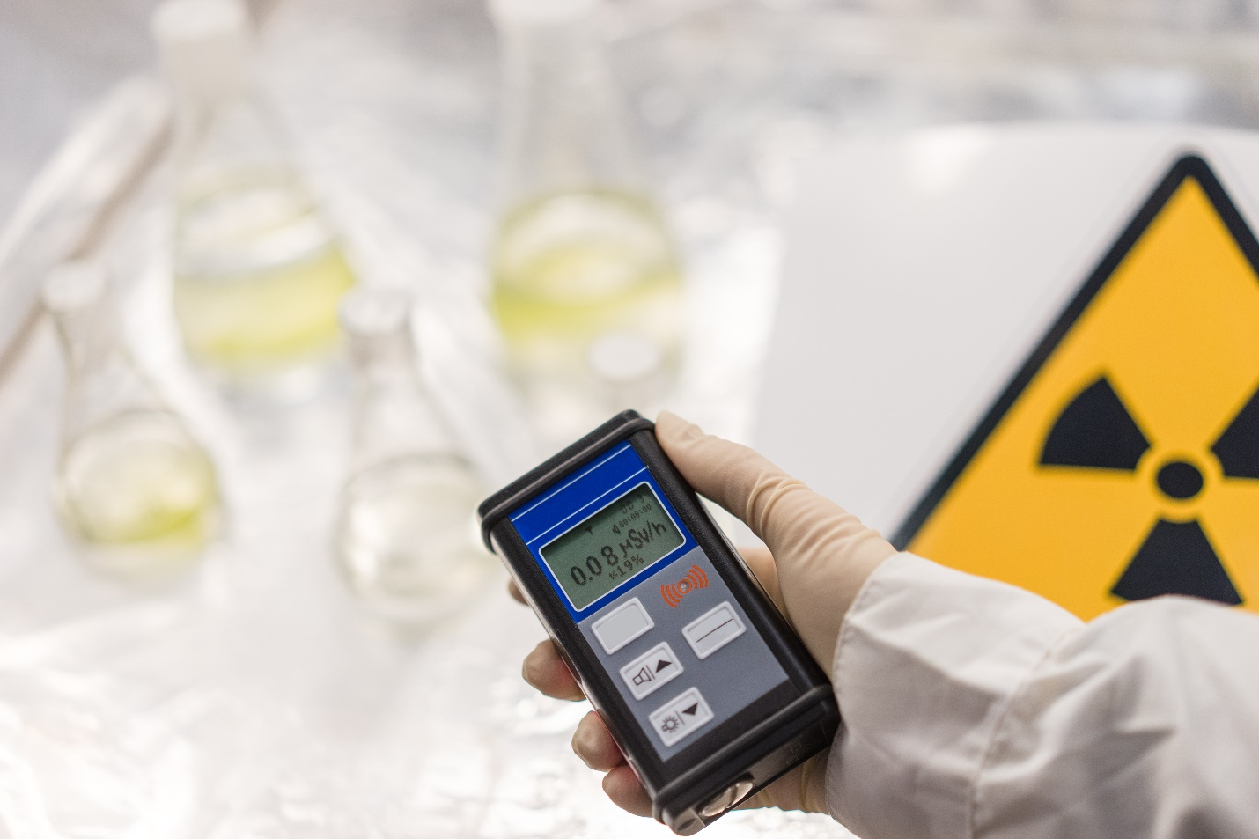

Radiological Resources

eLearning: Radiation Emergency Training for Poison Center and Public Health Professionals

Centers for Disease Control and Prevention (CDC)

This online self-study course is designed to prepare poison control staff to react appropriately and share vital information in the unlikely event of a radiation emergency. This training will consist of five modules including: Types of Radiation, Protective Measures, Exposure and Contamination, Decontamination and Medical Countermeasures, and Risk Communication.

More Information

Radiation Emergency Training for Poison Center and Public Health Professionals I CDC

Additional Resources: Radiation Emergency Training, Education, and Tools I CDC

Job Aid: CDC Specimen Collection Protocol for a Radiological Incident

Centers for Disease Control and Prevention (CDC)

This job aid provides step-by-step instructions for collecting a specimen from a person after a radiological exposure incident.

More Information

Specimen Collection Protocol for Radiological Incident I CDC

Additional Resources: Laboratory Information for Radiation Emergencies I CDC

For questions, please contact: NCEHsamplelogistics@cdc.gov, 770-488-7227

Publication: A Possible Approach to Large-Scale Laboratory Testing for Acute Radiation Sickness After a Nuclear Detonation

John Hopkins Center for Health Security
Journal: Biosecurity and Bioterrorism: Biodefense Strategy, Practice, and Science

This document describes possible approaches to identify patients at risk for acute radiation sickness after a nuclear detonation.

More Information
A Possible Approach to Large-Scale Laboratory Testing for Acute Radiation Sickness After a Nuclear Detonation

Reference Guide: Radiological Laboratory Sample Analysis Guide for Incidents of National Significance – Radionuclides in Air
Environmental Protection Agency (EPA)

The document describes the likely analytical decision paths that would be made by personnel at a radioanalytical laboratory following a radiological or nuclear incident, such as that caused by a terrorist attack. This document presents three radioanalytical scenarios, responding to two different public health questions, that address the immediate need to determine the concentration of known or unknown radionuclides in air particulate samples.

More Information
Radiological Laboratory Sample Analysis Guide for Incidents of National Significance - Radionuclides in Air | EPA

Reference Guide: Radiological Laboratory Sample Analysis Guide for Incidents of National Significance – Radionuclides in Soil
Environmental Protection Agency (EPA)

The document describes the likely analytical decision paths that would be required by personnel at a radioanalytical laboratory following a radiological or nuclear incident, such as that caused by a terrorist attack. Three radioanalytical scenarios, responding to two different public health questions, address the immediate need to determine the concentration of known or unknown radionuclides in water.

More Information
Radiological Laboratory Sample Analysis Guide for Incidents of National Significance - Radionuclides in Soil | EPA

Reference Guide: Radiological Laboratory Sample Analysis Guide for Incidents of National Significance – Radionuclides in Water
Environmental Protection Agency (EPA)

The document describes the likely analytical decision paths that would be required by personnel at a radioanalytical laboratory following a radiological or nuclear incident, such as that caused by a terrorist attack. Three radioanalytical scenarios, responding to two different public health questions, address the immediate need to determine the concentration of known or unknown radionuclides in water.

More Information
Radiological Laboratory Sample Analysis Guide for Incidents of National Significance - Radionuclides in Water | EPA

Appendix: Website URL Addresses

eLearning: Basic Molecular Biology Series………………………………………………………………………………….7 https://www.cdc.gov/labtraining/training-courses/basic-molecular-biology/index.html

eLearning: Biosafety: Avoiding Laboratory Acquired Infections (LAI)………………………………….……..7
https://prepareiowa.training-source.org/training/courses/Biosafety%3A%20Avoiding%20Lab%20Acquired%20Infections%20%28LAI%29/detail/

eLearning: Biosecurity for Clinical Laboratories……………………………………………………….………………...7
https://prepareiowa.training-source.org/training/courses/Biosecurity%20for%20Clinical%20Laboratories/detail

eLearning: Fundamentals of Centrifuge Safety………………………………………………………….……………….8
https://www.cdc.gov/labtraining/training-courses/fundamentals-centrifuge-safety.html

eLearning: Fundamentals of Personal Protective Equipment (PPE) in Clinical Laboratories……....8
https://www.cdc.gov/labtraining/training-courses/basic-microbiology/fundamentals-personal-protective-equipment.html

eLearning: Fundamentals of Working Safely in a Biological Safety Cabinet…………………………..……8
https://www.cdc.gov/labtraining/training-courses/biological-safety-cabinets.html

eLearning: Introduction to Laboratory Risk Management (LRM)………………………………………………..9
https://www.cdc.gov/labtraining/training-courses/Introduction-to-Laboratory-Risk- Management.html

eLearning: Microbiology Series………………………………………………………………………………………………….9
https://www.cdc.gov/labtraining/training-courses/basic-microbiology/index.html

eLearning: Packing and Shipping Dangerous Goods: What the Laboratory Staff Must Know……..9
https://www.cdc.gov/labtraining/training-courses/packing-shipping-division-6.2- materials.html

Instructor Lead: Biological Agent Identification and Counterterrorism…………………………………....10
https://usamriid.health.mil/education/bait.htm

Instructor Lead: Field Identification of Biological Warfare Agents……………………………..…………....10
https://usamriid.health.mil/education/fibwacourse.htm

Job Aid: Sensitivity and Specificity for Clinical Laboratory Testing…………………………………………….10
https://www.cdc.gov/labtraining/docs/job_aids/additional_resources/Sensitivity_and_S pecificity_Final_5_23_2022_508.pdf

Job Aid: Individualized Quality Control Plan (IQCP) …………………………………………………………………11
https://www.cdc.gov/labquality/docs/IQCP-Layout.pdf

https://www.cdc.gov/labquality/iqcp.html

Job Aid: Provider-Performed Microscopy (PPM) Procedures…………………………………….…………….11
https://www.cdc.gov/labquality/docs/PMP_Booklet_7252019.pdf

https://www.cdc.gov/labtraining/training-courses/CLIA-and-Provider-performed-Microscopy-Procedures-Introduction.html

https://www.cdc.gov/labquality/ppm.html?CDC_AA_refVal=https%3A%2F%2Fwww.cdc.gov%2Fclia%2Fppm.html

Job Aid: Ready? Set? Test! Patient Testing is Important. Get the Right Results……………………….12
https://www.cdc.gov/labquality/images/waived-tests/RST-Booklet_Dec-2019.pdf

https://www.cdc.gov/labtraining/training-courses/ready-set-test.html

https://www.cdc.gov/labquality/waived-tests.html?CDC_AA_refVal=https%3A%2F%2Fwww.cdc.gov%2Fclia%2Fwaived-tests.html

Job Aid: Specimen Storage and Shipping Guidance………………………………………………………………….12
https://www.cdc.gov/laboratory/specimen-submission/pdf/Specimen-Packing-and- Shipping-Guidance-Infectious-Diseases-Laboratories.pdf

Job Aid: To Test or Not to Test?....................................................................................................13
https://www.cdc.gov/labquality/docs/waived-tests/15_255581-test-or-not-test-booklet.pdf

https://www.cdc.gov/labquality/waived-tests.html?CDC_AA_refVal=https%3A%2F%2Fwww.cdc.gov%2Fclia%2Fwaived-tests.html

Presentation Slides: Blood Borne Pathogen Training...................................................................13
https://www.train.org/cdctrain/course/1047781/

Publication: Good Laboratory Practice for Waived Testing Sites……………………………..…………..…..13
https://www.cdc.gov/mmwr/preview/mmwrhtml/rr5413a1.htm

Webinar Recording: The Laboratory Risk Assessment Cycle…………………………………………….…..….14
https://web.aphl.org/events/Risk-Assessments-in-Our-Everyday-Life-588-636-21--4260/details

Webinar Recording: Respirator Fit 101 Intro to Quantitative Fit Testing………………...…………...….14
https://www.train.org/cdctrain/course/1091016/

Virtual Reality: Biosafety Cabinet Edition………………………………………………………………………….……..14
https://www.cdc.gov/labtraining/training-courses/vr/labtrainingVR_BSC.html

Virtual Reality: Personal Protective Equipment (PPE) Edition………………………………….……………….15 https://www.cdc.gov/labtraining/training-courses/vr/labtrainingVR_PPE.html

eLearning: Fundamentals of Chemical Fume Hood Safety Training…………………………….….……..…17
https://www.cdc.gov/labtraining/training-courses/fundamentals-chemical-fume-hood-safety.html

eLearning: Introduction to Chemical Agents……………………………………………………….......................17
https://www.train.org/cdctrain/course/1009766/

Job Aid: CDC Specimen-Collection Protocol for a Chemical-Exposure Incident………….…………..…17
https://emergency.cdc.gov/labissues/pdf/chemspecimencollection.pdf

https://emergency.cdc.gov/chemical/lab.asp

Presentation Slides: Chemical Terrorism Program - Packaging and Shipping of Blood and Urine Samples ………………………………………………………………………………………………………………………………..…18
http://www.shl.uiowa.edu/edtrain/sentlabtrain/Presentation%20-%20Chemical%20Terrorism_Packaging%20Shipping.pdf

eLearning: Radiation Emergency Training for Poison Center and Public Health Professionals….20
https://www.cdc.gov/radiationtraining/rad-toolkit/index.html

https://www.cdc.gov/nceh/radiation/emergencies/training.htm

Job Aid: CDC Specimen Collection Protocol for a Radiological Incident………………………..……..…..20
https://emergency.cdc.gov/radiation/pdf/urinecollectionflowchart.pdf

https://www.cdc.gov/nceh/radiation/emergencies/labinfo.htm?CDC_AA_refVal=https%3A%2F%2Femergency.cdc.gov%2Fradiation%2Flabinfo.asp

Publication: A Possible Approach to Large-Scale Laboratory Testing for Acute Radiation Sickness after a Nuclear Detonation……………………………………………………………..……………………………………….21
https://www.centerforhealthsecurity.org/our-work/pubs_archive/pubs-pdfs/2011/2011-12-01-possible_lab_test_rad.pdf

Reference Guide: Radiological Laboratory Sample Analysis Guide for Incidents of National Significance – Radionuclides in Air……………………….………………………………………………………………….21
https://www.epa.gov/sites/default/files/2015-05/documents/402-r-09-007-air-guide.pdf

Reference Guide: Radiological Laboratory Sample Analysis Guide for Incidents of National Significance – Radionuclides in Soil……………………….…………………………………………………………………22
https://www.epa.gov/sites/default/files/2015-05/documents/402-r-12- 006_soil_guide_sept_2012.pdf

Reference Guide: Radiological Laboratory Sample Analysis Guide for Incidents of National Significance – Radionuclides in Water……………………….…………………………………………………………….22
https://www.epa.gov/sites/default/files/2015-05/documents/402-r-07-007_water_guide.pdf

