- Purpose
This document provides quality control (QC) guidance for the analysis of nucleic acid next generation sequencing (NGS) data. Following the generation of NGS data, this guidance should be utilized with the analytical techniques used to process sequence data. The guidance takes into account specific QC checkpoints between computational processes to ensure each step is completed correctly, with high confidence, and to generate quality data metrics that yield an informative study.

QC checkpoints are necessary at several stages of bioinformatics analysis including filtering raw read sequences, de novo or reference based alignment/assembly and characterization stages. These steps ensure that NGS data generated through the sequencing process meets standards for analysis through removal of low quality reads and reduction of false negatives and positives. This guidance also aims to promote standardized best practice measures in order to improve reproducibility of results.

- Scope
This document provides information on sequencing QC: quality control steps to be performed on NGS data after it comes off the sequencing instrument and before Pre-Analysis QC.

- Related Documents
Title | Document Control Number
Bioinformatics QC Workflows

- Responsibilities
Position | Responsibility
All Laboratory Staff | - Follow documented procedures
Team Lead | - Ensure documented procedures for data quality checks are established  - Ensure documented procedures are followed
Quality Manager | - Ensure documented procedures are available to the end user  - Review records of data quality checks as required

- Definitions
Term | Definition
SAV | Sequence Analysis Viewer
Intensity (also referred to as P90) | The 90% percentile extracted intensity for a given image (lane/tile/cycle/channel combination). On platforms using four-channel sequencing, 4 channels (A, C, G, and T) are shown.
FWHM | The average full width of clusters at half maximum (representing their approximate size in pixels).
Corrected Intensity | The intensity corrected for cross talk between the color channels and phasing and prephasing.
Called Intensity | For a given base in a lane/tile/cycle, the average intensity for all clusters that were called as that base.
% No Calls | The percentage of clusters on a tile for which no base (N) has been called
% Base | The percentage of called (non-N) clusters for which the selected base has been called.
Signal to Noise | The signal to noise ratio is calculated as mean called intensity divided by standard deviation of noncalled intensities.
Error Rate | The calculated error rate, as determined by a spiked PhiX control sample. If a PhiX control sample is not run in the lane, this number is not available.
% Perfect Reads | The percentage of reads that align perfectly, as determined by a spiked in PhiX control sample. If a PhiX control sample is not run in the lane, this number is not available.
%Q >/= 20, %Q >/= 30 | The percentage of bases with a phred or Q quality score of 20 or 30 or higher, respectively.
Median Q-Score | The median Q-Score for each tile over all bases for the current cycle. These charts are generated after the 25th cycle. This metric is best used to examine the Q-scores of your run as it progresses. The %Q30 plot can give an over simplified view due to its reliance on a single threshold.
Density | The density of clusters for each tile (in thousands per mm²).
Desnity PF | The density of clusters passing filter for each tile (in thousands per mm²).
Clusters | The number of clusters for each tile (in millions).
Clusters PF | The number of clusters passing filter for each tile (in millions).
% Pass Filter | The percentage of clusters passing filter.
% Phasing, % Prephasing | The average rate (percentage per cycle) at which molecules in a cluster fall behind (phasing) or jump ahead (prephasing) during the run.
% Aligned | The percentage of the passing filter clusters that aligned to the PhiX genome.
Time | The date and time the tile was processed for that cycle.
Minimum / Maximum Contrast | The 10th and 99.5th percentiles per channel of selected columns of the raw image, respectively.

- Equipment
N/A
- Reagents and Media
N/A
- Supplies, Other Materials
N/A
- Safety Precautions
N/A

- Sample Information / Processing
Upon completion of the NGS run, transfer data to Isilon. (Specify your laboratory data storage location here.)
- Quality Control
N/A
- Workflow Chart
N/A
- Process Overview
N/A

- SAV Procedure
  - Once the sequencing run is complete load data into SAV
    - Double click the Illumina Sequencing Analysis Viewer Software desktkop shortcut, or go to C:\Illumina\Illumina Sequencing Analysis Viewer Software and doublc click Sequencing Analysis Viewer Software.exe.
    - The Sequencing Analysis Viewer Software opens.
    - Click the tab containing the appropriate query information.
    - In the Run Folder field, copy the folder location or click Browse to select a run folder. Make sure to highlight the run folder and not the parent folder or any folder/file inside the run folder.
    - Click Refresh. The SAV Software starts loading data showing quality metrics for that run.

  - Under the Summary Tab (see Figure 1), review the following metrics:
- In the top table review:
Metric | Expected Value
Level | The sequencing read level
Yield Total | MiSeq Reagent Kit V2:  Output Max: 7.5 Gb  2.25 Gb at 2 x 300 bp  4.5 Gb at 2 x 150 bp  7.5 Gb at 2 x 250 bp  MiSeq Reagent Kit V3:  Up to 15 Gb at 2 x 300 bp  Up to 3.75 Gb at 2 x 75 bp
Projected Total Yield | The projected number of bases expected to be sequenced at the end of the run, which is updated as the run progresses.
Aligned | The percentage that aligned to the PhiX genome i.e. if 1% PhiX was the initial input quantity, the aligned value should be equal to 1% or below.
Error Rate | The calculated error rate of the reads that aligned to PhiX.
Intensity Cycle 1 | The average of the A channel intensity measured at the first cycle averaged over filtered clusters.
%Q >/= 30 | MiSeq Reagent Kit V2:  > 90% bases higher than Q30 at 1 × 36 bp  > 90% bases higher than Q30 at 2 × 25 bp  > 80% bases higher than Q30 at 2 × 150 bp  > 75% bases higher than Q30 at 2 × 250 bp  MiSeq Reagent Kit V3:  > 85% bases higher than Q30 at 2 × 75 bp  > 70% bases higher than Q30 at 2 × 300 bp
Figure 1. Sequence Analysis Viewer version 1.9.1 Summary Tab

- In the Read Table (see Figure 2), review
Metric | Expected Value
Organism | (Specify the organism here.)
Range | (Specify the range here.)
Tiles | Standard Flow Cell in MiSeq Reagent Kit v3 (38 tiles)  PGS Flow Cell in MiSeq Reagent Kit v3 (38 tiles)  Standard Flow Cell in MiSeq Reagent Kit v2 (28 tiles)  Micro Flow Cell in MiSeq Reagent Micro Kit v2 (8 tiles)  Nano Flow Cell in MiSeq Reagent Nano Kit v2 (4 tiles)
Density | Kit V2:  Loading Concentration: 10-15 pM  Cluster Density:1000-1200 k/mm²  Kit V3:  Loading Concentration: 15 pM  Cluster Density:1200-1400 k/mm²
Clusters PF | 80-95%
Phas./Prephas. | <0.25
Reads | Kit V3: 25M  Kit V2 : 15M  Micro Kit V2: 4M  Nano Kit V2: 1M
Reads PF | Kit V2: Single Reads: 12-15M Paired End Reads: 24-30M  Kit V3: Single Reads 22-25M, Paired End Reads: 44-50M
%Q >/= 30 | Kit V2:  > 90% bases higher than Q30 at 1 × 36 bp  > 90% bases higher than Q30 at 2 × 25 bp  > 80% bases higher than Q30 at 2 × 150 bp  > 75% bases higher than Q30 at 2 × 250 bp  Kit V3:  > 85% bases higher than Q30 at 2 × 75 bp  > 70% bases higher than Q30 at 2 × 300 bp
Yield | Kit V2:  Output Max: 7.5 Gb  2.25 Gb at 2 x 300 bp  4.5 Gb at 2 x 150 bp  7.5 Gb at 2 x 250 bp  Kit V3:  Up to 15 Gb at 2 x 300 bp  Up to 3.75 Gb at 2 x 75 bp
Cycles Err Rated | The number of cycles that have been error-rated using PhiX,  starting at cycle 1.
Aligned | The percentage that aligned to the PhiX genome.
Error Rate | The calculated error rate, as determined by the PhiX alignment.  Subsequent columns display the error rate for cycles 1–35, 1–75,  and 1–100.
Intensity Cycle 1 | The average of the A channel intensity measured at the first cycle  averaged over filtered clusters.

Figure 2. Sequence Analysis Viewer version 1.9.1 Read Table
  - On the Indexing Tab (see Figure 3) select the displayed lane through the drop-down list.
- Review the first table that contains a summary of the indexing performance for that lane.
Metric | Expected Value
Total Reads | Kit V2 : 15M  Micro Kit V2: 4M  Nano Kit V2: 1M
PF Reads | Kit V2: Single Reads: 12-15M Paired End Reads: 24-30M  Kit V3: Single Reads 22-25M, Paired End Reads: 44-50M
% Reads Identified (PF) | The total fraction of passing filter reads assigned to an index.
CV | The coefficient of variation for the number of counts across all indexes.
Min | The lowest representation for any index.
Max | The highest representation for any index.

Figure 3. Sequence Analysis Viewerv version 1.9.1 Indexing Tab Overview
- In the Indexing Tab (see Figure 4a and 4b) review the below:
Metric | Expected Value
Organism | (Specify the organism here.)
Range | (Specify the range here.)
Index Number | A unique number assigned to each index by SAV for display purposes.
Sample ID | The sample ID assigned to an index in the sample sheet.
Project | The project assigned to an index in the sample sheet.
Index 1 (I7) | The sequence for the first Index Read.
Index 2 (I5) | The sequence for the second Index Read.
% Reads Identified (PF) | The number of reads (only includes Passing Filter reads) mapped to this index.

Figure 4a. Sequence Analysis Viewer version 1.9.1 Indexing Tab Table

Figure 4b. Sequence Analysis Viewer 1.9.1 Indexing Tab Plot

  - Based on your MiSeq configuration, data is either stored locally or automatically transferred to the network storage.
- If data is stored locally, after reviewing data in SAV, transfer data using an FTP-based program (e.g. WinSCP or FileZilla) to a specified directory (include your storage location here).

- Trending over Time
  - Several of the aforementioned values shown by SAV might indicate decreasing health of a sequencer. Ensure that you are not seeing a decrease in these values over time (provided other variables remain constant). Keep in mind that they could also be the result of poor library prep or faulty templates/kit(s). These metrics include: Number of reads, Percentage >Q30, Error rate and Demultiplexing.

- Method Performance Specifications
N/A
- Calculations
N/A

- Reference Values, Alert Values
N/A
- Interpretation of Results
  - Assess the eveness and consistency of yield across all samples.
    - Low yield in one sample and high/double yield in another with all others having consistent yield may indicate mixed tags. In this case, consult with a bioinformatician on the best way to proceed.
    - Low yield overall may indicate an issue in library prep. Consult with a bioinformatician or prepare a new library.
  - Mean quality score should be above 30 for each sample. Run FastQC (a quality control tool for high throughput sequence data) on each sample with a mean quality score less than 30.

- Results Review and Approval
N/A

- Sample Retention and Storage
Store data in compliance with all applicable regulations, CDC records retention policy, and laboratory data storage procedures. (Update to specify your laboratory’s data retention and storage policy)

- References
22.1 Illumina Sequence Analysis Viewer v1.11 Part # 15066069 v02 February 2016

- Appendices (Include example screen shots of good and poor quality data applicable to your laboratory methods)
SAV Sample Screenshots:
Figure A-1. Sequence Analysis Viewer 1.9.1 Analysis Tab

Figure A-2. Sequence Analysis Viewer 1.9.1 Imaging Tab

Figure A-3. Sequence Analysis Viewer 1.9.1 Summary Tab

Figure A-4. Sequence Analysis Viewer 1.9.1 Indexing Tab
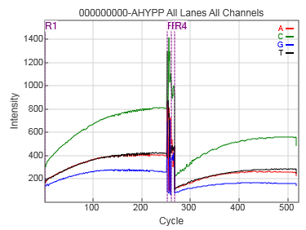

Figure A-5. Sequence Analysis Viewer 1.9.1 Intensity Plot
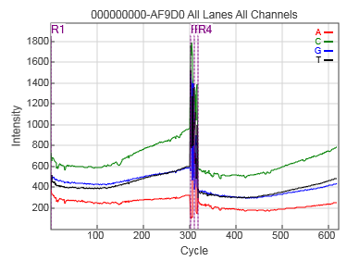

Figure A-6. Sequence Analysis Viewer 1.9.1 Intensity plot (600 cycle v3 run)
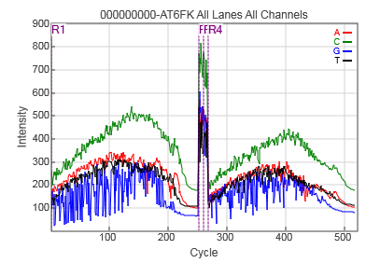

Figure A-7. Sequence Analysis Viewer 1.9.1 Intensity plot (for Amplicons)
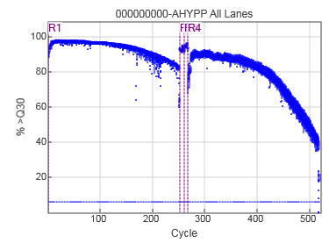

Figure A-8. Sequence Analysis Viewer 1.9.1 %Q30 plot (600 cycle v3) (Good Run)
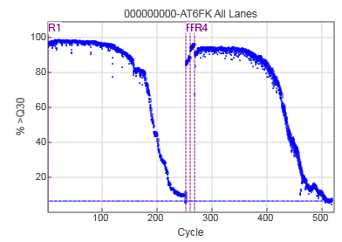
Figure A-9. Sequence Analysis Viewer 1.9.1 %Q30 plot (Low Quality Run)
%Q30 plot for 600 cycle v3 run:
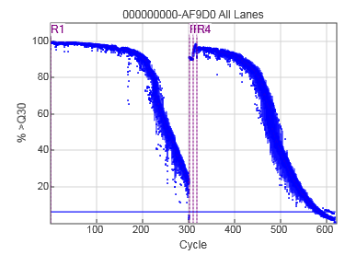

Figure A-10. Sequence Analysis Viewer 1.9.1 %Q30 plot (600 cycle v3)

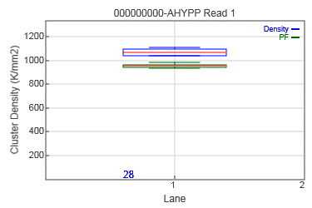
Figure A-11. Sequence Analysis Viewer 1.9.1 Cluster Density plot (Blue bar – Cluster Density, Green Bar – Cluster Pass filter)

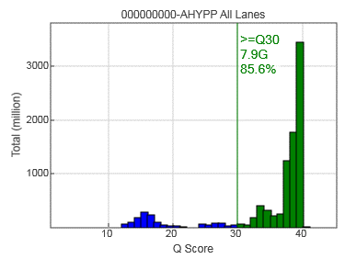

Figure A-12. Sequence Analysis Viewer 1.9.1 QScore Distribution plot
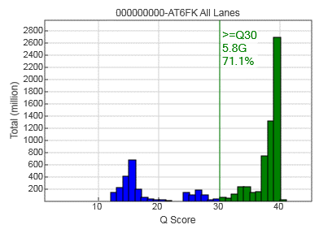
Figure A-13. Sequence Analysis Viewer 1.9.1 QScore Distribution plot (Low Quality)
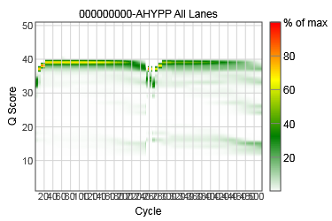

Figure A-14. Sequence Analysis Viewer 1.9.1 Qscore Heatmap

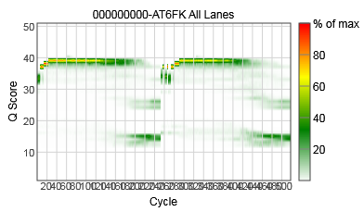

Figure A-15. Sequence Analysis Viewer 1.9.1 Qscore Heatmap (Low Quality)
Table A-1. Example of Pertussis Laboratory Expected Sample Cutoff Values and Ranges for the metrics in the Summary table.
Metric | Expected Value | Sample Values
Organism | (Specify the organism here.) | Pertussis  (Reagent Kit v3) |  | E.Coli K12 MG1655¹
Range | (Specify the range here.) | Cutoff | Ideal
Level | The sequencing read level
Yield Total | MiSeq Reagent Kit V2:  Output Max: 7.5 Gb  2.25 Gb at 2 x 300 bp  4.5 Gb at 2 x 150 bp  7.5 Gb at 2 x 250 bp  Kit V3:  Up to 15 Gb at 2 x 300 bp  Up to 3.75 Gb at 2 x 75 bp | < 9 Gb | 12-16 Gb
Projected Total Yield | The projected number of bases expected to be sequenced at the end of the run, which is updated as the run progresses.
Aligned | The percentage that aligned to the PhiX genome i.e. if 1% PhiX was the initial input quantity, the aligned value should be equal to 1% or below. |  | < 1%
Error Rate | The calculated error rate of the reads that aligned to PhiX.
Intensity Cycle 1 | The average of the A channel intensity measured at the first cycle averaged over filtered clusters.
%Q >/= 30 | MiSeq Reagent Kit V2:  > 90% bases higher than Q30 at 1 × 36 bp  > 90% bases higher than Q30 at 2 × 25 bp  > 80% bases higher than Q30 at 2 × 150 bp  > 75% bases higher than Q30 at 2 × 250 bp  MiSeq Reagent Kit V3:  > 85% bases higher than Q30 at 2 × 75 bp  > 70% bases higher than Q30 at 2 × 300 bp | Read 1 > 80%  Read 2 > 70% | Read 1 > 85%  Read 2 > 75% | MiSeq : 89.7 %  HiSeq: 87.7%

Table A-2. Example of Pertussis Laboratory Expected Sample Cutoff Values and Ranges for the metrics in the Read table.
Metric | Expected Value | Sample Values
Organism | (Specify the organism here.) | Pertussis
Range | (Specify the range here.) | Cutoff | Range
Tiles | Standard Flow Cell in MiSeq Reagent Kit v3 (38 tiles)  PGS Flow Cell in MiSeq Reagent Kit v3  (38 tiles)  Standard Flow Cell in MiSeq Reagent Kit v2 (28 tiles)  Micro Flow Cell in MiSeq Reagent Micro Kit v2 (8 tiles)  Nano Flow Cell in MiSeq Reagent Nano Kit v2 (4 tiles)
Density | Kit V2:  Loading Concentration: 10-15 pM  Cluster Density:1000-1200 k/mm²  Kit V3:  Loading Concentration: 15 pM  Cluster Density:1200-1400 k/mm² | < 800/mm² or  > 1500/ mm² | 1200-1400k/mm²
Clusters PF | 80-95% | < 75% | 80-95%
Phas./Prephas. | <0.25
Reads | Kit V3: 25M  Kit V2 : 15M  Micro Kit V2: 4M  Nano Kit V2: 1M | < 18M or > 28M
Reads PF | Kit V2:  Single Reads: 12-15M  Paired End Reads: 24-30M  Kit V3:  Single Reads 22-25M  Paired End Reads: 44-50M | Single Reads:  < 15M  Paired End Reads: < 30M | Single Reads:  22-25M  Paired End Reads: 44-50M
%Q >/= 30 | Kit V2:  > 90% bases higher than Q30 at 1 × 36 bp  > 90% bases higher than Q30 at 2 × 25 bp  > 80% bases higher than Q30 at 2 × 150 bp  > 75% bases higher than Q30 at 2 × 250 bp  Kit V3:  > 85% bases higher than Q30 at 2 × 75 bp  > 70% bases higher than Q30 at 2 × 300 bp | < 70% bases higher than Q30 at 2 × 300 bp | Read1 > 75 % bases higher than Q30 at 2 × 300 bp  Read2 > 70% bases higher than Q30 at 2 × 300 bp
Yield | Kit V2:  Output Max: 7.5 Gb  2.25 Gb at 2 x 300 bp  4.5 Gb at 2 x 150 bp  7.5 Gb at 2 x 250 bp  Kit V3:  Up to 15 Gb at 2 x 300 bp  Up to 3.75 Gb at 2 x 75 bp
Cycles Err Rated | The number of cycles that have been error-rated using PhiX, starting at cycle 1.
Aligned | The percentage that aligned to the PhiX genome.
Error Rate | The calculated error rate, as determined by the PhiX alignment.  Subsequent columns display the error rate for cycles 1–35, 1–75, and 1–100.
Intensity Cycle 1 | The average of the A channel intensity measured at the first cycle  averaged over filtered clusters.

Table A-3. Example of Pertussis Laboratory Cutoff Values and Ranges for the metrics in the Indexing Tab Table.
Metric | Expected Value | Example Sample Values
Organism | (Specify the organism here.) | Pertussis
Range | (Specify the range here.) | Cutoff | Range
Index Number | A unique number assigned to each index by SAV for display purposes.
Sample ID | The sample ID assigned to an index in the sample sheet.
Project | The project assigned to an index in the sample sheet.
Index 1 (I7) | The sequence for the first Index Read.
Index 2 (I5) | The sequence for the second Index Read.
% Reads Identified (PF) | The number of reads (only includes Passing Filter reads) mapped to this index. | < 95% | 98-99.5%

- Revision History
Rev # | DCR # | Change Summary | Date

- Approval

Approval Signature: __________________________________ Date: ________________

