The Next Generation Sequencing Quality Initiative
The Next Generation Sequencing (NGS) Quality Initiative is a collaboration between the Centers for Disease Control and Prevention (CDC), the Association of Public Health Laboratories (APHL), and state and local public health laboratories (PHLs) to address the many challenges laboratories encounter when implementing NGS-based assays. The Initiative is developing an NGS-focused quality management system (QMS) to assure foundational quality during the development and implementation of sequencing-based tests by providing customizable, ready-to-implement tools and resources that laboratories can use to standardize and institute quality management practices and procedures. The NGS Quality Initiative has published additional tools and resources, including templates and procedures, that may be of assistance to laboratories throughout their NGS workflow. Please visit the following website to access these resources: https://www.cdc.gov/labquality/qms-tools-and-resources.html.
This document is intended to be used as a tool for implementing, improving, or maintaining an NGS QMS. Blue text provides examples for appropriate input and can be changed, deleted, or augmented as needed for the laboratory’s specific requirements.
These documents and tools are not controlled files; format and content must be modified as needed to meet the document control, QMS, or regulatory requirements within your laboratory. It is the responsibility of your laboratory to take any necessary actions to ensure the information within these documents remains applicable.
Disclaimer:
Use of trade names and commercial sources is for identification only and does not imply endorsement by the U.S. Centers for Disease Control and Prevention or by the U.S. Department of Health and Human Services.

Insert Laboratory Specific Name Here
NGS QC Guidance for Illumina Workflows
Guidance

Purpose
  - This document provides quality control (QC) guidance for nucleic acid sequencing using Illumina technology. The guidance considers specific QC checkpoints between laboratory processes to ensure each step is completed accurately, with high confidence, to generate quality data metrics that are informative for downstream bioinformatics processes.
  - The quality of nucleic acid extraction and manipulation, fractionation and size selection, and library preparation affects fragment size uniformity and library diversity, which is important for achieving complete and even coverage of the total nucleic acid to be sequenced. Gaps resulting from poor sample preparation cannot be corrected downstream by error correction methods employed by some sequencing technologies. In addition, quality scores do not reflect errors introduced during sample preparation, as the sequencing signal will appear clean and error-free. The maximal achievable accuracy of most sequencing platforms is limited by the sample accuracy.
NOTE: The expected results included are based on standard NGS methods for Illumina sequencing at the time of document development. The advancement of new methods and technologies may allow for successful sequencing with QC results differing from those listed in this document.
  - Automated systems that perform multiple process steps during operation or generate unique sample preparations that are difficult to analyze using conventional QC methods, will still require QC checkpoints. Custom procedures may need to be developed to satisfy the recommendations listed below:

NGS QC Checkpoints
The following sections correspond to the process steps prior to sequencing, as outlined in Figure 1 (see Appendix A) for a detailed process map.

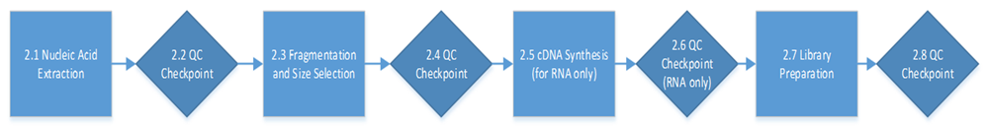
Figure 1. NGS QC Checkpoints for Illumina Workflows

  - Nucleic Acid Extraction:
    - The Illumina sequencing workflows utilize either DNA or RNA as starting material. High quality nucleic acid purification is essential for obtaining accurate NGS data. The extraction method depends greatly on the sample type and matrices involved.
  - Post-Extraction Nucleic Acid QC Checkpoint:
    - Nucleic acid purity and concentration should be quantitated after extraction to ensure that preparation is primarily the nucleic acid that the user is analyzing (dsDNA, RNA, or cDNA). It is to also ensure that the sample is mostly free of contamination. Quantitation of purity and concentration is highly recommended for all applications.
    - Purity is measured spectrophotometrically as the ratio of absorbance measurements is at 280 nm and 260 nm. The NanoDrop instruments and procedures are commonly used to measure absorbance of nucleic acid samples and to quantitate purity. For accurate quantitation of nucleic acid, fluorescent dyes are used to complex with select forms of nucleic acid (dsDNA and RNA) and their concentration is measured at a particular fluorometric emission and excitation wavelength.
    - Quantitation of dsDNA and RNA concentration are commonly completed with fluorometric instruments and methods such as Qubit or Quant-iT. In addition, real-time or quantitative PCR (qPCR) can also be used for very sensitive quantitation of dsDNA (e.g., KAPA qPCR). This is much more time consuming than fluorometric analysis described above and is usually not used until after library preparations are made, where very sensitive quantitation of pooled samples at low concentrations is crucial for successful sequencing.
    - In some cases, instruments that perform complete electrophoretic separation of nucleic acid such as the TapeStation, Bioanalyzer, or BluePippin can also measure absorbance and fluorescence of the electrophoretically separated nucleic acid. Hence, these instruments can measure nucleic acid purity and concentration, and can be used in lieu of the NanoDrop and Qubit or Quant-iT but are more costly and time-consuming to perform. This is not recommended for QC checks where qPCR is recommended. In addition, these instruments provide assessments of nucleic acid integrity by visualizing the abundance and size range of fragments. This additional information can assist the user in understanding DNA sample integrity as well as provide insight into any issues identified during extraction. Conventional gel electrophoresis may also be used to assess nucleic acid integrity and sample quality but does not quantitatively measure purity and concentration.
    - DNA Quality Check:
      - Purity and concentration of the isolated dsDNA should be quantitated immediately after extraction to ensure a successful extraction.
      - dsDNA Purity: Spectrophotometric measurement of absorbance ratio (A260/A280) should be used to quantitate purity of the DNA sample (e.g., NanoDrop). Although these methods also can quantitate DNA, the measurements are frequently affected by any present RNA or other biomolecules absorbing in the UV range and should not be used as quantitation for NGS library preparation. The ThermoFisher Scientific T009-Technical Bulletin on 260/280 and 260/230 ratios contains additional information on purity analysis.
        - Expected Results: A₂₆₀/A₂₈₀ = 1.8-2.0; a ratio of ~1.8 is generally accepted as “pure” for DNA.
        - If the ratio is appreciably lower, it may indicate the presence of protein, aromatic chemicals such as phenol, or other contaminants that absorb strongly at or near 280 nm.
      - dsDNA Concentration: Fluorescent measurements using a particular fluorescent dye and fluorimeter should be used to measure dsDNA. These methods, such as Qubit and Quant-iT, can quantitate dsDNA exclusively, even in the presence of contaminating RNA and other single-stranded DNA.
        - Expected Results: Concentration of preparation should be > 500 ng in a 20 -100 µL sample.
        - Be aware that if any contaminating DNA or other reagents are present that also generates a signal at the same emission/excitation wavelengths of the fluorometric assay, this will result in a false positive reading.
      - Alternative methods for quantitating purity, concentration, and assessing dsDNA quality: Electrophoretic instruments designed for NGS (e.g., TapeStation, Bioanalyzer, BluePippin) in some cases can be used to quantitate purity and concentration of DNA (read vendor instructions) and can be used in lieu of methods described in 2.2.5.b and 2.2.5.c. In addition, this type of analysis can also provide qualitative analysis on DNA sample integrity (DNA quality). Conventional gel electrophoresis can only be used to visually assess DNA quality and does not quantitate purity and concentration.
    - RNA Quality Check:
      - Purity and concentration of the isolated RNA should be quantitated after extraction to ensure successful extraction, as well as prior to use if not used immediately.
      - RNA Purity: see 2.2.5.b, which also applies to RNA, except a ratio of ~2.0 is generally accepted as “pure” for RNA.
      - RNA Concentration: Fluorescent measurements using a particular fluorescent dye and fluorimeter should be used to measure RNA. Fluorescent dyes that are selective for RNA can be used, such as Ribogreen.
        - Expected Results: Concentration of preparation should be > 500 ng in a 20-100 µL sample.
        - Be aware that if any contaminating RNA or other reagents are present that also generates a signal at the same emission/excitation wavelengths of the fluorometric assay, this will result in a false positive reading.
      - Alternative Methods for quantitating purity, concentration, and assessing RNA Quality: Electrophoretic instruments designed for NGS (e.g., TapeStation, Bioanalyzer, BluePippin) in some cases can be used to quantitate purity and concentration of RNA (read vendor instructions) can be used in lieu of methods described in 2.2.6.b and 2.2.6.c. Conventional gel electrophoresis can only be used to visually assess RNA quality and not quantitate purity and concentration.
  - Fragmentation and Size Selection:
    - The fragmentation process shears the gDNA using one of three general techniques, depending on the downstream application: mechanical (e.g., Covaris), nebulization, or enzymatic (e.g., NEB Fragmentase, tagmentation).

  - Fragmentation and Size Selection QC Checkpoint:
    - The success of fragmentation and size selection is best confirmed using an electrophoretic instrument designed for NGS. These instruments provide gel images and electropherograms, which are important qualitative and quantitative measurements of median fragment size and distributions of fragments sizes within the sample. The results provide important information on quality of fragmentation, especially during method development or processing novel and unknown sample types. Conventional gel electrophoresis can be used to qualitatively assess fragmentation and size selection, but does not provide comprehensive and quantitative analysis, such as electropherograms.
      - Expected Results: The electropherogram/gel band should reveal a single peak/band of desired size with no tailing and excessive broadening per laboratory specifications.
      - Several documents from the electrophoretic instrument vendor manual give examples on good and poorly fragmented samples and provide insight into the root cause of inconsistencies and errors.
  - Synthesis of cDNA from mRNA in a total RNA preparation:
    - After extraction, target RNA may be enriched from total RNA, fragmented (optional), and then converted to complementary DNA (cDNA) before library preparation. This is to increase stability of the sample as well as allow amplification. RNA to cDNA conversion is done using reverse transcriptase PCR.
  - cDNA Synthesis QC Checkpoint:
    - Refer to 2.2 for quantitation of purity and concentration.
        - Library Preparation:
    - There are many library preparation kits available specific to the kind of sequencing and downstream application. Generally, the fragments of nucleic acid become fused with adaptors recognized by the sequencing chip followed by PCR amplification.
        - Library Preparation QC Checkpoint:
    - It is recommended that libraries are quantified prior to pooling and loading into the sequencer to ensure optimum cluster densities across every lane of every flow cell are achieved. Libraries can be quantified using a fluorometric measurement or by real-time PCR (e.g., KAPA qPCR). In addition, it is recommended to verify the size of fragments and check for template size distribution through electrophoretic instrument analysis optimized for NGS. Conventional gel electrophoresis can also be used as a qualitative visualization of fragment size, distribution, and purity.
    - Expected Results: Library concentration > 1mM. The electropherogram/gel band analysis should reveal a single peak/band of desired size with no tailing and excessive broadening per laboratory specifications.

Related Documents
NOTE: Always check the manufacturer’s website for updates and recent versions of guides.
Document Title | Document No.
Agilent 2200 TapeStation Assay | Specify number
Bioanalyzer DNA 7500 and DNA 12000 Assay | Specify number
BluePippin DNA Size Selection System | Specify number
Fragment Analyzer Assay | Specify number
KAPA Library Quantification for Illumina Platforms | Specify number
KAPA Library Quantification for Ion Torrent Platforms | Specify number
NanoDrop Nucleic Acid Quantitation Assay | Specify number
Quant-it Nucleic Acid Quantitation Assay | Specify number
Qubit dsDNA Quantitation Assay | Specify number
Qubit RNA Quantitation Assay | Specify number
ThermoFisher Scientific T009-Technical Bulletin | Specify number

References:
- Agilent Technologies. (2015). Agilent 2200 TapeStation System User Manual. https://www.agilent.com/cs/library/usermanuals/public/G2964-90000_TapeStation_USR_ENU.pdf
- Agilent Technologies. (2019). Automated Nucleic Acid Sample Quality Control in NGS Workflows. https://www.agilent.com/cs/library/applications/appcompendium-ngs-sample-control-tapestation-5994-1591en-agilent.pdf
- Agilent Technologies. (2022). NGS Sample Quality Control. https://www.agilent.com/en/solutions/genomics-applications-solutions/sample-QC/ngs
- Endrullat et al. (2016). Standardization and quality management in next-generation sequencing. https://www.sciencedirect.com/science/article/pii/S2212066116300230
- Hussing et al. (2015). Comparison of techniques for quantification of next-generation sequencing libraries. https://retsmedicin.ku.dk/english/research-in-forensic-medicine/research-in-forensic-genetics/?pure=en%2Fpublications%2Fcomparison-of-techniques-for-quantification-of-nextgeneration-sequencing-libraries(14a897a6-cb15-4923-9eb3-b1b4273641da).html
- Illumina. (2022). Understanding the NGS workflow. https://www.illumina.com/science/technology/next-generation-sequencing/beginners/ngs-workflow.html
- Illumina. (2022). Recommended quality control of FFPE samples for Illumina FFPE-supported library preparation kits. https://support.illumina.com/bulletins/2017/03/recommended-quality-control-of-ffpe-samples-for-illumina-ffpe-su.html
- Illumina. (2016). Evaluating RNA Quality from FFPE Samples. https://www.illumina.com/content/dam/illumina-marketing/documents/products/technotes/evaluating-rna-quality-from-ffpe-samples-technical-note-470-2014-001.pdf
- NViGEN Personalized Medicine. (2022). DNA Size Selection: Basics & Development. https://www.nvigen.com/dna-size-selection-tutorial/
- ThermoFisher Scientific. (2015). Assessment of Nucleic Acid Purity. https://assets.thermofisher.com/TFS-Assets/CAD/Product-Bulletins/TN52646-E-0215M-NucleicAcid.pdf

Appendices:

  - Appendix A – Illumina NGS QC Checkpoints Process Map
  - Appendix B – Illumina NGS QC Checklist

NGS QI document review cycle
Rev # | DCR # | Change Summary | Date
[insert laboratory specific revision number here] | [insert laboratory specific corresponding document control number here] | [insert change summary here] | [insert date of revision here]

Approval:
Approved By: Date:
Author

Print Name and Title

Approved By: Date:
Supervisor

Print Name and Title

Approved By: Date:
Quality Manager

Print Name and Title

Appendix A – Illumina NGS QC Checkpoints Process Map
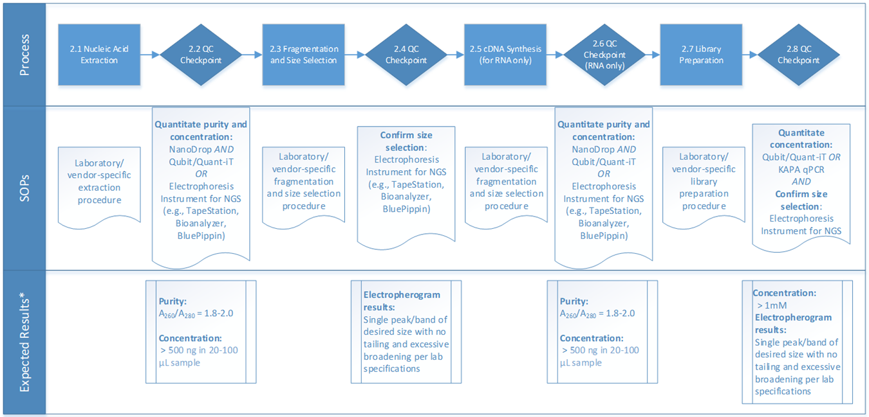

Appendix B – Illumina NGS QC Checklist
QC Checkpoint (Process Step) | Method (SOPs) | Expected Results*
Post-Extraction Nucleic Acid (2.2)  Quantitate purity and concentration | Purity (choose one):  NanoDrop Nucleic Acid Quantitation Assay  Other _________________  AND  Concentration (choose one):  Qubit dsDNA or RNA Quantitation Assay  Quant-iT Assay  Other _________________  OR  Electrophoresis Instrument for NGS (choose one):  TapeStation Assay  Bioanalyzer Assay  BluePippin Assay  Other _________________ | Purity: A₂₆₀/A₂₈₀ = 1.8-2.0  Concentration: > 500 ng in a 20-100 µL sample
Fragmentation and Size Selection (2.4)  Confirm size selection | Electrophoresis Instrument for NGS (choose one):  TapeStation Assay  Bioanalyzer Assay  BluePippin DNA Size Selection Assay  Other _________________ | Electropherogram results:  Single peak/band of desired size with no tailing and excessive broadening per lab specifications
cDNA Synthesis* (2.6)  Quantitate purity and concentration  *For RNA sample only | Purity (choose one):  NanoDrop Nucleic Acid Quantitation Assay  Other _________________  AND  Concentration (choose one):  Qubit dsDNA or RNA Quantitation Assay  Quant-iT Assay  Other _________________  OR  Electrophoresis Instrument for NGS (choose one):  TapeStation Assay  Bioanalyzer Assay  BluePippin DNA Size Selection Assay  Other ____________ | Purity: A₂₆₀/A₂₈₀ = 1.8-2.0  Concentration: > 500 ng in a 20-100 µL sample
Library Preparation (2.6)  Quantitate concentration and confirm size selection | Concentration (choose one):  Qubit dsDNA or RNA Quantitation Assay  Quant-iT Assay  KAPA qPCR  Other ____________  AND  Electrophoresis Instrument for NGS (choose one):  TapeStation Assay  Bioanalyzer Assay  BluePippin DNA Size Selection Assay  Other ____________ | Concentration: > 1 mM  Electropherogram results:  Single peak of desired size with no tailing and excessive broadening per lab specifications

*NOTE: The expected results included are based on standard NGS methods in use at the time of document development. The advancement of new methods and technologies may allow for successful sequencing with QC results differing from those listed in this document.

