- Purpose
  - This document provides quality control (QC) guidance for nucleic acid sequencing using the Oxford Nanopor MinION technology. The guidance takes into account specific QC checkpoints between laboratory processes to ensure each step is completed correctly, with high confidence, and to generate quality data metrics that are informative for downstream bioinformatics processes.
  - The quality of nucleic acid extraction and manipulation, fractionations and size selection, and library preparations affects fragment size uniformity and library diversity, which is important for achieving complete and even coverage of the total nucleic acid to be sequenced. Gaps resulting from poor sample preparation cannot be corrected downstream by error correction methods employed by some sequencing technologies. In addition, quality scores do not reflect errors introduced during sample preparation, as the sequencing signal will appear clean and error-free. The maximal achievable accuracy of most sequencing platforms is limited by the sample accuracy.

- NGS QC Checkpoints
The following sections correspond to the process steps prior to sequencing, as outlined in Figure 1.

Figure 1: NGS QC Checkpoints for MinION 1D Workflows

  - Nucleic Acid Extraction
- High quality nucleic acid purification is essential for obtaining accurate NGS data. The extraction method depends greatly on the sample type and matrices involved. See Appendix A for extraction methods recommended by Nanopore.
Note: Proteinase K has been known to cause pore degradation. It is recommended to use an extraction method that does not use proteinase K.
  - Post Extraction Nucleic Acid QC Checkpoint
It is important to check input DNA for quality before beginning library preparation. Low molecular weight, incorrectly qualified and/or contaminated DNA (e.g, salt, EDTA, protein, organic solvents) can have a significant impact on downstream processes and ultimately, your sequencing run.
- Criteria for Input DNA
- Purity as measured using Nanodrop – OD 260/280 of ~1.8 and OD 260/230 of 2.0-2.2. A 260/280 which is higher than ~1.8 indicates the presence of RNA. A 260/280 which is lower than ~1.8 can indicate the presence of protein or phenol. Establish the precise acceptable 260/280 range for your test during development and validation.
- Average fragment size >30kb. Fragment size may be measured using several methods (e.g., pulse-field, low percentage agarose gel analysis, blue pippin). This quality checkpoint is important during the development and validation of the test. Labs may elect to omit this quality check after validation if the test has proven robust and stable.
- Input mass, as measured by Qubit – 1 µg or 1.5 µg if carrying out a DNA repair step. In order to maximize sequencing yield, it is important that the nanopores are kept filled with DNA to minimize the time they are idle between strands. For further optimization of fragment length to improve throughput, see table 1 in section 2.6.
- Use the configuration test cell to confirm the MinION is communicating with the computer.
- The configuration protocol has been successfully completed when the message “Customer configuration run has completed” is displayed in the notifications panel. If configuration reports that it has failed, reinsert the flow cell and trouble shoot per manufacturer’s instructions. Upon successful configuration, the MinION and MinKNOW systems are ready for platform QC of the flow cell (see Section 2.7).
  - DNA Fragmentation (optional): DNA fragmentation is an optional step for when experiments require specific fragment sizes.
  - Fragmentation QC Checkpoint
- Determine the fragment size, quantity, and quality using the Agilent Bioanalyzer or similar instrument. Confirm the fragment size is within the expected range. If the results yield smaller fragments, this is indicative of substantial shearing/degradation of the input material and is likely to reduce the quality of the library preparation and the read length distribution
  - Library Preparation: Perform library preparation according to the selected protocol. It is recommended that the repaired/end-prepped DNA sample is subjected to clean-up with AMPure XP beads. This clean-up can be omitted for simplicity and to reduce library preparation time. However, it has been observed that omission of this clean-up can: reduce subsequent adapter ligation efficiency, increase the prevalence of chimeric reads, and lead to an increase in pores being unavailable for sequencing.
  - Library Preparation QC Checkpoint
- In order to maximize sequencing yield, it is important that the nanopores are kept filled with DNA to minimize the time they are idle between strands. The less material goes into the flow cell, the fewer “threadable ends” will be present to be captured by the pores. Therefore, the pores will be searching for molecules for longer, and if the pores are not always sequencing, throughput could be compromised.
- Note: During development and optimization of a method it is advisable to check the fragment size and final DNA input concentration of the library before proceeding to priming and loading the library. The below table may be used to inform optimization experiments.
Mass of extracted nucleic acid | No. of moles if library fragment length = 2kb | No. of moles if library fragment length = 8kb | No. of moles if library fragment length = 50 kb
10 μg | 7.7 pmol | 1.9 pmol | 308 fmol
5 μg | 3.9 pmol | 963 fmol | 154 fmol
3.5 μg | 2.7 pmol | 674 fmol | 108 fmol
2 μg | 1.5 pmol | 385 fmol | 62 fmol
1.5 μg | 1.2 pmol | 289 fmol | 46 fmol
1 μg | 770 fmol | 193 fmol | 31 fmol
500 ng | 385 fmol | 96 fmol | 15 fmol
400 ng | 308 fmol | 77 fmol | 12 fmol
200 ng | 154 fmol | 39 fmol | 6.2 fmol
100 ng | 77 fmol | 19 fmol | 3.1 fmol
30 ng | 23 fmol | 5.8 fmol | 0.9 fmol
10 ng | 7.7 fmol | 1.9 fmol | 0.3 fmol
10 pg | 0.0077 fmol | 0.009 fmol | 0.0003 fmol
Table 1: Fragment Length
- In order to keep the pores full, the current R9.4.1 and R9.5.1 pores require about 5-50 fmol of good quality library put into the flow cell.
- Quantify 1 µL of adapter ligated DNA using a Qubit fluorometer. Expected recovery is 430 ng.
  - Pre-loading QC Checkpoint: As the MinKNOW script progresses, check the following:
- Number of active pores should be 800 or greater
- Heatsink temperatures: (34°C)
  - Post Loading QC Checkpoint: The library is loaded dropwise. Ensure each drop flows into the port before adding the next. Be sure to pipette slowly when adding priming mix to priming port to ensure the membrane stays intact. For further details on loading the Oxford Nanopore MinION flow cell click here.
  - Post Loading QC Checkpoint
- Number of active pores should be above 800
- Development of the read histogram: Confirm the histogram reflects expected read lengths for the experimental design being used.
- Pore occupancy: Monitor the pore occupancy for the first 30 minutes of a sequencing experiment. If you are not observing the expected percentage of pores in stand sequencing, stop the run, wash the flow cell and store it for use in another run. A good library will be indicated by a higher proportion of light green channels in Sequencing state (neon green) than are in Pore state (green). The combination of Sequencing and Pore channels indicate the number of active pores at any point in time. A low proportion of sequencing channels will reduce the throughput of the run.
- Recovering (dark blue) indicates channels that may become available for sequencing again. A high proportion of this may indicate additional clean up steps are required during your library preparation.
- Inactive (light blue) indicates channels that are no longer available for sequencing. A high proportion of these as soon as the run begins may indicate an osmotic imbalance.
- Unclassified are channels that have not yet been assigning one of the above classifications.
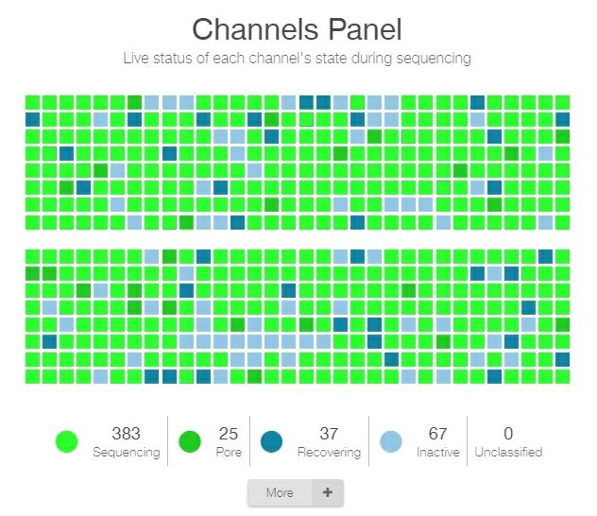

- Good quality library: A good quality library will result in most of the pores being in the “Sequencing” state (neon green), and very few in “Pore” (green), “Recovering” (dark blue), or “Inactive” (light blue). A library that results in a Duty Time graph like the example below is likely to give a good sequencing throughput. The graph populates over time, and can be used as a way to assess the quality of your sequencing experiment, and make an early decision whether to continue with the experiment or to stop the run.
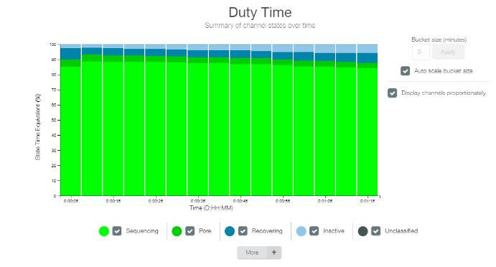
- Base Calling Report: Confirm the local basecalling is being recorded in the base calling report and is within expected range (insert laboratory specific range here).

- Appendices
  - Appendix A – NGS MinION Extraction Methods

- Revision History
Rev # | DCR # | Change Summary | Date

- Approval

Approved By: _________________________________ Date: __________________
Author

_______________________________________________________
Print Name and Title

Approved By: _________________________________ Date: _________________
Supervisor

_______________________________________________________
Print Name and Title

Approved By: _________________________________ Date: __________________
Quality Manager

_______________________________________________________
Print Name:

Appendix A – Extraction Methods
Extraction Method
Gram-negative bacterial DNA | Click here for protocol
Gram-positive bacterial DNA | Click here for protocol
Yeast DNA | Click here for protocol
Yeast RNA | Click here for protocol

