Insert Laboratory Specific Name Here
Illumina iSeq 100 Waste Disposal

- Purpose
The following document acts as a procedure on the proper disposal methods for Illumina iSeq 100 waste.

- Scope
This document applies to all staff that operate the Illumina iSeq 100 and supervisors that oversee these operations.

- Related Documents
Title | Document Control Number
N/A | Specify number

- Responsibilities
Position | Responsibility
All laboratory staff | - Ensure the iSeq 100 waste is disposed of in accordance with manufacturer recommendations or program disposal procedures  - Follow documented waste disposal procedures
Laboratory Leadership | - Ensure personnel are trained on the documented procedures for the disposal of iSeq 100 waste
Safety Staff | - Ensure that all safety procedures are established and followed
Quality Manager | - Ensure documented iSeq 100 waste disposal procedures are available to the end user  - Review records of instrument maintenance / calibration, as required

- Reagents and Media
Reagent | Manufacturer | Catalog #
N/A | N/A | N/A
- Supplies, Other Materials
Supply/Material | Manufacturer | Catalog #
Absorbent Material | N/A | N/A
Storage Bags | N/A | N/A
Spill Proof Storage Tray | N/A | N/A

- Safety Precautions
  - All practices and safety equipment must comply with the recommendations for the specific biosafety level (BSL) and as listed in the most current version of Biosafety in Microbiology and Biomedical Laboratories (BMBL).
  - Appropriate personal protective equipment (PPE) must be worn at all times when working in the laboratory, including laboratory coat, gloves, and safety glasses.
- Formamide waste will be ticketed for chemical waste disposal through the Laboratory Waste Management System (specify your laboratory’s system/process here).
  - For iSeq, the fluidics, reagents, and waste are contained within the cartridge, which is disposed as chemical waste.
  - Place the entire cartridge in a storage bag (e.g., Ziploc bags). The bags can be left to accumulate in a spill proof tray.
  - The spill proof tray will need to have a satellite accumulation label if it accumulates material beyond the use day.
  - Once ready for disposal, create a label for pickup (specify your laboratory’s process for indicating waste is ready for disposal).
  - Select the appropriate waste profile (specify to your laboratory’s waste management system profile) (e.g., “Toxic liquid, organic, non-regulated”) when creating the labels.
  - Appropriately trained Hazardous Waste Management Personnel (specify the title for these personnel in your laboratory) packages the formamide waste cartridges into drums and sends them off site to be incinerated. Since this waste is not regulated the extra weight from the cartridges does not change the waste generator status.
- The flow cell undergoes a wash cycle after formamide exposure. Illumina recommends that the flow cell does not need to be discarded as chemical waste.
  - Dispose of the flow cell as “hard waste”, following laboratory specific hard waste disposal procedures.
- Please see below for information regarding how to determine the concentration of formamide.
  - For iSeq, there is a total volume of 2 mL of formamide in the kit potentially mixed with 144.5 mL of reagent (final concentration 1.4% formamide)
- Formamide concentration in the final waste solution of each run varies depending on the instrument and the length of the run. To determine the concentration of formamide, measure the final waste volume and perform the appropriate calculations as explained in the following table.
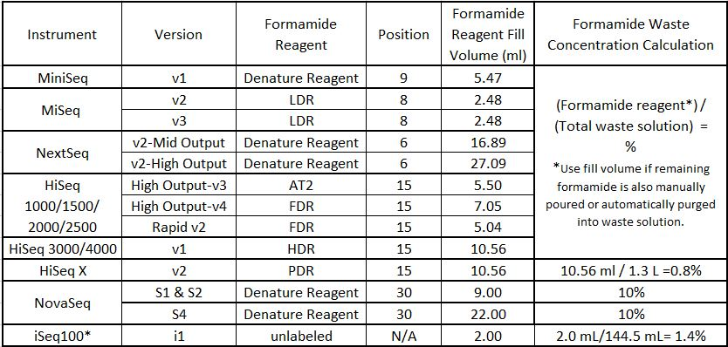
- Quality Control
N/A
- References
  - Final formamide concentration in the waste solution of Illumina sequencing systems: https://support.illumina.com/bulletins/2016/10/what-is-the-final-formamide-concentration-in-the-waste-solution-of-illumina-sequencing-systems.html
  - Illumina Safety Data Sheets (SDS): https://support.illumina.com/sds.html
  - Reference Laboratory Specific Waste Disposal Procedure

- Appendices
N/A
- Revision History
Rev # | DCR # | Change Summary | Date

- Approval
Approved By: _________________________________ Date: _______________
Author
______________________________________________________
Print Name and Title

Approved By: _________________________________ Date: _______________
Supervisor
______________________________________________________
Print Name and Title

Approved By: _________________________________ Date: _______________
Quality Manager
______________________________________________________
Print Name

