Insert Laboratory Specific Name Here
Illumina NextSeq 550 Waste Disposal

- Purpose
The following document acts as a procedure on the proper disposal methods for Illumina NextSeq 550 waste.

- Scope
This document applies to all staff that operate the Illumina NextSeq 550 and supervisors that oversee these operations.

- Related Documents
Title | Document Control Number
N/A | Specify number

- Responsibilities
Position | Responsibility
All laboratory staff | - Ensure the NextSeq 550 waste is disposed of in accordance with manufacturer recommendations or program disposal procedures  - Follow documented waste disposal procedures
Laboratory Leadership | - Ensure personnel are trained on the documented procedures for the disposal of iSeq 100 waste
Safety Staff | - Ensure that all safety procedures are established and followed
Quality Manager | - Ensure documented NextSeq 550 waste disposal procedures are available to the end user  - Review records of instrument maintenance/calibration, as required

- Reagents and Media
Reagent | Manufacturer | Catalog #
N/A | N/A | N/A

- Supplies, Other Materials
Supply/Material | Manufacturer | Catalog #
Absorbent Material | N/A | N/A
Storage Bags | N/A | N/A
Spill Proof Storage Tray | N/A | N/A

- Safety Precautions
  - All practices and safety equipment must comply with the recommendations for the specific biosafety level (BSL) and as listed in the most current version of Biosafety in Microbiology and Biomedical Laboratories (BMBL).
  - Appropriate personal protective equipment (PPE) must be worn at all times when working in the laboratory, including laboratory coat, gloves, and safety glasses.
- Formamide waste will be ticketed for chemical waste disposal through the Laboratory Waste Management System (specify your laboratory’s system/process here).
  - For the NextSeq reagent cartridge, a small amount of formamide is present in well 6 of the cartridge.
  - Place tape over cartridge well 6 and place the entire cartridge in a storage bag (e.g., Ziploc bags).
  - The spill proof tray will need to have a satellite accumulation label if it accumulates material beyond the use day.
  - Once ready for disposal, create a label for pickup (specify your laboratory’s process for indicating waste is ready for disposal).
  - Select the appropriate waste profile (specify to your laboratory’s waste management system profile) (e.g., “Toxic liquid, organic, non-regulated”) when creating the labels.
  - Appropriately trained Hazardous Waste Management Personnel (specify the title for these personnel in your laboratory) packages the formamide waste cartridges into drums and sends them off site to be incinerated. Since this waste is not regulated the extra weight from the cartridges does not change the waste generator status.

- The flow cell undergoes a wash cycle after formamide exposure. Illumina recommends that the flow cell does not need to be discarded as chemical waste.
  - Dispose of the flow cell as “hard waste”, following laboratory specific solid biohazardous waste disposal procedures.

- Please see below for information regarding how to determine the concentration of formamide.
  - For NextSeq, overall volumes will change depending on which version and cycle kit is used.
    - V2-Mid Output has 150, and 300 cycles
    - V2-High Output has 75, 150, and 300 cycles

- Formamide concentration in the final waste solution of each run varies depending on the instrument and the length of the run. To determine the concentration of formamide, measure the final waste volume and perform the appropriate calculations as explained in the following table.
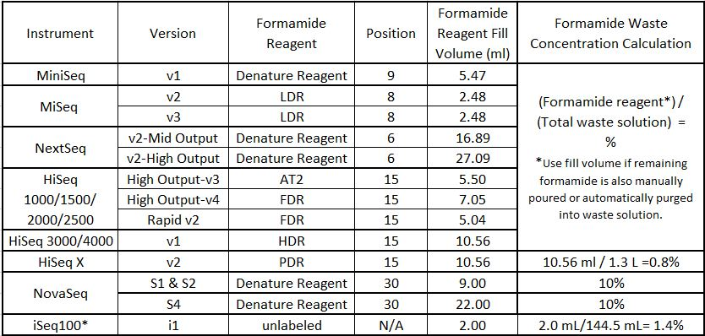

- Quality Control
N/A

- References
  - Final formamide concentration in the waste solution of Illumina sequencing systems: https://support.illumina.com/bulletins/2016/10/what-is-the-final-formamide-concentration-in-the-waste-solution-of-illumina-sequencing-systems.html
  - Illumina Safety Data Sheets (SDS): https://support.illumina.com/sds.html
  - Insert Laboratory Specific waste disposal procedure here

- Appendices
N/A

- Revision History
Rev # | DCR # | Change Summary | Date

- Approval
Approved By: _________________________________ Date: _______________
Author
______________________________________________________
Print Name and Title

Approved By: _________________________________ Date: _______________
Supervisor
______________________________________________________
Print Name and Title

Approved By: _________________________________ Date: _______________
Quality Manager
______________________________________________________
Print Name

