The Next Generation Sequencing Quality Initiative
The Next Generation Sequencing (NGS) Quality Initiative is a collaboration between the Centers for Disease Control and Prevention (CDC), the Association of Public Health Laboratories (APHL), and state and local public health laboratories (PHLs) to address the many challenges laboratories encounter when implementing NGS-based assays. The Initiative is developing an NGS-focused quality management system (QMS) to assure foundational quality during the development and implementation of sequencing-based tests by providing customizable, ready-to-implement tools and resources that laboratories can use to standardize and institute quality management practices and procedures. The NGS Quality Initiative has published additional tools and resources, including templates and procedures, that may be of assistance to laboratories throughout their NGS workflow. Please visit the following website to access these resources: https://www.cdc.gov/lab-quality/php/ngs-quality-initiative/qms-tools-resources.html.
This document is intended to be used as a tool for implementing, improving, or maintaining an NGS QMS. Blue text provides examples for appropriate input and can be changed, deleted, or augmented as needed for the laboratory’s specific requirements.
These documents and tools are not controlled files; format and content must be modified as needed to meet the document control, QMS, or regulatory requirements within your laboratory. It is the responsibility of your laboratory to take any necessary actions to ensure the information within these documents remains applicable.
Disclaimer:
Use of trade names and commercial sources is for identification only and does not imply endorsement by the U.S. Centers for Disease Control and Prevention or by the U.S. Department of Health and Human Services.

Insert Laboratory-Specific Name Here
Proficiency Testing and Alternative Assessment
Standard Operating Procedure

Purpose
The Clinical Laboratory Improvement Amendment of 1988 (CLIA) regulations (Part 493 – Laboratory Requirements) define requirements for CLIA certification of laboratories performing testing on human samples and reporting results with unique patient identifiers. Evaluation of the accuracy and reliability of Next Generation Sequencing (NGS) laboratory test systems using Proficiency Testing (PT) or Alternative Assessment (AA) is required to maintain CLIA Compliance. It is important for laboratories that are not seeking certification to take quality measures to ensure their data is of quality and can be utilized by accredited laboratories in the future (e.g., data uploaded to reference databases).

Scope
This procedure describes the requirements for participation in an appropriate PT program or the establishment of an alternative assessment procedure when PT is unavailable or inadequate. This SOP can be used as guidance by laboratories performing NGS under CLIA non-CLIA (e.g., The College of American Pathologists [CAP] and the International Organization for Standardization [ISO]).

Related Documents
Title | Document Control Number
[insert laboratory-specific document here] | [insert laboratory-specific document control number here]

Responsibilities
Position | Responsibility
CLIA Laboratory Director (LD) | - Ensure laboratory compliance with requirements for PT specified in the CLIA regulations.  - Notify the Centers for Medicare & Medicaid Services (CMS) if PT samples are received from a laboratory not associated with the CLIA Certificate of Compliance/Certificate of Accreditation of the testing laboratory.  - Review and approve all PT/AA reports from CLIA laboratories under their direction or delegate this responsibility in writing to a qualified Technical Supervisor.
Quality Manager or designee | - Monitor PT/AA schedule and communicate with CLIA Technical Supervisor(s) to ensure PT/AA events are completed and reported on schedule by the due date.  - Ensure that PT/AA result reports are reviewed and that a self-evaluation is performed for any ungraded results.  - Ensure that unacceptable results/exceptions are investigated and that required corrective action is taken and documented.  - Ensure that PT/AA exceptions are documented in the laboratory’s quality management process and included in periodic management reviews.  - Review PT/AA documentation to ensure completion and maintain required records.
CLIA Technical Supervisor | - Ensure that the laboratory participates in an HHS-approved PT program for CLIA-regulated analyte testing or has defined AA procedures to verify the accuracy of all test systems performed.  - Ensure PT/AA samples are tested in the same manner as patient specimens and sign the laboratory attestation statement.  - Review and approve PT/AA result evaluation and ensure self-evaluation is performed when needed for ungraded PT samples.  - Ensure that unacceptable results/exceptions are investigated and that required corrective action is taken and documented.  - Notify the CLIA Laboratory Director if PT samples are received from a laboratory not associated with the laboratory’s CLIA Certificate of Compliance/Certificate of Accreditation.  - Ensure that PT results are communicated to appropriate lab staff and that required corrective action is implemented and monitored.  - Review PT/AA specimen results prior to submission to the PT/AA program.  - Assign a designee to support PT/AA testing and results review, as necessary.
CLIA Testing Personnel | - Examine PT/AA samples along with regular workload using the laboratory routine methods, procedures, and materials.  - Test PT/AA samples and review scored results according to PT/AA program requirements.  - Do not send PT samples to or accept PT samples from a laboratory not associated with the laboratory’s CLIA Certificate of Compliance/Certificate of Accreditation.  - Support the investigation and documentation of unacceptable PT/AA results.  - Comply with remedial or corrective action as necessary.
All parties | - Refrain from discussing PT/AA testing results with anyone until after the AA event evaluation is complete or the PT submission deadline date has passed.

Definitions
Term | Definition
Alternative Assessment (AA) | Procedures used to verify the accuracy of test systems when no CMS-approved PT program exists or when the PT program is inadequate to cover testing. For nonwaived laboratory tests or procedures performed that are not listed in Subpart I of the CLIA regulations, laboratories are required to verify the accuracy of testing at least twice a year.
Corrective action | Action taken to eliminate the cause of a detected nonconformity or other undesirable situation and prevent recurrence.
Corrective action plan | Written plan to address finding(s) of noncompliance, including correction of the problem, investigation of the impact on patient results reported, quality measures to ensure deficient practice does not reoccur, and plan for monitoring effectiveness plan.
Event | A single round of PT/AA, which may include more than one challenge sample.
Proficiency Testing (PT) | PT is a tool the laboratory uses to verify the accuracy and reliability of testing. It can also be used to monitor the entire testing process, including the competency of testing personnel. CLIA requires laboratories performing nonwaived testing to participate in PT. According to Subpart H-Participation in Proficiency Testing for Laboratories Performing Nonwaived Testing, each laboratory must enroll in a PT program that meets the criteria in Subpart I-Participation in Proficiency Testing for Laboratories Performing Nonwaived Testing of the CLIA regulations and that is approved by the Department of Health and Human Services (HHS). The laboratory must enroll in an approved program or programs for each of the specialties and subspecialties for which it is certified to perform testing.
Proficiency Test Analyte | A specific substance or parameter reported by the laboratory as a patient test result. The specific substance can be any well-characterized sample by NGS-based assay, using unbiased procedures (e.g., blinded samples, external laboratory, certified materials). See Appendix A – Examples of Proficiency Testing (PT) and/or Alternative Assessment (AA) Samples for NGS.

PT/AA Plan

  - Each test system performed, including unique or low-volume testing (e.g., reduced number of samples), must be evaluated periodically for accuracy and reliability using either external PT or AA procedures.
  - Examples of PT/AA programs include:
    - CLIA Approved Proficiency Testing Program and CLIA Proficiency Testing and PT Referral Booklet
    - CAP Surveys Catalog
    - External Quality Assurance Program Oversight Laboratory (EQAPOL) – Duke University
    - European Molecular Genetics Quality Network also offers a NGS pilot sequencing and dry-lab EQA schemes for human genetic testing – ISO 17043 accredited
    - Quality Control for Molecular Diagnostics (QCMD) – ISO 17043 accredited
    - The GMI Proficiency Tests - Global Microbial Identifier
  - PT is required in each CLIA specialty or subspecialty for each CLIA-regulated analyte and test procedure performed by the laboratory. AA procedures should be used for all other test systems or when a PT program is inadequate to cover testing performed for a regulated analyte.
  - The frequency of PT for regulated analytes or test procedures is defined in the CLIA regulations.
  - Laboratories might enroll in PT/AA programs according to the needs and compatibility of the NGS assays.
    - Non-CLIA laboratories might also enroll in a CLIA, CAP, or internal CDC (e.g., Newborn Screening Quality Assurance Program) PT/AA as an NGS quality assurance measure.
    - Laboratories might include PT/AA domestic or international programs. For example, a laboratory might use an international program when the NGS assay focuses on the detection of a pathogen of global impact and/or the goal is to improve standardization of data sharing.
    - Laboratories and PT/AA programs should verify the compatibility of NGS assays and performance characteristics against expected QC metrics for genomic regions of interest or targets of PT/AA.
    - PT/AA programs might develop tests based on surveys and laboratory requirements (see Appendixes A and B). For example, if the NGS test is intended for surveillance, the PT/AA might evaluate if the laboratory is able to generate phylogenic trees, identify the source of the pathogen, and/or provide high-quality reads.
    - Some of the benefits of PT/AA might include:
      - Run blind samples to compare inter-laboratory-NGS results.
      - Identify analytical and interpretative errors (e.g., problems with QC, calibration, and/or assay design).
    - See Appendix C for a general PT/AA Overview.

PT for CLIA-Regulated Analytes and Test Procedures

  - Enroll in a CLIA-Approved Proficiency Testing Program for each CLIA-regulated analyte and test procedure performed by the laboratory.
  - Three PT events (or shipments) are required for most regulated analytes and tests (except mycobacteriology).
  - HHS-approved PT programs are required to provide PT events with the frequency designated by CLIA for each specialty and subspecialty. CLIA laboratories must complete all PT events required by the PT program within the program-established timeframe.
  - Provide the PT program with the laboratory’s CLIA certificate number to authorize the release of PT results to CMS.
  - The laboratory must not communicate with other laboratories concerning the PT sample results until after the submission deadline.
  - The PT samples or portions of PT samples must not be sent to another laboratory outside their CLIA certificate, even when that is the regular next step in a testing process.
  - PT samples or portions of PT samples from other laboratories must not be accepted as referred samples. Notify the CLIA Laboratory Director if another laboratory attempts to send a PT sample to the laboratory. The CLIA Laboratory Director will notify CMS.

Alternative Assessment (AA) Procedures

  - For test systems where no HHS-approved PT program exists or the PT program is inadequate to cover testing (e.g., unique specimen type, rare variant, pathogen discovery), the laboratory must develop an AA procedure to evaluate the accuracy and reliability of the test system.
    - AA might include an external, experienced NGS laboratory.
  - AA procedures should include a method used to evaluate the accuracy and reliability of the test system. For example:
    - Samples should be blinded to the laboratory and/or laboratory personnel running the NGS test.
    - Participation in an external AA (not HHS-approved) or quality assessment program (e.g., WHO).
    - Testing of laboratory-prepared samples using previously tested specimens with known results, sufficiently deidentified to the testing personnel performing the AA.
NOTE: Sample selection and preparation responsibilities should be defined in the procedure.
    - Testing of samples provided by an external partner laboratory with an exchange agreement. Testing of samples acquired from an outside source such as CAP, American Type Culture Collection (ATCC), or another vendor with verified results.
    - Aliquoted blind samples can be used for an AA:
      - Internal split samples – dividing a single sample into multiple aliquots and comparing results using a different platform and/or different operators.
      - External split samples – Sending samples (number of samples defined by a laboratory) to another laboratory for comparison of results, retesting samples received from another laboratory.
    - See Appendix A – Examples of Proficiency Testing (PT) and/or Alternative Assessment (AA) Samples for NGS.
    - Laboratories might use ring trials or tests as an AA of accuracy and reproducibility. See Appendix B – Examples of Proficiency Testing (PT)/Alternative Assessment (AA) Programs and Studies Developed for NGS Assays.
  - AA procedures should include criteria for acceptable results and frequency of conducting AA. AA is required at least twice annually for each test system.
    - Acceptable results might consider pre- and post-analytical phases of the test (e.g., how samples were handled, turnaround time of the test).
    - Laboratories should consider NGS assay variability while establishing acceptable QC metrics (e.g., quality of the reads).
  - Some considerations for AA might include:
    - Due to the low volume of patient samples used for AA, comparison of performance among laboratory peers might be limited, reducing chances to identify discrepancies and systematic errors.
    - Similar methods would evaluate inter-laboratory agreement and testing errors but not necessarily accuracy unless the method is calibrated to a reference method (e.g., a sample that has been identified as positive only by NGS-based assays might generate hesitation due to incorrect cut-off metrics. Ideally, establishing a true positive AA sample might require using alternative techniques such as Polymerase Chain Reaction [PCR], Fluorescence In Situ Hybridization [FISH] assay, etc.).
    - Testing aliquoted samples verifies reproducibility and stability of assay calibration but does not necessarily measure accuracy. Bias occurs when laboratories re-run the same ‘blinded’ samples.
    - De-identify patient samples to protect patients’ personal identifiable information (PII) and protected health information (PHI).
    - Specimen conditions during transportation and storage between laboratories should allow for repeat analysis and must be stable at defined storage conditions over time.
    - Manufacturers might provide certified calibrators to assess specific NGS assays.
    - See Appendix A – Examples of Proficiency Testing (PT) and/or Alternative Assessment (AA) Samples for NGS.

Performing PT/AA
Personnel involved in all phases of the NGS testing process (e.g., laboratory staff, bioinformaticians, epidemiologists, clinical staff, etc.) must follow the CLIA regulations and/or applicable enrolled program regulations for sample handling, testing, evaluation, and corrective action when performing PT/AA of test systems.

  - PT/AA samples must be tested with the laboratory’s regular patient workload and in the same manner as patient samples.
NOTE: The only exception to this is with low-volume testing. If patient specimens are not in the queue, it is acceptable to run just the PT/AA to meet the program PT/AA results due date/deadline.
  - Samples must be tested by competent personnel authorized to perform patient testing.
Conditions to perform the test system should follow the PT/AA guidelines established. Some testing options might include the following:
    - Rotating the testing personnel who perform the PT/AA testing for each PT event is one option for accomplishing participation over time.
    - Distributing samples during the PT event to different testing personnel is another option.
    - Depending on the number of testing personnel and number of PT samples per event, all testing personnel may be able to participate in each PT event.
    - Testing personnel performing each PT/AA sample must be documented and verified by the Technical Supervisor. The selection of testing personnel must follow PT/AA program requirements.
  - Testing must be performed using the test system SOP routinely used for patient testing unless there are specific instructions by the PT provider (e.g., reconstituting lyophilized samples prior to testing).
  - Samples must be tested the same number of times that routine patient samples are tested.
  - Samples must be tested using analyzers and equipment used for patient testing. Experimental conditions used for testing (e.g., number of samples, equipment selected) should follow PT/AA established guidelines. Some conditions may include the following:
    - Rotating the analyzer used for each PT event (e.g., if the same instrument is unavailable due to system failure or repair).
    - Distributing samples during each PT event to be tested using all analyzers/equipment is another option for accomplishing the use of all analyzers.
    - Depending on the number of analyzers/equipment and the number of PT samples per event, all analyzers/equipment may be able to be used during each PT event.
    - Analyzer/equipment used for each PT/AA sample must be documented.
    - If the laboratory uses multiple methods for an analyte, the PT panel is tested by the primary method assigned by the technical supervisor. PT panels can be tested on alternative methods for educational verification and competency testing purposes after the data submission deadline to the proficiency testing provider has passed.
  - Do not use PT samples for additional testing (e.g., competency assessment for more than one testing personnel) until after the PT/AA result submission period has passed. The laboratory needs to use caution and ensure the following:
    - Only one person performs testing per PT/AA sample unless routine patient testing includes testing by more than one person.
    - PT/AA results are reported by the due date for submission.
    - PT/AA sample or aliquots of the sample may be retained in storage.
    - Additional testing of the retained PT/AA samples is not performed until after the PT/AA results are submitted and the results have been evaluated. Based on the specific needs, laboratories might decide to use retained PT/AA samples for competency assessments and/or result comparisons (e.g., performing a run immediately due to unstable samples).

Reporting PT/AA Results
Testing personnel should follow routine laboratory procedures for submitting test results (with worksheets and instrument printouts) for supervisor review and approval prior to reporting patient results. Once results are approved, testing personnel should follow laboratory procedures for PT/AA result reporting.

  - External PT Programs
    - Laboratory procedures should define responsibilities for completing and submitting PT provider result forms. The PT provider instructions must be carefully reviewed and followed for completing result forms and submitting results.
    - Testing worksheets and instrument printouts should be retained with copies of results reported.
    - The Technical Supervisor for the test system and all testing personnel who participated in sample testing for the PT event must sign the laboratory attestation statement provided by the PT provider to attest in writing that the samples were integrated into the routine patient workload using the laboratory’s routine testing procedures.
    - Results should be returned to the PT provider before the due date.
  - Internal AA Procedures
    - The laboratory AA procedure should be followed for recording and submitting test results.
    - Testing worksheets and instrument printouts should be retained with recorded results.
    - The Technical Supervisor for the test system and all testing personnel who participated in sample testing for the AA event must sign the laboratory attestation statement.

Grading and Evaluation of PT/AA Performance
All PT/AA results must be reviewed and evaluated by the Technical Supervisor to identify unacceptable results requiring follow-up, including PT results not formally evaluated by the PT provider. See Appendix D.

  - External PT Programs
    - The PT provider will evaluate the sample results submitted and provide an evaluation report indicating acceptable or unacceptable results.
    - The Technical Supervisor must self-evaluate PT samples not formally evaluated by the PT provider (e.g., ungraded challenges, non-consensus results, educational challenges).
      - Information in the PT provider participant summary report may be used to review the intended response and compare results reported by other participants to evaluate agreement with the majority of participant responses. This includes raw data submitted back to the provider (e.g., Ct values obtained in your laboratory compared to Ct values obtained across all participating laboratories).
      - Self-evaluation must be documented.
    - Failure to receive at least 80% (or 100% for ABO, Rh, unexpected antibody detection, and compatibility testing, as is required) correct results for a regulated analyte, subspecialty, or specialty is considered unsatisfactory.
    - CMS may impose sanctions for failure to achieve satisfactory performance for two consecutive testing events or two out of three consecutive testing events.
  - Internal AA Procedures
    - The Technical Supervisor should evaluate test results submitted for the AA challenge against expected results to identify acceptable or unacceptable sample results.
    - Satisfactory AA performance must be defined in the AA procedure and should require an overall score of at least 80% (refer to section 13.0 for additional information).

PT/AA Review and Approval

  - The Technical Supervisor must review and approve final PT/AA event result evaluations to ensure the following:
    - Self-assessment is performed for ungraded PT/AA samples.
    - All sample failures are investigated, and corrective action is taken when needed.
    - Determination of whether testing accuracy is compromised and should be discontinued.
  - Review and approve PT/AA event result evaluations must be documented.
NOTE: It is acceptable to review and sign the PT/AA result evaluation report received from the PT provider.

PT Scoring Failure Levels
The PT program scores the reported results and sends the results back to the laboratory. Laboratories are expected to perform PT successfully, but there are instances when a laboratory does not receive a satisfactory score.
All types of unsatisfactory scores require investigation of results (and corrective action, if necessary). Other actions required are based on the level of failure. These CLIA-specific PT scoring failures may also be applied to AA processes. See section 14 and Appendix E for more details. It is important to understand the different PT failures based on the terms in the CLIA regulations.

  - Unacceptable score for a PT challenge or sample — PT results that are outside the criteria for acceptable performance for a single PT challenge or sample. The overall score of the PT event is satisfactory according to the criteria established by the PT program.
  - Unsatisfactory PT performance — Failure to attain the minimum satisfactory score (generally 80% for an analyte, test, subspecialty, or specialty for a testing event.
  - Unsuccessful Participation in PT— Includes any of the following:
    - Unsatisfactory performance for the same analyte in two out of three testing events.
    - Repeated unsatisfactory overall testing event scores for two out of three testing events for the same specialty or subspecialty.
    - Unsatisfactory testing event score for those subspecialties not graded by analyte (i.e., bacteriology, mycobacteriology, virology, parasitology, mycology, blood compatibility, immunohematology, or syphilis serology) for the same subspecialty for two consecutive or two out of three testing events.
  - Unsuccessful PT performance — Failure to attain the minimum satisfactory score for an analyte, test, subspecialty, or specialty for two consecutive or two of three consecutive testing events.

Investigation and Corrective Actions for PT/AA Failure Level

  - Unacceptable Score for a PT Challenge or Sample
    - The laboratory must investigate and document the cause of the failure and take necessary corrective action(s). See Appendix E.
    - When all identifiable sources of error have been excluded and documented, a single unacceptable result may be attributed to random error, mainly when the result of repeat analysis is acceptable.
    - The PT/AA event does not need to be repeated.
  - Unsatisfactory PT Performance
    - For PT scores less than 80% or AA scores less than laboratory-defined scores, the laboratory must notify the CLIA Laboratory Director. Specific cases will require discontinuation of testing (e.g., an AA with multiple different analytes); the Laboratory Director has the authority to cease testing for a particular test system until corrective actions are complete and the laboratory can prove the test system's accuracy.
    - The laboratory must investigate and document the cause of the failure and take corrective action.
    - Actions to take if PT performance is unsatisfactory must include:
      - An investigation into the root cause of the problem should be documented.
      - An assessment of the problem’s effect on patient test results.
      - Corrective action (eliminating the root cause whenever possible).
      - An audit to verify that the corrective action was effective.
    - After corrective actions are implemented, a repeat AA must be performed to confirm that corrective actions are sufficient.
  - Unsuccessful Participation in PT
    - The laboratory must retrain staff and/or obtain technical assistance.
    - Follow steps 14.2b-14.2d above.
  - Unsuccessful PT Performance
    - In cases where a laboratory has received repeated or consecutive unsuccessful PT participation/performance for an analyte, test, specialty, or subspecialty, the laboratory must cease patient testing for that analyte, test, specialty, or subspecialty.
    - The CLIA Laboratory Director must be contacted.
    - If the laboratory does not cease testing prior to receiving notification of proposed enforcement actions, the laboratory’s CLIA certificate can be suspended or limited.
    - Follow steps 14.2b-14.2d above.

Documentation and Retention

  - A procedure that describes the process that the laboratory uses to perform PT/AA must be documented and retained.
  - All documentation must clearly indicate the test system being evaluated.
  - Records must be maintained for a minimum of 2 years.
  - The laboratory must document the handling, preparation, processing, testing, and reporting of PT/AA samples. Documentation should include:
    - A summary of the PT/AA result evaluation
    - PT/AA attestation statement located in the laboratory should be signed by the Technical Supervisor and all testing personnel who participated in the PT/AA sample testing
NOTE: When PT results are submitted electronically to the provider, the attestation must be printed, signed, and maintained for the retention time specified for PT records by regulatory and accreditation organizations.
    - Every stage of the PT process, from sample arrival to receipt of the evaluation report and any follow-up action, needs to be traceable with well-prepared documentation. The laboratory needs to retain records of all primary data from PT events, including:
      - QC results and calibration data
      - Lot numbers and expiration dates of reagents and kits
      - All raw data, including worksheets and instrument run data (i.e., worksheets and instrument printouts), in addition to the date of testing and the personnel performing the test.
  - The laboratory must document the investigation of PT/AA failures (see Appendix E), conclusions, and corrective action(s) taken, if applicable.
    - This documentation must include the signature and date of the Technical Supervisor review of the final PT/AA result evaluation.

References
- CAP Surveys Catalog
- CCP.060 Revision 01. Clinical Laboratory Improvement Amendments of 1988 (CLIA) Compliance Manual for CDC Atlanta Infectious Disease Laboratories. March 2020.
https://www.cdc.gov/clia/clia-documents.html
- https://www.ecfr.gov/current/title-42/chapter-IV/subchapter-G/part-493
- Clinical and Laboratory Standard Institute (CLSI). Quality Management System: Using Proficiency Testing and Alternative Assessments to Improve Medical Laboratory Quality; Approved Guideline-Third Edition. CLSI document QMS24-Ed3. Wayne PA: Clinical and Laboratory Standards Institute; 2016.
https://community.clsi.org/standards/products/quality-management-systems/documents/qms24/
- CLSI. Design of Molecular Proficiency Testing/External Quality Assessment; Approved Guidelines—Second edition. CLSI document MM14-A2. Wayne, PA: Clinical and Laboratory Standards Institute; 2013.
https://clsi.org/standards/products/molecular-diagnostics/documents/mm14/
- Duncavag, EJ, Abel H J, Pfeifer JD (2017). In Silico Proficiency Testing for Clinical Next-Generation Sequencing. J Mol Diagn. 19(1), 35–42. doi:10.1016/j.jmoldx.2016.09.005
https://www.jmdjournal.org/article/S1525-1578(16)30184-2/fulltext
- Dylus, D, et al. (2020). NGS-Based S. aureus Typing and Outbreak Analysis in Clinical Microbiology Laboratories: Lessons Learned From a Swiss-Wide Proficiency Test. Frontiers in microbiology, 11, 591093. doi.org/10.3389/fmicb.2020.591093
https://www.frontiersin.org/articles/10.3389/fmicb.2020.591093/full
- European Molecular Genetics Quality Network also offers a NGS pilot sequencing and dry-lab EQA schemes for human genetic testing – ISO 17043 accredited
- External Quality Assurance Program Oversight Laboratory (EQAPOL) – Duke University
- Gargis AS, Kalman L, Berry MW, et al (2012). Assuring the quality of next-generation sequencing in clinical laboratory practice (2012). Nat Biotechnol. 30(11):1033-1036. doi:10.1038/nbt.2403
https://www.nature.com/articles/nbt.2403
- Gargis AS, Kalman L, Lubin IM (2016). Assuring the Quality of Next-Generation Sequencing in Clinical Microbiology and Public Health Laboratories. J Clin Microbiol. 201654(12):2857-2865. doi: 10.1128/JCM.00949-16International Organization for Standardization (ISO) 17025:2017. General requirements for the competence of testing and calibration laboratories. Section 7.7. Ensuring the Validity of Results. Geneva, Switzerland: International Organization for Standardization; 2017.
https://pubmed.ncbi.nlm.nih.gov/27510831/
- Mellmann A, et al. (2017). High Interlaboratory Reproducibility and Accuracy of Next-Generation-Sequencing-Based Bacterial Genotyping in a Ring Trial. Journal of clinical microbiology, 55(3), 908–913. doi.org/10.1128/JCM.02242-16
https://journals.asm.org/doi/10.1128/jcm.02242-16
- Merker JD, et al (2019). Proficiency testing of standardized samples shows very high interlaboratory agreement for clinical next-generation sequencing-based oncology assays. Arch Pathol Lab Med. 143(4):463-471. doi:10.5858/arpa.2018-0336-CP
https://pubmed.ncbi.nlm.nih.gov/30376374/
- Moran-Gilad J, et al (2015). Proficiency testing for bacterial whole genome sequencing: An end-user survey of current capabilities, requirements and priorities. BMC Infect Dis. 15(1). doi:10.1186/s12879-015-0902-3
https://bmcinfectdis.biomedcentral.com/articles/10.1186/s12879-015-0902-3
- Quality Control for Molecular Diagnostics (QCMD) – ISO 17043 accredited
- The GMI Proficiency Tests - Global Microbial Identifier
- Yohe S, Thyagarajan B (2017). Review of Clinical Next-Generation Sequencing. Arch Pathol Lab Med. 141(11):1544-1557. doi:10.5858/arpa.2016-0501-RA
https://pubmed.ncbi.nlm.nih.gov/28782984/

Appendix

  - Appendix A – Examples of Proficiency Testing (PT) and/or Alternative Assessment (AA) Samples for NGS
  - Appendix B – Examples of Proficiency Testing (PT)/Alternative Assessment (AA) Programs and Studies Developed for NGS Assays
  - Appendix C – PT/AA Overview
  - Appendix D – PT/AA Performance
  - Appendix E – PT/AA Failures

Revision History
Rev # | DCR # | Change Summary | Date
[insert laboratory-specific revision number here] | [insert laboratory-specific document control number here] | [insert change summary here] | [insert date of revision here]

Approval
Approved By: Date:
Author

Print Name and Title

Approved By: Date:
Team Lead/Supervisor
Print Name and Title

Approved By: Date:
Quality Manager
Print Name

Appendix A – Examples of Proficiency Testing (PT) and/or Alternative Assessment (AA) Samples for NGS
PT/AA Sample | Description | Benefits | Limitations
Real specimens (e.g., blood, CFS) | Well-characterized human samples | - Actual patient samples  - Can be used to evaluate any test | - Limited amount of genomic material
DNA/RNA from contrived specimens | Mixture of characterized genomic material with a negative sample or human-like matrix | - Similar to patient samples,  - Can be used to evaluate any test | - Limited amount of genomic material  - May not perform as real specimen
DNA/RNA from cell lines | Engineered cell lines with genomic material of interest | - Can be customized and used to evaluate any test  - Unlimited amount of genomic material | - May not perform as patient samples  - Low similarity to patient samples  - May change with time and cell passages due to genomic modifications
Synthetic genomic material | DNA/RNA created artificially | - Can be customized and used to evaluate any test  - Unlimited amount of genomic material | - Not representative of patient samples  - Some errors and variability due to the synthesis process
Electronic samples | Previous sequenced sample data from patients or engineered sequence data | - Can be customized to evaluate bioinformatic pipelines or software performance | - Limited only for dry workflows  - Limited to platform compatibility
NOTE: Laboratories and programs performing PT/AA might need to check the compatibility of the samples and tests to be evaluated. External laboratories might require evaluating and confirming sample characteristics (e.g., expected QC metrics according to specific genomic regions or targets) prior to shipment of the PT/AA samples. This confirmation might require secondary methodologies (e.g., Sanger sequencing, PCR). External laboratories might describe the limitations of PT/AA samples according to the technologies available. Information from the table was adapted from Gargis A., et al (2012). Assuring the quality of Next-Generation sequencing in clinical laboratory practice. Nat Biotechnol 30, 1033–1036.

Appendix B – Examples of Proficiency Testing (PT)/Alternative Assessment (AA) Programs and Studies Developed for NGS Assays.
- In 2015, the Global Microbial Identifier initiative – Working Group 4 wanted to establish a global inter-laboratory PT program for bacterial whole genome sequencing to promote standardization and harmonization of NGS results. To address this goal, the group performed a global survey to identify NGS capabilities and priorities among the members (including NGS platforms), desired pathogens to be included in the PT, evaluation criteria (e.g., reads quality, capacity for analysis of emerging biothreats, building of phylogenic trees), NGS applications (e.g., metagenomics, RNA-seq), and capabilities to receive international samples. Based on this survey, the working group performed three PTs from 2015 to 2017. For additional information and details, please see Forside - Global Microbial Identifier and Moran-Gilad J., et al. Proficiency testing for bacterial whole genome sequencing: an end-user survey of current capabilities, requirements and priorities. Moran-Gilad J, et al. (2015). Proficiency testing for bacterial whole genome sequencing: an end-user survey of current capabilities, requirements and priorities. BMC Infectious Diseases, 15.
- In 2017, the Swiss clinical bacteriology community started a ring trial (RT) for standardization and to be a quality control test of NGS-based staphylococcus aureus typing. This RT assessed three parts (named increments), which covered specific parts of the NGS workflow spanning from sample preparation through reporting. Each increment was defined with expected inputs, outputs, and timelines to evaluate. For example, for increment 1, the laboratories received ten samples and one reference genome; the laboratories had to return results within three months (e.g., raw reads, SNPs, phylogenetic tree, report interpreting results). For more details, see Dylus D. et al. (2020). NGS-Based S. aureus Typing and Outbreak Analysis in Clinical Microbiology Laboratories: Lessons Learned From a Swiss-Wide Proficiency Test. Frontiers in microbiology, 11, 591093.
- Mellmann, A., et al. tested the reproducibility and accuracy of bacterial typing by NGS-based assay using an international ring trial of five laboratories from three European countries. The participants sequenced 20 blinded DNA samples using an Illumina MiSeq sequencer. The research study defined specific acceptance criteria (e.g., Q30 read quality scores of >75%), typing procedures (e.g., spa typing, ribosomal multilocal sequence typing), and discrepant results. This ring trial showed high reproducibility and accuracy of NGS-based bacterial typing for surveillance. For more details, see Mellmann A., et al. (2017). High Interlaboratory Reproducibility and Accuracy of Next-Generation-Sequencing-Based Bacterial Genotyping in a Ring Trial. Journal of clinical microbiology, 55(3), 908–913.

Appendix C – PT/AA Overview
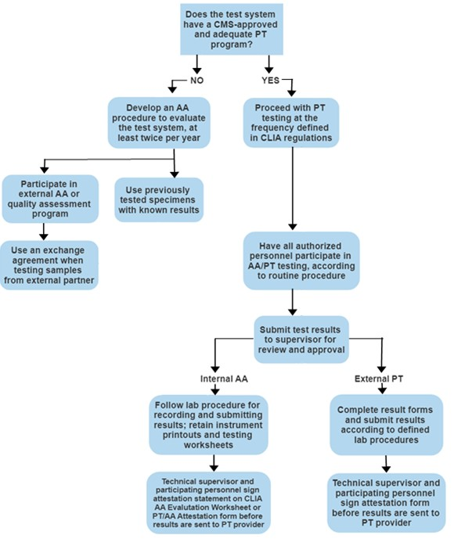

Appendix D – PT/AA Performance
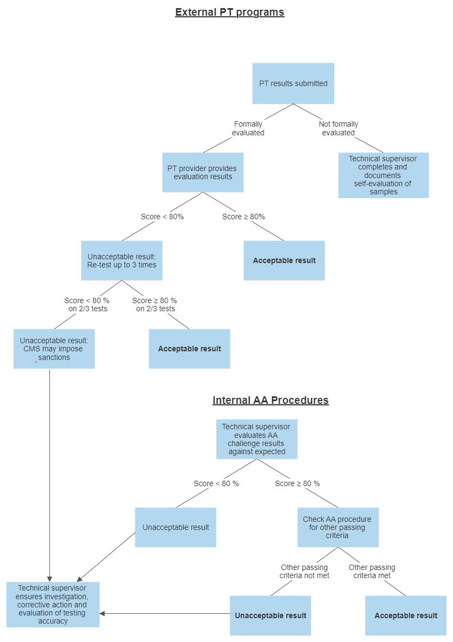

Appendix E – PT/AA Failures
