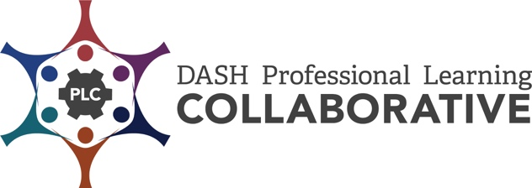

CDC Professional Development Practices Inventory
The CDC Professional Development Practices (PDPs) are a series of steps based on research and best practices. When effectively applied, they increase active learner engagement and provide optimal conditions for the transfer of learning and implementation of the knowledge and skills in the work setting. These practices provide a process to achieve sustainability over time.
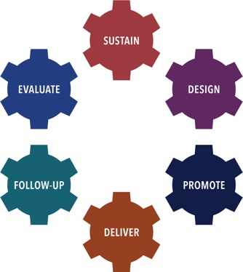 | There are six PD Practices used as the framework for this inventory:  - Sustain a PD Infrastructure,  - Design PD Offerings,  - Promote PD Offerings,  - Deliver PD,  - Provide Follow-Up Support, and  - Evaluate PD Processes.

The CDC Professional Development (PD) Practices Inventory was developed to assist DASH funded partners in identifying best practices and processes for establishing a comprehensive professional development (PD) program. The Inventory is designed as a tool for an individual and/or team to assess strengths, areas of growth, priorities, and next steps in the implementation of the CDC PD Practices.

Directions:
- Individually, or with other colleagues responsible for providing effective professional development, review all or selected CDC PD Practice Inventory items.
- Decide if each CDC PD Practice item is “not yet in place”, “partially in place”, “mostly in place”, or “fully in place”.
- Determine your strengths and areas of growth for each CDC PD Practice reviewed.
- Identify your priorities and next steps to implement each CDC PD Practice reviewed.

DASH Definitions:
Professional Development (PD) is an intentionally designed, systematic process used to strengthen the knowledge, skills, and attitudes of a particular workforce. The goal of PD, in the context of Centers for Disease Control and Prevention’s (CDC’s) Division of Adolescent and School Health (DASH) priorities, is to help improve the health, education, and well-being of youth. Professional development contributes to this goal by enhancing the knowledge, skills, and attitudes of health and education professionals so that they can more effectively implement strategies that positively impact young people. The strategies may support classroom management, effective teaching, and the DASH strategies, such as sexual health education, sexual health services, and safe and supportive environments.
- Professional Development Event is a set of skill-building processes and activities designed to assist targeted groups of participants in mastering specific learning objectives. Such events are delivered in an adequate time span (at least three hours) and may include curriculum and other training, workshops, and online or distance learning courses.
- Professional Development Offering is events, information and presentation sessions, and technical assistance.
- Technical Assistance is targeted support provided to an individual or group of individuals with the intent to increase knowledge and skills to strengthen an organization’s capacity to achieve PS18-1807 NOFO goals. Support may be provided through professional development events, technical assistance, the provision of guidance and resource materials, or referrals to other agencies or organizations.

Sustain a PD Infrastructure  Understand and leverage the existing structure and practices for providing PD in your agency. | 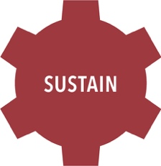

Processes to Establish, if necessary, an Infrastructure  Steps for this include: | Not yet in place | Partially in Place | Mostly in Place | Fully in Place
Identify a person to provide leadership and accountability for all PD efforts.
Work within your agency to ensure that there are policies and procedures to support effective PD.
Secure financial and human resources to support PD and collaboration.
Establish a clearly defined process to support PD providers.
Establish a system to record and manage your data.

Processes to Sustain a PD Infrastructure  Sustaining a PD infrastructure relies on a clearly defined plan and high standards of practice. Steps for this include: | Not in Place | Partially in Place | Mostly in Place | Fully in Place
Establish and implement an overall PD plan that addresses all required PD activities and incorporates the PDPs.
Ensure PD plan is in alignment with state and local PD policies and practices.
Develop a process for recruitment, development, and assessment of qualified PD providers; consultants may be external or in-house.
Provide skilled PD providers who can implement the results-based PD plan.
Confirm that PD providers:
- Apply the fundamentals of effective training design and delivery.
- Have content expertise and experience.
- Apply adult learning principles.
- Meet the needs of diverse learners by using a variety of teaching and learning strategies.
- Create a safe and functional learning environment for participants.
- Are skilled at managing conflict/controversy.
Provide ongoing assistance for PD providers to foster continuous growth.

Establish / Sustain a PD Infrastructure
Strengths: | Areas of Growth:

Establish / Sustain a PD Infrastructure – Priorities / Next Steps | By When | Person Responsible

Modified by the ICF-CDC DASH Professional Learning Collaborative (PLC), 2019. Adapted from CDC DASH Professional Development Practices - Inventory | ETR-CDC DASH Professional Learning Collaborative (PLC), 2015. Original version created by RMC Health-CDC DASH Professional Development Partnership (PDP), 2009

