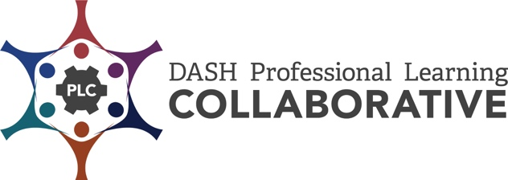

CDC Professional Development Practices Inventory
The CDC Professional Development Practices (PDPs) are a series of steps based on research and best practices. When effectively applied, they increase active learner engagement and provide optimal conditions for the transfer of learning and implementation of the knowledge and skills in the work setting. These practices provide a process to achieve sustainability over time.
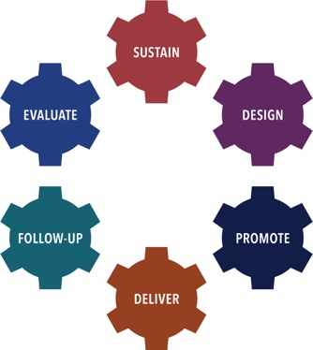 | There are six PD Practices used as the framework for this inventory:  - Sustain a PD Infrastructure,  - Design PD Offerings,  - Promote PD Offerings,  - Deliver PD,  - Provide Follow-Up Support, and  - Evaluate PD Processes.

The CDC Professional Development (PD) Practices Inventory was developed to assist DASH funded partners in identifying best practices and processes for establishing a comprehensive professional development (PD) program. The Inventory is designed as a tool for an individual and/or team to assess strengths, areas of growth, priorities, and next steps in the implementation of the CDC PD Practices.

Directions:
- Individually, or with other colleagues responsible for providing effective professional development, review all or selected CDC PD Practice Inventory items.
- Decide if each CDC PD Practice item is “not yet in place”, “partially in place”, “mostly in place”, or “fully in place”.
- Determine your strengths and areas of growth for each CDC PD Practice reviewed.
- Identify your priorities and next steps to implement each CDC PD Practice reviewed.

DASH Definitions:

Professional Development (PD) is an intentionally designed, systematic process used to strengthen the knowledge, skills, and attitudes of a particular workforce. The goal of PD, in the context of Centers for Disease Control and Prevention’s (CDC’s) Division of Adolescent and School Health (DASH) priorities, is to help improve the health, education, and well-being of youth. Professional development contributes to this goal by enhancing the knowledge, skills, and attitudes of health and education professionals so that they can more effectively implement strategies that positively impact young people. The strategies may support classroom management, effective teaching, and the DASH strategies, such as sexual health education, sexual health services, and safe and supportive environments.

- Professional Development Event is a set of skill-building processes and activities designed to assist targeted groups of participants in mastering specific learning objectives. Such events are delivered in an adequate time span (at least three hours) and may include curriculum and other training, workshops, and online or distance learning courses.

- Professional Development Offering is events, information and presentation sessions, and technical assistance.

- Technical Assistance is targeted support provided to an individual or group of individuals with the intent to increase knowledge and skills to strengthen an organization’s capacity to achieve PS18-1807 NOFO goals. Support may be provided through professional development events, technical assistance, the provision of guidance and resource materials, or referrals to other agencies or organizations.

Promote PD Offerings
Know your target audience and use promotional strategies that capture their attention and interest.
You want them to request your PD offerings. Keep communication clear and simple, emphasizing what participants will learn and be able to do as a result of participating in the PD offering. Focus on how attending your PD offering will help them in their classrooms and work environments.

Processes to Promote PD Offerings | Not yet in place | Partially in Place | Mostly in Place | Fully in Place
Determine the PD offering that will match the primary target audience needs and availability.
Develop a comprehensive promotion plan. Steps for this include:
- Develop SMART (Specific, Measurable, Achievable, Realistic, and Time-phased) objectives that describe the promotion results to be achieved.
- Develop and pre-test messages and materials that will resonate with target audiences.
- Determine how promotional messages will be disseminated to effectively reach target audiences (e.g., social media, blast email, flyers).
- Create a promotional timeline including milestones and measures of success.
- Recruit partners who can support and assist in achieving promotion objectives.
Implement the promotion plan.
Collect and record promotion evaluation data (see Evaluate).
Monitor and adjust promotion plan, materials, and messages based on feedback and results.

Promote PD Offerings
Strengths: | Areas of Growth:

Promote PD Offerings – Priorities / Next Steps | By When | Person Responsible

Modified by the ICF-CDC DASH Professional Learning Collaborative (PLC), 2019. Adapted from CDC DASH Professional Development Practices - Inventory | ETR-CDC DASH Professional Learning Collaborative (PLC), 2015. Original version created by RMC Health-CDC DASH Professional Development Partnership (PDP), 2009

