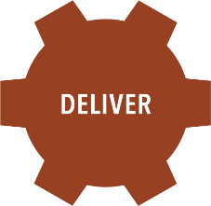
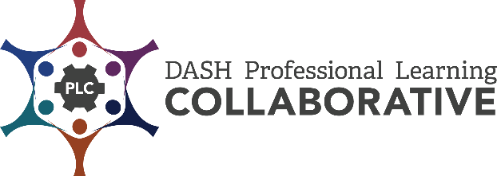

Energizer Activity Template

  - Name of Energizer:

This Energizer Activity:
- Does not require “skill” to complete,
- Uses both sides of your brain,
- Is not elimination based – meaning there are no winners or losers, and
- Is not overly strenuous – good for all participants’ abilities.

Describe How to Conduct the Energizer:

Why Do I Like this Energizer?

How Will I Know this Energizer Is Effective?:

