Companion for Android: Collecting and Analyzing Data on an Android Device

Introduction

Epi Info™ Companion for Android allows users to transfer forms to a mobile device and collect data remotely. The mobile application is compatible with Android tablets and phones running Android version 4.0.3 (codename “Ice Cream Sandwich”) and above. The ability to load Epi Info™ forms onto a mobile device allows users to collect data in places lacking information technology infrastructure and for activities that could benefit from mobility, GPS tracking, or photographic capabilities. Once data is collected, users can perform simple analysis with the Analyze Data function or view geographic data using the built in mapping function. These tools do not contain the full Epi Info™ functionality; however, data can be transferred from the mobile device to a PC for more complex analyses. The mobile application also contains a full featured StatCalc function similar to the one found in Epi Info™ 7.

Supported Field Types

Epi Info™ Companion for Android does not support all field types available in Form Designer. See below for a list of supported and non-supported field types. When designing a form for use with the mobile application, exclude non-supported field types from the form.
Supported field types:  - Label/Title  - Text (single line)  - Text (Uppercase)  - Multiline (text)  - Number  - Date  - Time (not “Date/Time”)  - Checkbox  - Yes/No  - Option  - Legal Values  - Comment Legal  - Group  - Command Button  - Image  - Relate | Non-Supported field types:  - Unique Identifier  - Phone Number  - Date/Time  - Mirror  - Grid  - Codes
If a form contains one or more of the non-supported field types, a message will identify the field(s) that will not publish. To publish the form, perform one of the following two actions:
- Delete the unsupported field(s). This will also delete any data that may have been in the Epi Info™ 7 Enter tool. If you want to preserve pre-existing data, make a project template and create a new project that you will customize for the Mobile application. In this new project, delete the non-supported fields.
- If a data table does not exist for the form, you can use the “Change To” feature to change the field type to one of the supported types. For example, you can change an unsupported Text (Uppercase) field to a standard Text field or a Multiline field.

Supported Check Code Commands and Functions

Epi Info™ Companion for Android does not support all check code commands and functions available in the Form Designer tool. See below for a list of supported and non-supported commands and functions. When designing a form for use with the mobile application, exclude non-supported check code commands from the form.
Supported Commands:  - Assign  - Clear  - Dialog  - Simple Dialog only  - Enable / Disable,  - Go To  - Hide / Unhide  - Highlight / Unhighlight  - If / Then / Else  - Set-Required / Set-Not-Required | Non-Supported Commands:  - AutoSearch  - Define  - Dialog  - Get Variable Dialog  - List of Values Dialog  - Execute  - Geocode  - Help  - NewRecord  - Quit
Supported Functions:
- ABS  - Cos  - Day  - Days  - FindText  - Hour  - Hours  - LN  - LOG | - Minute  - Minutes  - Month  - Months  - Rnd  - Round  - Second  - Seconds  - Sin | - StrLen  - Substring  - SystemDate  - SystemTime  - Tan  - Trunc  - UpperCase  - Year  - Years
Non-Supported Functions:
- CurrentUser  - DateDiff  - Date  - Environ  - EpiWeek  - Exists  - Exp  - FileDate  - Format | - Linebreak  - NumToDate  - NumToTime  - PFROMZ  - RecordCount  - Step  - TxtToDate  - TxtToNum  - ZSCORE
Although the non-supported commands and functions do not work when entering data into the mobile form, they are still compatible with check code on the downloaded version of the form. After downloading the responses to a PC, you can run these commands and functions as normal, or you can use Epi Info™ 7 Analysis to perform the necessary operation.

Initial Setup

The Epi Info™ Companion for Android is available for download at the Google Play store. Epi Info Android Download Location
With the mobile device connected to the Internet, enter the web address into your browser and select Download. Connect the mobile device to your computer through a USB cable.
Note: The mobile device must be connected through a hard line and will not synchronize with your computer wirelessly.
The mobile application is compatible with Android versions 4.0.3 and above. Since Android specifications are open source, device manufacturers are free to change positioning and appearance of common elements such as menus and buttons. For example, users should be aware that Samsung Galaxy Note II devices have their “Back” button on the right hand side of the device and the “Options Menu” on the bottom, while Google Nexus 7 devices have their “Back” button on the left hand side of the device and the “Options Menu” on the top corner. Furthermore, when an Android device is connected to a PC via a USB cable, it may register as a disk drive, media device, or a digital camera. Please note that data and forms can only be transferred in disk drive or media device modes.
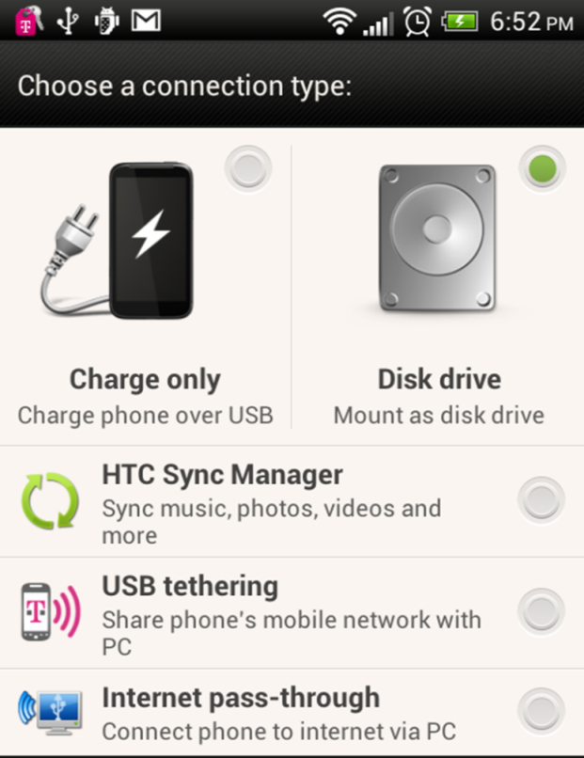
Figure 6.1: Connection Type

Figure 6.2: USB PC Connection
Internet connectivity is not required for using the core StatCalc, data collection, and data analysis modules. However, the mapping function utilizes Google Maps and requires Internet connectivity for downloading base map information.

Application Configurations

Epi Info™ Companion for Android allows users to establish certain application configurations. These settings should be reviewed before doing data collection especially if using any of the cloud supported services or if you are doing data collection in the international arena. These settings are:
- Identification
  - Device ID – allows assigning a name to the device. Used for sync file names
- Form Layout
  - Same as Epi Info™ 7- form elements are positioned and sized consistent with their Epi Info 7 Form Designer counterpart
  - Stacked Vertically- form elements are stacked vertically according to their Tab Order
  - Interview Mode – form elements are presented as questions one at a time

- Record List
  - Reverse Order – display records in reverse order
- Cloud Synchronization
  - Cloud Service - select the cloud service to use
    - Box
    - Secure FTP URL
    - Microsoft Azure
  - Upload data to cloud only - only-Data is only uploaded to the cloud This user will not see other users data
  - Upload and download data - Data is uploaded to the cloud and other users’ data is downloaded from the cloud. Please note that this allows users to inadvertently update other users’ data.
  - Download data from cloud only - Data is only downloaded from the cloud into the device. Data from the device is not uploaded to cloud.
  - Sync on save - Initiate cloud sync for a record when it is saved
  - Cloud data deletion - allows local record deletions to propagate to the cloud

- Samples
  - Sample forms – enables users to view forms that are packaged with the application
- Sync files
  - Windows decimal symbol – The representation of the decimal points in Microsoft Windows. Note that this setting affects the way numeric data is imported into Epi Info™ 7. Depending on the country of usage, the default setting of a decimal point (.) might need to be replaced with a comma (,).
  - Sync file size- establishes the maximum number or records each sync file contains

- Security
  - Admin password – Locks application settings using an administrative password

Designing Forms for Mobile

Epi Info™ Companion for Android allows for the transferring of short, single form projects (without grids) to a mobile device for data entry. This design creates certain features and behavioral differences between the mobile and PC format. Be aware of these differences and plan for them when designing a form. For example, not all field types or check code commands are supported or provide value on a mobile device. Additionally, required fields and drop-down lists may behave differently on a mobile device than they do on the Epi Info™ 7 Enter tool.
Note: Forms on a mobile device require a minimum of three data fields.
Companion for Android automatically adjusts the display when a form is accessed with a mobile device. Forms on ten-inch tablets appear with a similar field layout as the PC. For smaller mobile devices (seven inches or less), horizontal field placement is irrelevant, as the fields are stacked vertically.
Note: Fields on a mobile phone display vertically according to the Tab Order. Set the tab order according to the sequence you want the fields to display on the form.
After uploading the form, conduct a usability test before collecting data. Ensure all fields are displayed properly and oriented in the intended order.

Copy Form to Mobile Device

From the Epi Info™ main menu, click Create Forms or select Tools > Create Forms from the navigation menu. Open the desired project form or create a new form to transfer to the mobile device. (See Form Designer).
- Connect the mobile device to your computer via a USB cable. Ensure that the PC recognizes the mobile device in disk drive or media device mode before proceeding to the next step.
- From the Form Designer menu, select Copy Form to Android Device.
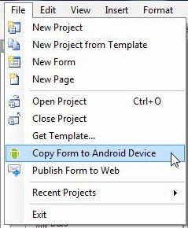
Figure 6.3: Copy Form to Android Device
The form automatically transfers to the device and is ready for use.
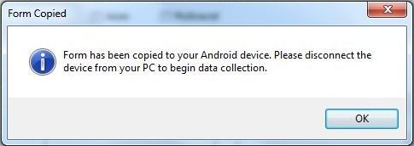
Figure 6.4: Form Copied

When a form is uploaded to a mobile device to replace an existing one of the same name, an error may occur indicating that fields no longer match.
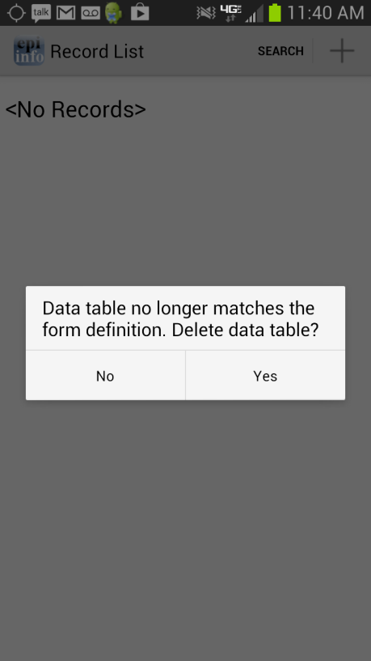
Figure 6.5: Data Table Error Message
Select Yes to delete the data table and continue data collection.
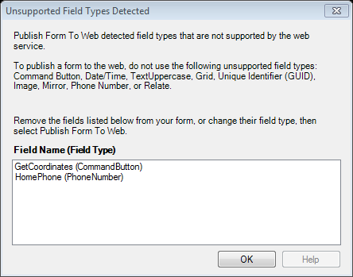
Figure 6.6: Unsupported Field Types error message
To meet publishing requirements, the non-supported fields must be deleted or the field type must be changed. Before deleting a field, be aware that any associated data with that field will be deleted as well. The data removal is automatic and irreversible. Consider backing up all data prior to deleting a field. Alternatively, use the “Change To” option to change the field to a supported field type. This action can only be performed if a data table is not associated with the form.
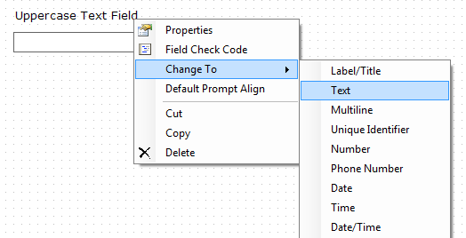
Figure 6.7: Fields Change To function

NOTE: If you are unable to copy the form into your device because the device is not recognized by Epi Info 7, you could copy the form into your device by creating a template of your form. In order to create a form template, please review the Form Designer chapter of the User’s Manual. Once the form template is created, you can simply copy the form template file (which will have an .XML file extension) into your device or email the form template to yourself or others. Once the file has been copied to your device, it would be recognized by the Companion for Android application and you will be able to begin data collection.

Working with Child Forms
The Companion for Android application supports data collection for a relational database model. Child forms are copied from Epi Info 7 to the Companion for Android application using the same mechanism previously mentioned. However, there are just a few things to be aware of regarding naming convention that are unique to child forms. These requirements are as follows:

Requirement 1
When creating a related form in Epi Info 7, the Field Name and the Related Form Name must match. In the example below, the Field Name and the Related Form name assignments match.
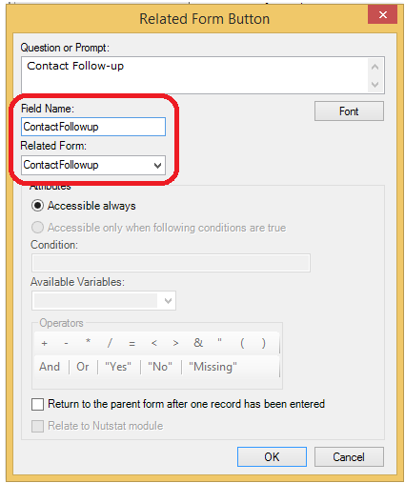
Figure 6.8: Field Name and Related Form name parameters.
Requirement 2
When copying the related form to the Android device, please add an underscore "_" prefix to the name to indicate to the Android app that this is a related form.
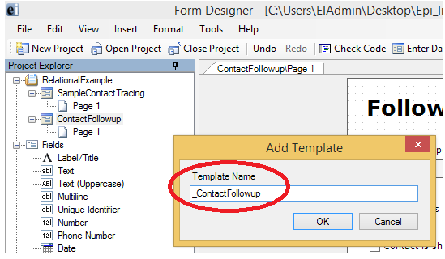
Figure 6.9: Child form name requires a _ prefix (i.e _ContactFollowup)

Collect Data on Mobile Device

Access the mobile companion titled Epi Info™ from your device’s application list. Note that the application layout is different between a tablet and a phone. The screen will appear in a portrait format on a phone and landscape format on a tablet.
Figure 6.10: Mobile Home screen
- The Epi Info™ Mobile main menu appears.
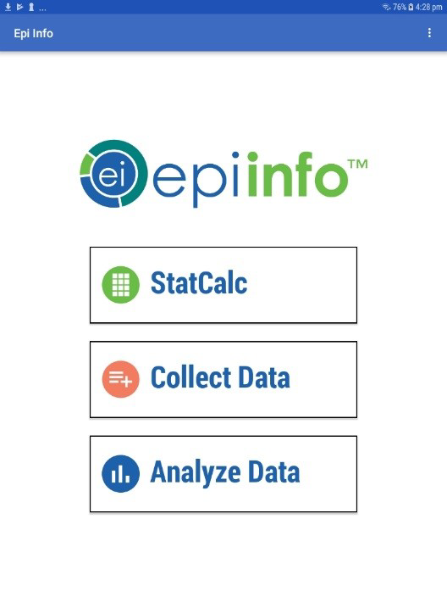
Figure 6.11: Epi Info™ Mobile main menu

- Select Collect Data. Click on the triangle on the right hand corner to see a list of available forms. Select the form for data collection from the drop-down list by pressing on the form name.
- Click Load.
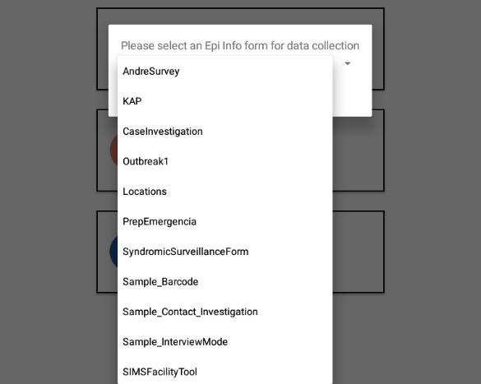
Figure 6.12: Available Forms drop-down list
The Collect Data page appears with a list of all records contained on the mobile device for that form. If there are no records, the record list displays <No Records>.
- To create a new record, press on the + sign located in the bottom right corner of the screen.

Figure 6.13: Collect Data main menu
The form appears on the mobile device. Fields appear vertically on a phone while the tablet can display fields horizontally. Users can slide their fingers across the screen to move around the form and tap into the desired field in order to enter data.
Note: Please make sure to check that the date format of the device matches the date format of the PC. Date formats must match between Android device and PC when data is being imported into the central Epi Info 7 database. You can check the date format being used by the device under the Settings>Date and Time>Select Date Format option.
Note: Always navigate using the back button instead of the home button. Use of the home button can cause cache issues that will lead to malfunctions.

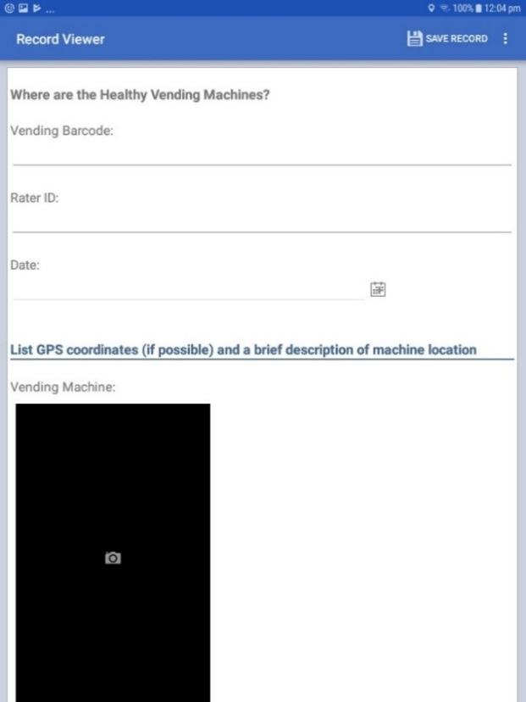

Figure 6.14: Mobile Form View

Text fields
This field allows open text characters. In order to enter data, tap into the field. A keyboard will be displayed to the user in order to enter data. Once data has been entered, click Done.
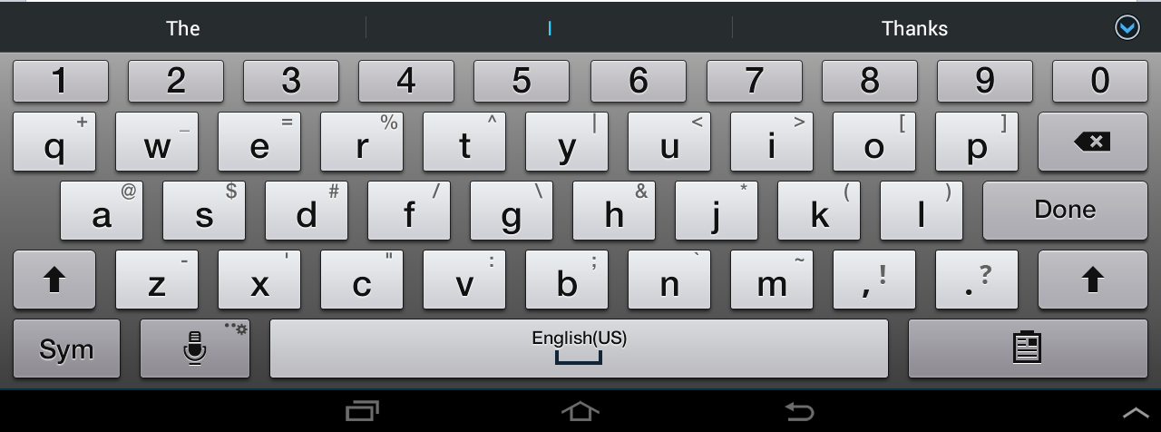
Figure 6.15: Keyboard for Text Fields

Numeric fields
This field allows numeric values. In order to enter data, tap into the field. A keyboard will be displayed to the user allowing only numbers and decimals to be entered. Once data has been entered, click Done.
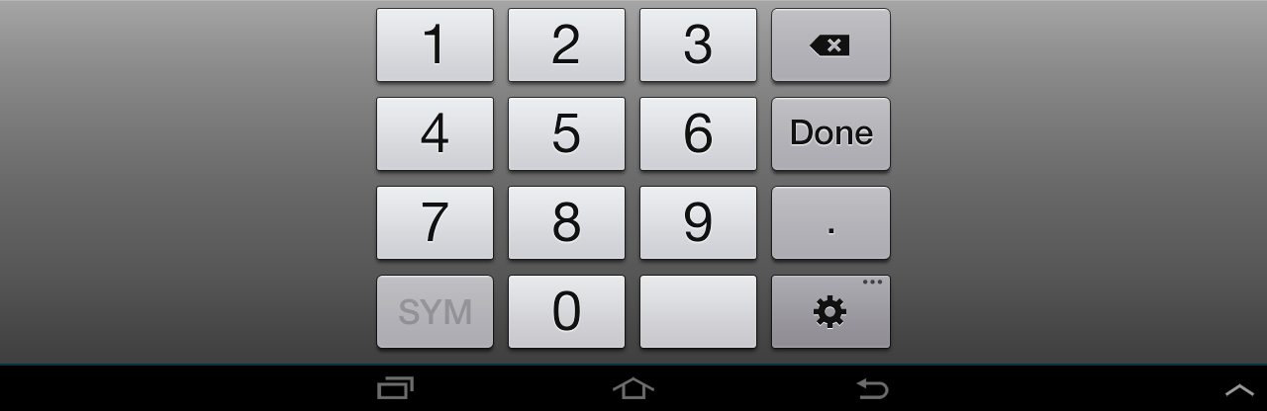 Figure 6.16: Keyboard for Numeric Fields

Date fields
Date fields can be entered by clicking the calendar icon located next to the field. The user can then select a value for each of the data elements (month,day,year). Once data has been entered, click Done.
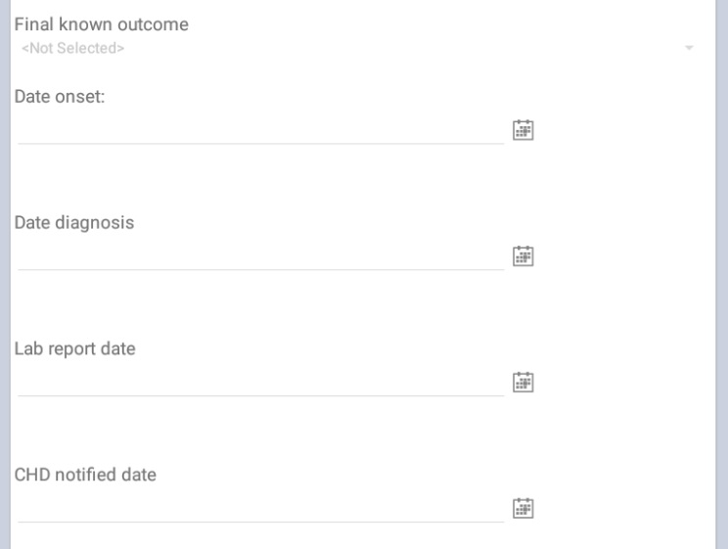
Figure 6.17: Calendar Icon for Dates

Figure 6.18: Date Calendar for Selecting Dates

Time fields
Time fields can be entered by clicking the clock icon located next to the field. The user can then specify a value for hour and minutes. Once data has been entered, click Done.
Figure 6.19: Clock Icon

Figure 6.20: Time Selection Screen

Drop down lists
This field type provides a list of possible values in response to a question therefore limiting the number of options to use. Initially this field will present the user with the prompt <Not Selected>. Tap into the field and select the desired response.

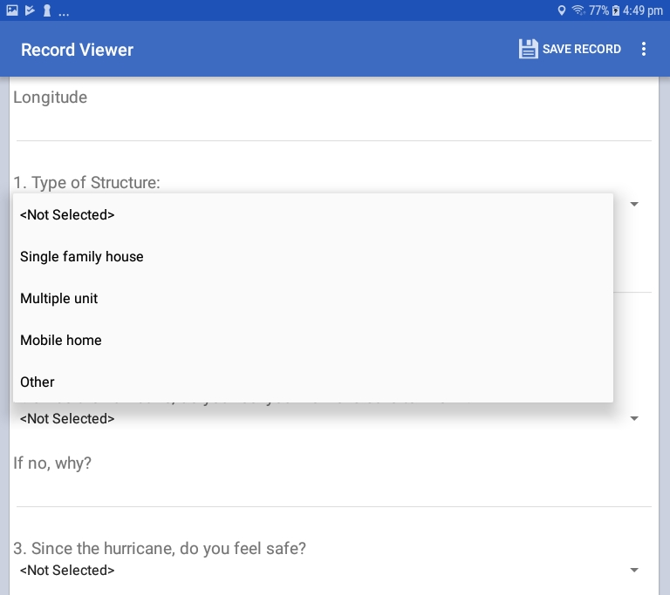
Figure 6.21: Drop Down Lists

Checkbox fields
The Checkbox field allows you to collect data by checking or unchecking a box. Multiple checkboxes can be used to quickly enter responses that are consistent in the study (e.g. symptoms or foods eaten). Checkbox fields collect binary data such as 0 or 1, True or False, Yes or No. The response is stored in the database as a 1 or 0 where 1 equals Yes and 0 equals No. Checkbox fields do not contain missing values. They are considered to be “No” until they are checked. The following figure provides an example of how Checkbox fields appear on a mobile device.
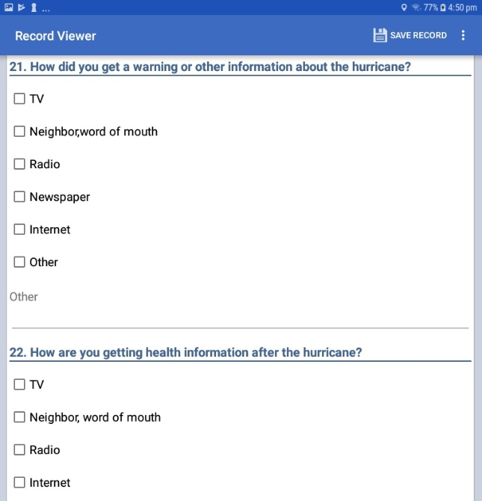
Figure 6.22: Checkbox Fields

Image/Photo Fields
The Image field will appear as a Photo field on a mobile device. This field allows the user to insert pictures taken with the mobile device onto the form. The photos taken will always stretch to the field shape that appears on the mobile device. The retain image size feature in the Image Field Definition dialog box will not affect the Photo field’s functionality. When inserting Image fields, adjust the field size to the anticipated aspect ratio of the mobile device.
      - To add a picture to the form, select the Photo field. The mobile device’s camera function automatically opens.
      - Take the photo (process varies depending on the mobile device)
      - Select Save. Epi Info™ inserts the photo into the Photo field.
Photo fields will appear as the same size regardless of layout on the PC version of Epi Info™ when using a phone.

Capture GPS Coordinates
If the mobile device is connected to the internet, latitude and longitude coordinates can be captured by selecting Capture Coordinates, located in the top right corner of the screen. Select the field containing the latitude coordinates from the Select latitude field drop-down list. Select the field containing the longitude coordinates from the Select longitude field drop-down list. Select Set.
Figure 6.23: GPS Settings
The coordinates appear in the latitude and longitude fields.
Figure 6.24: Latitude and Longitude Coordinates

Save Record
To save the form, select Save Record in the top right corner of the screen. An incomplete form can be saved and finished at a later time. The data is stored with a Record ID and Preview information.
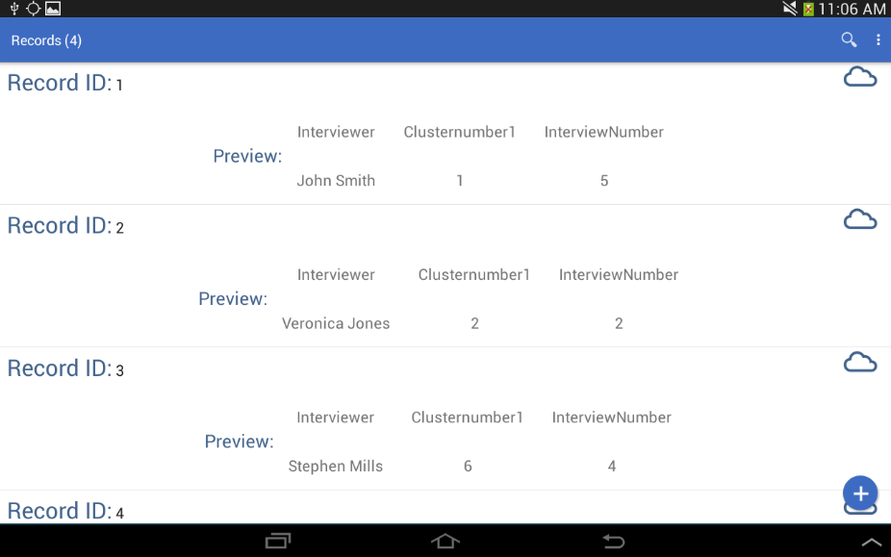
Figure 6.25: Record List

Edit Record
Press over the record you wish to edit from the Record List. The form appears on the device and is ready for editing. At any point, select the Save Record button to save the edited record.

Delete Record
Press and hold down on the desired Record from the Record List and a menu will appear. Select Delete Record.

Search Record
To search the Record list, press over the magnifying glass located in the top right corner of the Collect Data menu. This will open the Search option. The Epi Info Record list (top left corner of the screen) becomes blank with a blinking cursor. The Search function allows records to be located based on a series of matched variables. Type in the search criteria and press the search button. The records that match the search criteria appear in the record list. When searching for a record, you will need to specify the fieldname, the = operator, and then the value. If you are searching for a text field, use single quotes around the value being searched. For example PATIENTNAME=’Walter’ if you are searching for “Walter” as the patient name in your tablet.
Figure 6.26: Syntax for Searching for two parameters

You can use the AND or the OR operator to use more than one variable in your search criteria. If you are searching for a date or numeric field, simply type the value to be searched (i.e. DOB=06/12/1999 or AGE=35) without using any quotes.

Preloading data

In certain scenarios it is necessary to preload devices with some data (such as list of households to visit) before the investigators go out to the field. When the data need to be brought back into Epi Info 7, it is also important to ensure referential integrity (matching GlobalRecordID's and foreign keys) so that the correct records are updated on the desktop. The following process was put in place to accommodate these kinds of scenarios.

Step 1
Using Epi Info 7's Classic Analysis, export your form's data as a "Flat ASCII File". Ensure that the file name matches the form name on Android and has a ".csv" extension. Note: If you are selectively exporting only certain variables, GlobalRecordId must be one of the variables selected.
Please take into consideration that this functionality is intended for seeding few columns of data only and not designed to facilitate continuous integration of data between desktop and mobile. Furthermore, when data is loaded onto the device, it is considered an INSERT operation only.
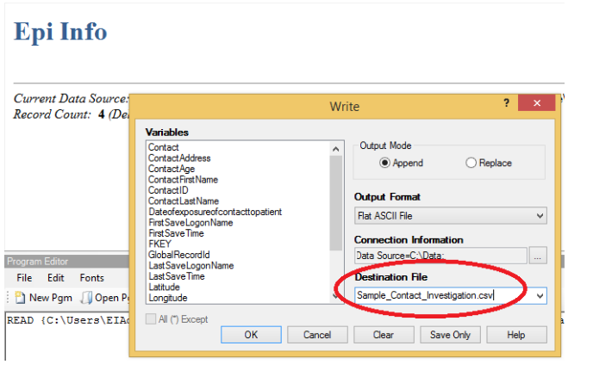
Figure 6.27: Create .CSV file in Classic Analysis

Step 2
Copy the CSV file to the device's "Download\EpiInfo\Preload" folder.
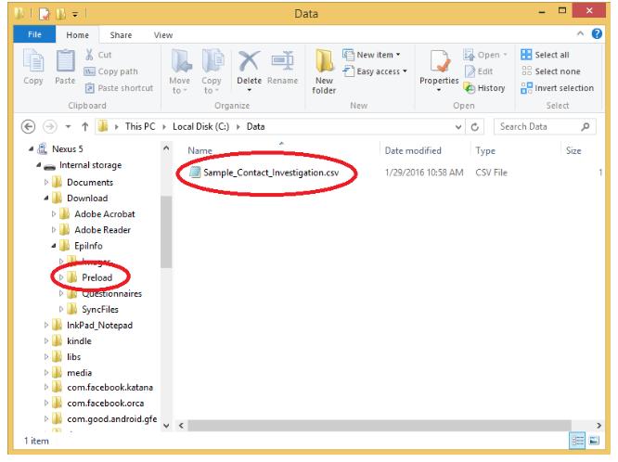
Figure 6.28: Copy .CSV file into mobile device

Once you start the app, the application will automatically import data from every CSV file to its corresponding form/database of the same name. The GlobalRecordId's are persisted during this import so that the data collected/updated in the field can be brought back into Epi Info 7 safely.

Transfer Data from Mobile Device

          - Select Create Sync File from the Collect Data menu or from the options menu. This feature is only accessible from the options menu on a phone.
Figure 6.29: Create Sync File

          - Create a password for the sync file. This password will be required to access the sync file and download the information to a computer. There are no password requirements; however, it is recommended that users create passwords to ensure secure information transfer with encrypted files.
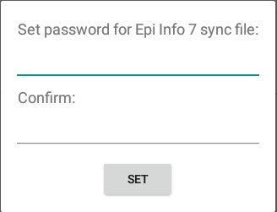
Figure 6.30: Set Sync File Password
          - Click OK and connect the device to your PC.
Figure 6.31: Sync File Created

      - Open the Epi Info™ software on your PC.
      - From the Epi Info™ main menu, select Enter Data or select Tools > Enter Data. The Enter tool opens.
      - Open the project and form used to collect the data on the mobile device.
      - From the File menu, select Import Data > From Mobile Device.
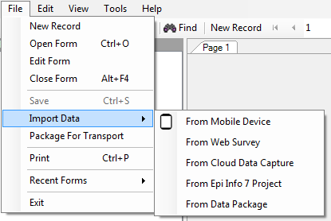

Figure 6.32: Import Data from Mobile Device
The Import Data from Mobile Device dialog box appears.
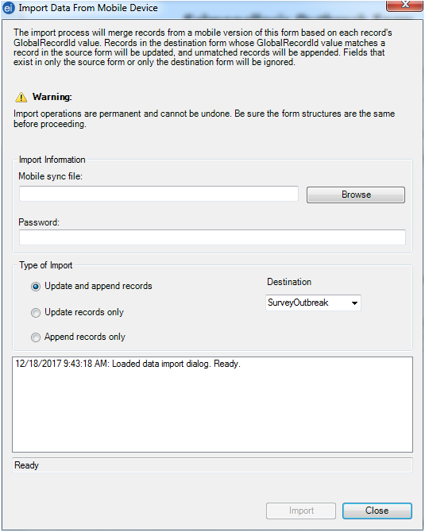

Figure 6.33: Import Mobile Sync File Dialog Box
      - Click on the Browse button next to the Mobile sync file: text box and select the sync file created with the mobile device. The file will be located in the Downloads > EpiInfo> SyncFiles folder on the mobile device.
      - Click Open. Note the file format, “Epi Info for Android” sync files.
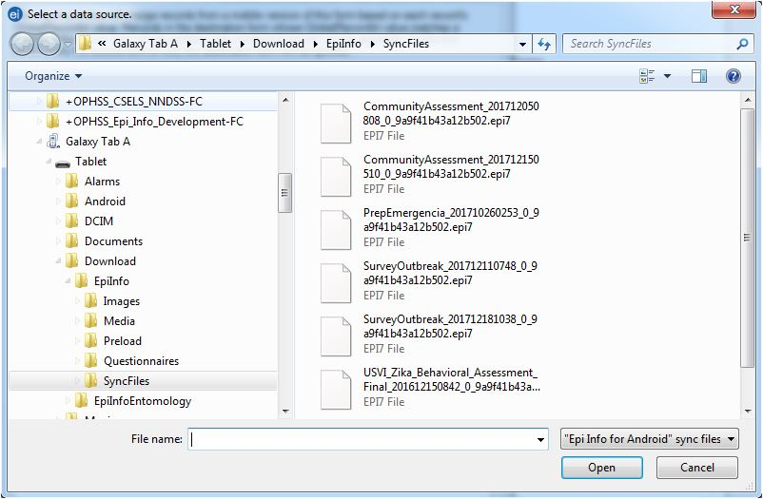
Figure 6.34: Select a Data Source Dialog Box

      - Enter the password created for the sync file in the Password field.
      - Select the Type of Import.
- Update and append records – Records in the destination form containing the same GlobalRecordId values as the source form will be updated (overwritten) if there is new information. However, values in the destination table will never be overwritten with a null or missing value. All other records will be appended (added) to the end of the table.
  - Update records only – Records in the destination form containing the same GlobalRecordId values as the source form will be updated (overwritten) if there is new information. However, values in the destination table will never be overwritten with a null or missing value. All other records will be ignored.
  - Append records only – All records in the source form will be appended (added) to the end of the table. No records will be updated (overwritten).
  - 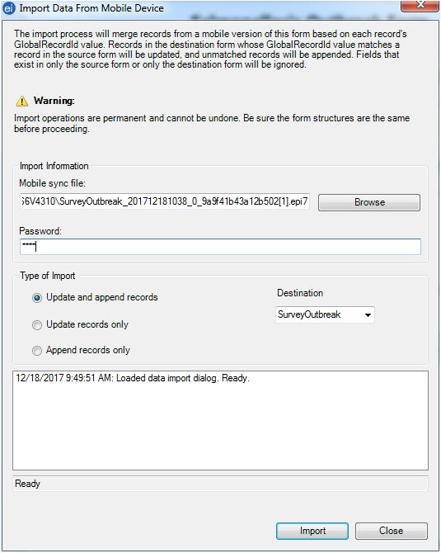

Figure 6.35: Type of Import options
Note: Import operations are permanent and irreversible. Be sure that the form structures are the same (including all form names and form table names) before proceeding.

      - Click Import. Import Complete will appear at the bottom of the dialog box upon successful completion of the import.
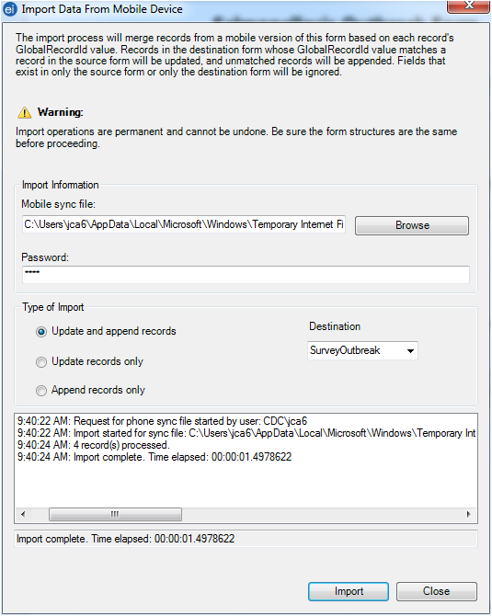
Figure 6.36: Import process completed
      - Click Close.
The data displays in the Enter Data tool at the end of the Record List. This information is now ready to be analyzed by Classic Analysis or Visual Dashboard.
NOTE: You might need to disconnect the cable from the Android device into your PC and reconnect it in order for the PC to recognize updated files on the device. In some devices, users had to restart the device in order for the PC to recognize updated files on the device.

Configuring cloud synchronization with Windows Azure
The Companion for Android application allows you to synchronize with a Windows Azure cloud service and consume the data using Epi Info™ Companion for Android to allow a team of epidemiologists to more efficiently collect data together. Data can be collected offline and synchronized with team members when Internet connectivity becomes available. If you are always connected, data shows up in the cloud instantly to allow for real-time data analysis and situational awareness.
You will need to first create a Windows Azure account at Windows Azure Home. The free tier is sufficient for many data collection activities. Please note that you MUST get organizational approval first if you are using this service for official purposes!
Please complete the steps documented below in order to set up your Companion for Android application with Windows Azure

Create an Azure App Service Mobile App
- Create new Mobile App by clicking on: New > Web + Mobile > Mobile App
  - Remember "App Name" as it will be used by your Android app
  - Create a new Resource Group or choose from Existing
  - Choose App Service plan
  - Click on Create
  - Wait a few minutes; refresh your web browser
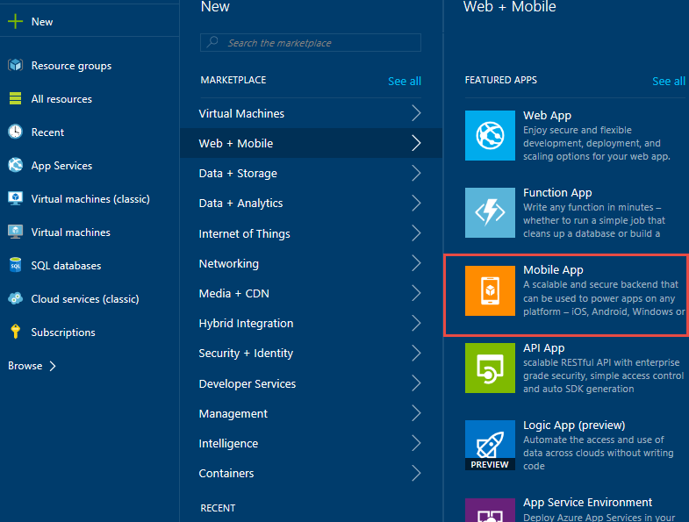
Figure 6.37: Create a Mobile Application in Windows Azure

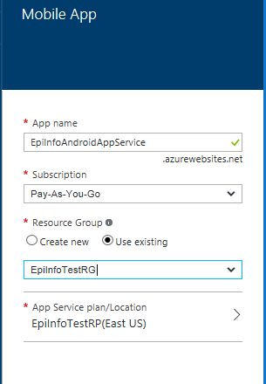
Figure 6.38: Resource group
- Click the new icon that got created on the dashboard that looks like a tablet. If you don’t see the icon you can go to All resources and find the App Service you just created.
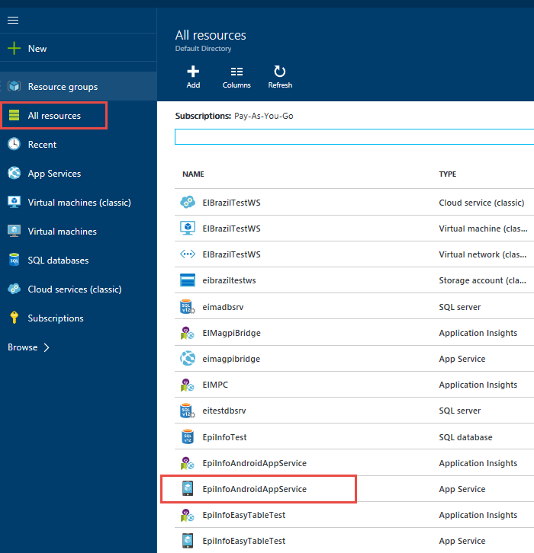
Figure 6.39: All Resources list

- Under Settings, Go to Mobile Section and click on Easy tables.
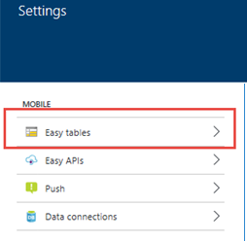
Figure 6.40: Easy Tables

- Click on "Need to configure Easy Tables/Easy APIs - Click here to continue."

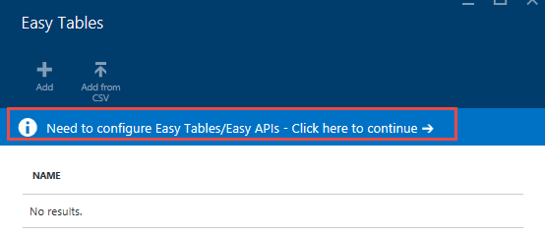
Figure 6.41: Configuring Easy Tables

- Perform Step 1 Connect a database -> "Click here to create one".

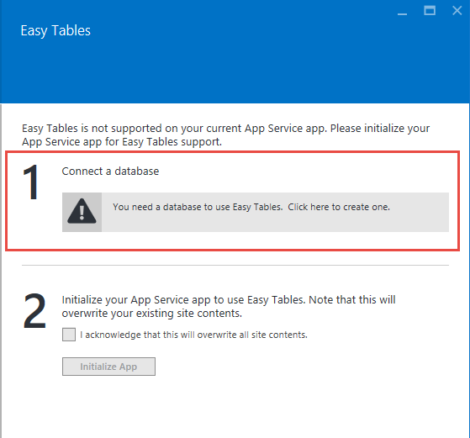
Figure 6.42: Connect to a database
- In Data Connections blade click on Add.
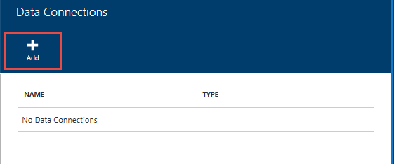
Figure 6.43: Adding data connections

- In Add data connection blade click on "Configure required settings".
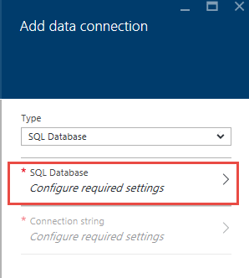
Figure 6.44: SQL Database configuration

- Create a new database or set an existing database.
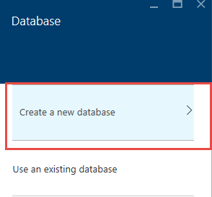
Figure 6.45: Create a new database

  - Provide Name for the database
  - Set pricing tier to Free or as per your need
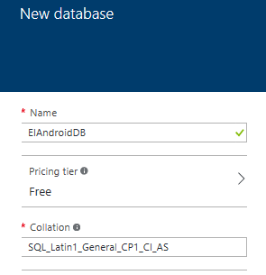
Figure 6.46: New database creation parameters
- Click on Configure required settings to configure database security setting.
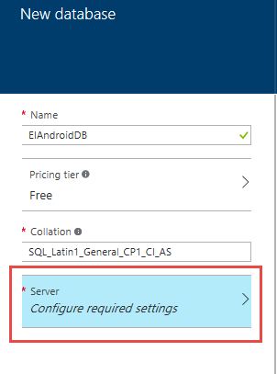
Figure 6.47: Configuring server

- In the New Server blade provide the Server name, Server admin login, Password, confirm password and choose the location of the server. Leave “Allow azure services to access server” checked. Click OK.
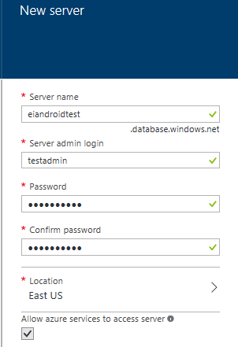
Figure 6.48: Configuring server parameters
- Click OK on New Database blade.
- Click OK in Add data connection blade.
- Data connection creation process starts. Wait for the process to complete in Notification area.
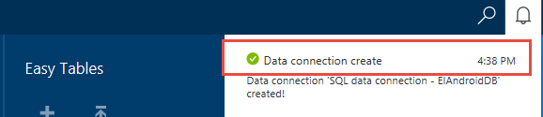
Figure 6.49: Data connection process
- Easy Tables > "Need to configure Easy Tables/Easy APIs - Click here to continue" (yes, AGAIN!) > Initialize app.

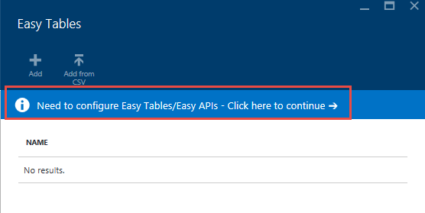
Figure 6.50: Configuring Easy tables

- In Easy Tables blade, perform Step 2 of Initialize app by clicking the acknowledgement check box.
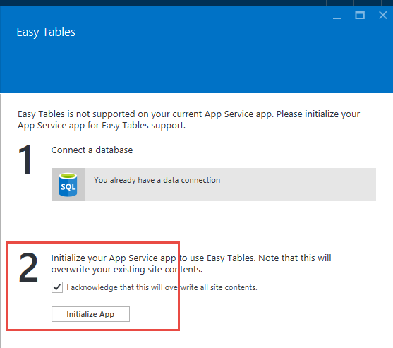
Figure 6.51: Initialize application service
- Wait for the process to complete, watch the notification area for progress.
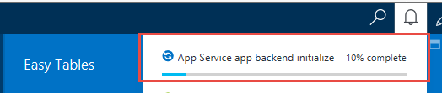
Figure 6.52: Initialize application service in progress

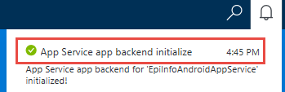
Figure 6.53: Initialize application service

- In Easy Tables click Add to add the table.
  - The "Name" here needs to match your Epi Info form name. Table created for both Parent and child form have exactly same name as form name in Epi Info even though we append an underscore on the form name when copying to Android tablet.
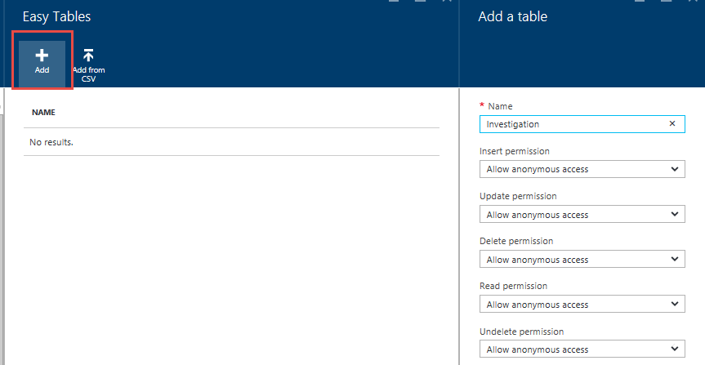

Figure 6.54: Easy Tables Creation

  - Leave everything anonymous or disable certain functions (don't enable authentication). Click OK.

- Newly created table is available in the list of Easy Tables.
- Click the newly created table.

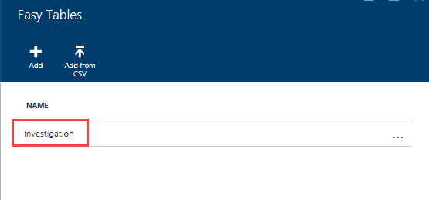
Figure 6.55: Newly created table

- In the blade for the table click on Edit Script.
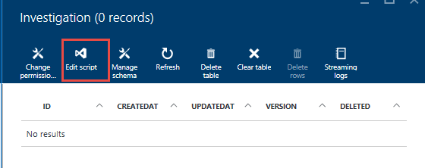
Figure 6.56: Edit script option

- Right-click on {your table name}.js and click on Delete in the context menu.
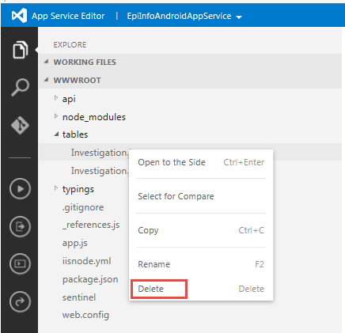
Figure 6.57: Deleting easy table with .js extension

- Right-click on tables and click on Upload Files in the context menu.
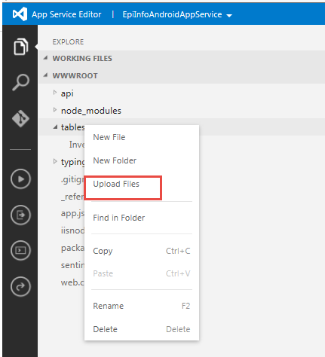
Figure 6.58: Uploading file

- Upload "easy_tables.js" file.
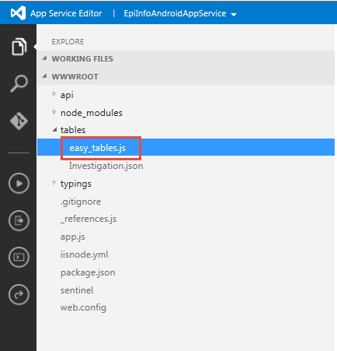
Figure 6.59: Import of Easy_table.js file

- In the javascript file for easy_tables.js file change the text that says "CHANGE ME" to a token that you will use on the Android app.
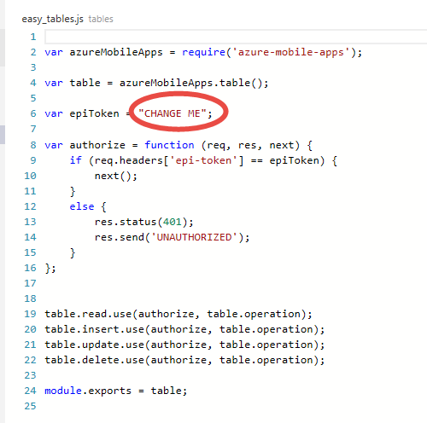

Figure 6.60: Modification of epiToken setting

- Right-click on "easy_tables.js" and rename to {your table name}.js.
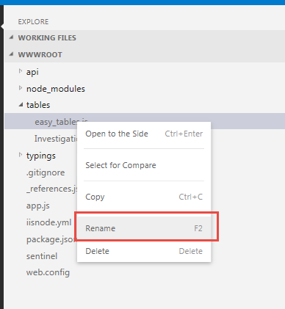
Figure 6.61: Renaming of Easy_table.js file
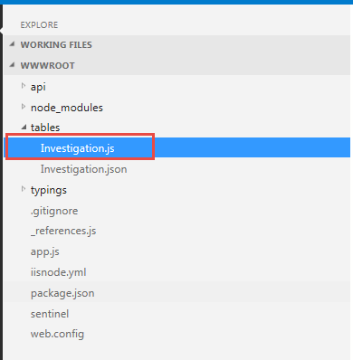
Figure 6.62: Renaming completed

- Click {your table name}.json.
  - Set "softDelete" to false.
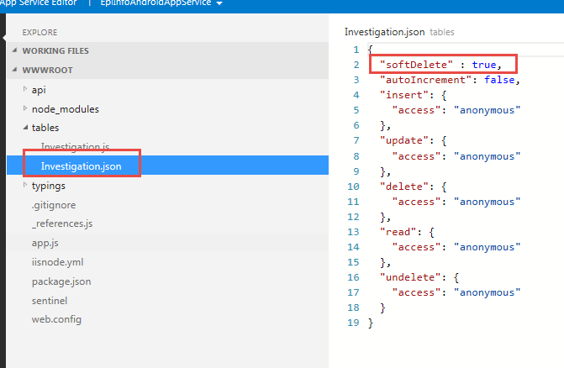
Figure 6.63: Modification of softDelete parameter in .json file
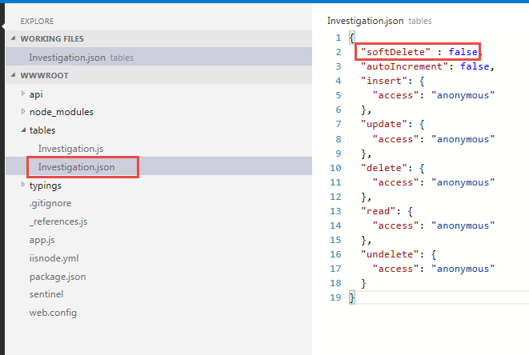
Figure 6.64: Modification of softDelete parameter in .json file

Configuring the application to use the settings
- From the Companion for Android main menu, click on the Settings option.
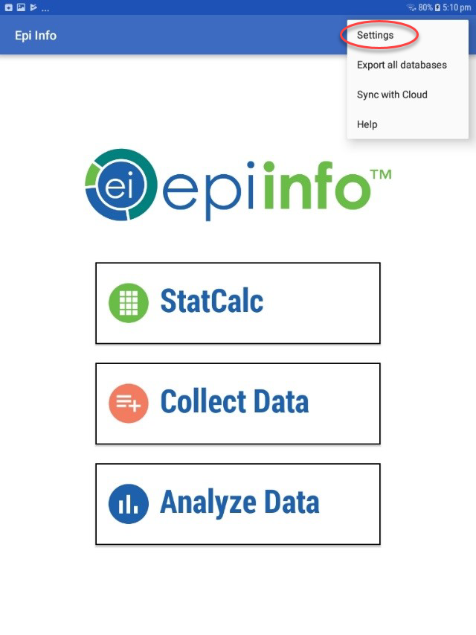
Figure 6.65: Companion for Android Configuration Settings
- Provide the Windows Azure Mobile Application name to use for data synchronization in
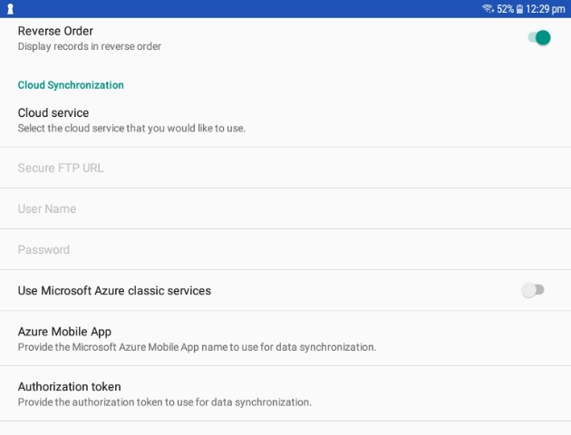
Figure 6.66: Specify Mobile Application name and Authorization token

the Azure Mobile Application section. Also, provide the Windows Azure authorization token to use for data synchronization. This was established in the epiToken setting of the .json file corresponding to the form. Turn off “Use Microsoft Azure classic services”.

Configuring cloud synchronization with Box
The Companion for Android application allows you to also synchronize with a Box cloud account and consume the data using Epi Info™ Companion for Android. Box is a cloud content management and file sharing service for businesses. The company uses a freemium business model to provide cloud storage and file hosting for personal accounts and businesses. In order to use this cloud service, you will need to complete these steps:
Step 1: Create a Box account
Step 2: Configure Cloud Synchronization setting on EI application to use Box
Step 3: Sign into Box account from device
Step 4: Send data to cloud

Create a Box Account
The first step will require you to create a Box account. This can be done at the following Box Website: https://www.box.com/pricing/individual. When creating the account, make sure to select the Free option which provides up to 10GB of storage.

Configure Cloud Synchronization Setting
Once the account has been created, users will need to configure the Cloud Synchronization setting on the Epi Info™ Companion for Android to use Box. In order to configure the device, click on the Settings icon located on the top-right corner of the main menu of the application. Press on the Cloud service option available under the Cloud Synchronization settings, and select Box.
Figure 6.67: Configure Box account on the device

Sign into Box Account From Device
In order to connect with the cloud service, users will need to open the form that will be used for data collection using the Collect Data module. Once the form is opened, select the Sign in to Box account option.
Figure 6.68: Sign in to Box account on the device

This will open the Box Log-in web page. Provide a username and password. After clicking in the Authorize button, the application provides a message stating that access is granted.
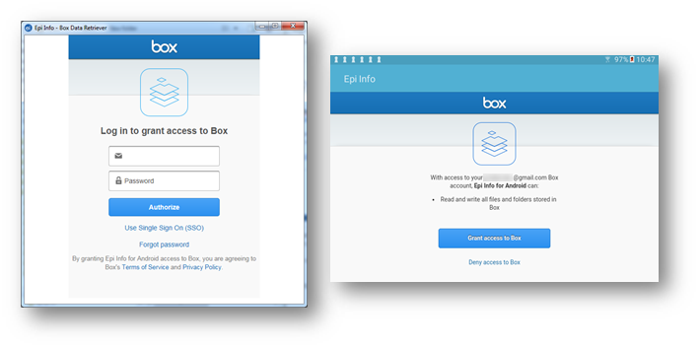
Figure 6.69: Sign in to Box account on the device

Once this process is completed, you will be able to send data to the cloud using the Sync with Cloud option available in the Settings menu options of the form.

StatCalc Epidemiologic Calculators

The StatCalc tool is a calculator capable of analysis pre and post data collection. The version available on the Companion for Android has similar functionality to the full Epi Info™ StatCalc tool and is capable of performing the analyses listed in the StatCalc menu listed below. For additional information regarding StatCalc, reference the StatCalc section of the user guide.
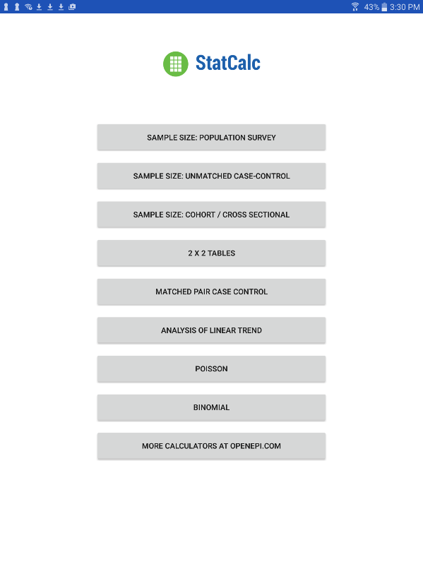

Figure 6.70: StatCalc main menu

Sample Size: Population Survey
The population survey calculates how many samples are recommended for a survey given a population size, expected frequency, design effect, the number of clusters and the desired confidence level.
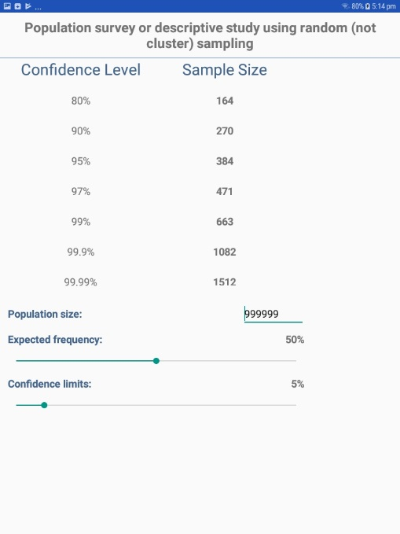
Figure 6.71: Population Survey

Sample Size: Unmatched Case-Control
The Unmatched Case Control study calculates how many samples are recommended for a study given the power, proportion of unexposed vs. exposed, percentage outcome in exposed group, percentage outcome in the unexposed group, and the desired confidence level.
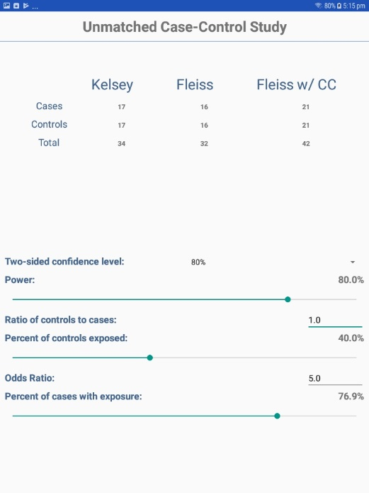
Figure 6.72: Unmatched Case-Control

Sample Size: Cohort / Cross Sectional
The Unmatched Cohort / Cross Section study calculates the sample size requirements for two groups that meet a set of research conditions: one group has a certain outcome (e.g., ill) or condition and other does not (e.g., not ill) based on a set of factors chosen by the researcher (e.g. confidence level, power (1 - α), ratio of exposed to unexposed, risk ratio, odds ratio, etc).
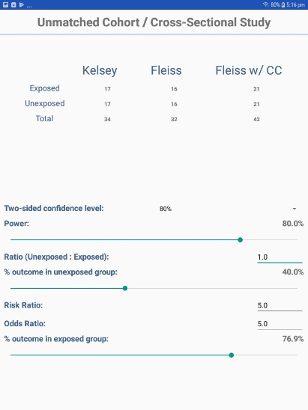
Figure 6.73: Cohort/Cross Sectional

Analysis of Single and Stratified Tables
Two by two tables are frequently used in epidemiology to explore associations between exposures to risk factors and disease or other outcomes. The table in StatCalc has Exposure on the left and Outcome across the top. Given a yes-no or other two-choice response describing disease and another describing exposure to a risk factor, StatCalc produces several kinds of statistics that test for relationships between exposure and disease.
Stratifying a dataset separates the population into distinct categories based on a parameter (i.e. sex). If confounding is present, associations between disease and exposure can be missed or falsely detected.
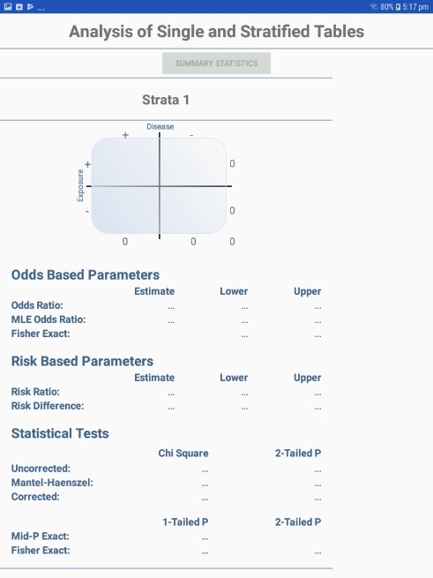
Figure 6.74: Single and Stratified Tables

Matched Pair Case Control
The Matched Pair Case-Control Study calculates the statistical relationship between exposures and the likelihood of becoming ill in a given patient population. This study is used to investigate a cause of an illness by selecting a non-ill person as the control and matching the control to a case. The control can be matched to one or more criteria.
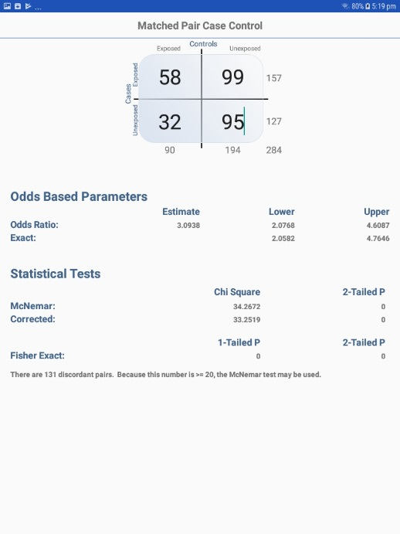
Figure 6.75: Match Pair Case Control

Analysis of Linear Trend
The Linear Trend function calculates the odds ratio, chi square for linear trend, and p-value statistics based on the response to an exposure score and whether or not the patient has become ill. The exposure score is a measured outcome from a study that states the level of exposure the patient received.
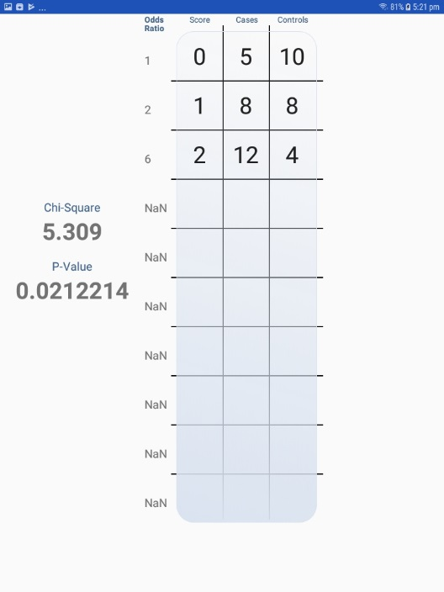
Figure 6.76: Analysis of Linear Trend

Poisson
The Poisson distribution states the probability that a number of positive outcomes occurs based on the expected number of positive outcomes. To analyze the Poisson distribution, enter the expected number of positive outcomes in Expected # of events and the value of positive outcomes you would like to determine the probability of in Observed # of events.
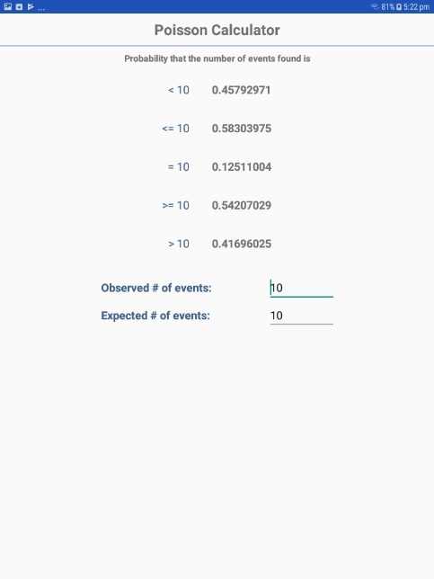
Figure 6.77: Poisson Distribution

Binomial
The binomial distribution states the probability that a number of positive outcomes occurs given the expected percentage of positive outcomes and the total number of observations taken.
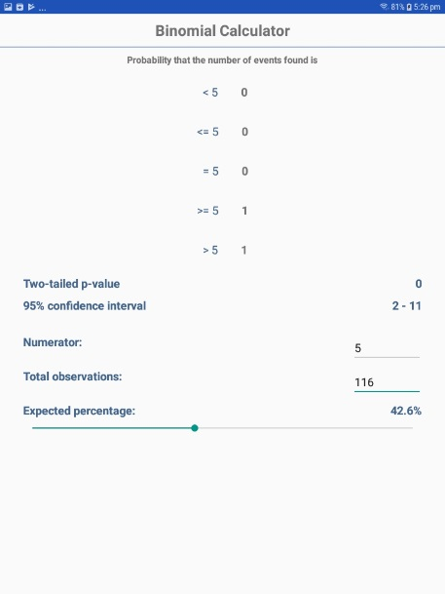
Figure 6.78: Binomial Distribution

OpenEpi.com
This website is an open source web tool that provides additional epidemiologic statistics.
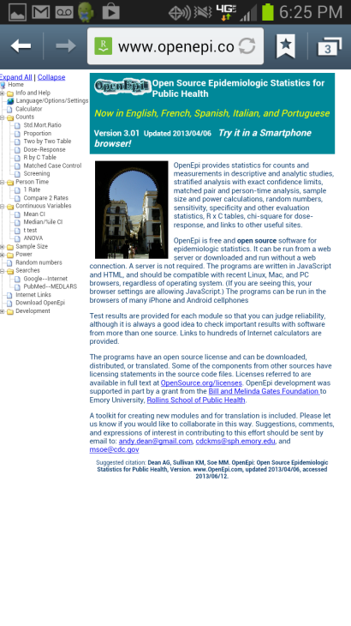
Figure 6.79: OpenEpi.com

Analyze Data

The Analyze Data tool contains a few commonly used analysis functions from the Visual Dashboard tool. For additional functionality, transfer the data to a PC and use the Epi Info™ Visual Dashboard tool (refer to Visual Dashboard section of the user guide).
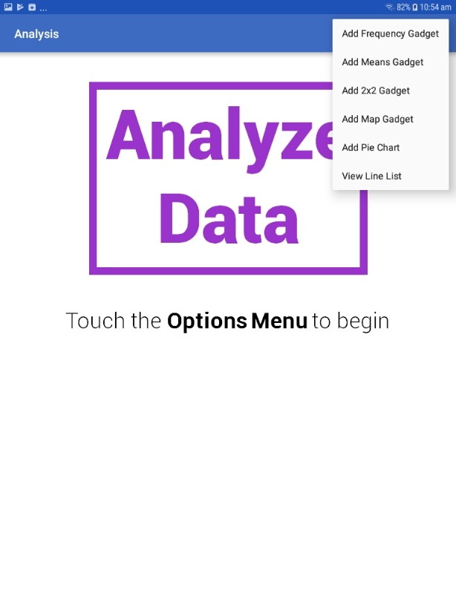

Figure 6.80: Analyze Data main menu

Note: The location of the options menu varies depending on the device.

Means Gadget
The Means gadget calculates the average for a continuous numeric variable. Mean, Variance, Standard deviation, Median, Minimum and Maximum values are calculated.
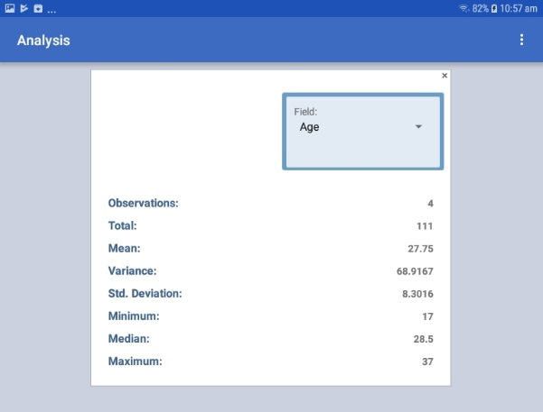
Figure 6.81: Means Gadget

Frequency Gadget
The Frequency gadget counts each occurrence in a category for a specified variable and gives the absolute and relative frequencies for each category. This option then produces a frequency table that shows how many records have a value for each variable, the percentage of the total, a cumulative percentage and upper and lower confidence intervals.
Figure 6.82: Frequency Gadget

2x2 Gadget
In epidemiology, 2 x 2 tables are frequently used to examine the relationship between two or more categorical values. In these tables, usually an “exposure” variable is considered the risk factor. The outcome variable is considered the disease of consequence. (e.g. the person had the disease or outcome of interest or they did not). Values of the first variable will appear on the left margin of the table, and those of the second will be across the top of the table. Normally, cells contain counts of records matching the values in corresponding marginal labels.
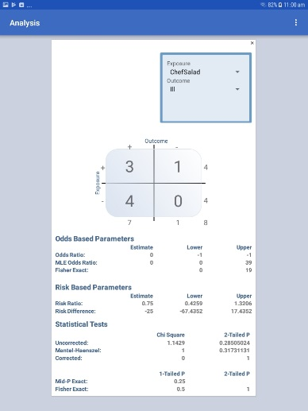
Figure 6.83: 2x2 Gadget

Map Gadget
The Map gadget allows you to geographically display case data on a map. The mobile version contains the ability to plot GPS coordinates on a Google Map base map. Internet connectivity is required to display maps on your mobile device using Google Maps. For additional mapping functionality, transfer the data to a computer and use the Epi Info™ Maps tool (See Maps).
        - Select Add Map Gadget from the Analyze Data menu options. A Map Settings dialog box appears.
        - Select the field containing the latitude coordinates from the Latitude Field drop-down list.
        - Select the field containing the longitude coordinates from the Longitude Field drop-down list.
The map appears displaying the location in Google Maps.
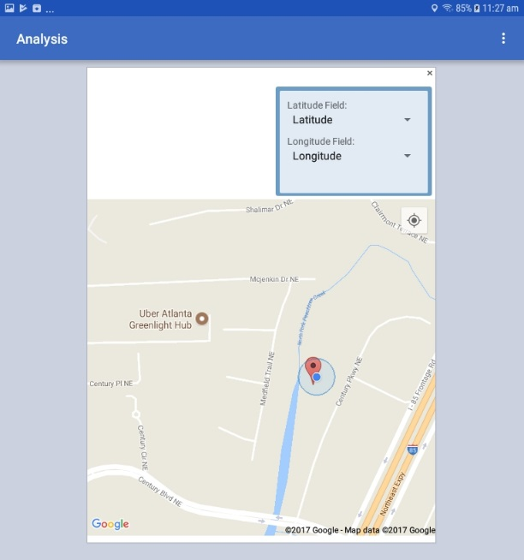
Figure 6.84: Map Gadget

Pie Chart Gadget
Pie charts are used for proportional assessment by comparing data elements as percentages or counts against other data elements and against the sum of the data elements. A pie chart is a circle having wedges dividing the circle into sectors that are proportional in area to the quantities of the data sets represented.
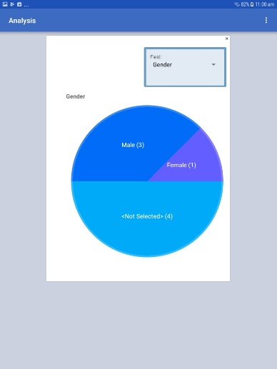
Figure 6.85: Pie Chart gadget

View Line List
This gadget provides a line list of the data collected in the device. It uses MS Excel to display the line list. The line list can be saved in the device.
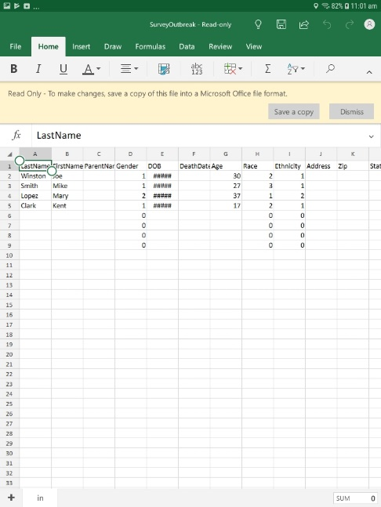
Figure 6.86: View Line List

