COVID-19 Tips for Airline Crew

[This section can include a note from your airline.]
As the pandemic continues, airline crew might have health and safety concerns. As you confront the challenges of COVID-19, you can take actions to protect yourself, your loved ones, your co-workers, and your passengers.

Protect yourself and others
To reduce the risk of infection among the airline workforce, limit close contact with others by maintaining a distance of at least 6 feet while at work and in public, when possible.
Do not come to work if you are sick or have tested positive for COVID-19. Please notify your supervisor and stay home, except to get medical care. If you are well but have a sick household member or have had other close exposure to a person with COVID-19 in the last 14 days, you should notify your supervisor and follow CDC-recommended precautions and guidance from your state and local health department. Discuss your work situation with your occupational health program before returning to work.
Notify your supervisor if you are awaiting COVID-19 test results and provide the reason for getting tested, for example, pre-surgery requirement, visiting a vulnerable family member, having symptoms, or possibly being exposed to someone with COVID-19.

To the extent possible, avoid working or traveling on aircraft while you are waiting for a COVID-19 test result.
  - If your test comes back positive while you are at your destination, you will need to self-isolate at your destination, and other members of your crew will need to quarantine.
  - You and your exposed co-workers will not be able to return by commercial airline until you are cleared by your employer for travel.

Take these important steps to reduce your chances of getting sick:
- During layovers, stay in your hotel room as much as possible. Eat in your hotel room with either room service or delivery service. If in-room food delivery options are not available, get take-out from the hotel restaurant or another restaurant nearby.
  - Limit activities in public to essential errands, such as getting food.

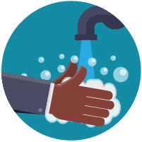
- Wash your hands often with soap and water for at least 20 seconds. Use hand sanitizer with at least 60% alcohol if soap and water aren’t available. Key times to wash your hands include:
  - Before eating food
  - Before preparing and serving food and beverages
  - Before and after work shifts
  - Before and after work breaks
  - After touching frequently touched surfaces
  - After using the restroom
  - After removing gloves or other personal protective equipment (PPE)
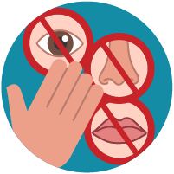

- Avoid touching your eyes, nose, and mouth with unwashed hands.

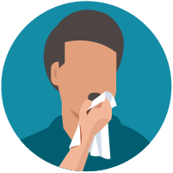
- Cover your mouth and nose with a tissue when you cough or sneeze or use the inside of your elbow. Throw used tissues in the trash and immediately wash your hands with soap and water for at least 20 seconds. If soap and water are not available, use hand sanitizer containing at least 60% alcohol.

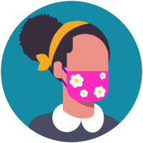
- Wear a mask to keep your nose and mouth covered while you are around other people, especially in situations where you cannot maintain the recommended physical distance from others.
  - When interacting with any sick traveler on board an aircraft, be sure to wear the surgical mask and other recommended PPE provided in the Universal Precaution Kit (UPK). Do not wear a cloth mask in this situation.
  - Be mindful that if oxygen masks are needed during your flight, you must remove your mask and put on an oxygen mask.
- Before each flight, inspect and confirm the condition and contents of the UPKs. Follow your airline’s policy and procedures for using the PPE in the kits if needed to provide care to a sick traveler on board.

Protect others
In addition to protecting yourself, you can help protect your co-workers and passengers on your flights each day.
If you identify sick passengers with fever, cough, or trouble breathing during your flight, follow the steps outlined in CDC’s guidance and report this illness to CDC as soon as possible before arrival.

Monitor your health and practice social distancing outside of work, following steps in COVID-19: Updated Interim Occupational Health and Safety Guidance for Air Carriers and Crews, provided jointly by CDC and the Federal Aviation Administration.

If you get sick with fever, cough, or trouble breathing during a flight, stop working immediately, put on a mask, notify your Lead Flight Attendant or Purser, and separate yourself from others as much as possible.

Steps we are taking as a company
We have COVID-19 health and safety plans to protect our employees. We are
[These are suggestions. This section can be adapted to include the actions your airline is taking]
- Implementing flexible sick leave and supportive policies and practices.
- Developing guidance describing what employees should do when a sick passenger or fellow crewmember gets sick.
- Completing a safety risk assessment and providing guidance to you on procedures for using masks because they could affect the donning of oxygen masks.
- Providing enough quantities of alcohol-based hand sanitizer containing at least 60% alcohol to crewmembers for personal use.
- Providing disinfectant products (e.g., disinfectant wipes) that are effective against COVID-19 for you to use on surfaces you touch frequently in the galley, in the passenger cabin, and on the flight deck.
- Providing enough PPE on board the aircraft for you to use when interacting with an ill traveler and ensuring enough masks are available to place on any travelers with symptoms.
- Training you in the correct use of PPE, including correct procedures for donning (putting on) and doffing (taking off).
- Before each flight, ensuring the UPKs are inspected for proper condition and contents, have adequate supplies, and are properly stored.
- Providing COVID-19 testing to air crews. [Insert information about under what circumstances testing is available (e.g., routine, illness, etc.) and how crew should access.]
- Designating someone to be responsible for responding to employees’ COVID-19 concerns. You can contact them by [insert contact info here]___________
- Following all applicable federal regulations and public health agency guidelines to protect you from COVID-19.

CDC provides these helpful tools for airlines:
- Guidance for Airlines on Reporting Onboard Deaths or Illnesses to CDC
- CDC Guidance for Airlines and Airline Crew: Coronavirus Disease 2019
- CDC Death and Disease Reporting Tool for Cabin Crew
- CDC Death and Disease Reporting Tool for Pilots
- Preventing Spread of Disease on Commercial Aircraft: Guidance for Cabin Crew
We thank our airline crew for your dedication and caring actions to ensure the health and safety of everyone on your flights.

