Slow the Spread of COVID-19 When You Travel
Many travelers are concerned about the current COVID-19 outbreak and may be anxious about their upcoming air travel. We understand your concerns and are taking the utmost care to ensure the health and safety of all those in flight and in their own communities. In addition, we ask that each of you play a part in our efforts to protect the public’s health.
Your safety is our top priority. Please follow CDC recommendations before, during, and after travel.

Steps you can take before travel
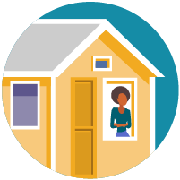
Decide whether you will travel. There are several things you should consider when deciding whether it is safe for you to travel. If you are traveling in the United States or abroad, visit CDC’s webpage for travelers to make an informed decision about your own risk.
Before you travel, consider the following:
    - Is COVID-19 spreading at your destination?
    - Do you live with someone who might be at increased risk for getting COVID-19?
    - Are you at increased risk for getting COVID-19?
    - Does your destination have requirements or restrictions for travelers? Check state and local requirements before you travel.
Consider getting tested with a viral test 1-3 days before your domestic travel. If traveling internationally, visit CDC’s webpage on testing and international air travel. Keep a copy of your test results with you during travel; you may be asked for them.

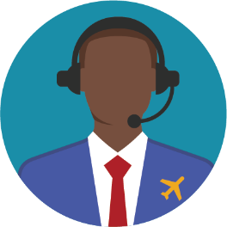
Help us maintain open communication during COVID-19. Please share your current contact information with our airline when booking your ticket. This information will allow us to notify you if you are exposed to a sick traveler on a flight. Under current federal regulations, pilots must report all illnesses and deaths on board aircraft to CDC before arriving at a US destination. Health departments also let CDC know if a person traveled on a plane while infectious.
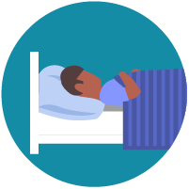
Avoid traveling if you are sick. If you feel sick before your planned travel, please stay home, except to get medical care. If you are sick, see additional steps you can take to help prevent the spread of COVID-19.

Do not travel if you test positive for COVID-19; immediately isolate yourself and follow public health recommendations.

Do not travel if you had close contact with a person with COVID-19. Stay home and quarantine by separating yourself from others.

Delay your travel if you are waiting for a COVID-19 viral test result. If your test comes back positive while you’re at your destination:
    - You will need to isolate yourself from others and delay your return.
    - Your travel companions will need to self-quarantine and delay their travel back home.

Steps you can take during travel
If you are feeling well, take these important steps to reduce your chances of getting sick during travel:
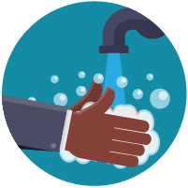
- Wear a mask to keep your nose and mouth covered when in public settings, including when using public transportation and in transportation hubs such as airports and stations.
- Avoid contact with sick people.
- Stay at least 6 feet/2 meters apart (about 2 arm lengths) from anyone who is not traveling with you, particularly in crowded areas. It’s important to do this everywhere, both indoors and outdoors.
- Avoid touching your eyes, nose, or mouth with unwashed hands
- Wash your hands often with soap and water for at least 20 seconds. If soap and water are not available, use an alcohol-based hand sanitizer that contains at least 60% alcohol.
      - It is especially important to wash your hands after going to the bathroom; before eating; and after coughing, sneezing, or blowing your nose.
- To the extent possible, avoid touching public door handles, handrails, and other frequently touched surfaces in public places. Also avoid shaking people’s hands.

Steps you can take after travel
You may have been exposed to COVID-19 on your travels. You may feel well but you can be contagious without symptoms and spread the virus to others. You and your travel companions (including children) may pose a risk to your family, friends, and community after your travel.
If returning from domestic travel, consider getting tested with a viral test 3-5 days after your trip and reducing non-essential activities for a full 7 days after travel, even if your test is negative. If you don’t get tested, consider reducing non-essential activities for 10 days after travel. If your test is positive or you have symptoms of COVID-19, isolate yourself to protect others from getting infected.

If returning from international travel, visit CDC’s webpage on After You Travel Internationally.

Consider taking these actions for 14 days after your return from travel to protect others from getting COVID-19:
- Stay at least 6 feet/2 meters (about 2 arm lengths) from anyone who did not travel with you, particularly in crowded areas. It’s important to do this everywhere -- both indoors and outdoors.
- Wear a mask to keep your nose and mouth covered when you are in shared spaces outside of your home, including when using public transportation.
- If there are people in the household who did not travel with you, wear a mask and ask everyone in the household to wear masks in shared spaces inside your home.
- Wash your hands often or use hand sanitizer with at least 60% alcohol.
- Avoid being around people who are at increased risk for severe illness.
- Watch your health: Look for symptoms of COVID-19, and take your temperature if you feel sick.

Follow all state and local recommendations or requirements after travel.
For more information on COVID-19 and ways to protect yourself and others, please visit www.cdc.gov/coronavirus.
Thank you for your care and attention to these public health measures that will help protect your health and the health of others. We appreciate your collaboration in the effort to slow the spread of COVID-19.

