Slow the spread of COVID-19 when you travel
Many travelers are concerned about the current COVID-19 outbreak and may be anxious about their upcoming air travel. We understand your concerns and are taking the utmost care to ensure the health and safety of all those in flight and in their own communities. In addition, we ask that each of you play a part in our efforts to protect the public’s health.
Your safety is our top priority. Please follow CDC recommendations before, during, and after travel.

Steps you can take before travel:
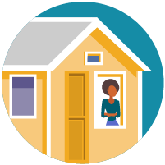
Decide whether you will travel. There are several things you should consider when deciding whether it is safe for you to travel. If you are traveling in the United States or abroad, visit CDC’s webpage about Travel during the COVID-19 Pandemic to make an informed decision about your own risk.
Before you travel, consider the following:
    - Is COVID-19 spreading at your destination?
    - Do you live with someone who might be at increased risk for getting COVID-19?
    - Are you at increased risk for getting COVID-19?
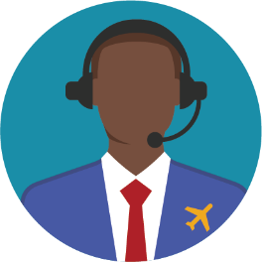
    - Does your destination have requirements or restrictions for travelers?
Help us maintain open communication during COVID-19. Please share your current contact information with our airline when booking your ticket. This information will allow us to notify you if you are exposed to a sick traveler on a flight. Under current federal regulations, pilots must report all illnesses and deaths on board aircraft to CDC before arriving at a US destination.

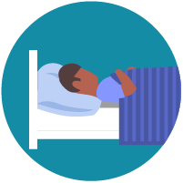

Avoid traveling if you are sick. If you feel sick before your planned travel, please stay home, except to get medical care. If you are sick, see additional steps you can take to help prevent the spread of COVID-19.

Steps you can take during travel:
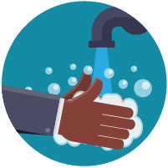
If you are feeling well, take these important steps to reduce your chances of getting sick during travel:
- Wear a mask to keep your nose and mouth covered when in public settings.
- Avoid contact with sick people.
- Avoid close contact by staying at least 6 feet apart (about 2 arms’ length) from anyone who is not from your household.
- Avoid touching your eyes, nose, or mouth with unwashed hands.
- Wash your hands often with soap and water for at least 20 seconds. If soap and water are not available, use an alcohol-based hand sanitizer that contains at least 60% alcohol.
      - It is especially important to clean hands after going to the bathroom; before eating; and after coughing, sneezing or blowing your nose.
    - To the extent possible, avoid touching public door handles, handrails, and other frequently touched surfaces in public places. Also avoid shaking people’s hands.

Steps you can take after travel:
You may have been exposed to COVID-19 on your travels and may feel well and not have any symptoms. However, you can be contagious without symptoms and spread the virus to others. You and your travel companions (including children) pose a risk to your family, friends, and community for 14 days after you were exposed to the virus. Regardless of where you traveled or what you did during your trip, take these actions to protect others from getting sick after you return:
- When around others, stay at least 6 feet apart (about 2 arms’ length) from other people who are not from your household. It is important to do this everywhere, both indoors and outdoors.
- Wear a mask to keep your nose and mouth covered when you are outside of your home.
- Wash your hands often for at least 20 seconds or use hand sanitizer (with at least 60% alcohol).
- Watch your health and look for symptoms of COVID-19. Take your temperature if you feel sick.

Follow state and local recommendations or requirements after travel.
Some types of travel and activities can put you at higher risk for exposure to COVID-19. If you participated in higher risk activities or think that you may have been exposed before or during your trip, see additional precautions you can take to protect others for 14 days after you travel.
If you know that you were exposed to someone with COVID-19, postpone further travel. Even without symptoms, you can spread COVID-19 to other people on your journey.
For more information on COVID-19 and ways to protect yourself and others, please visit www.cdc.gov/coronavirus.
Thank you for your care and attention to these public health measures that will protect your health and the health of others. We appreciate your collaboration in the effort to slow the spread of COVID-19.

