How to Access CITGO
Table 1 – Approval Chart
Approving Official | Branch/Office | Date
David B. Ausefski | SSO | 8/8/17
Table 2 – Revision History Chart
Revision Date | Version # | Author/Editor | Reason for Revision
8/8/17 | 1.0 | Suzanne Mabee | Released as final

Personnel Concerned:
All CDC Employees and Non-Employees using remote access via CITGOv5. All ITSO employees and non-employees involved in maintaining and supporting CITGOv5, including AHB, BSO, CSB, CTO, DTO, GA, IEP, NTB, OD, SSO, and TS.

How to Access CITGO
Step 1 | - Before you begin, make sure that you Exit Skype for Business on your local desktop, if you plan to use Skype from within your CITGO session.  - Insert your Smart Card into the Smart Card reader or make sure your RSA key fob is ready to enter the RSA Passcode.  - From your Internet browser, browse to citgo.cdc.gov to access the CITGO Login page.  - To use a Smart Card, click the Log On button next to the Smart Card image. OR  - To use a key fob, enter your User Name, Password and RSA Key Fob Passcode; then click the Log On button under your passcode and skip to step 4.  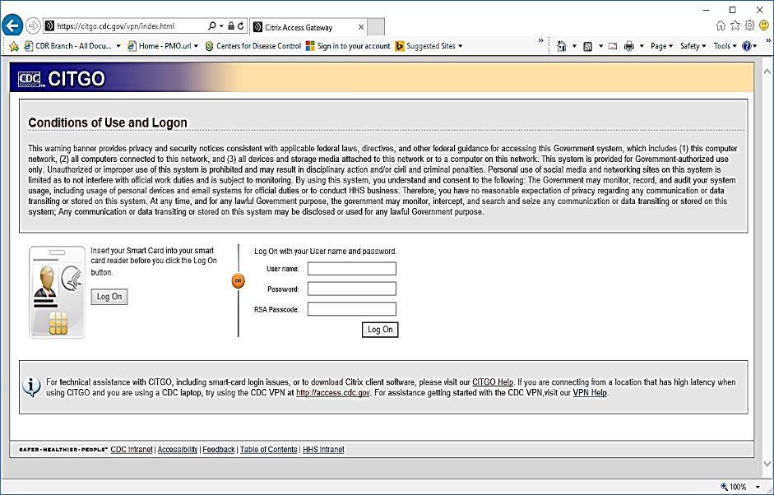
Step 2 | 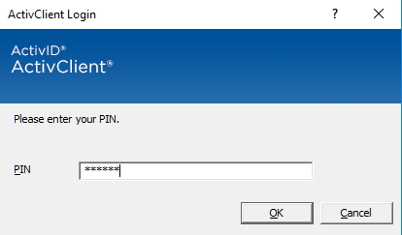  - If using your Smart Card, enter your 6-8 digit Personal Identification Number (PIN) and click OK.
Step 3 | - If a Windows Security pop-up appears prompting you to Select a Certificate, choose the certificate credential with the latest date range, and if prompted, re-enter your PIN.  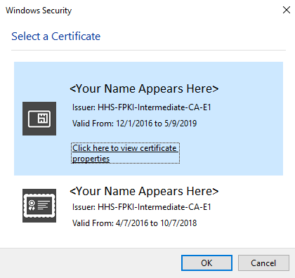  Note: You may not receive this prompt.

Step 4 | - From the CITGO home page, click the CITGO Virtual Desktop menu item to launch the CITGO Virtual Desktop.
Step 5 | - When the Windows sign-in screen appears, click the Sign-in Options button for PIV to sign in with your Smart Card.  Note: It may take up to 30 seconds for the Sign-in Options button to appear. Removing and re-inserting your Smart Card may expedite this prompt.  OR  - If using an RSA Key Fob, enter your network User ID and password at the Windows login screen.  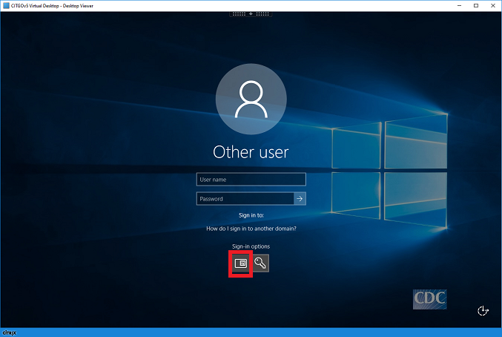
Step 6 | - When prompted, enter your 6-8 digit PIN and select Enter on your keyboard or click the  right-arrow button. The CITGO virtual desktop screen will appear when login completes.
Step 7 | 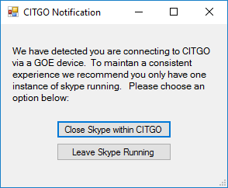  - If you did not exit Skype for Business on your local desktop but intend to use Skype within your CITGO session, select Leave Skype Running at the following CITGO notification prompt. Having two instances of Skype running simultaneously may result in a poor Skype experience.
End of Guide

