Getting Started with ShareFile
ShareFile is a secure CDC file-sharing and syncing service enabling CDC staff to securely share files and folders with other CDC staff and external partners. ShareFile is accessible by computer, tablet, and smartphone through the web-browser.
This document is an overview of the steps to send and request files using your ShareFile account. (NOTE: Some features in your ShareFile account may differ depending upon your settings.)

Request Access to ShareFile
You can request access to ShareFile by going to the ITSO Tools page at http://itsotools.cdc.gov and clicking on the ShareFile Request Tool link to initiate the approval workflow. Once the approval workflow is complete, you will receive notification from the ITSO team that you are enabled to use ShareFile. By default, all ShareFile requests are allocated 10 gigabytes (GB) of space. If you require more than 10 GB, you can request additional storage at the time you submit your initial request or by contacting the ITSO Service Desk at 404-639-6000, or toll free at 1-888-647-3375, or by email at itsoservicedesk@cdc.gov.

Access ShareFile
To access ShareFile, go to https://sharefile.cdc.gov, then enter your CDC user ID and password. If you are unable to login, be sure you have performed the one-time process described above for requesting access to ShareFile.

Account Dashboard
The Dashboard is the first page you will see after logging into ShareFile. You may use the navigation menu on the left side of the page to access folders. The Recent Files section displays up to five files you recently accessed from your computer. By clicking on any of the quick link buttons on the right side of the dashboard, you can also quickly access your folders, or send and request files.
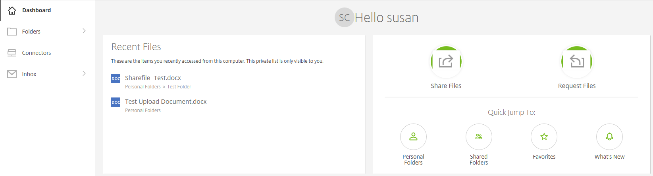
Figure 1 – ShareFile Dashboard

Sending a File
ShareFile can help you send a file or files to internal CDC staff and external partners. Instead of attaching files to email messages, you upload them to your ShareFile account and then send links to recipients for download.
- From the ShareFile Dashboard, click on the Share Files 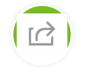 button. Select Email with ShareFile.
- In the Data fields, enter the recipients’ email addresses, a subject line, and a message.
- Upload the files to share in one of three ways:
  - Select any file from your computer and drag it to the Drag files here area.
  - Select Browse files and select the file from your computer.
  - Select Browse files and add from your ShareFile account.
- If you want to customize your notifications and security options, select Edit Message Options to reveal the Notifications and Security Options window. Click Done when finished.
- Click on the Send button to email your message to the recipient(s).

Reviewing Shared Files
You can review emails you have sent from ShareFile in your Outlook Inbox located in the sidebar menu of the home screen. To see a list of your sent emails and edit link expiration dates or notification settings, select the carat next to the Inbox, then select Sent.

Requesting a File
You can request that someone send files to your ShareFile account.
- From the ShareFile Dashboard, click on the Request Files 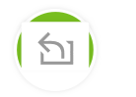 button. Select Email with ShareFile.
- In the data fields, enter the recipients’ email addresses, a subject line, and a message.
- Select a folder in ShareFile that you want to add the requested files. (NOTE: ShareFile automatically sends files to your File Box folder, but you can select Edit to change the destination.)
- Select Edit Message Options, if you want to customize your notifications and security options (i.e. determine how many downloads are allowed). Click Done when finished.

Setting up Folders to Organize your Files
You can set up folders to store files on your ShareFile account. Folders allow you to share data within the account.
- Click the green Floating Action button and select Create Folder.
- Enter a name for your folder. (NOTE: You may also enter a description for the folder, which displays as a note attached to the folder in your account.) Select Create Folder.
If you need assistance, contact the ITSO Service Desk at 404-639-6000, or toll free at 1-888-647-3375, or by email at itsoservicedesk@cdc.gov.

